EUROPEAN COMMISSION
DG Employment, Social Affairs and Inclusion

Resources, Planning and Communication
Information Technologies

Contact:
EMPL-EURES-INTEROP@ec.europa.eu

EURES formats and standards specification
Part 2: EURES job seeker profile data standard description

Subject | EURES formats and standards specification - part 2  Job seeker profile data standard description
Version | 1.3.1
Release Date | 14/02/2018
Filename | EFSS_v1.3.1_part_2_ JSP-v1.01.docx
Document Reference | EFSS_JSP

 |  | EURES Job Application Data Standard description
Abstract

The purpose of this document is to describe in detail the EURES Job Application Data Standard Specification, which is the format used for the exchanges of CVs between the national partners and the EURES central system. This document defines the structure, the code lists to be used and the Business Rules that apply for each of the elements.

Change log

Version | Description |  | Author | Creation  Date | Required review  date | Reviewed  By | Approval date
0. 1 | First draft of the document |  | EVERIS | 1/03/2013
1. 0 | Publication of the document |  | ARHS | 9/11/2016
1.1 | Update of inconsistencies |  | ARHS | 27/03/2017 | 27/03/2017 | Sébastien Deru
1.2 | Update of inconsistencies and Change requests logged in PORT-6701, PORT-6702 and PORT-6733 |  | ARHS | 31/07/2017 | 31/07/2017 | Sébastien Deru
1.3 | Update of inconsistencies and Change requests logged in PORT-6865, PORT-6866 and PORT-6867 |  | ARHS | 24/11/2017 | 24/11/2017 | Sébastien Deru
1.3.1 | Update of inconsistencies and Change requests logged in ENR-557 |  | ARHS | 14/02/2014 | 14/02/2018 | Sébastion Deru

History table

Internal  Version | Description | Author | Release Date | Review  date | Reviewed  By
0.01 | Update of inconsistencies and Change requests logged in PORT-6865, PORT-6866 and PORT-6867. Submission for review. | Sébastien Deru | 24/11/2017 | 24/11/2017 | Christophe Duterme
1.01 | Update of inconsistencies and Change requests logged in ENR-557 | Yassin Ouballouk | 14/02/2018 | 14/02/2018 | Sébastien Deru

Table of Contents
I. 1
1 Introduction 4
2 Background 4
3 CV Model Approach 4
4 EURES CV “Static” Standard Description 4
5 Annex 1. Ordered List With all Code Lists 4
6 Annex 2. Ordered List With all Elements of CV Schema 4
7 Annex 3. Treatment of Unfulfilled Business Rules 4
7 Annex 4. Examples 4

Table of Contents: Parts of the Model
I. 1
1 Introduction 4
1.1 Document Scope 4
1.2 Intended Audience 4
1.3 Document Structure 4
2 Background 4
2.1 Design Approach 4
3 CV Model Approach 4
3.1 Layers Approach 4
3.2 Design Criteria 4
3.3 Specific Topics 4
4 EURES CV “Static” Standard Description 4
4.1 Overall View 4
4.2 /Candidate (level 0) 4
4.3 /ID (level 1) 4
4.4 /Processing Information (level 1) 4
4.5 /Supplier (level 1) 4
4.6 /Supplier/Contact (level 2) 4
4.7 /Person (level 1) 4
4.8 /Person/PersonName (level 2) 4
4.9 /Person/Communication (level 2) 4
4.10 /Person/Disability (level 2) 4
4.11 /Profile (level 1) 4
4.12 /Profile/Person Availability (level 2) 4
4.13 /Profile/Education History (level 2) 4
4.14 /Profile/Qualifications (level 2) 4
4.15 /Profile/Experience Summary (level 2) 4
4.16 /Profile/Employment History (level 2) 4
4.17 /Profile/Employment References (level 2) 4
4.18 /Profile/Certifications (level 2) 4
4.19 /Profile/Employer Preferences (level 2) 4
4.20 /Profile/Position Preferences (level 2) 4
4.21 /Profile/Licenses (level 2) 4
4.22 /Profile/Military History (level 2) 4
4.23 /Profile/Patent History (level 2) 4
4.24 /Profile/Publication History (level 2) 4
4.25 /Profile/Organization Affiliations (level 2) 4
4.26 /Profile/Speaking History (level 2) 4
4.27 /Profile/Attachment (level 2) 4
4.28 Code Lists 4
5 Annex 1. Ordered List With all Code Lists 4
6 Annex 2. Ordered List With all Elements of CV Schema 4
7 Annex 3. Treatment of Unfulfilled Business Rules 4
7 Annex 4. Examples 4
7.1 Example 1 [EX-01] 4
7.2 Example 2 [EX-02] 4
7.3 Example 3 [EX-03] 4

Reference and Applicable Documents
The following contents or documents may be relevant for better understanding the project and the contents of this document.
Reference Documents
Ref. | Title | Reference | Version | Release
 | EURES Job Vacancy Data Standard description | EURES-JV-StandardStaticModel | 1.3.1 | 2018
 | EURES ReferenceData | EURES-ReferenceData | 1.3.1 | 2018

Abbreviations and Acronyms
BR | Business Rule
Card. | Abbreviation of Cardinality
CV | Curriculum Vitæ
CVO | CV Online
EEA | European Economic Area
ES | Employment Services
ESCO | European Skills/Competences, qualifications and Occupations
EURES | EURopean Employment Services
HR-XML | Human Resources Open Standards
JV | Job Vacancy
N/A | Not Applicable (or Not Available)
PES | Public Employment Services
PRES | Private Employment Services
XML | eXtended Markup Language

Introduction

Document Scope
EURES Job Application Data Standard is used to describe data models and business rules that are needed to communicate Job Applicant’s information (CV) within EURES Network and are further based on HR Open “Candidate” specification version 3.2.
The scope of this document is to provide a detailed description of the EURES Job Application Data Standard “static” model.
The “static” part describes the model as it is, including its elements, cardinality and necessary business rules without considering its interaction with other external systems. The description of this external interaction is known as the “dynamic” part of the model and is outside the scope of the present document.

Intended Audience
The present document is intended to be read by the following teams, among others:
- The DG EMPL Team;
- Technical integrator users from Employment Services (ES) interested in interoperating with the Interoperability Platform, with the responsibilities of adapting the CVs XMLs from the ES to the new standard;
- Interoperability Platform developers, responsible for implementing the different scenarios defined.

Document Structure
This document is structured in a comprehensible way, in order to facilitate implementation of the new CV standards defined. It includes:
- The CV standard model approach
- A detailed description of the EURES CV “static” standard, including examples of its application

Background

Design Approach
The tecnichal solution is designed to take advantage of the information contained in the JV and CV.
The approach was to:
- Not reinvent the wheel.
- Re-use an existing business language.
- Select an international standard.
- Have an open and royalty-free standard.
- Have, if possible, a HR domain-related standard.
The standards adopted are HR-Open Standards, as:
- It is an open and free international standard.
- It is not a merely generic business language.
- It covers a large part of the EURES business domain.
- It is already being used by Employment Services.

CV Model Approach
The static defined standard includes a tree of elements, where each element contains the following information:
- Cardinality, which measures the number of possible occurrences of the element (1, 0..n, ..).
- Attributes: it indicates the elements’ features. Only the most important attributes are shown in this tree of elements.
- Each element of the model tree has a type of layer (see “3.10 Layers Approach”) describing its relationship with the Interoperability Platform. It is represented by the colour of the elements.
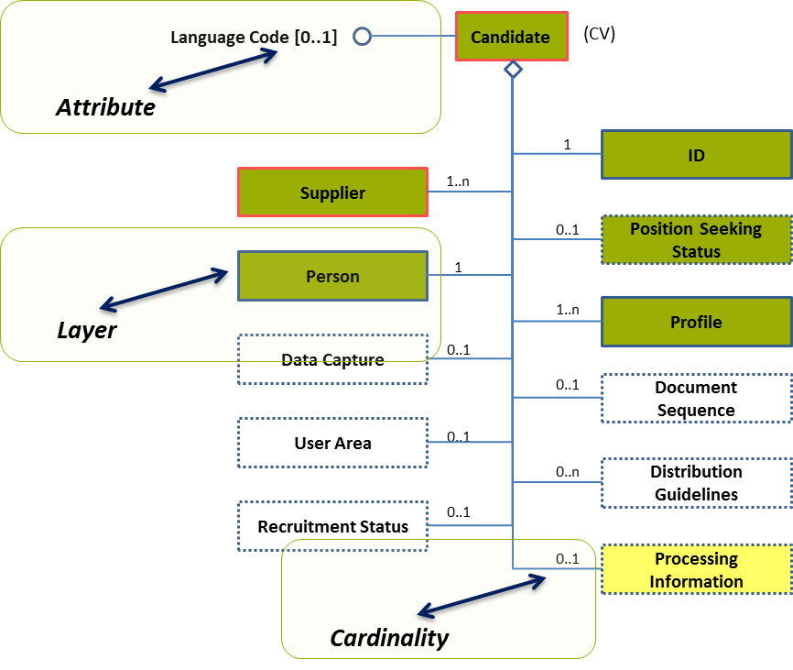
Figure 1: Example of a tree of elements representing the CV standard

Layers Approach
This model starts from the HR-Open Standards template. This template determines the structure and the number of fields possible. The EURES version of this model considers all elements of this standard template and assigns them in 3 layers. Some of the layers will impose extra requirements for certain fields.
- Green colour: This indicates that this information is essential to the EURES standard, and should be provided by the source of this job vacancy. The information could be essential for job matching and the lack of it can influence our main goal.
- Yellow colour: The information elements in this layer are optional for the use by the EURES system. They will be checked and can be used to display additional information or improve some optional search/matching features. The EURES partners are free to decide if they send in this information. However when they do so, the information needs to follow the rules of this standard.
- White colour: The remaining part of the template that is there to be fully compliant with the standard, but these elements are not used by the EURES System. Adding white elements in the XML will trigger warinings in the online validator tool.
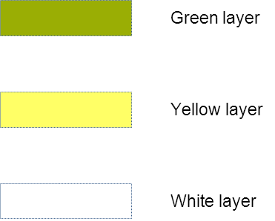
Figure 2: Description of the layer colours
An example:
Employer X can hand over a job vacancy in the HR-Open Standards to an employment agency Y. This EURES partner Y will adapt the information if needed and send it in to the EURES interoperability platform. This means that they will make sure the green and yellow parts are in line with the expectations specified in this document. The white part (information send in by the employer but outside of the matching scope) will not be removed; it just remains in the job vacancy. If the job vacancy would be retrieved by another player, they may still want to use the other layers.

To understand the layers that have been added to this implementation of the HR-Open Standards, you have to consider the 2 main targeted user groups:
- The model is designed to be used by the EURES partners to exchange information and perform matching according to an agreed set of data.
- Next to this, the model will be used by interested industry partners to exchange data beyond the boundaries of the EURES partners. They can benefit from the advantages of the open standard, and a fast exchange opportunity from or to a EURES partner.

Next to this division in 3 layers, the model can represent each element with some special indicators (dotted/solid lines, red border). These details are more important for the technical implementation of validation rules.
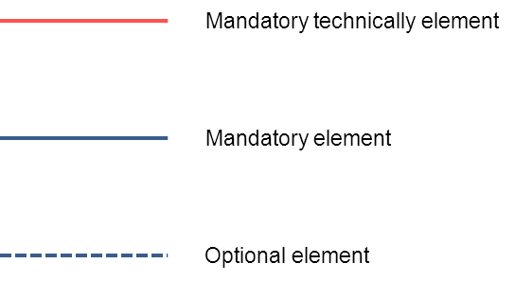
Figure 3: Description of the layer lines types
The diagram below provides a detailed overview:
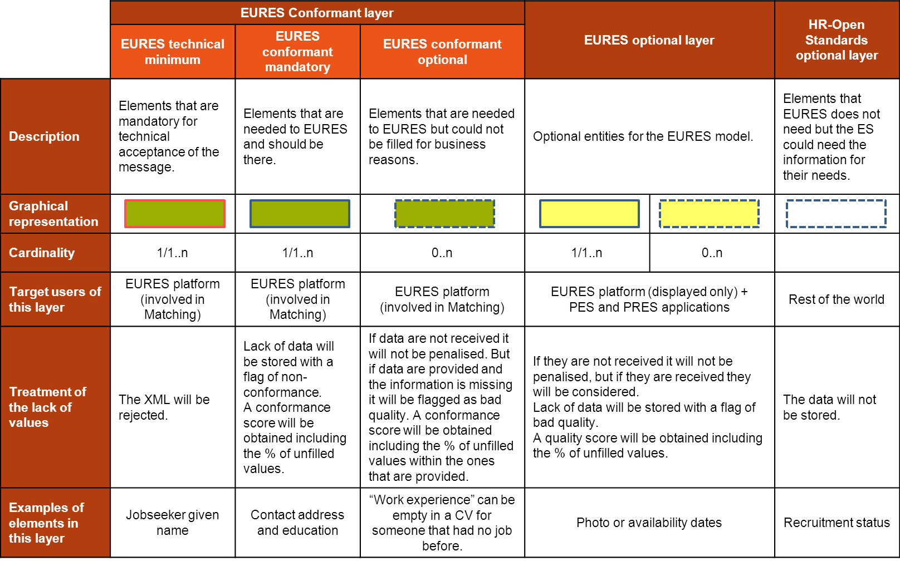
Figure 4: Detailed description of EURES layers
The ES will be able to share CV information with the EURES Hub using any of the layers.

Design Criteria
The following design criteria have been followed:
TREE DECOMPOSITION:
- Each diagram will have one decomposed sub-element. This means, that the root element will be repeated (e.g. profiles, languages, etc.), in each decomposed diagram.
ASSIGNMENT OF THE LAYER TYPE
- The layer type of an element will be constrained by its parent's layer, meaning that a sub-element may have the same layer type than its parent, or a less restrictive one.
- In this example, the root element belongs to the “EURES conformant layer” (green). However, its sub-elements may be “EURES conformant layer” (green), but also they may be “EURES optional layer” (yellow) or “HR-Open Standards optional layer” (white), regardless of their cardinality (i.e. 1, 1..n or 0..n):
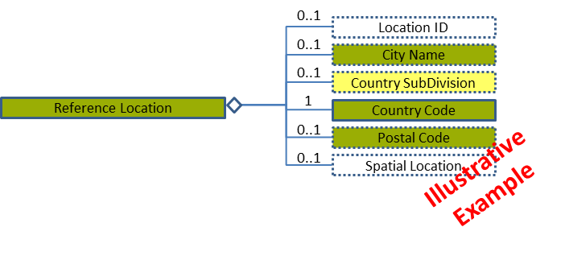
Figure 5: Example of tree of elements applying "EURES conformant layer" design criteria
- The same applies to an element that belongs to the “EURES optional layer” (yellow), which its sub-elements may be “EURES optional layer” (yellow) or “HR-Open Standards optional layer” (white). They can’t be green any more:
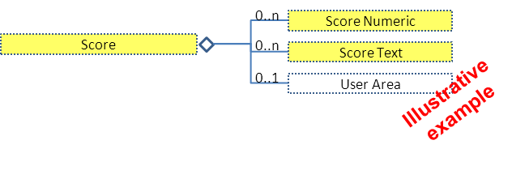
Figure 6: Example of tree of elements applying "EURES optional layer" design criteria
ASSIGNMENT OF THE CARDINALITY
- An element may be mandatory (cardinality 1 or 1..n) or optional (cardinality 0..1 or 0..n). However, its assignment does not depend on its layer type.
- A mandatory element is required to appear, as long as its parent also appears. According to the layer type, the lack of values of a mandatory element is treated in a different way.
For example, a mandatory element which layer is “EURES conformant layer” (green) may imply:
  - The XML will be rejected if the element is “EURES technical minimum”.
  - “EURES conformant mandatory”: the lack of data will be stored with a flag of non-conformance and a conformance score will be obtained including the % of unfilled values.
On the other hand, a mandatory element as “EURES optional layer” (yellow) implies:
  - Lack of data will be stored with a flag of bad quality. A quality score will be obtained including the % of unfilled values.
- The design criterion implies that a mandatory element should meet one of the criteria in order to not have an empty element:
  - At least one of its sub-elements should be mandatory (cardinality 1 or 1..n):
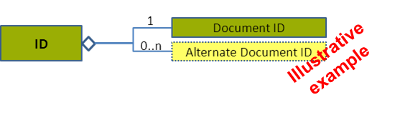
Figure 7: Example of tree of elements applying "EURES mandatory" design criteria
- A Business Rule (BR) will be applied pointing out that at least one of its sub-elements must be filled in:
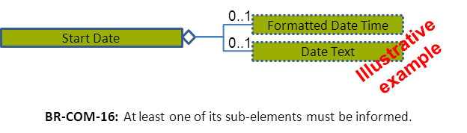
Figure 8: Example of tree of elements applying "EURES mandatory" business rule
MISSING VALUES
- Information could be missing because of 2 reasons. First because the Employment service does not have this information in its database at all. A second reason is when the database could have the information, but it was not provided by the jobseeker for this specific CV. The Interoperability Platform will differentiate between these 2 cases by the following rule:
  - Not including the tags of an element in the XML file means that the Employment services do not have this information in their database for all CV’s.
  - Including an element’s tags in the XML file, but leaving them empty (e.g. <EmploymentHistory> </EmploymentHistory>) means that the Jobseeker did not provide any work experience.
Please note that this differentiation may be used by matching engines in certain rules.

Specific Topics
The following topics impact on the whole model:

CV in Multiple Languages
How should EURES check that a Candidate has the same CV in different languages?
The agreed solution is that:
- It will be controlled at the Candidate Profile level and each language will have a profile (see section “4.11.2 Profile Attributes”).
- This decision will include the following Business Rules:
  - BR-COM-01: If not otherwise specified, “EN” (English) is used as the default language.
  - BR-COM-02: Multiple profiles are allowed, but it must be expressed in different languages.
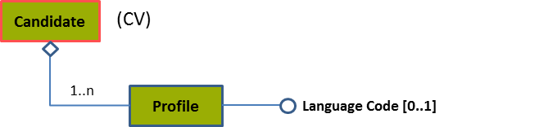
Please, see section “4.11.3 Profile Examples” for more examples.

Content Versioning
Versioning is involved at the level of the standard template used for exchanging the data and at the level of changes in the content of a CV (changes in the content of one or more fields of a CV).
- The Interoperability Platform will not store the history of content versions. This means that when a CV is updated (for instance the address of the jobseeker is changed), its old content will be removed and lost inside the interoperability platform storage.
This does NOT mean that the owner of this CV can’t keep a history of all changes in a CV in its own system. However when sending the data to the interoperability platform, it is expected to represent only the most recent information and no history of changes.
- In each exchange also the version of the EURES schema (template) being used needs to be expressed (i.e. 3.1, 3.2).
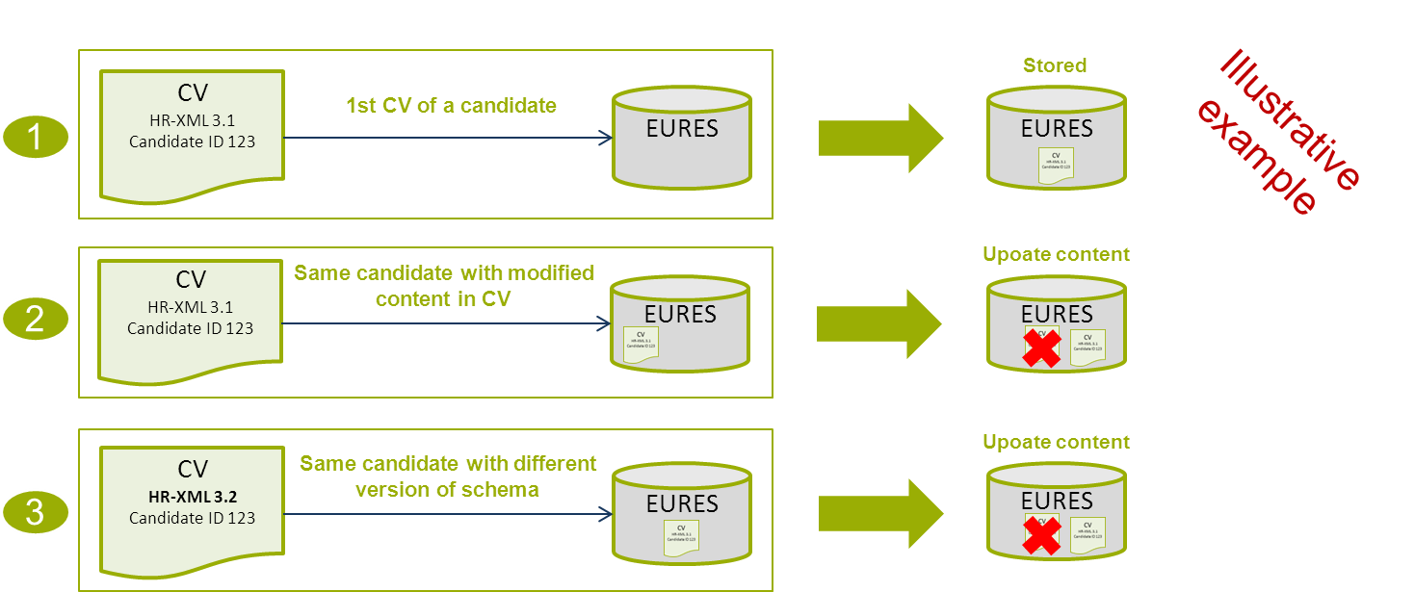

Code List Version
Codes are used to identify concepts. The standard EURES CV and JV use codes intensively, as codes are one of the most powerful solutions for ensuring interoperability.
Which version of these code lists will this standard use?
- For each code list, the latest available version of the current versions of the standard being designed is used. Only one version for each code list is used.
- However, for specific cases, a code list may be limited or a specific version may be chosen; this will be explained where the code list is specified.

Identifiers
A CV can pass from partner to partner before entering the interoperability platform. Each system may want to add its own identifier to the document for traceability. This way the EURES partner that puts the document on the platform can trace back to the owner when needed for referral. Therefore this document will set the rules to enable all parties to trace back when needed.
The document identifiers are stored in the Document ID:
- The Document ID element will store the original document identifier. Any additional identifiers will be stored in Alternate Document ID.
- The following attributes establishes the identifier order:
  - The SchemaAgencyID attribute of the DocumentID and SupplierID elements must be the same.
  - The Supplier’s Precedence element must store the identifier’s order of arrival.
Please see sections “4.3 /ID (level 1)” and “4.5 /Supplier (level 1)” for more examples.

EURES CV “Static” Standard Description
The EURES CV model is based on the HR-Open Standards 3.2 “Candidate” specification.
It has the following characteristics:
- This specification has been customised in order to better meet the information exchange and matching objectives defined in EURES.
- The elements which are not described in this specification are not allowed
- The XSD specifies that the elements of the XML implementation MUST appear in a sequence. One of the validation rules is to check that the sequence of the elements is compliant with the XSD
- Adding white elements in the XML will trigger warinings in the online validator tool

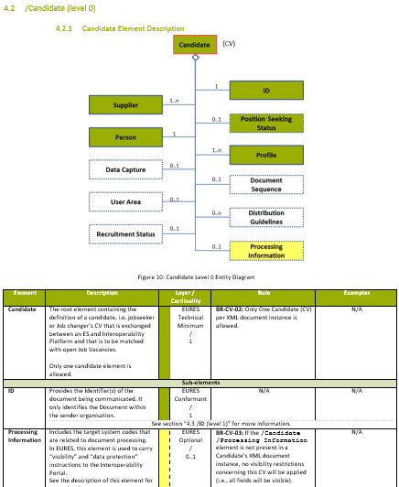
The model is shown in the diagram level by tree level:
- An overall view of the entities diagram.
- A description of how the entity diagrams correspond to details of the relevant information elements with business semantics (only when not previously disaggregated).
- Names and descriptions for each of these elements, their restrictions and when relevant Business Rules should be taken into consideration.
- An examples column where some elements are complex (including different sub-elements) and are represented with N/A.

Overall View
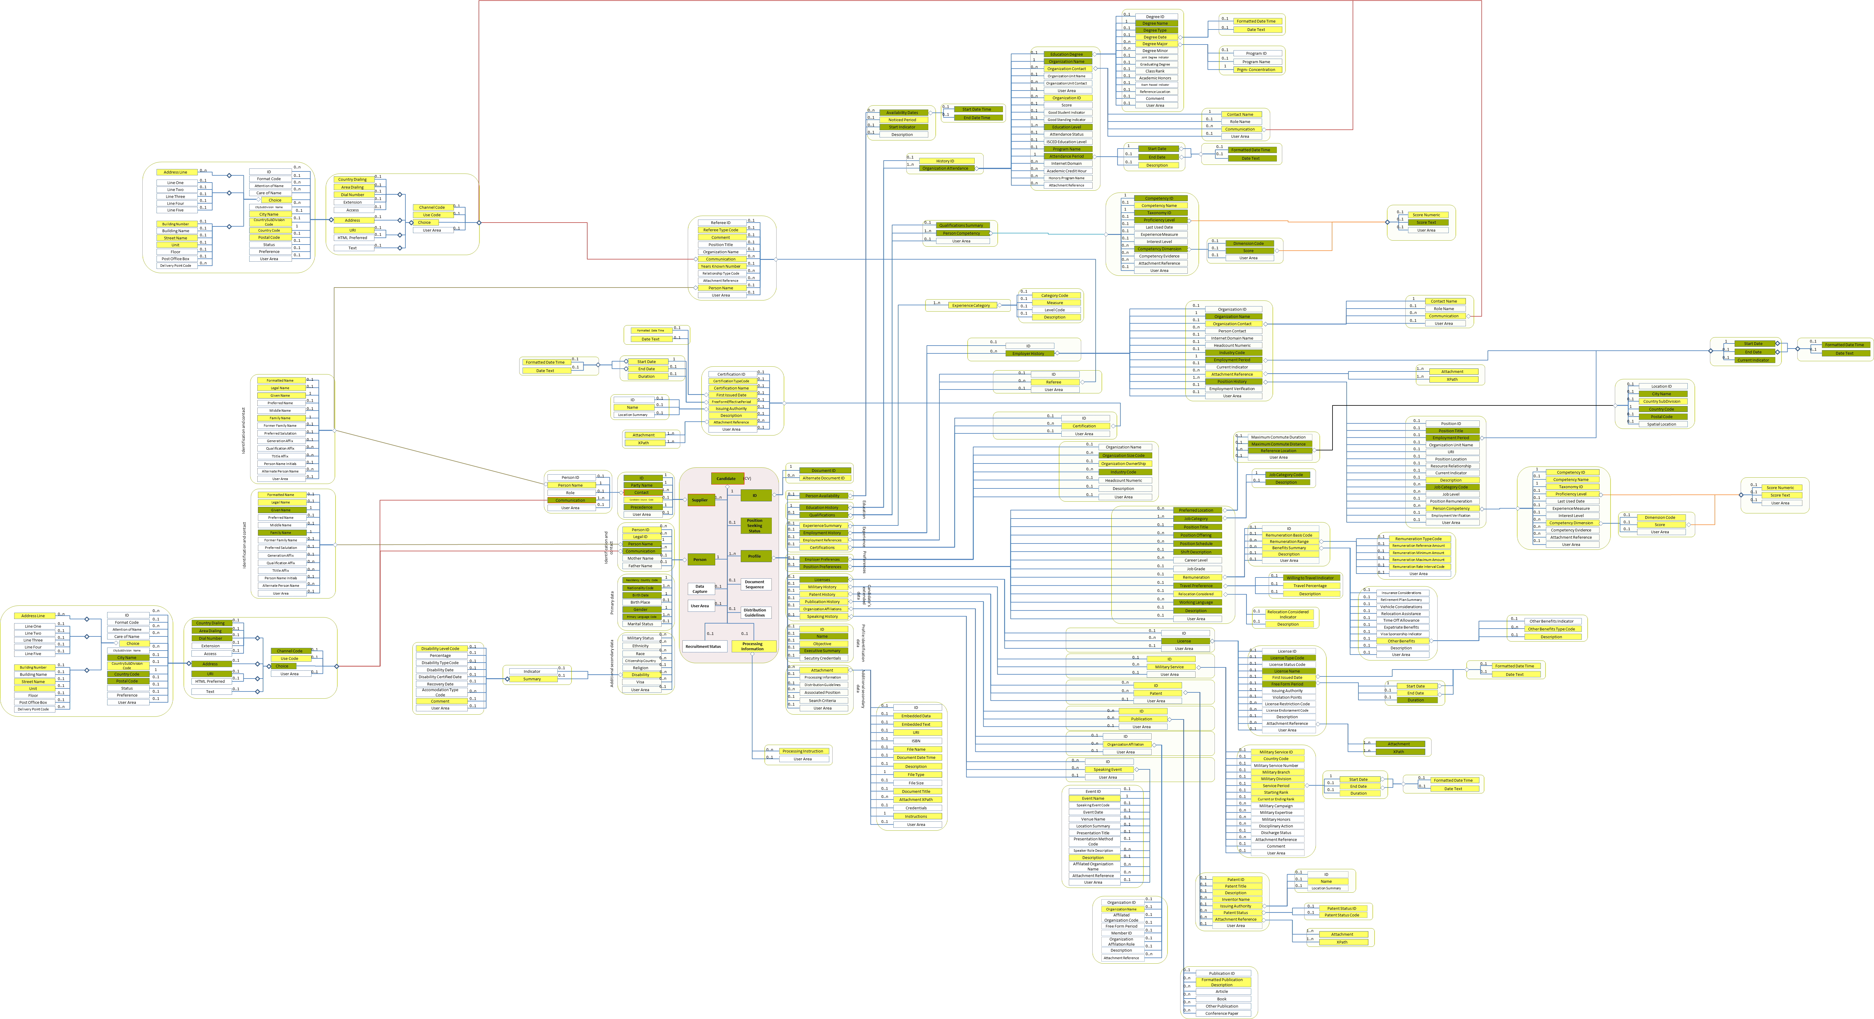
Figure 9: Overall view Entity Diagram

/Candidate (level 0)

Candidate Element Description
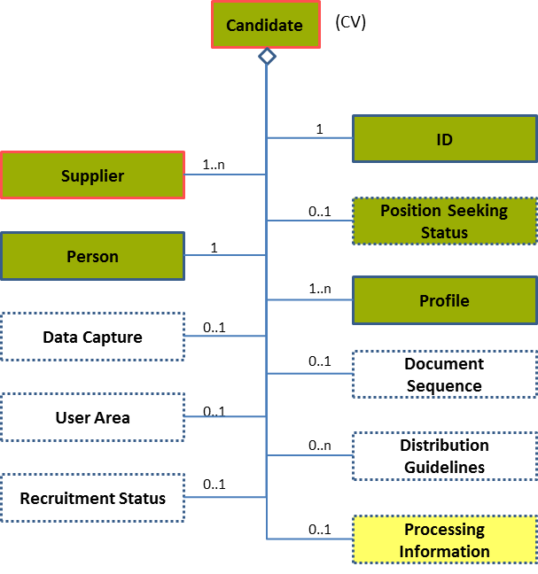
Figure 10: Candidate Level 0 Entity Diagram
Element | Description | Layer /  Cardinality |  | Rule | Examples
Candidate | The root element containing the definition of a candidate, i.e. jobseeker or Job changer’s CV that is exchanged between an ES and Interoperability Platform and that is to be matched with open Job Vacancies.  Only one candidate element is allowed. |  | EURES Technical Minimum  /  1 | BR-CV-02: Only One Candidate (CV) per XML document instance is allowed. | N/A
Sub-elements
ID | Provides the Identifier(s) of the document being communicated. It only identifies the Document within the sender organisation. |  | EURES Conformant  /  1 | N/A | N/A
 | See section “4.3 /ID (level 1)” for more information.
Processing Information | Includes the target system codes that are related to document processing.  In EURES, this element is used to carry “visibility” and “data protection” instructions to the Interoperability Portal.  See the description of this element for more details. |  | EURES Optional  /  0..1 | Information: If the /Candidate /Processing Information element is not present in a Candidate’s XML document instance, no visibility restrictions concerning this CV will be applied (i.e., all fields will be visible) | N/A
 | See section “4.4 /Processing Information (level 1)” for more information.
Supplier | Information about the supplier of the candidate details. This can be the candidate him/herself through the EURES Portal, or a third party (a PES, for instance). |  | EURES Technical Minimum  /  1..n | N/A | N/A
 | See section “4.5 /Supplier (level 1)” for more information.
Position Seeking Status | A code classifying the candidate's job search pattern or disposition.  This is an HR-Open Standards open list. |  | EURES Conformant Optional  /  0..1 | BR-CV-04: The “PositionSeekingCodeContentType” HR-Open Standards Code List must be used to codify the /Candidate /Position Seeking Status. | “Active”, ”Passive”, “NotConsideringPositions”  Full code list: “4.28.28 Position Seeking Status Enum Type [CL39]”
Person | Personal details of the person seeking a job, such as his/her name, age, gender, and so on. |  | EURES Conformant  /  1 | N/A | N/A
 | See section “4.7 /Person (level 1)” for more information.
Profile | The candidate’s structured set of characteristics, such as his/her Qualifications, Work Experience, and so on.  More than one profile is allowed in order to provide the information in different languages. Thus the need for cardinality 1..n.  It is the responsibility of the person who builds up the CV to make sure that a profile is expressed in the same language and those different profile language versions contain exactly the same information. |  | EURES Conformant  /  1..n | BR-COM-01: If not otherwise specified, “EN” (English) is used as the default language.  BR-COM-02: Multiple profiles are allowed, but it must be expressed in different languages. | N/A
See section “4.11
/Profile (level 1)

” for more information.

Candidate Attributes
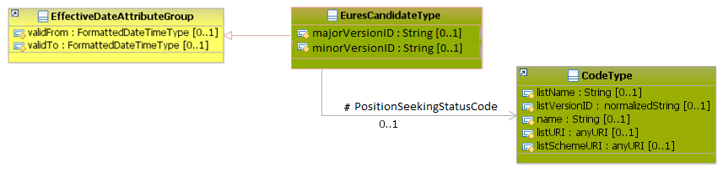
Figure 11: Candidate Attributes Schema
Attributes | Description | Card. | Rules/Comments | Examples
majorVersionID | Identifies the major version of the HR-Open Standards schema. | 0..1 | BR-COM-56: The attributes “majorVersionID” and “minorVersionID” are mandatory.  BR-COM-57: Compulsory use of the version 3.2 of HR-OS (“majorVersionID” is 3 and “minorVersionID” is 2). | “3”
minorVersionID | Identifies the minor version of the HR-Open Standards schema. | 0..1 | BR-COM-56: The attributes “majorVersionID” and “minorVersionID” are mandatory.  BR-COM-57: Compulsory use of the version 3.2 of HR-OS (“majorVersionID” is 3 and “minorVersionID” is 2). | “2”
validFrom | Specifies the date of reception of the document in the Interoperability Platform. | 0..1 | BR-COM-05: If not specified, the “validFrom” date will default to “assigned by EURES on reception”.  BR-COM-06: Compulsory Date Format is: YYYY-MM-DD, YYYY-MM, YYYY or YYYY-MM-DDThh:mm:ss. | “2012-10-10”
validTo | Specifies the last date when the CV will be active. | 0..1 | BR-COM-07: If not specified, the “validTo” date will be decided by EURES depending on the transaction context.  BR-COM-06: Compulsory Date Format is: YYYY-MM-DD, YYYY-MM, YYYY or YYYY-MM-DDThh:mm:ss. | “2014-08-01”
PositionSeekingStatusCode sub-element
Attributes | Description | Card. | Rule/Comments | Examples
listName | The code list name | 0..1 | N/A | N/A
listVersionID | The code list identification | 0..1 | N/A | N/A
name | The text equivalent of the code content component | 0..1 | N/A | N/A
listURI | The Uniform Resource Identifier that identifies where the code list is located. | 0..1 | N/A | N/A
listSchemeURI | The Uniform Resource Identifier that identifies where the code list scheme is located. | 0..1 | N/A | N/A

Please notice that the Schema version is identified in EURES. It is based on the Schema namespace, which contains both the name and the version of a specific Schema. It consists in parsing the Schema namespace and isolating the version identification from the name. Therefore, EURES Schema names are compounded based on a strict compulsory pattern:
https://ec.europa.eu/eures/standards/[Year]/[SchemaName]-[IntegerVersionDigit.DcimalVersionDigit]
as in “https://ec.europa.eu/eures/standards/2012/Candidate-1.0”.
The EURES schema uses the following namespace definitions:
- xsi:schemaLocation="http://www.hr-xml.org/3 ../Developer/Nouns/Candidate.xsd"
- xmlns="http://www.hr-xml.org/3"
- xmlns:oa="http://www.openapplications.org/oagis/9"
- xmlns:xsi="http://www.w3.org/2001/XMLSchema-instance"

/ID (level 1)

ID Element Description
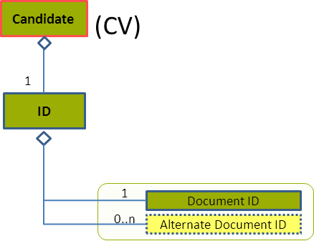
Figure 12: ID Level 1 Entity Diagram
Element | Description | Layer /  Cardinality |  | Rule | Examples
ID | A structured set of Identifier(s) of the document being communicated. It only identifies the document within the supplier organisation and facilitates document identification based on other stakeholder identification systems (such as the receiver’s, i.e. EURES), but is also the originator of the document (not the supplier’ system identifier) and other intermediate systems (the broker system, for example). |  | EURES Conformant  /  1 | N/A | N/A
Sub-elements
Document ID | This only identifies a document within the Candidate’s supplier organisation. Typically there is only document IDs within supplier organisation systems.  It stores the original identifier of the document. |  | EURES Conformant  /  1 | Information  The Document ID identifier must be a UUID and it must be provided by the first sender of the document. | “DOC-1828217”
Alternate Document ID | Additional identifiers for this document. If EURES has to exchange this document with third parties, a EURES alternate ID (only an identifier within the EURES information system) is added. This construct is designed to allow for these different identifications. |  | EURES Optional  /  0..n | N/A | “ES-DOC-1828217”
Please, see section “3.3 Specific Topics” for more information about how to establish the order of identifiers.

ID Attributes
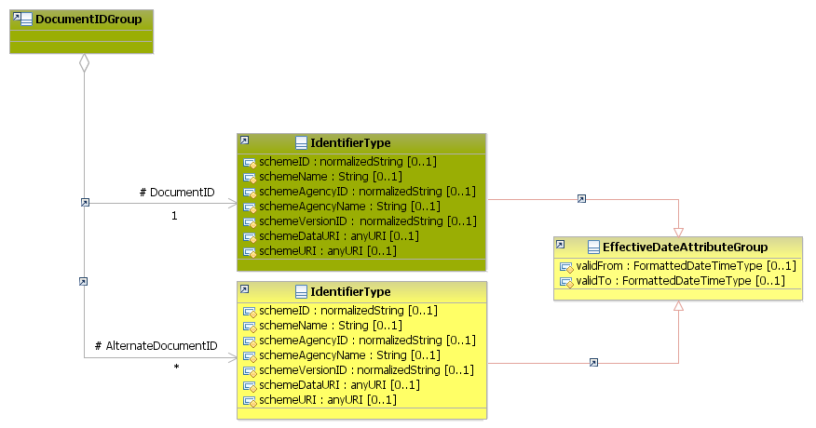
Figure 13: ID Attributes Schema
Attributes | Description | Card. | Rule
This element has no attributes.
DocumentID sub-element
Attributes | Description | Card. | Rule
schemeID | Identification of the identifier scheme | 0..1 | N/A
schemeName | The identification scheme name | 0..1 | N/A
schemeAgencyID | Identification of the agency that maintains the scheme | 0..1 | N/A
schemeAgencyName | The name of the agency that maintains the scheme | 0..1 | N/A
schemeVersionID | The version of the EURES HR Standards. | 0..1 | BR-COM-45: Compulsory use of EURES HR Standard version Version Codes [CL63]
schemeDataURI | The Uniform Resource Identifier that identifies where the data scheme is located | 0..1 | N/A
schemeURI | The Uniform Resource Identifier that identifies where the scheme is located | 0..1 | N/A
validFrom | Validity starting date for this ID | 0..1 | BR-COM-05: If not specified, the “validFrom” date will default to “assigned by EURES on reception”.  BR-COM-06: Compulsory Date Format is: YYYY-MM-DD, YYYY-MM, YYYY or YYYY-MM-DDThh:mm:ss.
validTo | Validity ending date for this ID | 0..1 | BR-COM-07: If not specified, the “validTo” date will be decided by EURES depending on the transaction context.  BR-COM-06: Compulsory Date Format is: YYYY-MM-DD, YYYY-MM, YYYY or YYYY-MM-DDThh:mm:ss.
AlternateDocumentID sub-element
Attributes | Description | Card. | Rule
It is the same as the “DocumentID” sub-element.

ID Examples
This example shows that the original document identifier is provided by a PES, named PES01 in this example, on January 1st 2014 and an additional identifier was provided by EURES the same day.
<Candidate xsi:schemaLocation="http://www.hr-xml.org/3 ../Developer/Nouns/Candidate.xsd" xmlns="http://www.hr-xml.org/3" xmlns:oa="http://www.openapplications.org/oagis/9" xmlns:xsi="http://www.w3.org/2001/XMLSchema-instance" majorVersionID="3" minorVersionID="2">

<!— Original identifier provided by the PES -->
<DocumentID
schemeID="ID-1234"
schemeName="DocumentIdentifier"
schemeAgencyID="PES01"
schemeAgencyName="PublicEmploymentService01"
schemeVersionID="1.2"
schemeDataURI="https://ec.europa.eu/eures/standards/2014/DOC/Data/ID"
schemeURI="https://ec.europa.eu/eures/standards/2014/DOC/ID"
validFrom="2015-12-10">
DOC-1828217
</DocumentID>

<!— Additional identifier provided by the PES -->
<AlternateDocumentID
schemeID="EURES"
schemeName="DocumentIdentifier"
schemeAgencyID="EURES"
schemeAgencyName="EURES"
schemeVersionID="1.0"
schemeDataURI="https://ec.europa.eu/eures/standards/2014/DOC/Data/ID"
schemeURI="https://ec.europa.eu/eures/standards/2014/DOC/ID"
validFrom="2015-12-12">
EURESID-1234
</AlternateDocumentID>
<Candidate/>

/Processing Information (level 1)

Processing Information Element Description
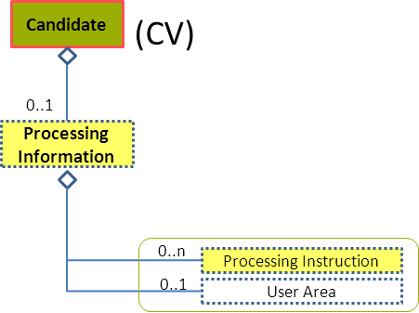
Figure 14: Processing Information Level 1 Entity Diagram
Element | Description | Layer /  Cardinality |  | Rule | Examples
Processing Information | Includes codes relevant to a target system related to document processing.  In EURES, this element is used to provide “visibility” and “data protection” instructions to the Interoperability Portal.  See the description of this element for more details. |  | EURES Optional  /  0..1 | InformationIf the /Candidate /Processing Information element is not present in a Candidate’s XML document instance, no visibility restrictions concerning this CV will be applied (i.e., all fields will be visible) | N/A
Sub-elements
Processing Instructions | The Interoperability Portal uses this element to hide certain CV data, such as the Candidate’s name, phone number, etc., and to define which the data protection information is.  The hidden element is identified using its xPath. |  | EURES Optional  /  0..n | Information  If the /Candidate /Processing Information element is not present in a Candidate’s XML document instance, no visibility restrictions concerning this CV will be applied (i.e., all fields will be visible)  BR-CV-32: The Xpath must be valid | /Candidate/CandidateProfile/EmploymentHistory/EmployerHistory[OrganizationName="EifEL"]  /Candidate/CandidateProfile/EmploymentHistory/EmployerHistory/PositionHistory[PositionTitle="Junior Software developer"]  /Candidate/CandidatePerson/Communication[1]

Processing Information Attributes
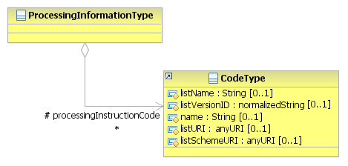
Figure 15: Processing Information Attributes Schema
Attributes | Description | Card. | Rule
This element has no attributes.
ProcessingInstructionCode sub-element
Attributes | Description | Card. | Rule
listName | The code list name | 0..1 | N/A
listVersionID | The code list identification | 0..1 | N/A
name | The text equivalent of the code content component | 0..1 | N/A
listURI | The Uniform Resource Identifier that identifies where the code list is located. | 0..1 | N/A
listSchemeURI | The Uniform Resource Identifier that identifies where the code list scheme is located. | 0..1 | N/A

Processing Information Examples
These examples show that no visibility restrictions are applied.
- The element is not displayed in XML file:
<Candidate xsi:schemaLocation="http://www.hr-xml.org/3 ../Developer/Nouns/Candidate.xsd" xmlns="http://www.hr-xml.org/3" xmlns:oa="http://www.openapplications.org/oagis/9" xmlns:xsi="http://www.w3.org/2001/XMLSchema-instance" majorVersionID="3" minorVersionID="2">
…

<Candidate/>

- The element is displayed, but it is empty.
<Candidate xsi:schemaLocation="http://www.hr-xml.org/3 ../Developer/Nouns/Candidate.xsd" xmlns="http://www.hr-xml.org/3" xmlns:oa="http://www.openapplications.org/oagis/9" xmlns:xsi="http://www.w3.org/2001/XMLSchema-instance" majorVersionID="3" minorVersionID="2">

</ProcessingInstructionCode>

<Candidate/>

This is an example of how to add visibility and searchability restrictions from different xPaths:
<Candidate xsi:schemaLocation="http://www.hr-xml.org/3 ../Developer/Nouns/Candidate.xsd" xmlns="http://www.hr-xml.org/3" xmlns:oa="http://www.openapplications.org/oagis/9" xmlns:xsi="http://www.w3.org/2001/XMLSchema-instance" majorVersionID="3" minorVersionID="2">

<ProcessingInstructionCode>Candidate/CandidatePerson/PersonName</ProcessingInstructionCode>

<ProcessingInstructionCode>Candidate/CandidatePerson/PersonName/LegalName</ProcessingInstructionCode>

<ProcessingInstructionCode>Candidate/CandidatePerson/NationalityCode[1]</ProcessingInstructionCode>

<ProcessingInstructionCode>Candidate/CandidatePerson/Communication/Address/@type</ProcessingInstructionCode>

<Candidate/>

/Supplier (level 1)

Supplier Element Description
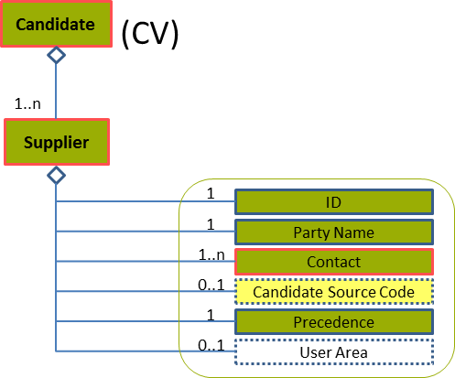
Figure 16: Supplier Level 1 Entity Diagram
Element | Description | Layer /  Cardinality |  | Rule | Examples
Supplier | Information about the supplier of the candidate details. This can be the candidate through the EURES Portal, or a third party (a EURES network member, for example). |  | EURES Technical Minimum  /  1..n | N/A | N/A
Sub-elements
ID | Only an identifier that distinguishes a party system involved in a transaction.  This identifier must be provided by the Interoperability Platform once registered. |  | EURES Conformant  /  1 | Information  The /Candidate /SupplierID must be an UUID provided by the sender system | ”SUP-34833”
Party Name | The name of the company supplying the candidate. |  | EURES Conformant  /  1 | N/A | “Randstad”, “Temp Jobs”
Contact | A detailed set of data about one or more people who should be contacted in order to communicate with the candidate’s supplier. |  | EURES Technical Minimum  /  1..n | N/A | N/A
 | See section “4.6 /Supplier/Contact (level 2)” for more information
Candidate Source Code | A code classifying the source that supplied the candidate.  This is an HR-Open Standards open list. |  | EURES Optional  /  0..1 | BR-CV-07: The HR-Open Standards Code List “CandidateSourceCodeType” must be used to codify the /Candidate /Supplier /Source. | “JobBoard”, “StaffingAgency”, “Intermediary”, “Referrer”  Full code list: “4.28.2 Candidate Source Type Codes [CL04]”
Precedence | As more than one supplier can be provided, this set of enumerations indicates the identifiers’ order of arrival.  This is an HR-Open Standards open list. |  | EURES Conformant  /  1 | BR-CV-08: The HR-Open Standards Code List “PrecedenceEnumType” must be used to codify the /Candidate /Supplier /Precedence. | “1”, “2”, “3”, “4”, “5”  Full code list: “4.28.29 Precedence Enum-Type Codes [CL41] ”

Supplier Attributes
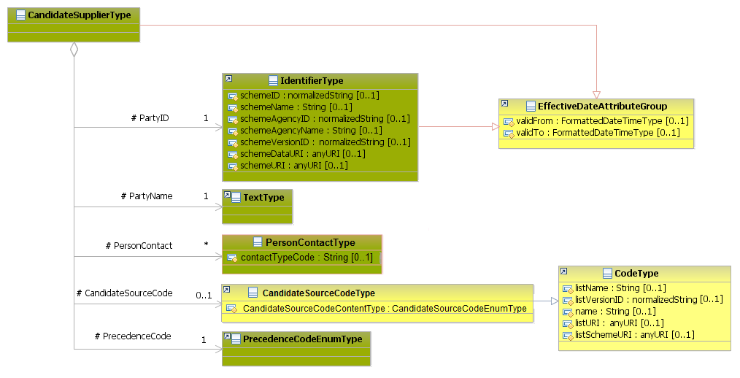
Figure 17: Supplier Attributes Schema
Attributes | Description | Card. | Rule
validFrom | Validity start date for this Supplier | 0..1 | BR-COM-05: If not specified, the “validFrom” date will default to “assigned by EURES on reception”.  BR-COM-06: Compulsory Date Format is: YYYY-MM-DD, YYYY-MM, YYYY or YYYY-MM-DDThh:mm:ss.
validTo | Validity end date for this Supplier | 0..1 | BR-COM-07: If not specified, the “validTo” date will be decided by EURES depending on the transaction context.  BR-COM-06: Compulsory Date Format is: YYYY-MM-DD, YYYY-MM, YYYY or YYYY-MM-DDThh:mm:ss.
PartyID sub-element
Attributes | Description | Card. | Rule
schemeID | The identification of the identifier scheme | 0..1 | N/A
schemeName | The identification scheme name | 0..1 | N/A
schemeAgencyID | The identification of the agency that maintains the scheme. | 0..1 | N/A
schemeAgencyName | The name of the agency that maintains the scheme | 0..1 | N/A
schemeVersionID | The identification scheme version | 0..1 | N/A
schemeDataURI | The Uniform Resource Identifier that identifies where the data scheme is located | 0..1 | N/A
schemeURI | The Uniform Resource Identifier that identifies where the scheme is located | 0..1 | N/A
validFrom | Validity starting date for this ID | 0..1 | BR-COM-05: If not specified, the “validFrom” date will default to “assigned by EURES on reception”.  BR-COM-06: Compulsory Date Format is: YYYY-MM-DD, YYYY-MM, YYYY or YYYY-MM-DDThh:mm:ss.
validTo | Validity ending date for this ID | 0..1 | BR-COM-07: If not specified, the “validTo” date will be decided by EURES depending on the transaction context.  BR-COM-06: Compulsory Date Format is: YYYY-MM-DD, YYYY-MM, YYYY or YYYY-MM-DDThh:mm:ss.
PartyName sub-element
Attributes | Description | Card. | Rule
This sub-element has no attributes.
PersonContact sub-element
Attributes | Description | Card. | Rule
See section “4.6.2 Contact Attributes” for more information
CandidateSourceCode sub-element
Attributes | Description | Card. | Rule
listName | The code list name | 0..1 | N/A
listVersionID | The code list identification | 0..1 | N/A
name | The text equivalent of the code content component | 0..1 | N/A
listURI | The Uniform Resource Identifier that identifies where the code list is located | 0..1 | N/A
listSchemeURI | The Uniform Resource Identifier that identifies where the code list scheme is located | 0..1 | N/A
PrecedenceCode sub-element
Attributes | Description | Card. | Rule
This sub-element has no attributes.

Supplier Examples
This example shows two document identifiers provided by a PES, named PES01 and EURES, and how are they ordered through the PrecedenceCode element. Firstly, PES01 sends the CV; because it is the 1st identifier, its PrecedenceCode is 1. The second identifier is provided by EURES, and its PrecedenceCode is 2.
<Candidate xmlns="http://www.hr-xml.org/3" xsi:schemaLocation="http://www.hr-xml.org/3 ../Developer/Nouns/Candidate.xsd">

<!-- 1st identifier of the document, send by PES01 1st January 2014 -->
<DocumentID
schemeID="ID-1234"
schemeName="DocumentIdentifier"
schemeAgencyID="PES01"
schemeAgencyName="PublicEmploymentServices01"
schemeVersionID="1.2"
schemeDataURI="https://ec.europa.eu/eures/standards/2014/DOC/Data/ID"
schemeURI="https://ec.europa.eu/eures/standards/2014/DOC/ID"
validFrom="2014-01-01" >
1067482948
</DocumentID>

<!-- 2nd identifier of the document, provided by EURES 31st January 2014 -->
<AlternateDocumentID
schemeID="EuresID"
schemeName="DocumentIdentifier"
schemeAgencyID="EURES"
schemeAgencyName="EURES"
schemeVersionID="1.00"
schemeDataURI="https://ec.europa.eu/eures/standards/2014/DOC/Data/ID"
schemeURI="https://ec.europa.eu/eures/standards/2014/DOC/ID"
validFrom="2014-01-31" >
EURESID-1234
</AlternateDocumentID>

<CandidateSupplier>
<PartyID schemeID="Party-IDs"
schemeName="PartyIdentifier"
schemeAgencyID="PES01"
schemeAgencyName="PES01"
schemeVersionID="1.00"
schemeDataURI="https://ec.europa.eu/eures/standards/2014/Supplier/Data/ID"
schemeURI="http://www.pes01.eu"
validFrom="2014-01-01"
validTo="2016-12-31">
Suplier-1234
</PartyID>
<PartyName>PES01</PartyName>

<!-- PersonContact element must be filled in too. See the description of this element -->
<PersonContact>...</PersonContact>

<CandidateSourceCode listName="CandidateSourceCodeType" listVersionID="1.0" name="Intermediary supplier" listURI="http://www.hr-xml.org/" listSchemeURI="http://www.hr-xml.org/3 ../Developer/Common/CodeLists.xsd">
Intermediary</CandidateSourceCode>
<PrecedenceCode>1</PrecedenceCode>
</CandidateSupplier>

<CandidateSupplier>
<PartyID schemeID="Party-IDs"
schemeName="PartyIdentifier"
schemeAgencyID="EURES"
schemeAgencyName="EURES"
schemeVersionID="1.00"
schemeDataURI="https://ec.europa.eu/eures/standards/2014/Supplier/Data/ID"
schemeURI="https://ec.europa.eu/eures/"
validFrom="2014-01-31">
Suplier-1234
</PartyID>
<PartyName>EURES</PartyName>

<!-- PersonContact element must be filled in too. See the description of this element -->
<PersonContact>...</PersonContact>

<CandidateSourceCode listName="CandidateSourceCodeType" listVersionID="1.0" name="job board supplier" listURI="http://www.hr-xml.org/" listSchemeURI="http://www.hr-xml.org/3 ../Developer/Common/CodeLists.xsd">
JobBoard</CandidateSourceCode>
<PrecedenceCode>2</PrecedenceCode>
</CandidateSupplier>
<Candidate/>

/Supplier/Contact (level 2)

Contact Element Description
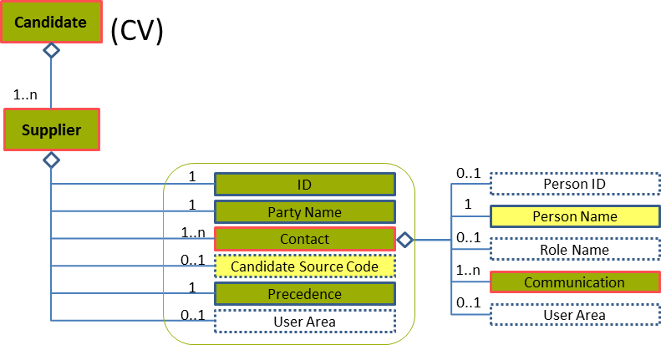
Figure 18: Contact Level 2 Entity Diagram
Element | Description | Layer /  Cardinality |  | Rule | Examples
Contact | A detailed set of data about one or more people who should be contacted in order to communicate with the supplier of the candidate |  | EURES Technical Minimum  /  1..n | N/A | N/A
Sub-elements
Person Name | Name of the contact of the supplier |  | EURES Optional  /  1 | N/A | N/A
 | See section “4.6.3 Sub-element: /Name (level 3)” for more information
Communication | A detailed set of data about communication data of the supplier contact person |  | EURES Technical Minimum  /  1..n | BR-COM-10: If the Communication element is filled in, at least one of its sub elements should be filled in too. | N/A
 | See section “4.6.4 Sub-element: /Communication (level 3)” for more information

Contact Attributes
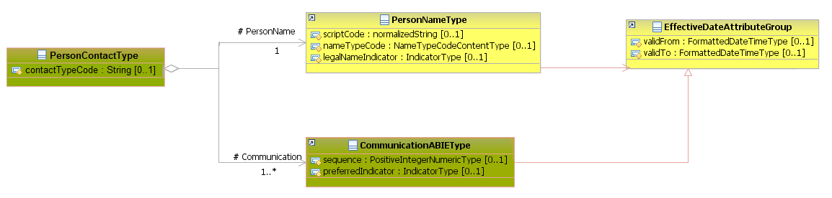
Figure 19: Contact Attribute Schema
Attributes | Description | Card. | Rule
contactTypeCode | The person’s type of contact, such as “CompanyManager” or “WorkplaceContact”  This is a free text element. | 0..1 | N/A
PersonName sub-element
Attributes | Description | Card. | Rule
See section “4.6.3.2 Name Attributes” for more information
Communication sub-element
Attributes | Description | Card. | Rule
See section “4.6.4.2 Communication Attributes” for more information

Sub-element: /Name (level 3)

Name Element Description
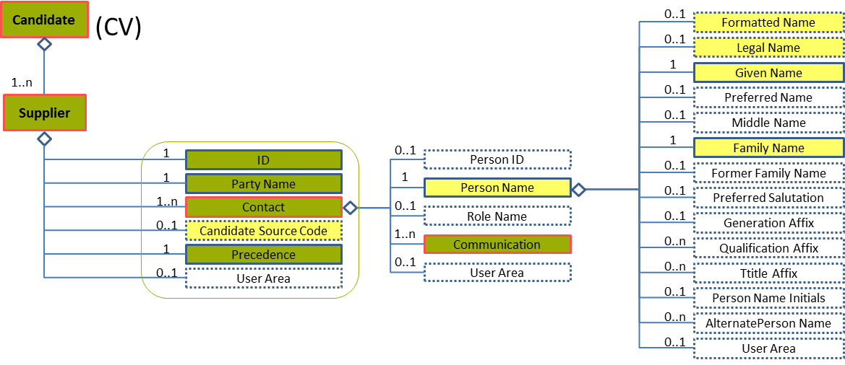
Figure 20: Name Level 3 Entity Diagram
Element | Description | Layer /  Cardinality |  | Rule | Example
Name | Name of the contact of the supplier |  | EURES Optional  /  1 | N/A | N/A
Sub-elements
Formatted Name | This is a formatted presentation of a name (for example, a Person Name) that might alternatively be presented as discretely fielded components, or it could be a name with alternative formatted representations.  The formatCode is an optional available attribute for specifying the applicable "mask" or type of format presentation to which the content conforms. |  | EURES Optional  /  0..1 | N/A | “Paula Cook”, “James Black”, etc.
Legal Name | The name that an individual is given at birth and/or is recognised by a government or other legal entity, or that appears on a birth certificate |  | EURES Optional  /  0..1 | N/A | “Paula Cook”, “James Black”, etc.
Given Name | A people given name or first name. |  | EURES Optional  /  1 | N/A | “Mark”, “Silvia”, etc.
Family Name | Contains a non-given name. This is an inherited name or one representing a family relationship, or in some cultural contexts a "Place Name" (where someone is from). In some cultural contexts, a single family name is typical, while in others there may be multiple family names. A "primary" attribute may be used in the case where there are multiple last names. A family name can have a "prefix," such as Von, De, Van, Al, etc. These can be represented using the FamilyName "prefix" attribute. Not all implementers may find it necessary to separate prefixes from the family name itself. Capturing the prefix and FamilyName as discrete fields can become important when formatting, or appearance may vary based on context. For example, in some cultural contexts it may be common to use a blank space as the delimiter between the prefix and the family name, while in others, a hyphen might be used. Separating the prefix from the FamilyName allows such formatting requirements to be handled flexibly. |  | EURES Optional  /  1 | N/A | “Smith”, “Santos Tavares”, “Van der Meyde”, etc.

Name Attributes
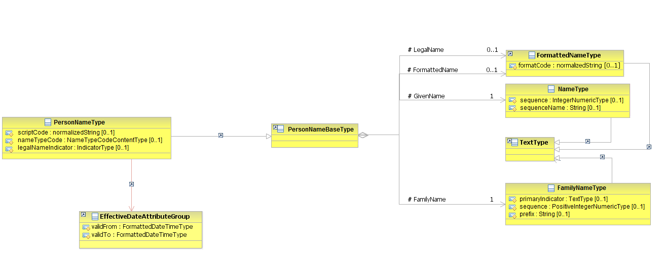
Figure 21: PersonName Attributes Schema
Attributes | Description | Card. | Rule
scriptCode | Type of alphabet that the name is written with such as “Roman”, “Kenji”, etc. | 0..1 | N/A
nameTypeCode | A code classifying the type of name, such as “CurrentName” or “FormerName” (full code list “4.28.21 Name Enum-Type Codes [CL32] ”)  This is an HR-Open Standards open list. | 0..1 | BR-COM-09: Compulsory use of the Name Enum Type Codes [CL32].
legalNameIndicator | Boolean indicating if it is the legal name or not | 0..1 | N/A
validFrom | Validity start date for this Person Name | 0..1 | BR-COM-06: Compulsory Date Format is: YYYY-MM-DD, YYYY-MM, YYYY or YYYY-MM-DDThh:mm:ss.
validTo | Validity end date for this Person Name | 0..1 | BR-COM-06: Compulsory Date Format is: YYYY-MM-DD, YYYY-MM, YYYY or YYYY-MM-DDThh:mm:ss.
LegalName sub-element
Attributes | Description | Card. | Rule
formatCode | Type of format shown | 0..1 | N/A
FormattedName sub-element
Attributes | Description | Card. | Rule
The same as the “LegalName” sub-element
GivenName sub-element
Attributes | Description | Card. | Rule
sequence | Establishes the name order as an integer | 0..1 | N/A
sequenceName | Establishes the name order as a string | 0..1 | N/A
FamilyName sub-element
Attributes | Description | Card. | Rule
primaryIndicator | Boolean indicating that it is a single name | 0..1 | N/A
sequence | Establishes the name order as an integer | 0..1 | N/A
prefix | A family name’s prefix | 0..1 | N/A

Sub-element: /Communication (level 3)

Communication Element Description
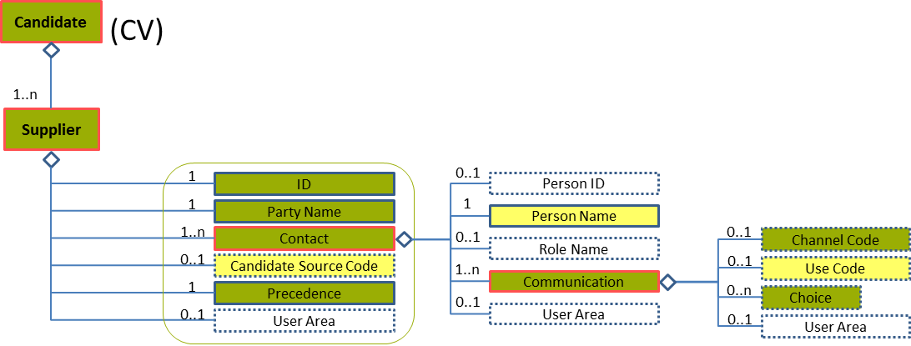
Figure 22: Communication Level 2 Entity Diagram
Element | Description | Layer /  Cardinality |  | Rule | Examples
Communication | A person’s contact information: ChannelCode, Address, URI –for email, for instance—, etc. |  | EURES Technical Minimum  /  1..n | BR-COM-10: If the Communication element is filled in, at least one of its sub elements should be filled in too. | N/A
Sub-elements
Channel Code | The communication channel used to contact a person or an organisation  This is an HR-Open Standards open list. |  | EURES Conformant Optional  /  0..1 | BR-COM-13: The Open HR-Open Standards Code List “ChannelCodeContentType” must be used to codify the /ChannelCode element.  BR-CV-31: If URI element is provided, ChannelCode element must contain either "Email" or "Web". | “Telephone”, “MobileTelephone”, “Fax”, “Email”, “InstantMessage”, “Web”  Full code list: “4.28.3 Channel Type Codes [CL05] ”
Use Code | The type of use given to the communication channel used to contact a person or an organisation  This is an HR-Open Standards open list. |  | EURES Optional  /  0..1 | BR-COM-14: The Open HR-Open Standards Code List “ContactUseCodeContentType” must be used to codify the /UseCode element. | “Personal”, “Business”  Full code list: “4.28.4 Contact Use Type Codes [CL06] ”
Choice | Selection between the types of communication channels. | N/A |  | BR-CV-30: At least one of the following sub-elements (either Address or URI or DialNumber) must be provided. | N/A
 | See section “4.6.5 Sub-element: /Choice (level 4)” for more information

Communication Attributes
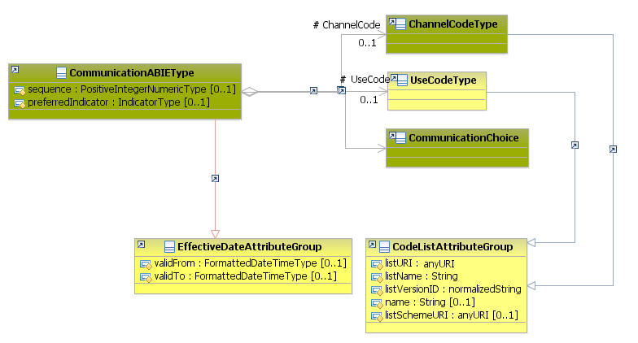
Figure 23: Communication Attributes Schema
Attributes | Description | Card. | Rule
sequence | Establishes the order of the contact data | 0..1 | N/A
preferredIndicator | Boolean indicating if the current contact data is the preferred one | 0..1 | N/A
validFrom | Validity start date for this Communication | 0..1 | BR-COM-06: Compulsory Date Format is: YYYY-MM-DD, YYYY-MM, YYYY or YYYY-MM-DDThh:mm:ss.
validTo | Date up to when the communication channel is available | 0..1 | BR-COM-06: Compulsory Date Format is: YYYY-MM-DD, YYYY-MM, YYYY or YYYY-MM-DDThh:mm:ss.
ChannelCode sub-element
Attributes | Description | Card. | Rule
listName | The code list name | 0..1 | N/A
listVersionID | The code list identification | 0..1 | N/A
name | The text equivalent of the code content component | 0..1 | N/A
listURI | The Uniform Resource Identifier that identifies where the code list is located | 0..1 | N/A
listSchemeURI | The Uniform Resource Identifier that identifies where the code list scheme is located | 0..1 | N/A
UseCode sub-element
Attributes | Description | Card. | Rule
The same as the “ChannelCode” sub-element
CommunicationChoice sub-element
Attributes | Description | Card. | Rule
See section “4.6.5.2 Choice Attributes” for more information

Sub-element: /Choice (level 4)

Choice Element Description
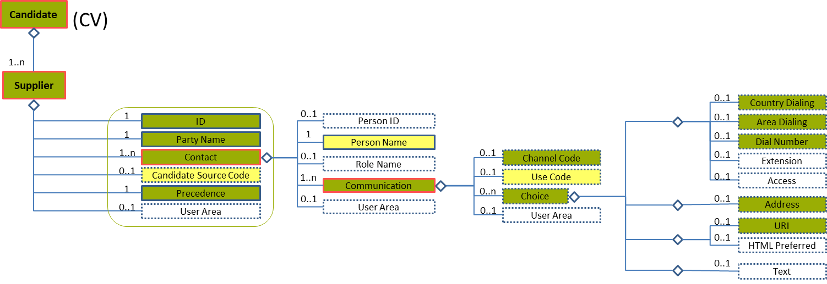
Figure 24: Choice Level 4 Entity Diagram
Element | Description | Layer /  Cardinality |  | Rule | Examples
Choice | Selection between the types of channels  1-Address  2-Telephone  3-URL  4-Text | BR-CV-30: At least one of the following sub-elements (either Address or URI or DialNumber) must be provided. |  | N/A | N/A
Sub-elements
Country Dialling | The country dialling code for a contact number |  | EURES Conformant Optional  /  0..1 | N/A | “0032”, “0034”, etc.
Area Dialling | The area dialling code for a contact number |  | EURES Conformant Optional  /  0..1 | N/A | “2”, “71, “93”, etc.
Dial Number | The contact number, not including country dialling or area dialling codes |  | EURES Conformant Optional  /  0..1 | N/A | “3445654”, “1234567”, etc.
Address | Properties specifying an entity’s physical location |  | EURES Conformant Optional  /  0..1 | N/A | N/A
 | See section “4.9.4.1 Address Element Description” for more information
URI | Uniform Resource Identifier Reference (URI). A URI value can be absolute or relative, and may have an optional fragment identifier (i.e., it may be a URI Reference). This type should be used to specify that the value is to fulfil the role of a URI, as defined by [RFC 2396] and as amended by [RFC 2732]. |  | EURES Conformant Optional  /  0..1 | N/A | “mymail@test.org”, “mymail@noreply.com”, etc.

Choice Attributes
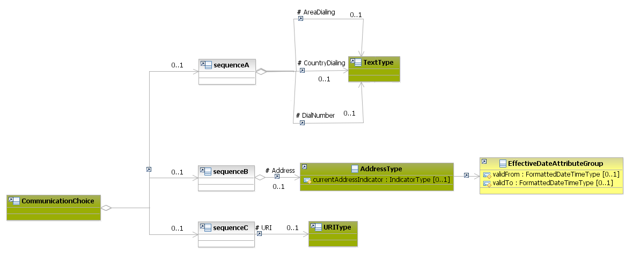
Figure 25: Choice Attributes Schema
Attributes | Description | Card. | Rule
This element has no attributes.
CountryDialling sub-element
Attributes | Description | Card. | Rule
This element has no attributes.
AreaDialling sub-element
Attributes | Description | Card. | Rule
This element has no attributes.
DialNumber sub-element
Attributes | Description | Card. | Rule
This element has no attributes.
Address sub-element
Attributes | Description | Card. | Rule
See section “4.9.4.2 Address Attributes” for more information
URIs sub-element
Attributes | Description | Card. | Rule
This sub-element has no attributes.

/Person (level 1)

Person Element Description
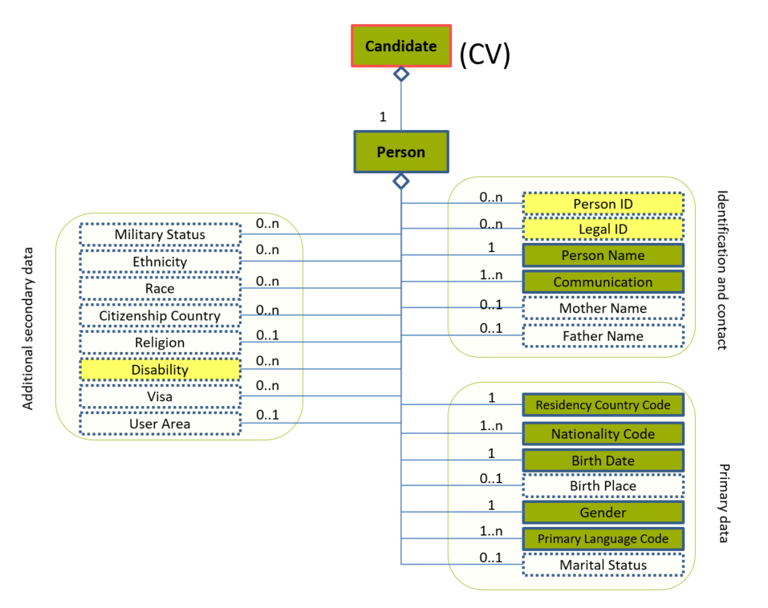
Figure 26: Person Level 1 Entity Diagram
Element | Description | Layer /  Cardinality |  | Rule | Examples
Person | Personal details of the person seeking a job, such as the name, age, gender, and so on. |  | EURES Conformant  /  1 | N/A | N/A
Sub-elements
Person ID | Systemic identifiers only for this person “Usually fed by the document sender, the recipient also may (and usually does) add his/her own ID, in order to build complex transaction paths”. |  | EURES Optional  /  0..n | BR-CV-09: If the identifier is not provided an automatic ID will be provided by the Interoperability Platform. | “PER-21987”, “PER-18911”, etc.
Legal ID | An identifier issued to a person by a governmental organisation, like a social security or driver’s license number. |  | EURES Optional  /  0..n | N/A | “11111111A”, “12345678Z”, etc.
Person Name | A detailed set of data about the candidate’s names, such as his/her GivenName, FamilyName, MiddleName, Former Family Name, etc. |  | EURES Conformant  /  1 | N/A | N/A
 | See section “4.8 /Person/PersonName (level 2)” for more information
Communication | The candidate’s contact information. ChannelCode, Address, URI –for email, for instance—, etc. |  | EURES Conformant  /  1..n | BR-COM-10: If the Communication element is filled in, at least one of its sub elements should be filled in too. | N/A
 | See section “4.9 /Person/Communication (level 2)” for more information
Residency Country Code | Code specifying the country where the Candidate usually lives |  | EURES Conformant  /  1 | BR-COM-12: Compulsory use of the “Countries-CodeList.gc” list defined by EURES. This is based on ISO 3166-1 Alpha-2, which includes all countries of the world. | “AR” – Argentina, “AU” – Austria, “CS” – Costa Rica, etc.  Full code list: “4.28.5 Country Codes [CL07]”
Nationality Code | Code specifying the candidate’s nationality |  | EURES Conformant  /  1..n | BR-COM-12: Compulsory use of the “Countries-CodeList.gc” list defined by EURES. This is based on ISO 3166-1 Alpha-2, which includes all countries of the world.  BR-COM-43: Multiple entries of this code list are allowed. | “AR” – Argentina, “AU” – Austria, “CS” – Costa Rica, etc.  Full code list: “4.28.5 Country Codes [CL07] ”
Birth Date | The person’s date of birth |  | EURES Conformant  /  1 | BR-COM-06: Compulsory Date Format is: YYYY-MM-DD, YYYY-MM, YYYY or YYYY-MM-DDThh:mm:ss. | 1987-08-05
Gender | Code indicating the candidate’s gender  This is an HR-Open Standards open list |  | EURES Conformant  /  1 | BR-CV-10: Compulsory use of HR-Open Standards “GenderEnumType” to specify a Person’s Gender. | “NotKnown”, “Male”, “Female”, “NotSpecified”  Full code list: “4.28.14 Gender Enum-Type Codes [CL18] ”
Primary Language Code | The candidate’s primary or preferred language or languages |  | EURES Conformant  /  1..n | BR-COM-11: Compulsory use of the “LanguageCodes-CodeList.gc” list defined by EURES. This is based on ISO-639-1:2002 Alpha-2, which includes all world languages.  BR-COM-43: Multiple entries of this code list are allowed. | “AA” = Afar,  “AB” = Abkhazian, etc.  Full code list: “4.28.17 Language Codes [CL24] ”
Disability | Describes a disability associated with a specific person.  The absence of a Disability element for a candidate will mean “No disabilities”. |  | EURES Optional  /  0..n | N/A | N/A
 | See section “4.10 /Person/Disability (level 2)” for more information

Person Attributes
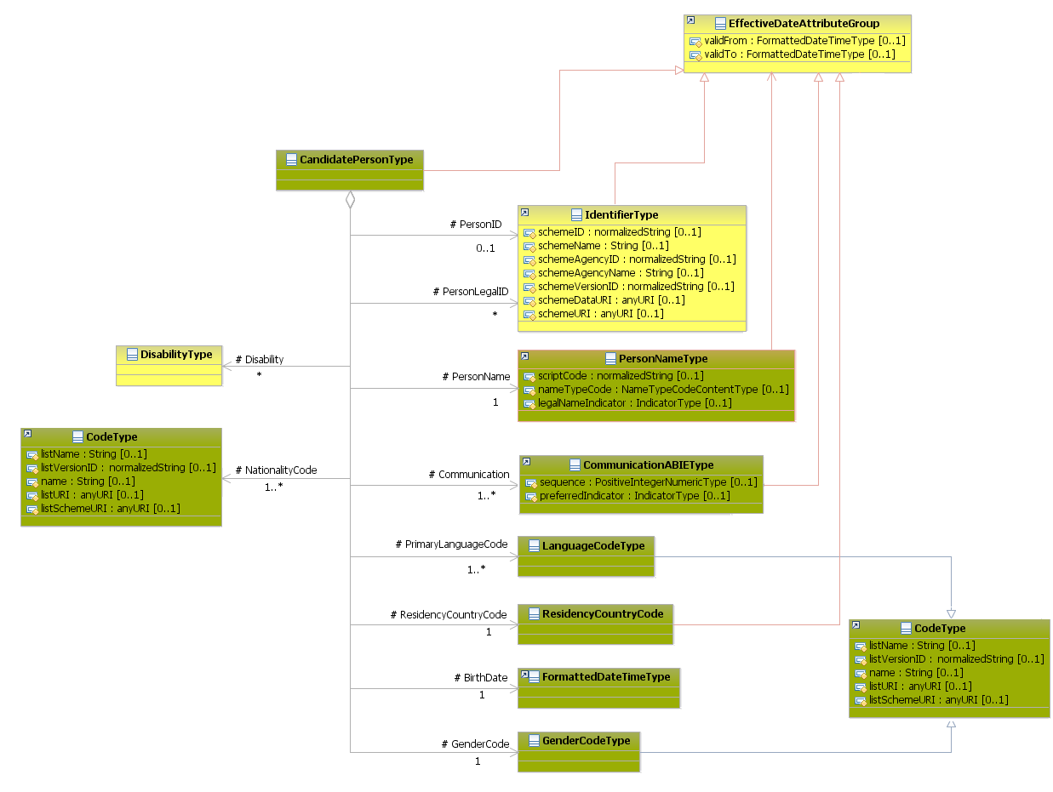
Figure 27: Person Attributes Schema
Attributes | Description | Card. | Rule
validFrom | Validity start date for this entity’s information | 0..1 | BR-COM-05: If not specified, the “validFrom” date will default to “assigned by EURES on reception”.  BR-COM-06: Compulsory Date Format is: YYYY-MM-DD, YYYY-MM, YYYY or YYYY-MM-DDThh:mm:ss.
validTo | Validity end date for this entity’s information | 0..1 | BR-COM-06: Compulsory Date Format is: YYYY-MM-DD, YYYY-MM, YYYY or YYYY-MM-DDThh:mm:ss.
PersonID sub-element
Attributes | Description | Card. | Rule
schemeID | Identification of the identifier scheme | 0..1 | N/A
schemeName | The identification scheme name | 0..1 | N/A
schemeAgencyID | Identification of the agency that maintains the scheme | 0..1 | N/A
schemeAgencyName | The name of the agency that maintains the scheme | 0..1 | N/A
schemeVersionID | The identification scheme version | 0..1 | N/A
schemeDataURI | The Uniform Resource Identifier stating where the data scheme is located | 0..1 | N/A
schemeURI | The Uniform Resource Identifier stating where the scheme is located | 0..1 | N/A
validFrom | Validity start date for this ID | 0..1 | BR-COM-05: If not specified, the “validFrom” date will default to “assigned by EURES on reception”.  BR-COM-06: Compulsory Date Format is: YYYY-MM-DD, YYYY-MM, YYYY or YYYY-MM-DDThh:mm:ss.
validTo | Validity end date for this ID | 0..1 | BR-COM-07: If not specified, the “validTo” date will be decided by EURES depending on the transaction context.  BR-COM-06: Compulsory Date Format is: YYYY-MM-DD, YYYY-MM, YYYY or YYYY-MM-DDThh:mm:ss.
PersonLegalID sub-element
Attributes | Description | Card. | Rule
The same as the “PersonID” sub-element
PersonName sub-element
Attributes | Description | Card. | Rule
See section “4.8.2 PersonName Attributes” for more information
Communication sub-element
Attributes | Description | Card. | Rule
See section “4.9.2 Communication Attributes” for more information
ResidencyCountryCode sub-element
Attributes | Description | Card. | Rule
validFrom | Validity start date as a resident of the country | 0..1 | BR-COM-06: Compulsory Date Format is: YYYY-MM-DD, YYYY-MM, YYYY or YYYY-MM-DDThh:mm:ss.
validTo | Validity end date as a resident of the country | 0..1 | BR-COM-06: Compulsory Date Format is: YYYY-MM-DD, YYYY-MM, YYYY or YYYY-MM-DDThh:mm:ss.
NationalityCode sub-element
Attributes | Description | Card. | Rule
listName | The code list name | 0..1 | N/A
listVersionID | The code list identification | 0..1 | N/A
name | The text equivalent of the code content component | 0..1 | N/A
listURI | The Uniform Resource Identifier that identifies where the code list is located | 0..1 | N/A
listSchemeURI | The Uniform Resource Identifier that identifies where the code list scheme is located | 0..1 | N/A
BirthDate sub-element
Attributes | Description | Card. | Rule
This sub-element has no attributes.
GenderCode sub-element
Attributes | Description | Card. | Rule
The same as the “NationalityCode” sub-element
PrimaryLanguageCode sub-element
Attributes | Description | Card. | Rule
The same as the “NationalityCode” sub-element
Disability sub-element
Attributes | Description | Card. | Rule
See section “4.10.2 Disability Attributes” for more information

/Person/PersonName (level 2)

Name Element Description
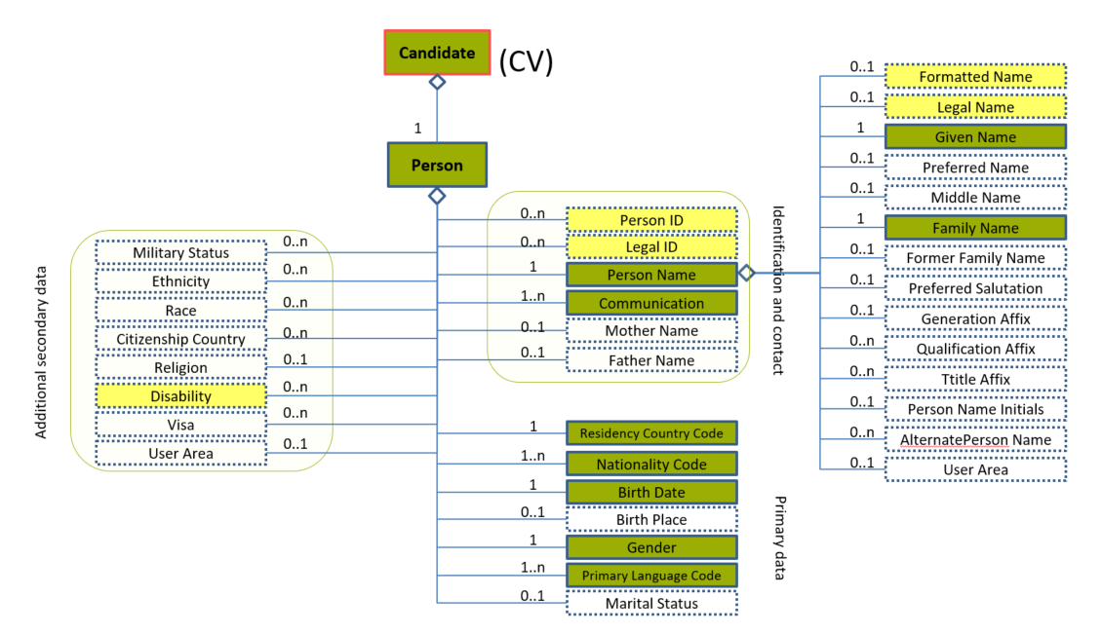
Figure 28: Name Level 2 Entity Diagram
Element | Description | Layer /  Cardinality |  | Rule | Example
PersonName | A detailed set of data about the names of the person’s names, such as his/her GivenName, FamilyName, MiddleName, FormerFamilyName, etc. |  | EURES Conformant  /  1 | N/A | N/A
Sub-elements
Formatted Name | This is a formatted presentation of a name (for example, a Person Name) that might alternatively be presented as discretely fielded components, or it could be a name with alternative formatted representations.  The formatCode is an optional available attribute for specifying the applicable "mask" or type of format presentation to which the content conforms. |  | EURES Optional  /  0..1 | N/A | “Paula Cook”, “James Black”, etc.
Legal Name | The name that an individual is given at birth and/or is recognised by a government or other legal entity, or that appears on a birth certificate |  | EURES Optional  /  0..1 | N/A | “Paula Cook”, “James Black”, etc.
Given Name | A people given name or first name. |  | EURES Conformant  /  1 | N/A | “Mark”, “Silvia”, etc.
Family Name | Contains a non-given name. This is an inherited name or one representing a family relationship, or in some cultural contexts a "Place Name" (where someone is from). In some cultural contexts, a single family name is typical, while in others there may be multiple family names. A "primary" attribute may be used in the case where there are multiple last names. A family name can have a "prefix," such as Von, De, Van, Al, etc. These can be represented using the FamilyName "prefix" attribute. Not all implementers may find it necessary to separate prefixes from the family name itself. Capturing the prefix and FamilyName as discrete fields can become important when formatting, or appearance may vary based on context. For example, in some cultural contexts it may be common to use a blank space as the delimiter between the prefix and the family name, while in others, a hyphen might be used. Separating the prefix from the FamilyName allows such formatting requirements to be handled flexibly. |  | EURES Conformant  /  1 | N/A | “Smith”, “Santos Tavares”, “Van der Meyde”, etc.

PersonName Attributes
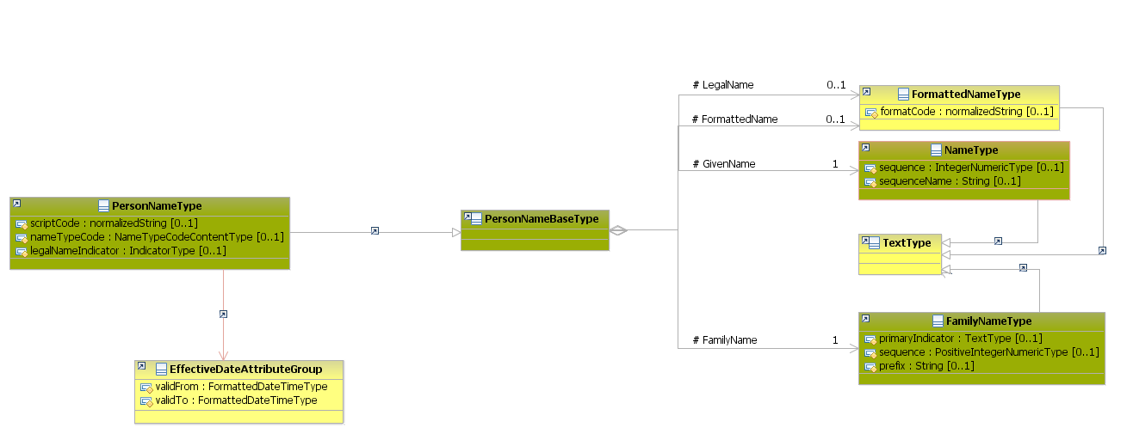
Figure 29: PersonName Attributes Schema
Attributes | Description | Card. | Rule
scriptCode | Type of alphabet that the name is written with such as “Roman”, “Kenji”, etc. | 0..1 | N/A
validFrom | Validity start date for this Person Name | 0..1 | BR-COM-06: Compulsory Date Format is: YYYY-MM-DD, YYYY-MM, YYYY or YYYY-MM-DDThh:mm:ss.
validTo | Validity end date for this Person Name | 0..1 | BR-COM-06: Compulsory Date Format is: YYYY-MM-DD, YYYY-MM, YYYY or YYYY-MM-DDThh:mm:ss.
nameTypeCode | A code classifying the type of name, such as “CurrentName” or “FormerName” (full code list “4.28.21 Name Enum-Type Codes [CL32] ”)  This is an HR-Open Standards open list. | 0..1 | BR-COM-09: Compulsory use of the Name Enum Type Codes [CL32].
legalNameIndicator | Boolean indicating if it is the legal name or not | 0..1 | N/A
LegalName sub-element
Attributes | Description | Card. | Rule
formatCode | Type of format shown | 0..1 | N/A
FormattedName sub-element
Attributes | Description | Card. | Rule
The same as the “LegalName” sub-element
GivenName sub-element
Attributes | Description | Card. | Rule
sequence | Establishes the name order as an integer | 0..1 | N/A
sequenceName | Establishes the name order as a string | 0..1 | N/A
FamilyName sub-element
Attributes | Description | Card. | Rule
primaryIndicator | Boolean indicating that it is a single name | 0..1 | N/A
sequence | Establishes the name order as an integer | 0..1 | N/A
prefix | A family name’s prefix | 0..1 | N/A

PersonName Examples
This example shows how to fill in the candidate’s legal and current name within the PersonName element.
<Candidate xmlns="http://www.hr-xml.org/3" xsi:schemaLocation="http://www.hr-xml.org/3 ../Developer/Nouns/Candidate.xsd" >
<CandidatePerson>
<PersonName legalNameIndicator="true" nameTypeCode="CurrentName">
<!-- EURES Optional layer -->
<FormattedName formatCode="Family Name, Given Name">
Van Whye, John
</FormattedName>
<LegalName formatCode="Given Name Family Name">Johann Van Whye</LegalName>

<!-- EURES Conformant layer required and optional -->
<oa:GivenName>John</oa:GivenName>
<FamilyName prefix="Van">Whye</FamilyName>
</PersonName>
</CandidatePerson>
<Candidate/>

/Person/Communication (level 2)

Communication Element Description
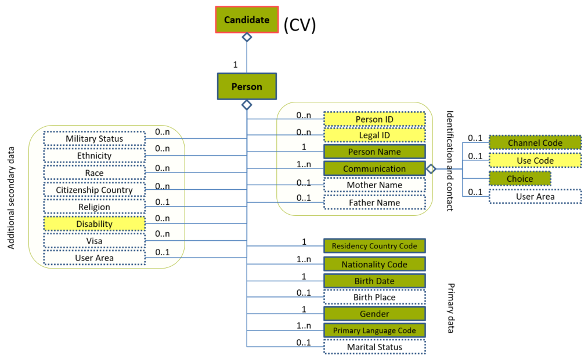
Figure 30: Communication Level 2 Entity Diagram
Element | Description | Layer /  Cardinality |  | Rule | Examples
Communication | A person’s contact information: ChannelCode, Address, URI –for email, for instance—, etc. |  | EURES Conformant  /  1..n | BR-COM-10: If the Communication element is filled in, at least one of its sub elements should be filled in too. | N/A
Sub-elements
Channel Code | The communication channel used to contact a person or an organisation  This is an HR-Open Standards open list. |  | EURES Conformant Optional  /  0..1 | BR-COM-13: The Open HR-Open Standards Code List “ChannelCodeContentType” must be used to codify the /ChannelCode element. | “Telephone”, “MobileTelephone”, “Fax”, “Email”, “InstantMessage”, “Web”  Full code list: “4.28.3 Channel Type Codes [CL05] ”
Use Code | The type of use given to the communication channel used to contact a person or an organisation  This is an HR-Open Standards open list. |  | EURES Optional  /  0..1 | BR-COM-14: The Open HR-Open Standards Code List “ContactUseCodeContentType” must be used to codify the /UseCode element. | “Personal”, “Business”  Full code list: “4.28.4 Contact Use Type Codes [CL06] ”
Choice | Selection between the types of communication channels. | N/A |  | N/A | N/A
 | See section “4.9.3 Sub-element: /Choice (level 3)” for more information

Communication Attributes
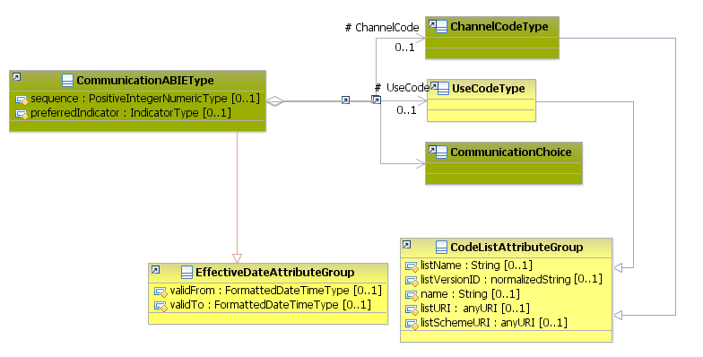
Figure 31: Communication Attributes Schema
Attributes | Description | Card. | Rule
sequence | Establishes the order of the contact data | 0..1 | N/A
preferredIndicator | Boolean indicating if the current contact data is the preferred one | 0..1 | N/A
validFrom | Validity start date for this Communication | 0..1 | BR-COM-06: Compulsory Date Format is: YYYY-MM-DD, YYYY-MM, YYYY or YYYY-MM-DDThh:mm:ss.
validTo | Date up to when the communication channel is available | 0..1 | BR-COM-06: Compulsory Date Format is: YYYY-MM-DD, YYYY-MM, YYYY or YYYY-MM-DDThh:mm:ss.
ChannelCode sub-element
Attributes | Description | Card. | Rule
listName | The code list name | 0..1 | N/A
listVersionID | The code list identification | 0..1 | N/A
name | The text equivalent of the code content component | 0..1 | N/A
listURI | The Uniform Resource Identifier that identifies where the code list is located | 0..1 | N/A
listSchemeURI | The Uniform Resource Identifier that identifies where the code list scheme is located | 0..1 | N/A
UseCode sub-element
Attributes | Description | Card. | Rule
The same as the “ChannelCode” sub-element
CommunicationChoice sub-element
Attributes | Description | Card. | Rule
See section “4.9.3.2 Choice Attributes” for more information

Sub-element: /Choice (level 3)

Choice Element Description
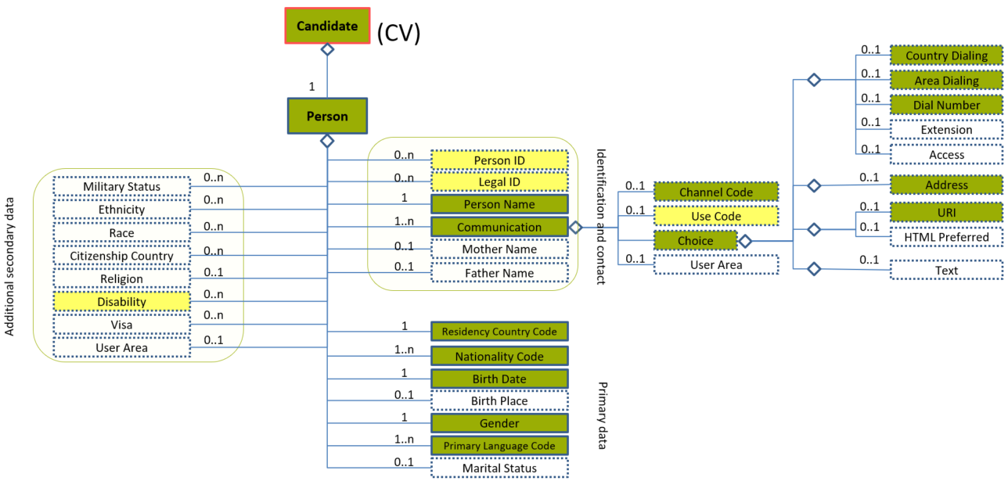
Figure 32: Choice Level 3 Entity Diagram
Element | Description | Layer /  Cardinality |  | Rule | Examples
Choice | Selection between the types of channels  1-Address  2-Telephone  3-URL  4-Text | N/A |  | N/A | N/A
Sub-elements
Country Dialling | The country dialling code for a contact number |  | EURES Conformant Optional  /  0..1 | N/A | “0032”, “0034”, etc.
Area Dialling | The area dialling code for a contact number |  | EURES Conformant Optional  /  0..1 | N/A | “2”, “71, “93”, etc.
Dial Number | The contact number, not including country dialling or area dialling codes |  | EURES Conformant Optional  /  0..1 | N/A | “3445654”, “1234567”, etc.
Address | Properties specifying an entity’s physical location |  | EURES Conformant Optional  /  0..1 | N/A | N/A
 | See section “4.9.4.1 Address Element Description” for more information
URI | Uniform Resource Identifier Reference (URI). A URI value can be absolute or relative, and may have an optional fragment identifier (i.e., it may be a URI Reference). This type should be used to specify that the value is to fulfil the role of a URI, as defined by [RFC 2396] and as amended by [RFC 2732]. |  | EURES Conformant Optional  /  0..1 | N/A | “mymail@test.org”, “mymail@noreply.com”, etc.

Choice Attributes
Figure 33: Choice Attributes Schema
Attributes | Description | Card. | Rule
This element has no attributes.
CountryDialling sub-element
Attributes | Description | Card. | Rule
This element has no attributes.
AreaDialling sub-element
Attributes | Description | Card. | Rule
This element has no attributes.
DialNumber sub-element
Attributes | Description | Card. | Rule
This element has no attributes.
Address sub-element
Attributes | Description | Card. | Rule
See section “4.9.4.2 Address Attributes” for more information
URIs sub-element
Attributes | Description | Card. | Rule
This sub-element has no attributes.

Choice Examples
This example shows how to fill in the candidate’s personal telephone number.
<Candidate xmlns="http://www.hr-xml.org/3" xsi:schemaLocation="http://www.hr-xml.org/3 ../Developer/Nouns/Candidate.xsd" >
<CandidatePerson>
<Communication>
<ChannelCode listName="ChannelCodeContentType" listVersionID="1.0" listURI="http://www.hr-xml.org/">Telephone</ChannelCode>
<UseCode listName="ContactUseCodeContentType" listURI="http://www.hr-xml.org/" listVersionID="1.0">Personal</UseCode>
<oa:CountryDialing>34</oa:CountryDialing>
<oa:AreaDialing>93</oa:AreaDialing>
<oa:DialNumber>55445676</oa:DialNumber>
</Communication>
</CandidatePerson>
<Candidate/>

This example shows how to fill in the candidate’s business e-mail.
<Candidate xmlns="http://www.hr-xml.org/3" xsi:schemaLocation="http://www.hr-xml.org/3 ../Developer/Nouns/Candidate.xsd">
<CandidatePerson>
<Communication>
<ChannelCode listName="ChannelCodeContentType" listVersionID="1.0" listURI="http://www.hr-xml.org/">Email</ChannelCode>
<UseCode listName="ContactUseCodeContentType" listURI="http://www.hr-xml.org/" listVersionID="1.0">Business</UseCode>

<oa:URI>fake-account@aol.es</oa:URI>
</Communication>
</CandidatePerson>
<Candidate/>

Sub-element: /Choice /Address (level 4)

Address Element Description
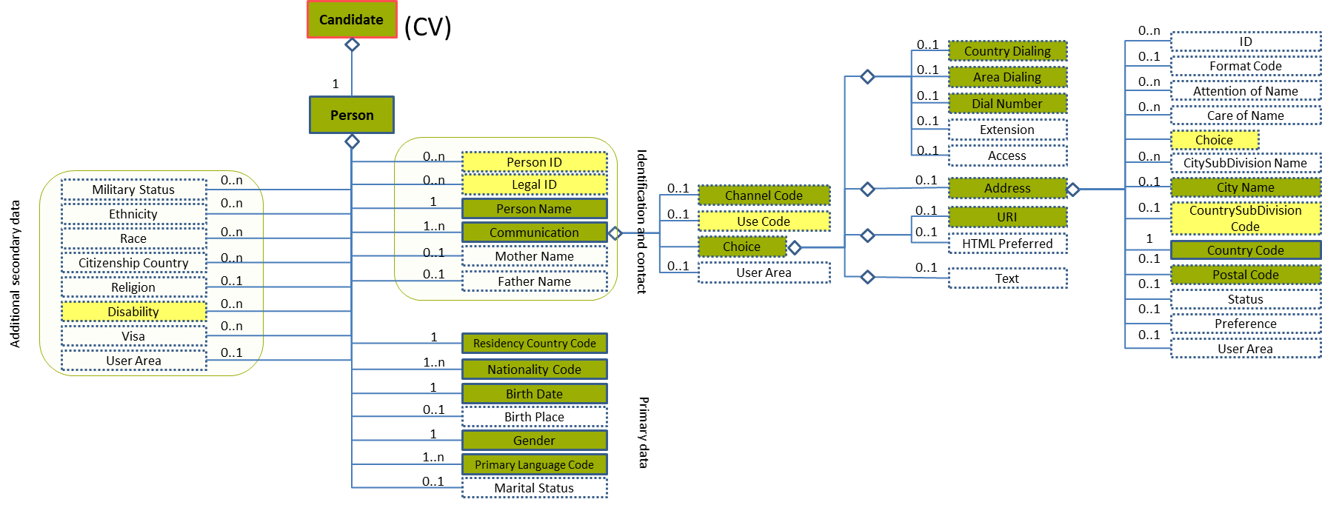
Figure 34: Address Level 4 Entity Diagram
Element | Description | Layer /  Cardinality |  | Rule | Examples
Address | Properties specifying an entity’s physical location |  | EURES Conformant Optional  /  0..1 | N/A | N/A
Sub-elements
Choice | Selection between the types of addresses:  1-Address Line  2-Building Number  3-Street Name  4-Unit | N/A |  | N/A | N/A
 | See section “4.9.5.1 Choice Element Description” for more information
City Name | Identifies the town or city |  | EURES Conformant Optional  /  0..1 | N/A | “Bruxelles”, “Roma”, etc.
Country Subdivision Code | Qualifies further division of the Member States of Europe, possibly into Districts, Regions, States, Provinces, etc. |  | EURES Optional  /  0..1 | BR-COM-21: Compulsory use of the “EURES_CountrySubdivisionCodes-CodeList.gc” list defined by EURES. This is based on NUTS 2013 – Level 3.  BR-COM-53: If CountryCode is specified, CountrySubDivisionCode value must correspond to CountryCode value. | “BE07”, “CS01”, etc.  Full code list: “4.28.6 Country Subdivision Codes [CL08] ”
Country Code | The address’ Country Code  This is an HR-Open Standards open list. |  | EURES Conformant  /  1 | BR-COM-12: Compulsory use of the “Countries-CodeList.gc” list defined by EURES. This is based on ISO 3166-1 Alpha-2, which includes all countries of the world. | “AR” – Argentina, “AU” – Austria, “CS” – Costa Rica, etc.  Full code list: “4.28.5 Country Codes [CL07]”
Postal Code | the Address’ Postal Code |  | EURES Conformant Optional  /  0..1 | N/A | N/A

Address Attributes
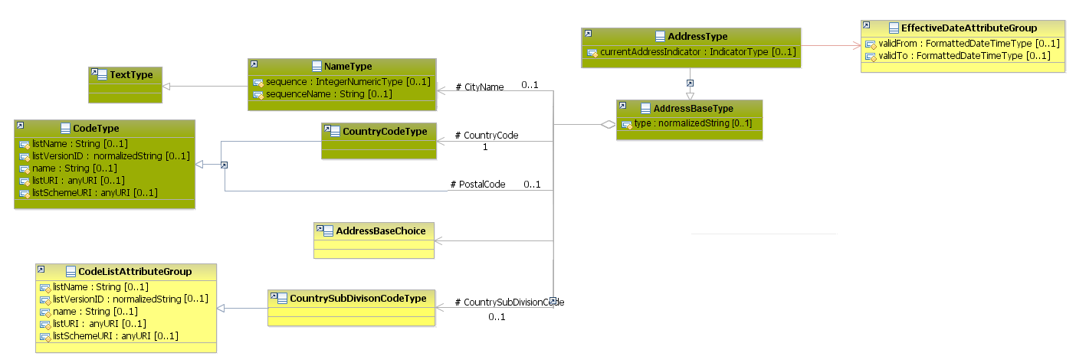
Figure 35: Address Attributes Schema
Attributes | Description | Card. | Rule
validFrom | Validity start date for this entity’s information | 0..1 | BR-COM-06: Compulsory Date Format is: YYYY-MM-DD, YYYY-MM, YYYY or YYYY-MM-DDThh:mm:ss.
validTo | Validity end date for this entity’s information | 0..1 | BR-COM-06: Compulsory Date Format is: YYYY-MM-DD, YYYY-MM, YYYY or YYYY-MM-DDThh:mm:ss.
currentAddressIndicator | Current address of the information | 0..1 | N/A
type | The address type | 0..1 | N/A
CityName sub-element
Attributes | Description | Card. | Rule
sequence | Establishes the order of the contact data | 0..1 | N/A
sequenceName | Establishes the order of the contact data | 0..1 | N/A
CountryCode sub-element
Attributes | Description | Card. | Rule
listName | The code list name | 0..1 | N/A
listVersionID | The code list identification | 0..1 | N/A
name | The text equivalent of the code content component | 0..1 | N/A
listURI | The Uniform Resource Identifier that identifies where the code list is located | 0..1 | N/A
listSchemeURI | The Uniform Resource Identifier that identifies where the code list scheme is located | 0..1 | N/A
CountrySubdivisionCode sub-element
Attributes | Description | Card. | Rule
The same as “CountryCode”
PostalCode sub-element
Attributes | Description | Card. | Rule
The same as “CountryCode”

Sub-element: /Choice /Address /Choice (level 5)

Choice Element Description
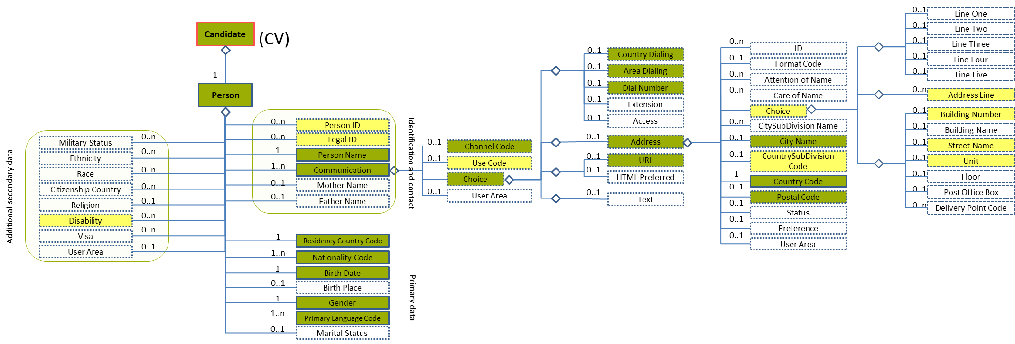
Figure 36: Choice Level 5 Entity Diagram
Element |  | Description | Layer /  Cardinality |  | Rule | Examples
Choice |  | Selection between the types of addresses:  1-Address Line  2-Building Number  3-Street Name  4-Unit | N/A |  | N/A | N/A
Sub-elements
A | Address Line | Full address text in a text field |  | EURES Optional  /  0..n | N/A | “Apartment 10, Derp House, 20 Longstreet, Rotterdam, Netherlands, 3000 AA”, etc.
B | Building Number | The Building/house Number on the street that identifies where to deliver mail (for example, Building 300 on Standards Parkway) |  | EURES Optional  /  0..1 | N/A | “10”, etc.
 | Street Name | The Street Name where the building/house is located |  | EURES Optional  /  0..1 | N/A | “Longstreet”, etc.
 | Unit | The apartment number or office suite |  | EURES Optional  /  0..1 | N/A | “20”, etc.

Choice Attributes
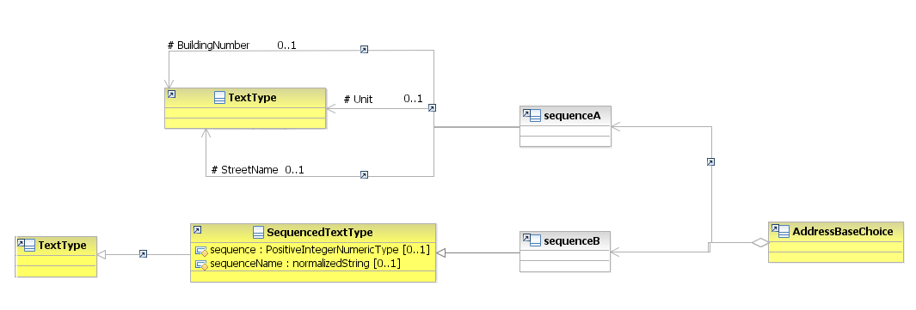
Figure 37: Address Choice Attributes Schema
Attributes | Description | Card. | Rule
This element has no attributes.
BuildingNumber, Unit, StreetName sub-elements
Attributes | Description | Card. | Rule
This sub-element has no attributes.
AddressLine sub-element
Attributes | Description | Card. | Rule
sequence | Establishes the order of the contact data | 0..1 | N/A
sequenceName | Establishes the order of the contact data | 0..1 | N/A

Choice Examples
This is an example of how to fill in a post office address in a line:
Address example:
Les Marchands de Bruxelles SA
Boîte postale 10 Bruxelles 1
1000 BRUSSELS
BELGIUM
<Candidate xmlns="http://www.hr-xml.org/3" xsi:schemaLocation="http://www.hr-xml.org/3 ../Developer/Nouns/Candidate.xsd">
<CandidatePerson>
<Communication>
<Address currentAddressIndicator="true" type="Residence">
<oa:CityName>Brussels</oa:CityName>
<oa:CountrySubDivisionCode listName="EURES_CountrySubdivisionCodes" listVersionID="2013-Level-3" name="Arr. de Bruxelles-Capitale" listURI="http://ec.europa.eu/eurostat"
>BE100</oa:CountrySubDivisionCode>

<CountryCode listName="Countries" listVersionID="3166-1-alpha-2" name="Belgium" listURI="http://ec.europa.eu/esco/ConceptScheme/country"
>BE</CountryCode>
<oa:AddressLine>Les Marchands de Bruxelles SA, Boîte postale 10 Bruxelles 1, 1000 Brussels (Belgium)</oa:AddressLine>
</Address>
</Communication>
</CandidatePerson>
</Candidate>

This is an example of how to fill in a standard address in specific fields:
Address example:
LOCAL 480, 4ème étage
ZONING INDUSTRIEL
Rue Louis Hap 25
1040 Etterbeek
Belgium
<Candidate xmlns="http://www.hr-xml.org/3" xsi:schemaLocation="http://www.hr-xml.org/3 ../Developer/Nouns/Candidate.xsd">
<CandidateProfile languageCode="en"> <EmploymentHistory><EmployerHistory><PositionHistory>
<PositionLocation>
<Address currentAddressIndicator="true" type="Residence">
<oa:CityName>Etterbeek</oa:CityName>

<oa:CountrySubDivisionCode listName="EURES_CountrySubdivisionCodes" listVersionID="2013-Level-3" name="Arr. de Bruxelles-Capitale" listURI="http://ec.europa.eu/eurostat"
>BE100</oa:CountrySubDivisionCode>

<CountryCode listName="Countries" listVersionID="3166-1-alpha-2" name="Belgium" listURI="http://ec.europa.eu/esco/ConceptScheme/country"
>BE</CountryCode>

<oa:BuildingNumber>25</oa:BuildingNumber>
<oa:StreetName>Rue Louis Hap</oa:StreetName>
<oa:Unit>Local 480, 4ème étage</oa:Unit>
</Address>
</PositionLocation>
</PositionHistory></EmployerHistory></EmploymentHistory></CandidateProfile>
</Candidate>

/Person/Disability (level 2)

Disability Element Description
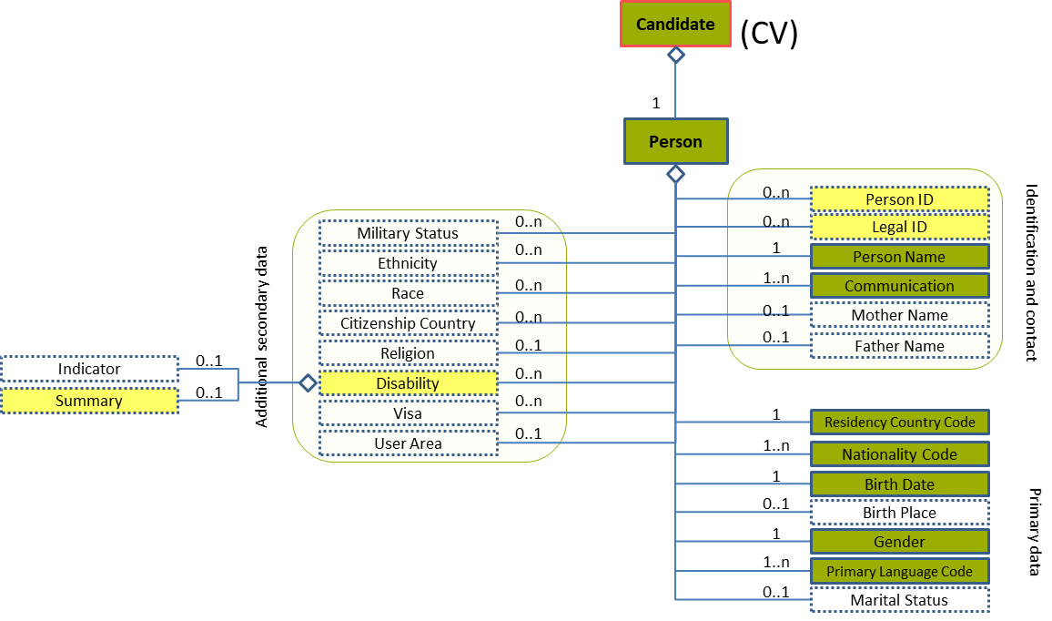
Figure 38: Disability Level 2 Entity Diagram
Element | Description | Layer /  Cardinality |  | Rule | Examples
Disability | Describes a disability associated with a specified person, lack of ability to discharge a function and incapacity in the eyes of the law.  The absence of the Disability element will mean “No disabilities”. |  | EURES Optional  /  0..n | N/A | N/A
Sub-elements
Summary | Describes a disability associated with a specified person, lack of ability to discharge a function and incapacity in the eyes of the law |  | EURES Optional  /  0..1 | N/A | N/A
 | See section “4.10.3 Sub-element: /Summary (level 3)” for more information

Disability Attributes
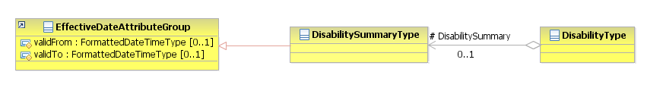
Figure 39: Disability Attributes Schema
Attributes | Description | Card. | Rule
This element has no attributes.
DisabilitySummary sub-element
Attributes | Description | Card. | Rule
See section “4.10.3.2 Summary Attributes” for more information

Sub-element: /Summary (level 3)

Summary Element Description
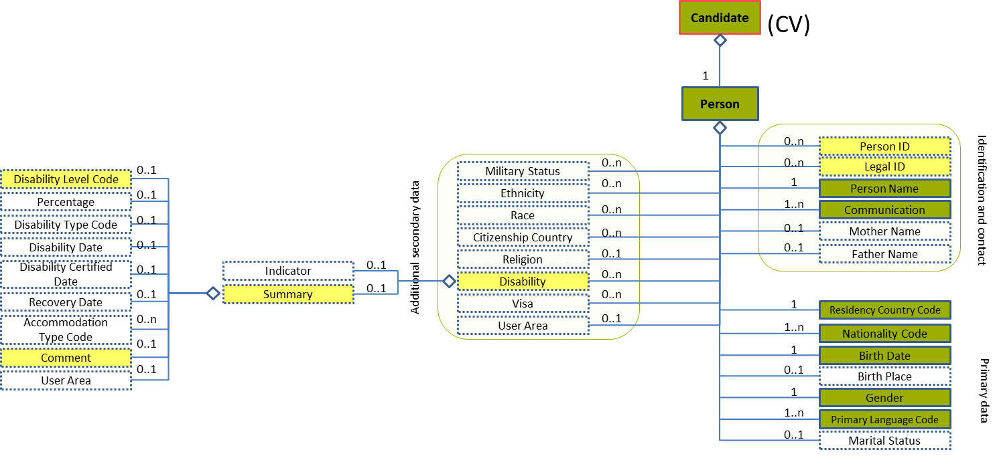
Figure 40: Summary Level 3 Entity Diagram
Element | Description | Layer /  Cardinality |  | Rule | Example
Summary | Describes a disability associated with a specified person, lack of ability to discharge a function and incapacity in the eyes of the law |  | EURES Optional  /  0..1 | N/A | N/A
Sub-elements
Disability Level Code | A value from an external code list classifying the level of disability |  | EURES Optional  /  0..1 | BR-CV-17: Compulsory use of the “EURES_DisabilityLevelCode-CodeList.gc” list defined by EURES. | "1" – need for another person's assistance with daily life tasks  "2" – inability to perform one or more sensory or physical functions, etc.  Full code list: “4.28.10 Disability Level Code [CL12]”
Comment | A free form for comments |  | EURES Optional  /  0..1 | N/A | “Comment about the free form”

Summary Attributes
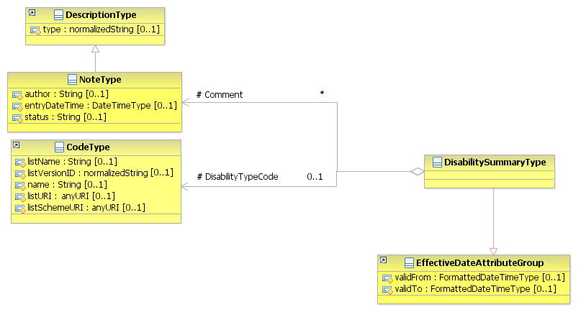
Figure 41: Summary Attributes Schema
Attributes | Description | Card. | Rule
validFrom | Validity start date for this entity’s information | 0..1 | BR-COM-06: Compulsory Date Format is: YYYY-MM-DD, YYYY-MM, YYYY or YYYY-MM-DDThh:mm:ss.
validTo | Validity end date for this entity’s information | 0..1 | BR-COM-06: Compulsory Date Format is: YYYY-MM-DD, YYYY-MM, YYYY or YYYY-MM-DDThh:mm:ss.
DisabilityLevelCode sub-element
Attributes | Description | Card. | Rule
listName | The code list name | 0..1 | N/A
listVersionID | The code list identification | 0..1 | N/A
name | The text equivalent of the code content component | 0..1 | N/A
listURI | The Uniform Resource Identifier that identifies where the code list is located | 0..1 | N/A
listSchemeURI | The Uniform Resource Identifier that identifies where the code list scheme is located | 0..1 | N/A
Comment sub-element
Attributes | Description | Card. | Rule
type | The comment type | 0..1 | N/A
author | The author of the comment | 0..1 | N/A
entryDateTime | The date when the comment was entered or last modified | 0..1 | BR-COM-06: Compulsory Date Format is: YYYY-MM-DD, YYYY-MM, YYYY or YYYY-MM-DDThh:mm:ss.
status | The status of the comment | 0..1 | N/A

/Profile (level 1)

Profile Element Description
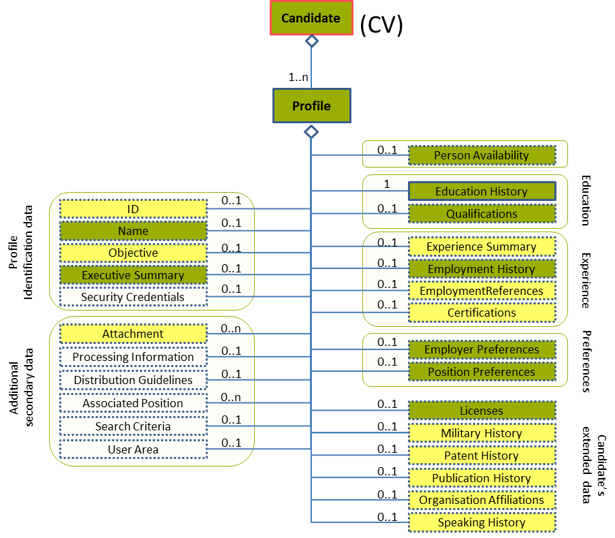
Figure 42: Profile Level 1 Entity Diagram
Element | Description | Layer /  Cardinality |  | Rule | Example
Profile | The candidate’s structured set of characteristics, such as his/her Qualifications, Work Experience, and so on.  More than one profile is allowed in order to provide the information in different languages. Thus the need for cardinality 1..n.  It is the responsibility of the person who builds up the CV to make sure that a profile is expressed in the same language and those different profile language versions contain exactly the same information. |  | EURES Conformant  /  1..n | BR-COM-01: If not otherwise specified, “EN” (English) is used as the default language.  BR-COM-02: Multiple profiles are allowed, but it must be expressed in different languages. | N/A
Sub-elements
ID | Unique systemic identifiers for this Profile |  | EURES Optional  /  0..1 | BR-CV-09: If the identifier is not provided an automatic ID will be provided by the Interoperability Platform. | “PR-009”, “ID-111”, etc.
Name | A descriptive name for this Profile |  | EURES Conformant Optional  /  0..1 | N/A | “Profile 1. English”, etc.
Person Availability | A detailed set of data about the person’s availability |  | EURES Conformant Optional  /  0..1 | N/A | N/A
 | See section “4.12 /Profile/Person Availability (level 2)” for more information
Objective | Narrative description of the candidate’s overall intentions |  | EURES Optional  /  0..1 | N/A | “Job search”, etc.
Executive Summary | Narrative summary on the person and his/her competencies normally used as the CV presentation.  In some cases, content may include a mark-up or might be encoded, for example, HTML content. In such cases, the content might be enclosed within a CDATA section. |  | EURES Conformant Optional  /  0..1 | N/A | “Presentation example”, etc.
Employer Preferences | Information about a candidate’s employer preferences |  | EURES Conformant Optional  /  0..1 | N/A | N/A
 | See section “4.19 /Profile/Employer Preferences (level 2)” for more information
Position Preferences | Information about a candidate’s preferences in a position |  | EURES Conformant Optional  /  0..1 | N/A | N/A
 | See section “4.20 /Profile/Position Preferences (level 2)” for more information
Experience Summary | Categorisation of the candidate’s Experience |  | EURES Optional  /  0..1 | N/A | N/A
 | See section “4.15 /Profile/Experience Summary (level 2)” for more information
Employment History | Prior and current details of a person’s employment, work, or relevant experience that can be reported on a professional profile, CV, resume, employment application, or similar document |  | EURES Conformant Optional  /  0..1 | N/A | N/A
 | See section “4.16/Profile/Employment History (level 2)” for more information
Education History | Information documenting a person’s education, including data relevant to verifying such education, continuous education, schooling or training in preparation for work life; by extension or training obtained as an adult. |  | EURES Conformant  /  1 | N/A | N/A
 | See section “4.13 /Profile/Education History (level 2)” for more information
Licenses | Contains details regarding one or more licenses (such as a driver’s licence) |  | EURES Conformant Optional  /  0..1 | N/A | N/A
 | See section “4.21 /Profile/Licenses (level 2)” for more information
Certifications | Information about one or more certifications. Certifications are formal statements by an issuing authority that the certification holder has met educational or testing requirements associated with it. |  | EURES Optional  /  0..1 | N/A | N/A
 | See section “4.18 /Profile/Certifications (level 2)” for more information
Military History | Information about the person’s military status |  | EURES Optional  /  0..1 | N/A | N/A
 | See section “4.22 /Profile/Military History (level 2)” for more information
Patent History | Information about the Patents owned by the person |  | EURES Optional  /  0..1 | N/A | N/A
 | See section “4.23 /Profile/Patent History (level 2)” for more information
Publication History | Information about one or more publications text by the person |  | EURES Optional  /  0..1 | N/A | N/A
 | See section “4.24 /Profile/Publication History (level 2)” for more information
Speaking History | Information about one or more events in which the person has spoken (as keynote speaker, for example) |  | EURES Optional  /  0..1 | N/A | N/A
 | See section “4.26 /Profile/Speaking History (level 2)” for more information
Qualifications | Information related to matching capacities, knowledge, skills, abilities, awards and other resource deployment-related characteristics (including “competencies”) offered by a candidate |  | EURES Conformant Optional  /  0..1 | N/A | N/A
 | See section “4.14 /Profile/Qualifications (level 2)” for more information
Organization Affiliations | Details on one or more organisational affiliations, for example, membership in a trade or civic organisation, seat on a board of directors, membership in a union, etc. |  | EURES Optional  /  0..1 | N/A | N/A
 | See section “4.25 /Profile/Organization Affiliations (level 2)” for more information
Employment References | Contains information on one or more people who may be a source of information about a person’s skills, prior employment, character, or suitability for employment |  | EURES Optional  /  0..1 | N/A | N/A
 | See section “4.17 /Profile/Employment References (level 2)” for more infomation
Attachment | Allows for embedding or referencing external documents or digital objects |  | EURES Optional  /  0..n | N/A | N/A
 | See section “4.27 /Profile/Attachment (level 2)” for more information

Profile Attributes
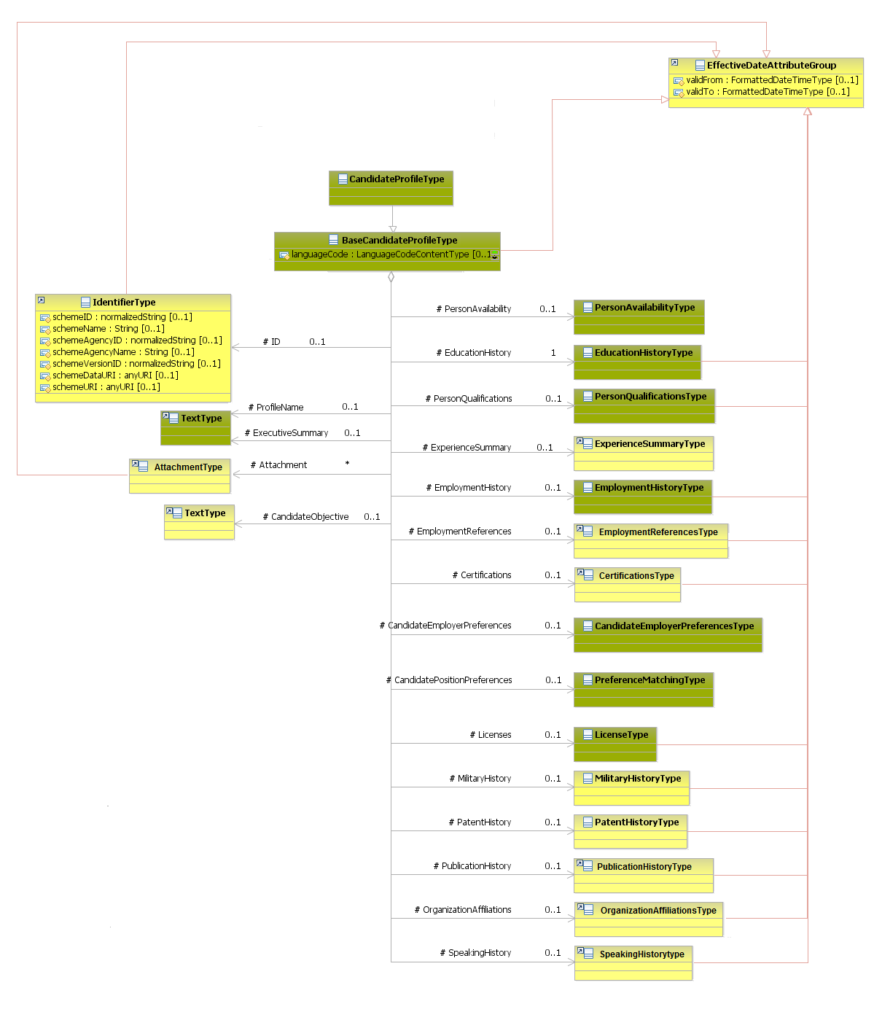
Figure 43: Profile Attributes Schema
Attributes | Description | Card. | Rule
languageCode | Language used throughout the whole document.  Only official European Country languages are allowed. | 0..1 | BR-COM-01: If not otherwise specified, “EN” (English) is used as the default language.  BR-COM-04: Compulsory use of the “EURES_EULanguageCodes-CodeList.gc” list defined by EURES. Adapted EU countries only are used, based on ISO 639-1:2002 Alpha-2. If there is a code specified which is not a valid one, this language version of the CV is rejected.
validFrom | Validity start date for this entity’s information | 0..1 | BR-COM-05: If not specified, the “validFrom” date will default to “assigned by EURES on reception”.  BR-COM-06: Compulsory Date Format is: YYYY-MM-DD, YYYY-MM, YYYY or YYYY-MM-DDThh:mm:ss.
validTo | Validity end date for this entity’s information | 0..1 | BR-COM-07: If not specified, the “validTo” date will be decided by EURES depending on the transaction context.  BR-COM-06: Compulsory Date Format is: YYYY-MM-DD, YYYY-MM, YYYY or YYYY-MM-DDThh:mm:ss.
PersonAvailability sub-element
Attributes | Description | Card. | Rule
See section “4.12.2 Person Availability Attributes” for more information
EducationHistory sub-element
Attributes | Description | Card. | Rule
See section “4.13.2 Education History Attributes” for more information
PersonQualifications sub-element
Attributes | Description | Card. | Rule
See section “4.14.2 Qualifications Attributes” for more information
ExperienceSummary sub-element
Attributes | Description | Card. | Rule
See section “4.15.2 Experience Summary Attributes” for more information
EmploymentHistory sub-element
Attributes | Description | Card. | Rule
See section “4.16.2 Employment History Attributes” for more information
EmploymentReferences sub-element
Attributes | Description | Card. | Rule
See section “4.17.2 Employment References Attributes” for more information
Certifications sub-element
Attributes | Description | Card. | Rule
See section “4.18.2 Certifications Attributes” for more information
CandidateEmploymentPreferences sub-element
Attributes | Description | Card. | Rule
See section “4.19.2 Employer Preferences Attributes” for more information
CandidatePositionPreferences sub-element
Attributes | Description | Card. | Rule
See section “4.20.2 Position Preferences Attributes” for more information
Licenses sub-element
Attributes | Description | Card. | Rule
See section “4.21.2 Licenses Attributes” for more information
MilitaryHistory sub-element
Attributes | Description | Card. | Rule
See section “4.22.2 Military History Attributes” for more information
PatentHistory sub-element
Attributes | Description | Card. | Rule
See section “4.23.2 Patent History Attributes” for more information
PublicationHistory sub-element
Attributes | Description | Card. | Rule
See section “4.24.2 Publication History Attributes” for more information
OrganizationAffiliations sub-element
Attributes | Description | Card. | Rule
See section “4.25.2 Organization Affiliations Attributes” for more information
SpeakingHistory sub-element
Attributes | Description | Card. | Rule
See section “4.26.2 Speaking History Attributes” for more information
ID sub-element
Attributes | Description | Card. | Rule
schemeID | Identification of the identifier scheme | 0..1 | N/A
schemeName | The identification scheme name | 0..1 | N/A
schemeAgencyID | Identification of the agency that maintains the scheme | 0..1 | N/A
schemeAgencyName | The name of the agency that maintains the scheme | 0..1 | N/A
schemeVersionID | The identification scheme version | 0..1 | N/A
schemeDataURI | The Uniform Resource Identifier that identifies where the data scheme is located | 0..1 | N/A
schemeURI | The Uniform Resource Identifier that identifies where the scheme is located | 0..1 | N/A
validFrom | Validity start date for this ID | 0..1 | BR-COM-06: Compulsory Date Format is: YYYY-MM-DD, YYYY-MM, YYYY or YYYY-MM-DDThh:mm:ss.
validTo | Validity end date for this ID | 0..1 | BR-COM-06: Compulsory Date Format is: YYYY-MM-DD, YYYY-MM, YYYY or YYYY-MM-DDThh:mm:ss.
ProfileName sub-element
Attributes | Description | Card. | Rule
This sub-element has no attributes.
ExecutiveSummary sub-element
Attributes | Description | Card. | Rule
This sub-element has no attributes.
Attachment sub-element
Attributes | Description | Card. | Rule
See section “4.27.2 Attachment Attributes” for more information
CandidateObjective sub-element
Attributes | Description | Card. | Rule
This sub-element has no attributes.

Profile Examples
The example below shows a CV XML with profiles in different languages, through the LanguageCode attribute.
<Candidate xsi:schemaLocation="http://www.hr-xml.org/3 ../Developer/Nouns/Candidate.xsd" xmlns="http://www.hr-xml.org/3" xmlns:oa="http://www.openapplications.org/oagis/9" xmlns:xsi="http://www.w3.org/2001/XMLSchema-instance" majorVersionID="3" minorVersionID="2">
<CandidateProfile languageCode="en">
...
<CandidateObjective>Software engineer / Programmer</CandidateObjective>
...
</CandidateProfile>

<CandidateProfile languageCode="fr">
...
<CandidateObjective>Ingénieur logiciel / Programmeur</CandidateObjective>
...
</CandidateProfile>
</Candidate>

/Profile/Person Availability (level 2)

Person Availability Element Description
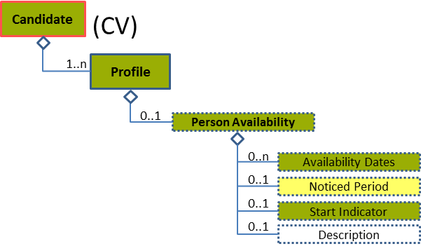
Figure 44: Person Availability Level 2 Entity Diagram
Element | Description | Layer /  Cardinality |  | Rule | Examples
Person Availability | Detailed set of data about the person’s availability |  | EURES Conformant Optional  /  0..1 | N/A | N/A
Sub-elements
Availability Dates | Start and end dates of availability |  | EURES Conformant Optional  /  0..n | N/A | N/A
 | See section “4.12.4 Sub-element: /Availability Dates (level 3)” for more information
Noticed Period | A period measured in number of days, weeks, or months in advance of which an employee must give notice of his or her intention to resign his or her employment |  | EURES Optional  /  0..1 | N/A | “5”, “2”, etc.
Start Indicator | An indicator as to whether the person is available to start immediately |  | EURES Conformant Optional  /  0..1 | N/A | “True” = This person is available to start immediately.  “False” = This person is not available to start immediately.

Person Availability Attributes
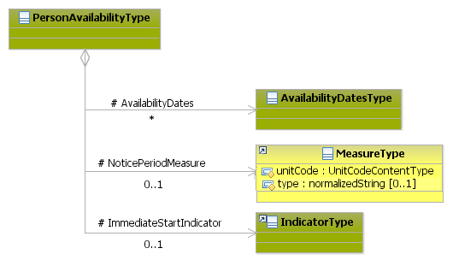
Figure 45: Person Availability Attributes Schema
Attributes | Description | Card. | Rule
This element has no attributes.
AvailabilityDates sub-element
Attributes | Description | Card. | Rule
See section “4.12.4.2 Availability Dates Attributes” for more information
NoticePeriodMeasure sub-element
Attributes | Description | Card. | Rule
unitCode | Code indicating the type of unit measure, such as “minutes” or “hours” (full code list “4.28.37 Unit Codes [CL54]”) | 0..1 | BR-COM-36: Compulsory use of the Unit Codes [CL54].
type | The description type | 0..1 | N/A
InmediateStartIndicator sub-element
Attributes | Description | Card. | Rule
This sub-element has no attributes.

Person Availability Examples
This example shows how to indicate that the candidate is available during certain dates, and that he/she needs to know it 2 weeks in advance.
<Candidate xmlns="http://www.hr-xml.org/3" xsi:schemaLocation="http://www.hr-xml.org/3 ../Developer/Nouns/Candidate.xsd" >
<CandidateProfile languageCode="en">
<PersonAvailability>
<AvailabilityDates>
<StartDateTime>2014-07-30</StartDateTime>
</AvailabilityDates>
<AvailabilityDates>
<StartDateTime>2014-02-01</StartDateTime>
<EndDateTime>2014-04-01</EndDateTime>
</AvailabilityDates>

<NoticePeriodMeasure unitCode="week">2</NoticePeriodMeasure>

<ImmediateStartIndicator>false</ImmediateStartIndicator>
</PersonAvailability>
</CandidateProfile>
<Candidate/>

Sub-element: /Availability Dates (level 3)

Availability Dates Element Description
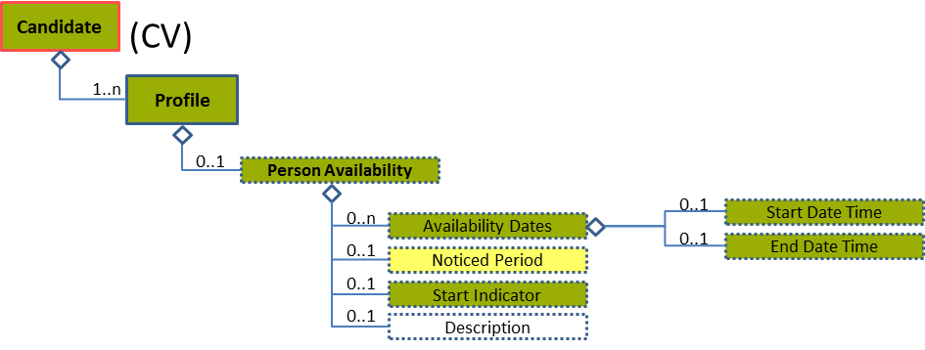
Figure 46: Availability Dates Level 3 Entity Diagram
Element | Description | Layer /  Cardinality |  | Rule | Examples
Availability Dates | Start and end dates of availability |  | EURES Conformant Optional  /  0..n | N/A | N/A
Sub-elements
Start Date Time | The timestamp marking the beginning of a time period during which a related entity or status is effective or applicable |  | EURES Conformant Optional  /  0..1 | BR-COM-06: Compulsory Date Format is: YYYY-MM-DD, YYYY-MM, YYYY or YYYY-MM-DDThh:mm:ss. | “2014-10-09”
End Date Time | The timestamp marking the end of a time period during which a related entity or status is effective or applicable |  | EURES Conformant Optional  /  0..1 | BR-COM-06: Compulsory Date Format is: YYYY-MM-DD, YYYY-MM, YYYY or YYYY-MM-DDThh:mm:ss. | “2015-10-09”

Availability Dates Attributes
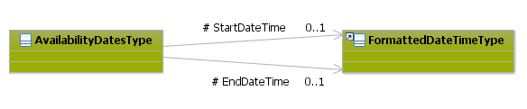
Figure 47: Availability Dates Attributes Schema
Attributes | Description | Card. | Rule
This element has no attributes.
StartDateTime sub-element
Attributes | Description | Card. | Rule
This sub-element has no attributes.
EndDateTime sub-element
Attributes | Description | Card. | Rule
This sub-element has no attributes.

/Profile/Education History (level 2)

Education History Element Description
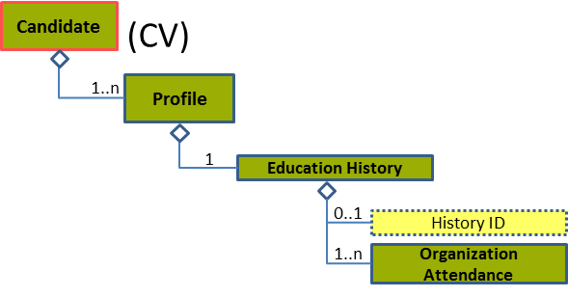
Figure 48: Education History Level 2 Entity Diagram
Element | Description | Layer /  Cardinality |  | Rule | Examples
Education History | A collection of information documenting a person’s education, including data relevant to verifying such education, continuous education, schooling or training in preparation for work life; by extension, similar instruction or training obtained as an adult. |  | EURES Conformant  /  1 | N/A | N/A
Sub-elements
History ID | A key by which to distinguish or refer to information about a person's education. |  | EURES Optional  /  0..1 | BR-CV-09: If the identifier is not provided an automatic ID will be provided by the Interoperability Platform. | “ED-002”, etc.
Organization Attendance | A detailed set of data with details regarding a person's attendance at an educational institution |  | EURES Conformant  /  1..n | N/A | N/A
 | See section “4.13.3 Sub-element: /Organization Attendance (level 3)” for more information

Education History Attributes
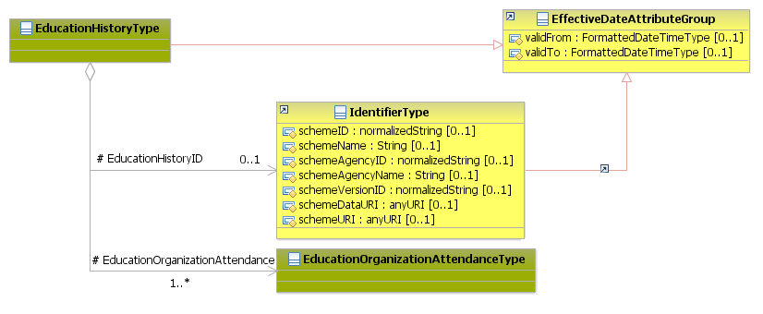
Figure 49: Education History Attributes Schema
Attributes | Description | Card. | Rule
validFrom | Validity start date for this entity’s information | 0..1 | BR-COM-06: Compulsory Date Format is: YYYY-MM-DD, YYYY-MM, YYYY or YYYY-MM-DDThh:mm:ss.
validTo | Validity end date for this entity’s information | 0..1 | BR-COM-06: Compulsory Date Format is: YYYY-MM-DD, YYYY-MM, YYYY or YYYY-MM-DDThh:mm:ss.
EducationHistoryID sub-element
Attributes | Description | Card. | Rule
schemeID | The identification of the identifier scheme | 0..1 | N/A
schemeName | The identification scheme name | 0..1 | N/A
schemeAgencyID | Identification of the agency that maintains the scheme | 0..1 | N/A
schemeAgencyName | The name of the agency that maintains the scheme | 0..1 | N/A
schemeVersionID | The identification scheme version | 0..1 | N/A
schemeDataURI | The Uniform Resource Identifier that identifies where the data scheme is located | 0..1 | N/A
schemeURI | The Uniform Resource Identifier that identifies where the scheme is located | 0..1 | N/A
validFrom | Validity start date for this entity’s information | 0..1 | BR-COM-05: If not specified, the “validFrom” date will default to “assigned by EURES on reception”.  BR-COM-06: Compulsory Date Format is: YYYY-MM-DD, YYYY-MM, YYYY or YYYY-MM-DDThh:mm:ss.
validTo | Validity end date for this entity’s information | 0..1 | BR-COM-07: If not specified, the “validTo” date will be decided by EURES depending on the transaction context.  BR-COM-06: Compulsory Date Format is: YYYY-MM-DD, YYYY-MM, YYYY or YYYY-MM-DDThh:mm:ss.
EducationOrganizationAttendance sub-element
Attributes | Description | Card. | Rule
See section “4.13.3.2 Organization Attendance Attributes” for more information

Sub-element: /Organization Attendance (level 3)

Organization Attendance Element Description
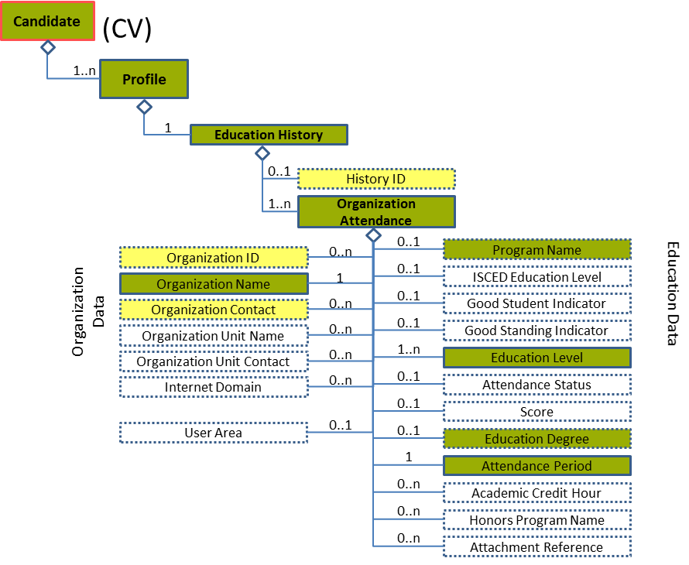
Figure 50: Organization Attendance Level 3 Entity Diagram
Element | Description | Layer /  Cardinality |  | Rule | Examples
Organization Attendance | A detailed set of data containing details regarding a person's attendance at an educational institution |  | EURES Conformant  /  1..n | N/A | N/A
Sub-elements
Organization ID | Identifier of the Educational Organisation |  | EURES Optional  /  0..n | BR-CV-09: If the identifier is not provided an automatic ID will be provided by the Interoperability Platform. | “ORG-122”, etc.
Organization Name | The official or legal name by which to refer to an organisation |  | EURES Conformant  /  1 | N/A | “University of Brussels”, etc.
Organization Contact | The Educational Organisation’s contact data |  | EURES Optional  /  0..n | N/A | N/A
 | See section “4.13.10 Sub-element: /Organization Attendance/Organization Contact (level 4)”
Program Name | The title of the qualification |  | EURES Conformant Optional  /  0..1 | N/A | “Education Leadership Program”, “Biomedical engineering”, etc.
Education Level | A code classifying the level of educational organisation. In this case, the standard used could be EQF or ISCED. |  | EURES Conformant  /  1..n | BR-COM-15: Compulsory use of the “EURES_ISCEDEducationLevel-CodeList.gc” list defined by EURES. This is based on ISCED-2011 (UNESCO). Or “EURES_EQF-CodeList.gc”, list defined by EURES and based on EQF (EU).  BR-COM-44: One value for each code list is allowed.  BR-COM-55: Compulsory use of the attributes “listVersionID”, “listName” and “listURI”. | “0”, “1”, “2”, etc.  Full code list: “4.28.12 Education Level Codes [CL15]”
Attendance Period | Free form options for representing attendance period data.  If the End Date sub-element is not filled, it means that the candidate is currently studying. |  | EURES Conformant  /  1 | N/A | N/A
Education Degree | Details about the student's degree |  | EURES Conformant Optional  /  0..1 | N/A | N/A
 | See section “4.13.4 Sub-element: /Organization Attendance/Education Degree (level 4)” for more information

Organization Attendance Attributes
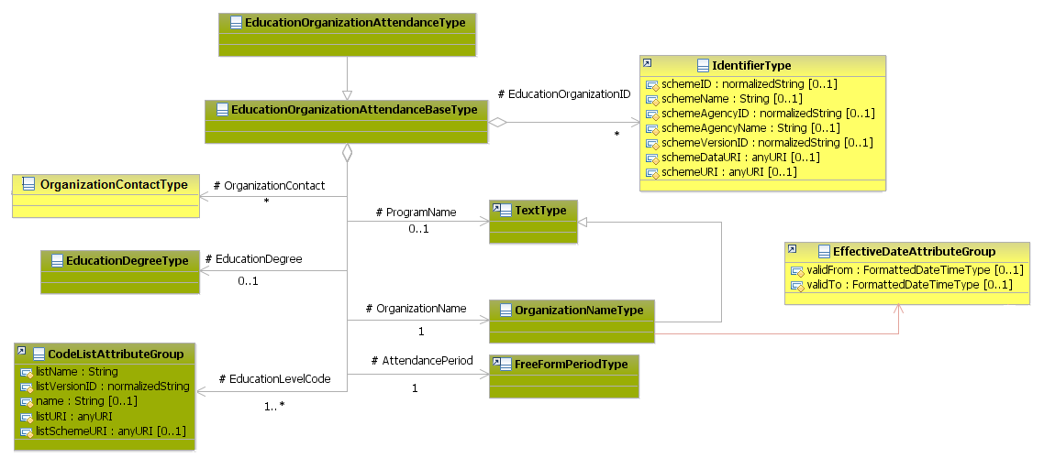
Figure 51: Organisation Attendance Attributes Schema
Attributes | Description | Card. | Rule
This element has no attributes.
EducationOrganizationID sub-element
Attributes | Description | Card. | Rule
schemeID | Identification of the identifier scheme | 0..1 | N/A
schemeName | The identification scheme name | 0..1 | N/A
schemeAgencyID | Identification of the agency that maintains the scheme | 0..1 | N/A
schemeAgencyName | The name of the agency that maintains the scheme | 0..1 | N/A
schemeVersionID | The identification scheme version | 0..1 | N/A
schemeDataURI | The Uniform Resource Identifier that identifies where the data scheme is located | 0..1 | N/A
schemeURI | The Uniform Resource Identifier that identifies where the scheme is located | 0..1 | N/A
validFrom | Validity start date for this entity’s information | 0..1 | BR-COM-05: If not specified, the “validFrom” date will default to “assigned by EURES on reception”.  BR-COM-06: Compulsory Date Format is: YYYY-MM-DD, YYYY-MM, YYYY or YYYY-MM-DDThh:mm:ss.
validTo | Validity end date for this entity’s information | 0..1 | BR-COM-07: If not specified, the “validTo” date will be decided by EURES depending on the transaction context.  BR-COM-06: Compulsory Date Format is: YYYY-MM-DD, YYYY-MM, YYYY or YYYY-MM-DDThh:mm:ss.
OrganizationContact sub-element
Attributes | Description | Card. | Rule
See section “4.13.10.2 Organization Contact Attributes” for more information
ProgramName sub-element
Attributes | Description | Card. | Rule
This sub-element has no attributes.
EducationDegree sub-element
Attributes | Description | Card. | Rule
See section “4.13.4.2 Education Degree Attributes” for more information
OrganizationName sub-element
Attributes | Description | Card. | Rule
validFrom | Validity start date for this entity’s information | 0..1 | BR-COM-06: Compulsory Date Format is: YYYY-MM-DD, YYYY-MM, YYYY or YYYY-MM-DDThh:mm:ss.
validTo | Validity end date for this entity’s information | 0..1 | BR-COM-06: Compulsory Date Format is: YYYY-MM-DD, YYYY-MM, YYYY or YYYY-MM-DDThh:mm:ss.
AttendancePeriod sub-element
Attributes | Description | Card. | Rule
See section “4.13.7.2 Attendance Period Attributes” for more information
EducationLevelCode sub-element
Attributes | Description | Card. | Rule
listName | The code list name. | 0..1 | N/A
listVersionID | The code list identification | 0..1 | N/A
name | The text equivalent of the code content component | 0..1 | N/A
listURI | The Uniform Resource Identifier that identifies where the code list is located | 0..1 | N/A
listSchemeURI | The Uniform Resource Identifier that identifies where the code list scheme is located | 0..1 | N/A

Organization Attendance Examples
This example shows a candidate current bachelor studies.
<Candidate xmlns="http://www.hr-xml.org/3" xsi:schemaLocation="http://www.hr-xml.org/3 ../Developer/Nouns/Candidate.xsd" >
<CandidateProfile languageCode="en">
<EducationHistory>
<EducationOrganizationAttendance>
<OrganizationName>UFR Amiens</OrganizationName>
<ProgramName>Modern Literature</ProgramName>

<EducationLevelCode listName="EURES_EQF" listURI="http://ec.europa.eu/esco/ConceptScheme/EQF2012/ConceptScheme" name="Short cycle" listVersionID="2008/C11/01">
5</EducationLevelCode>

<AttendancePeriod>
<StartDate>
<FormattedDateTime>2012-09-01</FormattedDateTime>
</StartDate>
</AttendancePeriod>
</EducationOrganizationAttendance>
</EducationHistory>
</CandidateProfile>
<Candidate/>

Sub-element: /Organization Attendance/Education Degree (level 4)

Education Degree Element Description
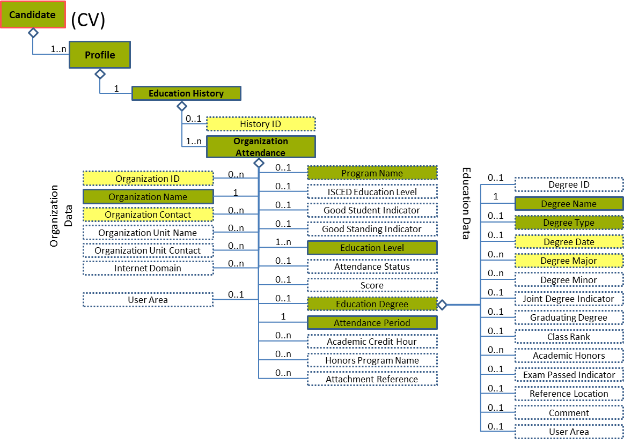
Figure 52: Education Degree Level 4 Entity Diagram
Element | Description | Layer /  Cardinality |  | Rule | Examples
Education Degree | Contains details about the student's degree |  | EURES Conformant  /  0..1 | N/A | N/A
Sub-elements
Degree Name | Narrative details of the degree awarded |  | EURES Conformant  /  1 | N/A | “B.B.A.”, “PhD”, etc.
Degree Type | The certificate obtained with the degree, or award granted for the successful completion of requirements of an academic program |  | EURES Conformant Optional  /  0..1 | BR-COM-17: Compulsory use of the “EURES_DegreeType-CodeList.gc” list defined by EURES. This is based on ESCO Qualifications – version 1.0 | “23938”, “23399”, etc.  Full code list: “4.28.8 Degree Codes [CL10]”
Degree Date | The date in which an educational degree is awarded or conferred |  | EURES Optional  /  0..1 | BR-COM-16: At least one of its sub-elements must be provided. | N/A
 | See section “4.13.5 Sub-element: /Organization Attendance/Education Degree/Degree Date (level 5)” for more information
Degree Major | The degree specialisation |  | EURES Optional  /  0..n | N/A | N/A
 | See section “4.13.6 Sub-element: /Organization Attendance/Education Degree/Degree Major (level 5)” for more information

Education Degree Attributes
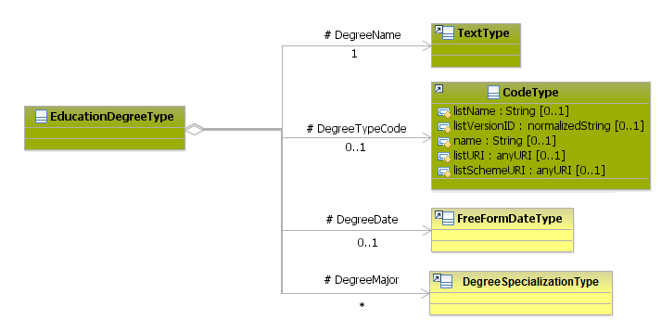
Figure 53: Education Degree Attributes Schema
Attributes | Description | Card. | Rule
This element has no attributes.
DegreeName sub-element
Attributes | Description | Card. | Rule
This sub-element has no attributes.
DegreeTypeCode sub-element
Attributes | Description | Card. | Rule
listName | The code list name | 0..1 | N/A
listVersionID | The code list identification | 0..1 | N/A
name | The text equivalent of the code content component | 0..1 | N/A
listURI | The Uniform Resource Identifier that identifies where the code list is located | 0..1 | N/A
listSchemeURI | The Uniform Resource Identifier that identifies where the code list scheme is located | 0..1 | N/A
DegreeDate sub-element
Attributes | Description | Card. | Rule
See section “4.13.5.2 Degree Date Attributes” for more information
DegreeMajor sub-element
Attributes | Description | Card. | Rule
See section “4.13.6.2 Degree Major Attributes” for more information

Sub-element: /Organization Attendance/Education Degree/Degree Date (level 5)

Degree Date Element Description
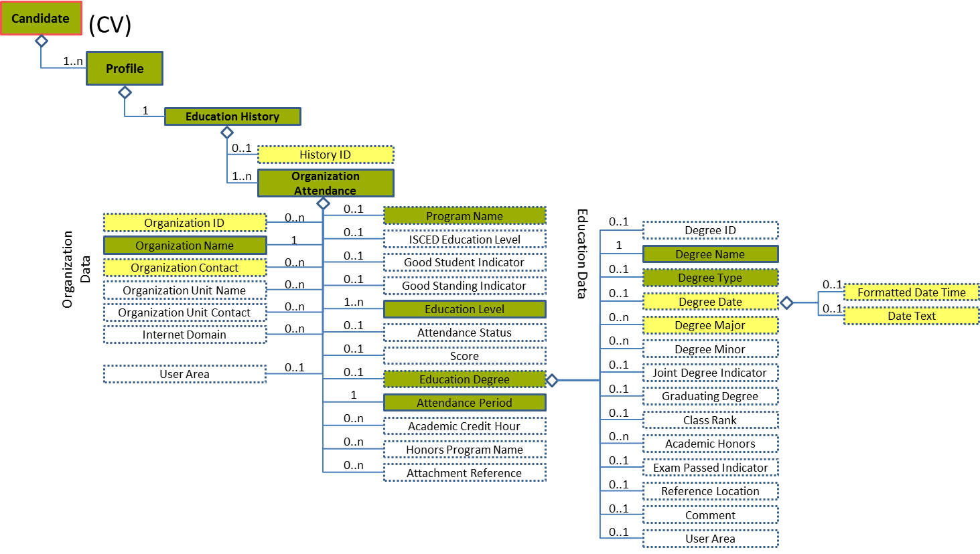
Figure 54: Degree Date Level 5 Entity Diagram
Element | Description | Layer /  Cardinality |  | Rule | Examples
Degree Date | The date in which an educational degree was awarded or conferred |  | EURES Optional  /  0..1 | BR-COM-16: At least one of its sub-elements must be provided. | N/A
Sub-elements
Formatted Date Time | A formatted representation of a date, which may be specified as a date, date/time, year, or year/month |  | EURES Optional  /  0..1 | BR-COM-06: Compulsory Date Format is: YYYY-MM-DD, YYYY-MM, YYYY or YYYY-MM-DDThh:mm:ss. | “2009-04-01” or “2009-04”, etc.
Date Text | A text or formatted representation of a date or date information |  | EURES Optional  /  0..1 | N/A | "January 4, 2009" or "Two Years Ago"

Degree Date Attributes
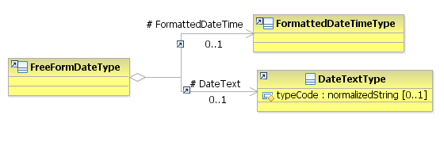
Figure 55: Degree Date Attributes Schema
Attributes | Description | Card. | Rule
This element has no attributes.
DateText sub-element
Attributes | Description | Card. | Rule
typeCode | The type of date text | 0..1 | N/A
FormattedDateTime sub-element
Attributes | Description | Card. | Rule
This sub-element has no attributes.

Degree Date Examples
This example shows how to fill in the degree date as a formatted representation of a date.
<Candidate xmlns="http://www.hr-xml.org/3" xsi:schemaLocation="http://www.hr-xml.org/3 ../Developer/Nouns/Candidate.xsd" >
<CandidateProfile languageCode="en">
<EducationHistory>
<EducationOrganizationAttendance>
<EducationDegree>
<DegreeDate>
<FormattedDateTime>2010-06-30</FormattedDateTime>
</DegreeDate>
</EducationDegree>
</EducationOrganizationAttendance>
</EducationHistory>
</CandidateProfile>
<Candidate/>
This example shows how to fill in the degree date as a text representation of a date.
<Candidate xmlns="http://www.hr-xml.org/3" xsi:schemaLocation="http://www.hr-xml.org/3 ../Developer/Nouns/Candidate.xsd" >
<CandidateProfile languageCode="en">
<EducationHistory>
<EducationOrganizationAttendance>
<EducationDegree>
<DegreeDate>
<DateText typeCode="Month,YYYY">June, 2010</DateText>
</DegreeDate>
</EducationDegree>
</EducationOrganizationAttendance>
</EducationHistory>
</CandidateProfile>
<Candidate/>

Sub-element: /Organization Attendance/Education Degree/Degree Major (level 5)

Degree Major Element Description
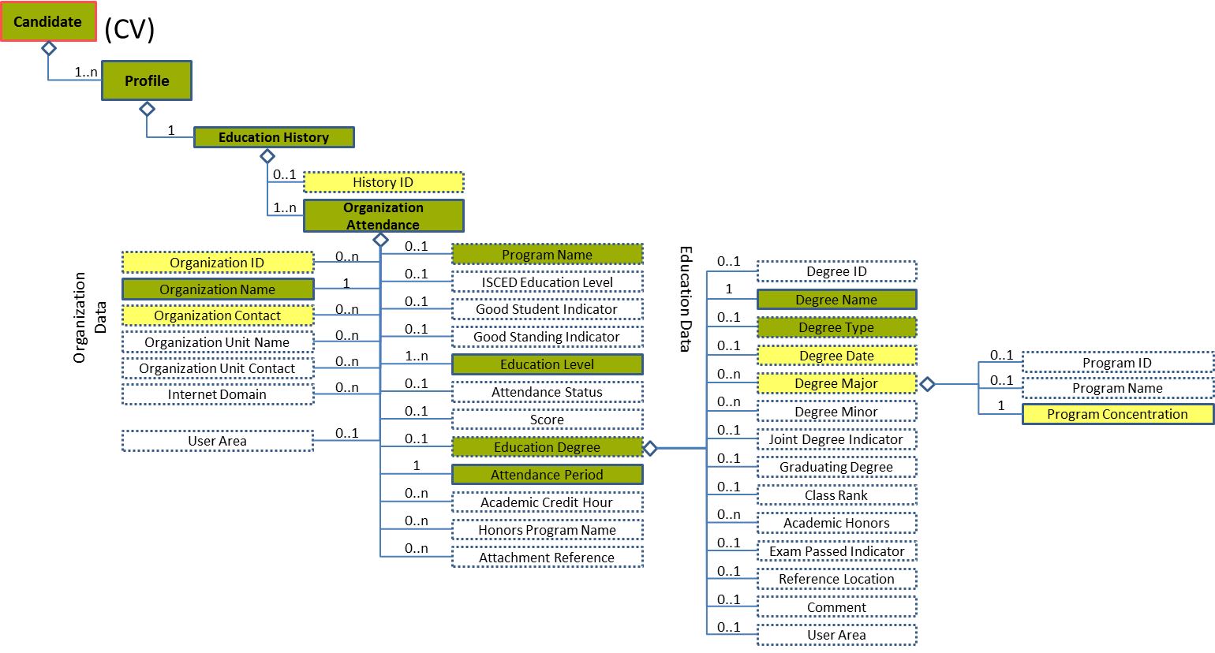
Figure 56: Degree Major Level 5 Entity Diagram
Element | Description | Layer /  Cardinality |  | Rule | Examples
Degree Major | The degree specialisation |  | EURES Optional  /  0..n | N/A | N/A
Sub-elements
Program Concentration | Degree specialisation |  | EURES Optional  /  1 | BR-CV-28: Compulsory use of the “EURES_ISCEDEducationField” list defined by EURES. | “001”, “002”, “003” etc.  Full code list: “4.28.15 ISCED Education Field [CL60] ”

Degree Major Attributes
Figure 57: Degree Major Attributes Schema
Attributes | Description | Card. | Rule
This element has no attributes.
ProgramConcentration sub-element
Attributes | Description | Card. | Rule
This sub-element has no attributes.

Sub-element: /Organization Attendance/Attendance Period (level 4)

Attendance Period Element Description
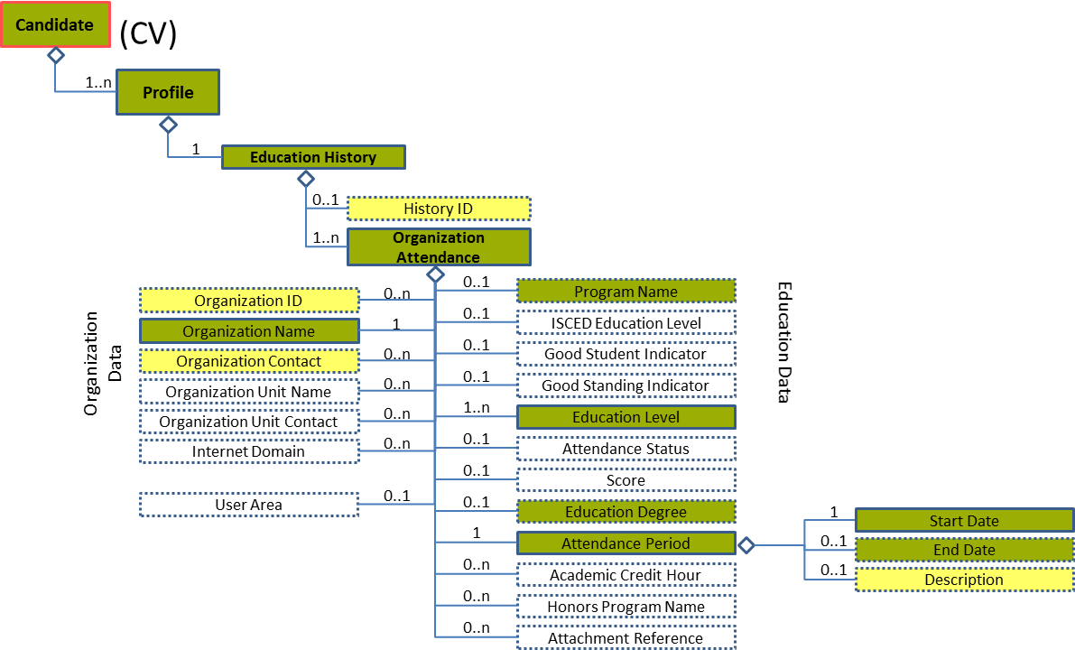
Figure 58: Attendance Period Level 4 Entity Diagram
Element | Description | Layer /  Cardinality |  | Rule | Examples
Attendance Period | Provides Freeform options for representing attendance period data |  | EURES Conformant  /  1 | N/A | N/A
Sub-elements
Start Date | A timestamp marking the beginning of the attendance period |  | EURES Conformant  /  1 | BR-COM-16: At least one of its sub-elements must be provided. | N/A
 | See section “4.13.8 Sub-element: /Organization Attendance/Attendance Period/Start Date (level 5)” for more information
End Date | A timestamp marking the end of the attendance period |  | EURES Conformant Optional  /  0..1 | BR-COM-16: At least one of its sub-elements must be provided. | N/A
 | See section “4.13.9 Sub-element: /Organization Attendance/Attendance Period/End Date (level 5)” for more information
Description | Narrative details of the attendance period |  | EURES Optional  /  0..1 | N/A | “Additional information about the attendance period.”

Attendance Period Attributes
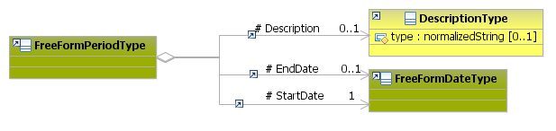
Figure 59: Attendance Period Attributes Schema
Attributes | Description | Card. | Rule
This element has no attributes.
Description sub-element
Attributes | Description | Card. | Rule
type | The description type | 0..1 | N/A
EndDate sub-element
Attributes | Description | Card. | Rule
See section “4.13.9.2 End Date Attributes” for more information
StartDate sub-element
Attributes | Description | Card. | Rule
See section “4.13.8.2 Start Date Attributes” for more information

Sub-element: /Organization Attendance/Attendance Period/Start Date (level 5)

Start Date Element Description
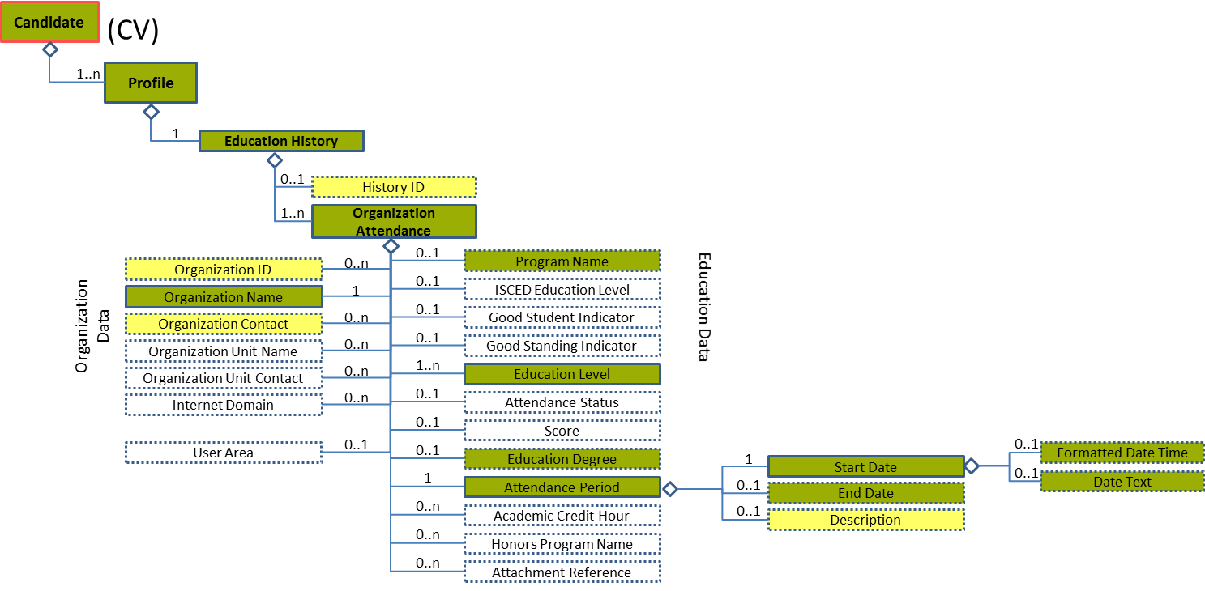
Figure 60: Start Date Level 5 Entity Diagram
Element | Description | Layer /  Cardinality |  | Rule | Examples
Start Date | A timestamp marking the beginning of the attendance period |  | EURES Conformant  /  1 | BR-COM-16: At least one of its sub-elements must be provided. | N/A
Sub-elements
Formatted Date Time | A formatted representation of a date, which may be specified as a date, date/time, year, or year/month |  | EURES Conformant Optional  /  0..1 | BR-COM-06: Compulsory Date Format is: YYYY-MM-DD, YYYY-MM, YYYY or YYYY-MM-DDThh:mm:ss. | “2009-01-04”, “2009-01”, etc.
Date Text | A text or formatted representation of a date or date information |  | EURES Conformant Optional  /  0..1 | N/A | "January 4, 2009" or "Two Years Ago"

Start Date Attributes
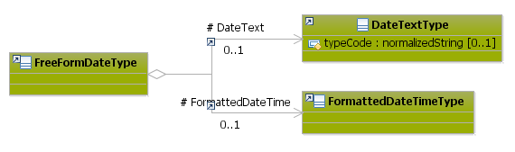
Figure 61: Start Date Attributes Schema
Attributes | Description | Card. | Rule
This element has no attributes.
DateText sub-element
Attributes | Description | Card. | Rule
typeCode | The type of the date text. | 0..1 | N/A
FormattedDateTime sub-element
Attributes | Description | Card. | Rule
This sub-element has no attributes.

Sub-element: /Organization Attendance/Attendance Period/End Date (level 5)

End Date Element Description
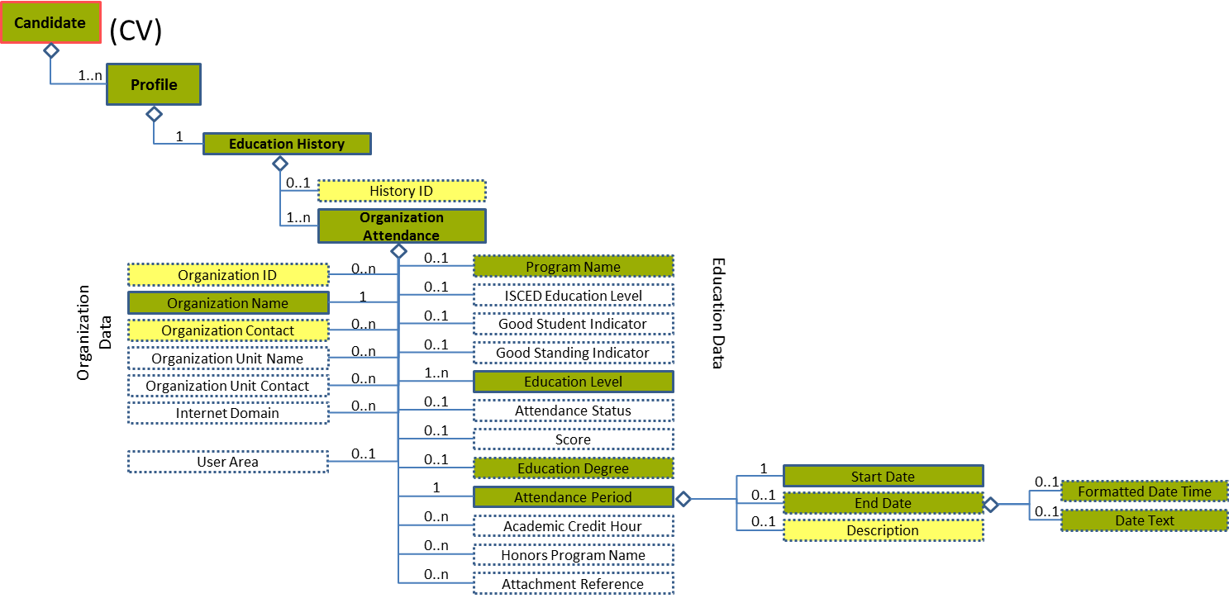
Figure 62: End Date Level 5 Entity Diagram

Element | Description | Layer /  Cardinality |  | Rule | Examples
End Date | A timestamp marking the end of the attendance period |  | EURES Conformant Optional  /  0..1 | BR-COM-06: Compulsory Date Format is: YYYY-MM-DD, YYYY-MM, YYYY or YYYY-MM-DDThh:mm:ss. | N/A
Sub-elements
The same as “4.13.8
Sub-element: /Organization Attendance/Attendance Period/Start Date (level 5)

”

End Date Attributes
Figure 63: End Date Attributes Schema
Attributes | Description | Card. | Rule
The same as “4.13.8.2 Start Date Attributes”

Sub-element: /Organization Attendance/Organization Contact (level 4)

Organization Contact Element Description
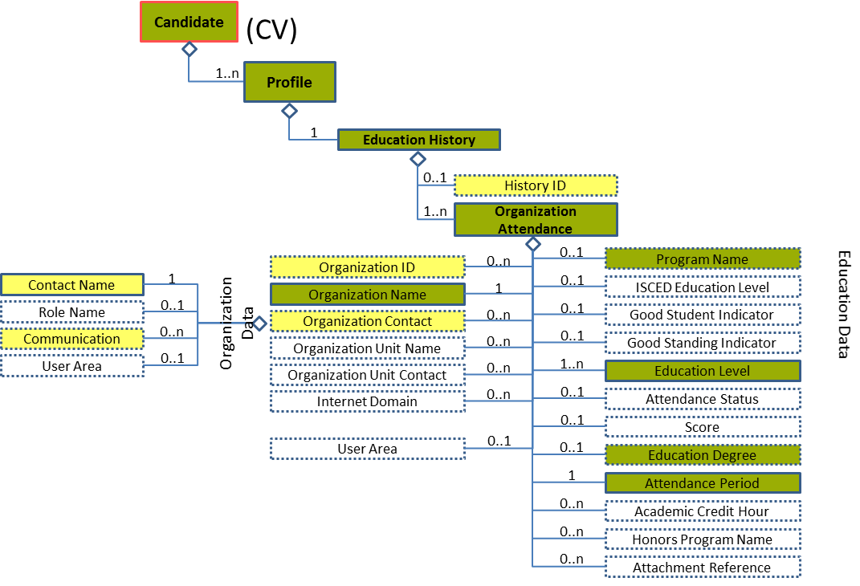
Figure 64: Organization Contact Level 4 Entity Diagram
Element | Description | Layer /  Cardinality |  | Rule | Examples
Organization Contact | The Educational Organisation’s contact data |  | EURES Optional  /  0..n | N/A | N/A
Sub-elements
The same as “4.16.4 Sub-element: /Employer History/Organization Contact (level 4)”

Organization Contact Attributes
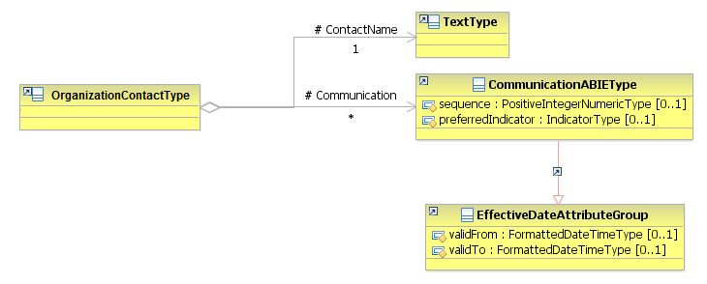
Figure 65: Organization Contact Attributes Schema
Attributes | Description | Card. | Rule
The same as “4.16.4.2 Organization Contact Attributes”

/Profile/Qualifications (level 2)

Qualifications Element Description
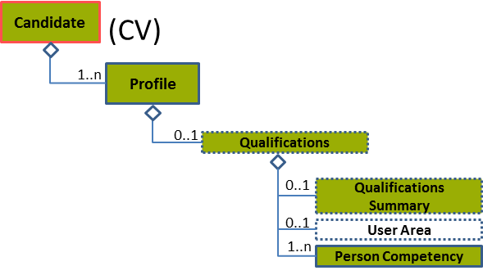
Figure 66: Qualifications Level 2 Entity Diagram
Element | Description | Layer /  Cardinality |  | Rule | Examples
Qualifications | Information related to matching capacities, knowledge, skills, abilities, awards and other resource deployment-related characteristics (including “competencies”) offered by a candidate |  | EURES Conformant Optional  /  0..1 | N/A | N/A
Sub-elements
Qualifications Summary | In the context of resumes, a "qualifications summary" is a paragraph or listing to "showcase" a candidate's most compelling skills and experience. In this context, the "qualifications summary" may be persuasive or have self-marketing content versus a "formal recognition of achievement or competence". In other words, use of term "qualifications" sometimes encompasses both qualifications asserted or claimed as well as those that have been formally recognised by an "awarding organisation." It is used in the context of recruiting and staffing as a container of information related to matching knowledge, skills, abilities, and other resource deployment-related characteristics (including "competencies") offered by a candidate and/or requested by a potential employer or customer. |  | EURES Conformant Optional  /  0..1 | N/A | “Qualification summary”, etc.
Person Competency | A specified person competency is a skill within the context of a personal record (profile, appraisal and assessment) that is assessed or asserted at a specified level of proficiency. |  | EURES Conformant  /  1..n |  | N/A
 | See section “4.14.3 Sub-element: /Person Competency (level 3)” for more information

Qualifications Attributes
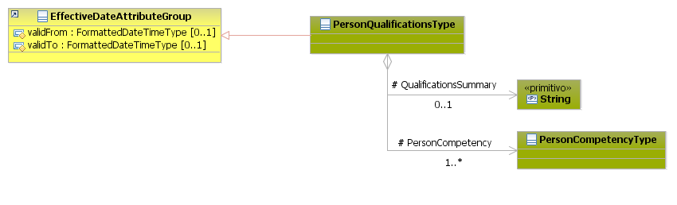
Figure 67: Qualifications Attributes Schema
Attributes | Description | Card. | Rule
validFrom | Validity start date for this entity’s information | 0..1 | BR-COM-06: Compulsory Date Format is: YYYY-MM-DD, YYYY-MM, YYYY or YYYY-MM-DDThh:mm:ss.
validTo | Validity end date for this entity’s information | 0..1 | BR-COM-06: Compulsory Date Format is: YYYY-MM-DD, YYYY-MM, YYYY or YYYY-MM-DDThh:mm:ss.
QualificationsSummary sub-element
Attributes | Description | Card. | Rule
This sub-element has no attributes.
PersonCompetency sub-element
Attributes | Description | Card. | Rule
See section “4.14.3.2 Person Competency Attributes” for more information

Sub-element: /Person Competency (level 3)

Person Competency Element Description
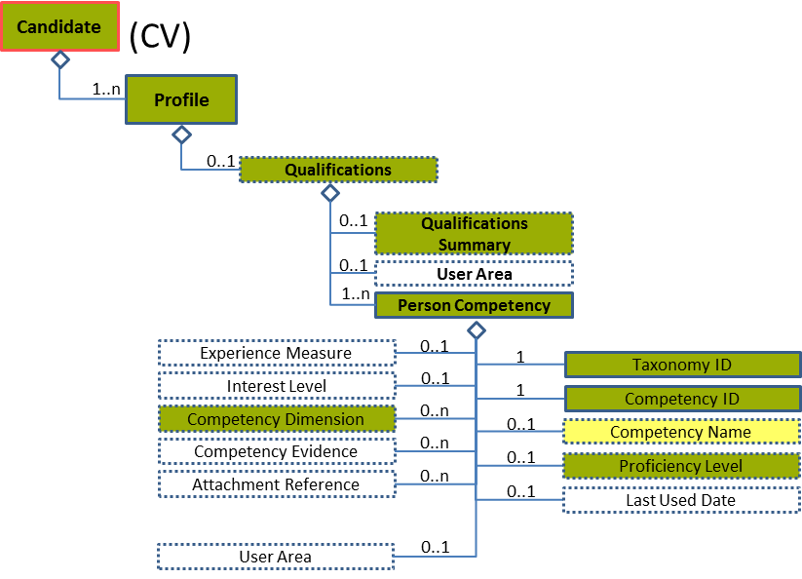
Figure 68: Person Competency Level 3 Entity Diagram
Element | Description | Layer /  Cardinality |  | Rule | Examples
Person Competency | A specified person competency is a skill within the context of a personal record (profile, appraisal and assessment) that is assessed or asserted at specified level of proficiency. |  | EURES Conformant  /  1..n | N/A | N/A
Sub-elements
Competency ID | Unique identifier for a skill or competency that depends on the taxonomy used.  Taxonomy information is included in the ID attributes. |  | EURES Conformant  /  1 | BR-COM-46: Compulsory use of Language Code [CL24], based on ISO-639-1:2002 Alpha 2 (ISO), if TaxonomyID’s value is “language”. Or the Skills and Competences Codes defined by ESCO, if TaxonomyID’s value is “other”. | “EN”, “FR”, etc.  Full code list: “4.28.17 Language Codes [CL24]”  Or,  “Aircraft Assembly”, “Aircraft Elecronics”, etc.  Full code list: “4.28.35 Skills and Competences Codes [CL58]”
Taxonomy ID | Unique identifier for the type of competency. |  | EURES Conformant  /  1 | BR-COM-54: TaxonomyID’s value should be “language” if the CompetencyID is a language or “other”, in the other competencies | “language”, “other”
Competency Name | A legible, descriptive name for a given competency |  | EURES Optional  /  0..1 | N/A | “English-Language”, “Social skills”, etc.
Proficiency Level | The state or degree of mastery or adeptness obtained or achieved for a given competency. Proficiency levels are expressed as a score, a point scale, or a mark in a range of values. |  | EURES Conformant Optional  /  0..1 | N/A | N/A
 | See section “4.14.4 Sub-element: /Person Competency/Proficiency Level (level 4)” for more information
Competency Dimension | A measurable characteristic of a competency |  | EURES Conformant Optional  /  0..n | N/A | N/A
 | See section “4.14.5 Sub-element: /Person Competency/Competency Dimension (level 4)” for more information

Person Competency Attributes
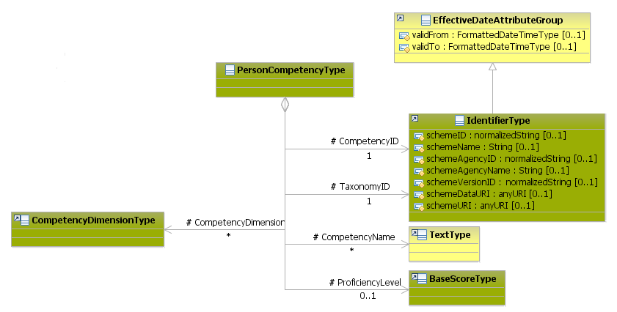
Figure 69: Person Competency Attributes Schema
Attributes | Description | Card. | Rule
This element has no attributes.
CompetencyID sub-element
Attributes | Description | Card. | Rule
schemeID | Identification of the identifier scheme | 0..1
schemeName | The identification scheme name | 0..1
schemeAgencyID | Identification of the agency that maintains the scheme | 0..1
schemeAgencyName | The name of the agency that maintains the scheme | 0..1
schemeVersionID | The identification scheme version | 0..1
schemeDataURI | The Uniform Resource Identifier that identifies where the data scheme is located | 0..1
schemeURI | The Uniform Resource Identifier that identifies where the scheme is located | 0..1
validFrom | Validity start date for this entity’s information | 0..1 | BR-COM-06: Compulsory Date Format is: YYYY-MM-DD, YYYY-MM, YYYY or YYYY-MM-DDThh:mm:ss.
validTo | Validity end date for this entity’s information | 0..1 | BR-COM-06: Compulsory Date Format is: YYYY-MM-DD, YYYY-MM, YYYY or YYYY-MM-DDThh:mm:ss.
TaxonomyID sub-elements
Attributes | Description | Card. | Rule
schemeID | Identification of the identifier scheme | 0..1 | N/A
schemeName | The identification scheme name | 0..1 | N/A
schemeAgencyID | Identification of the agency that maintains the scheme | 0..1 | N/A
schemeAgencyName | The name of the agency that maintains the scheme | 0..1 | N/A
schemeVersionID | The identification scheme version | 0..1 | N/A
schemeDataURI | The Uniform Resource Identifier that identifies where the data scheme is located | 0..1 | N/A
schemeURI | The Uniform Resource Identifier that identifies where the scheme is located | 0..1 | N/A
validFrom | Validity start date for this entity’s information | 0..1 | BR-COM-06: Compulsory Date Format is: YYYY-MM-DD, YYYY-MM, YYYY or YYYY-MM-DDThh:mm:ss.
validTo | Validity end date for this entity’s information | 0..1 | BR-COM-06: Compulsory Date Format is: YYYY-MM-DD, YYYY-MM, YYYY or YYYY-MM-DDThh:mm:ss.
CompetencyName sub-element
Attributes | Description | Card. | Rule
This sub-element has no attributes.
ProficiencyLevel sub-element
Attributes | Description | Card. | Rule
See section “4.14.4.2 Proficiency Level Attributes” for more information
CompetencyDimension sub-element
Attributes | Description | Card. | Rule
See section “4.14.5.2 Competency Dimension Attributes” for more information

Person Competency Examples
This is an example of how to add language skills. In this case, it adds French language skills, as defined by CEFR, with the proficiency level:
<Candidate xmlns="http://www.hr-xml.org/3" xsi:schemaLocation="http://www.hr-xml.org/3 ../Developer/Nouns/Candidate.xsd" >
<CandidateProfile languageCode="en">
<PersonQualifications>
<PersonCompetency>
<CompetencyID schemeID="ISO-639-1/2-Languages" schemeAgencyID="ISO" schemeAgencyName="ISO" schemeVersionID="639-1:2002 Alpha 2" schemeDataURI="http://www.loc.gov">EN</CompetencyID>

<TaxonomyID>language</TaxonomyID>

<CompetencyName>French</CompetencyName>

<ProficiencyLevel>
<ScoreText>A2</ScoreText>
</ProficiencyLevel>

<!—CompetencyDimension element may be filled in too. See the description of this element. -->
</PersonCompetency>
</PersonQualifications>
</CandidateProfile>
</Candidate>

This is an example of how to add other skills. In this case, it adds the Problems Management skill and is defined by a national agency.
The elements to define non-language skills are CompetencyID (it identifies the skills) and TaxonomyID (it identifies that it is a non-language skill):
<Candidate xmlns="http://www.hr-xml.org/3" xsi:schemaLocation="http://www.hr-xml.org/3 ../Developer/Nouns/Candidate.xsd" >
<CandidateProfile languageCode="en">
<PersonQualifications>
<PersonCompetency>
<CompetencyID schemeID="Identifier of schema" schemeAgencyID="Identifier of the agency" schemeAgencyName="Name of the agency" schemeVersionID="Version of the schema" schemeDataURI="URL">Problems Management</CompetencyID>
<TaxonomyID>other</TaxonomyID>

<CompetencyName>Problems Management </CompetencyName>

</PersonCompetency>
</PersonQualifications>
</CandidateProfile>
</Candidate>

Sub-element: /Person Competency/Proficiency Level (level 4)

Proficiency Level Element Description
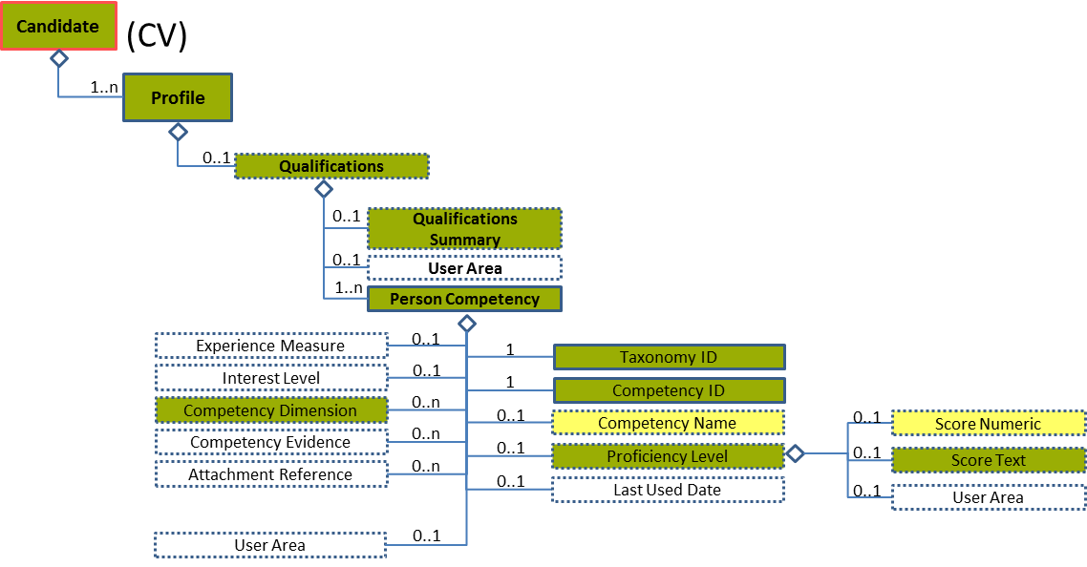
Figure 70: Proficiency Level Level 4 Entity Diagram
Element | Description | Layer /  Cardinality |  |  | Rule | Examples
Proficiency Level | The state or degree of mastery or adeptness obtained or achieved for a given competency. A proficiency level is expressed as a score a point scale or a mark among range of values. |  | EURES Conformant Optional  /  0..1 |  | BR-COM-49: If “CompetencyDimension / TypeCode” is specified, “ProficiencyLevel” is mandatory. | N/A
Sub-elements
Score Numeric | A numerical record of the marks allotted to individuals in the measurement of abilities, capacity to learn, personality assessment, or in other measurable characteristics (e.g. credit worthiness), including a set of attributes to identify the scoring scheme and its characteristics |  | EURES Optional  /  0..1 | N/A |  | “1”, “2”, “3”, etc.
Score Text | A non-numerical or text representation of a score. A record of the marks allotted to an individual in measuring his/her abilities, capacity to learn, personality assessment, or in other measurable characteristics (e.g., credit worthiness). It represents either the total number of points awarded, or a general standard achieved, including a set of attributes to identify the scoring scheme |  | EURES Conformant Optional  /  0..1 | BR-COM-47: Compulsory use of Language Proficiency Codes [CL25], if TaxonomyID’s value is “language”. |  | “A1”, “A2”, “B1”, etc.  Full code list: “4.28.18 Language Proficiency Codes [CL25]”

Proficiency Level Attributes
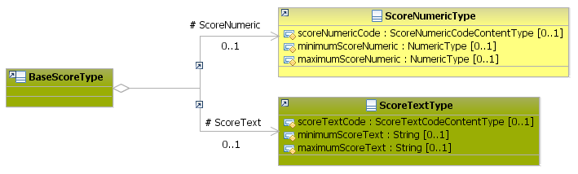
Figure 71: Proficiency Level Attributes Schema
Attributes | Description | Card. | Rule
This element has no attributes.
ScoreText sub-element
Attributes | Description | Card. | Rule
scoreTextCode | The score text | 0..1 | N/A
minimumScoreText | The minimum score | 0..1 | N/A
maximumScoreText | The maximum score | 0..1 | N/A
ScoreNumeric sub-element
Attributes | Description | Card. | Rule
scoreNumericCode | The numeric type of scoring scheme | 0..1 | N/A
minimumScoreNumeric | The minimum score | 0..1 | N/A
maximumScoreNumeric | The maximum score | 0..1 | N/A

Proficiency Level Examples
This example shows how to fill in the score as a text with CEFR taxonomy, where the minimum value is Basic User and the maximum Proficient User.
<Candidate xmlns="http://www.hr-xml.org/3" xsi:schemaLocation="http://www.hr-xml.org/3 ../Developer/Nouns/Candidate.xsd" >
<CandidateProfile languageCode="en">
<PersonQualifications>
<PersonCompetency>
<CompetencyID schemeID="ISO-639-1/2-Languages" schemeAgencyID="ISO" schemeAgencyName="ISO" schemeVersionID="639-1:2002 Alpha 2" schemeDataURI="http://www.loc.gov">EN</CompetencyID>

<TaxonomyID>language</TaxonomyID>

<ProficiencyLevel>
<ScoreText>A2</ScoreText>
</ProficiencyLevel>
</PersonCompetency>
<PersonQualifications>
</CandidateProfile>
<Candidate/>

Sub-element: /Person Competency/Competency Dimension (level 4)

Competency Dimension Element Description
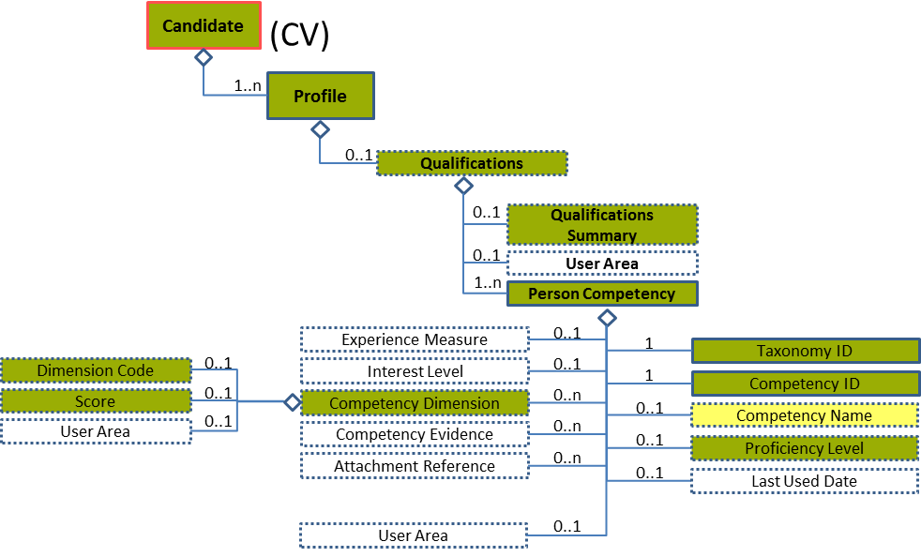
Figure 72: Competency Dimension Level 4 Entity Diagram
Element | Description | Layer /  Cardinality |  | Rule | Examples
Competency Dimension | A measurable characteristic of a skill or competency |  | EURES Conformant Optional  /  0..n | Only used for language skills  BR-COM-48: If "CompetencyDimension" element is specified, "TypeCode" and "Score" are mandatory elements.  BR-COM-49: If “CompetencyDimension / TypeCode” is specified, “ProficiencyLevel” is mandatory. | N/A
Sub-elements
Dimension Code | A code classifying the type of competency dimension described |  | EURES Conformant Optional  /  0..1 | BR-COM-37: Compulsory use of the “EURES_Dimension-CodeList.gc” list defined by EURES. This is based on CEFR, if TaxonomyID’s value is “language”.  BR-COM-55: Compulsory use of the attributes “listVersionID”, “listName” and “listURI”. | “CEF-Understanding-Reading”, “CEF-Understanding-Listening”, etc.  Full code list: “4.28.9 Dimension Codes [CL11] ”
Score | Details regarding the student's scores at a specific dimension |  | EURES Conformant Optional  /  0..1 | N/A | N/A
 | See section “4.14.6 Sub-element: /Person Competency/Competency Dimension/Score (level 5)” for more information

Competency Dimension Attributes
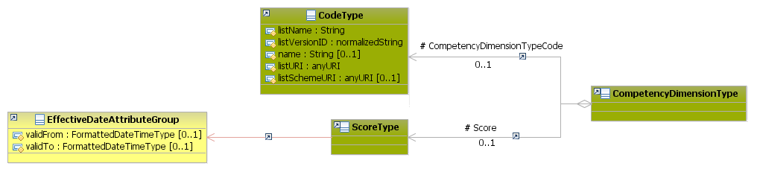
Figure 73: Competency Dimension Attributes Schema
Attributes | Description | Card. | Rule
This element has no attributes.
CompetencyDimensionTypeCode sub-element
Attributes | Description | Card. | Rule
listName | The code list name | 1 | N/A
listVersionID | The code list identification | 1 | N/A
name | The text equivalent of the code content component | 0..1 | N/A
language | The language of the text | 1 | N/A
listURI | The Uniform Resource Identifier that identifies where the code list is located | 1 | N/A
listSchemeURI | The Uniform Resource Identifier that identifies where the code list scheme is located | 0..1 | N/A
Score sub-element
Attributes | Description | Card. | Rule
See section “4.14.6.2 Score Attributes” for more information

Competency Dimension Examples
This example shows how to fill in the dimensions of language skills.
<Candidate xmlns="http://www.hr-xml.org/3" xsi:schemaLocation="http://www.hr-xml.org/3 ../Developer/Nouns/Candidate.xsd" >
<CandidateProfile languageCode="en">
<PersonQualifications>
<PersonCompetency>
<CompetencyID schemeID="ISO-639-1/2-Languages" schemeAgencyID="ISO" schemeAgencyName="ISO" schemeVersionID="639-1:2002 Alpha 2" schemeDataURI="http://www.loc.gov">EN</CompetencyID>

<TaxonomyID>language</TaxonomyID>

<CompetencyDimension>
<CompetencyDimensionTypeCode listName="EURES_Dimension" listVersionID="1.0" name="Understanding listening" listURI="http://www.coe.int">CEF-Understanding-Listening
</CompetencyDimensionTypeCode>
<Score>
<ScoreText>B1</ScoreText>
</Score>
</CompetencyDimension>
</PersonCompetency>
<PersonQualifications>
</CandidateProfile>
<Candidate/>

Sub-element: /Person Competency/Competency Dimension/Score (level 5)

Score Element Description
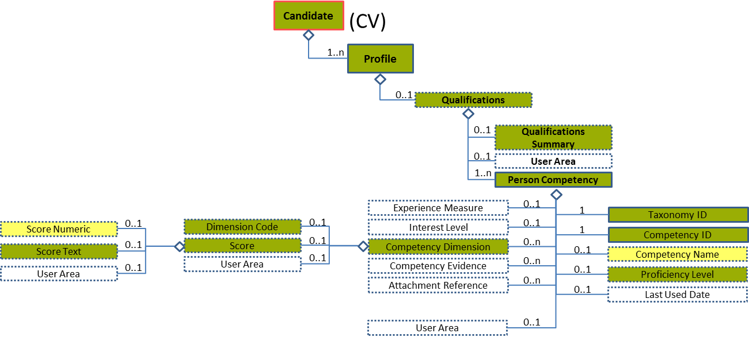
Figure 74: Score Level 4 Entity Diagram
Element | Description | Layer /  Cardinality |  | Rule | Examples
Score | Details regarding the student's scores at a specific dimension |  | EURES Conformant Optional  /  0..1 | N/A | N/A
Sub-elements
The same as “4.14.4.1 Proficiency Level Element Description”

Score Attributes
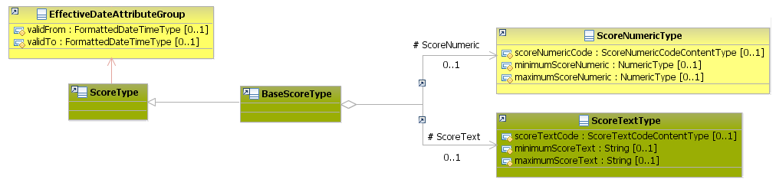
Figure 75: Score Attributes Schema
Attributes | Description | Card. | Rule
This element has no attributes.
Sub-elements
Attributes | Description | Card. | Rule
The same as "4.14.4.2 Proficiency Level Attributes”

/Profile/Experience Summary (level 2)

Experience Summary Element Description
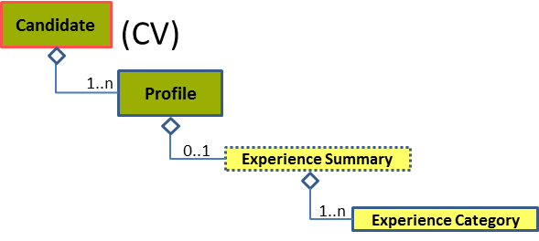
Figure 76: Experience Summary Level 2 Entity Diagram
Element | Description | Layer /  Cardinality |  | Rule | Examples
Experience Summary | Narrative summary of the person and of his/her competencies, normally used as the CV presentation |  | EURES Optional  /  0..1 | N/A | N/A
Sub-elements
Experience Category | This is intended as a fielded summary of qualifications. It can be used as a "roll-up" of data within the candidate history and experience components. |  | EURES Conformant  /  1..n | N/A | N/A
 | See section “4.15.3 Sub-element: /Experience Category (level 3)” for more information

Experience Summary Attributes
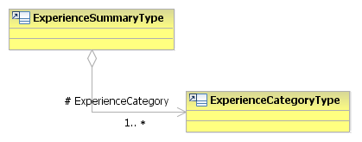
Figure 77: Experience Summary Attributes Schema
Attributes | Description | Card. | Rule
This element has no attributes.
Experience Category sub-element
Attributes | Description | Card. | Rule
See section “4.15.3.2 Experience Category Attributes” for more information

Sub-element: /Experience Category (level 3)

Experience Category Element Description
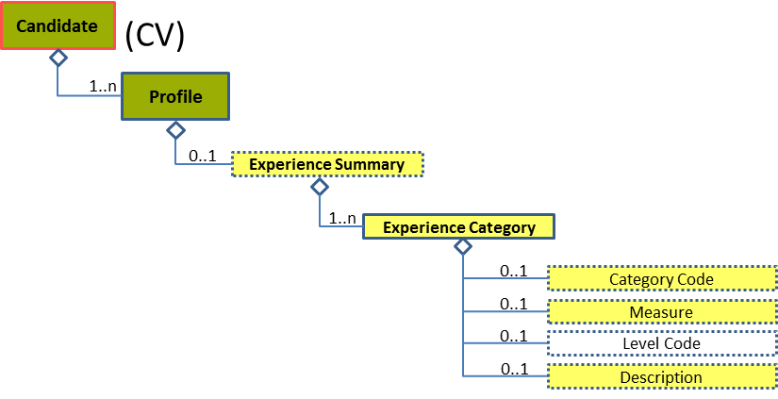
Figure 78: Category Level 3 Entity Diagram
Element | Description | Layer /  Cardinality |  | Rule | Examples
Experience Category | This is intended as a fielded summary of qualifications. It can be used as a "roll-up" of data within the candidate history and experience components. |  | EURES Optional  /  1..n | N/A | N/A
Sub-elements
Category Code | A code classifying the job type or category. This may be used for occupational classification of the job. The JobCategoryCode will usually be repeatable so that a single job can be classified across multiple dimensions.  The JobCategoryCode can be used to classify the job by industry, but note that an explicit IndustryCode is available in contexts such as PositionOrganizationDetails. |  | EURES Optional  /  0..1 | BR-COM-29: Compulsory use of the “ISCO2008-CodeList.gc” list defined by EURES and based on ISCO-08. Alternatively, use of ESCO Occupations – version 1.0.  BR-COM-55: Compulsory use of the attributes “listVersionID”, “listName” and “listURI”. | “1” – Managers,  “12” – Administrative, etc.  Full code list: “4.28.16 Job Category Codes [CL20]”
Measure | Code indicating the period of time, measured in years or months of experience |  | EURES Optional  /  0..1 | N/A | 5, 3, etc.
Description | Description of the category |  | EURES Optional  /  0..1 | N/A | “Years of Financial Industry Management Experience”, etc.

Experience Category Attributes
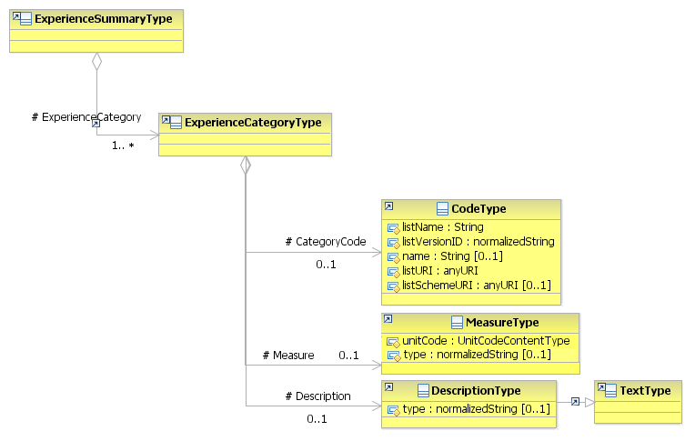
Figure 79: Experience Category Attributes Schema
Attributes | Description | Card. | Rule
This element as no attributes.
CategoryCode sub-element
Attributes | Description | Card. | Rule
listName | The code list name | 0..1 | N/A
listVersionID | The code list identification | 0..1 | N/A
name | The text equivalent of the code content component | 0..1 | N/A
listURI | The Uniform Resource Identifier that identifies where the code list is located | 0..1 | N/A
listSchemeURI | The Uniform Resource Identifier that identifies where the code list scheme is located | 0..1 | N/A
Measure sub-element
Attributes | Description | Card. | Rule
unitCode | Code indicating the type of unit measure, such as “minutes” or “hours” (full code list “4.28.37 Unit Codes [CL54]”) | 1 | BR-COM-36: Compulsory use of the Unit Codes [CL54].
type | The description type | 0..1 | N/A
Description sub-element
Attributes | Description | Card. | Rule
type | The description type | 0..1 | N/A

/Profile/Employment History (level 2)

Employment History Element Description
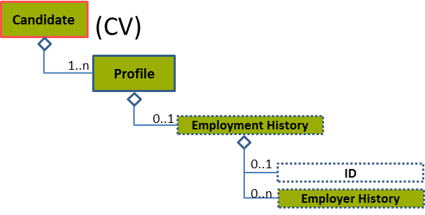
Figure 80: Employment History Level 2 Entity Diagram
Element | Description | Layer /  Cardinality |  | Rule | Examples
Employment History | The prior and current details of a person’s employment, work, or relevant experience as they would be reported in a professional profile, CV, resume, employment application, or similar document |  | EURES Conformant Optional  /  0..1 | N/A | N/A
Sub-elements
Employer History | Details regarding a person's tenure while working for an employer |  | EURES Conformant Optional  /  0..n | N/A | N/A
 | See section “4.16.3 Sub-element: /Employer History (level 3)” for more information

Employment History Attributes
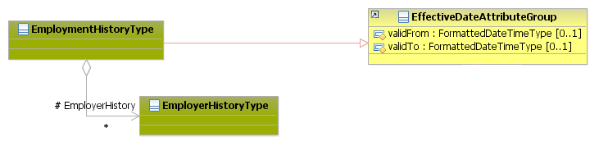
Figure 81: Employment History Attributes Schema
Attributes | Description | Card. | Rule
validFrom | Validity start date for this entity’s information | 0..1 | BR-COM-06: Compulsory Date Format is: YYYY-MM-DD, YYYY-MM, YYYY or YYYY-MM-DDThh:mm:ss.
validTo | Validity end date for this entity’s information | 0..1 | BR-COM-06: Compulsory Date Format is: YYYY-MM-DD, YYYY-MM, YYYY or YYYY-MM-DDThh:mm:ss.
EmployerHistory sub-element
Attributes | Description | Card. | Rule
See section “4.16.3.2 Employer History Attributes” for more information

Sub-element: /Employer History (level 3)

Employer History Element Description
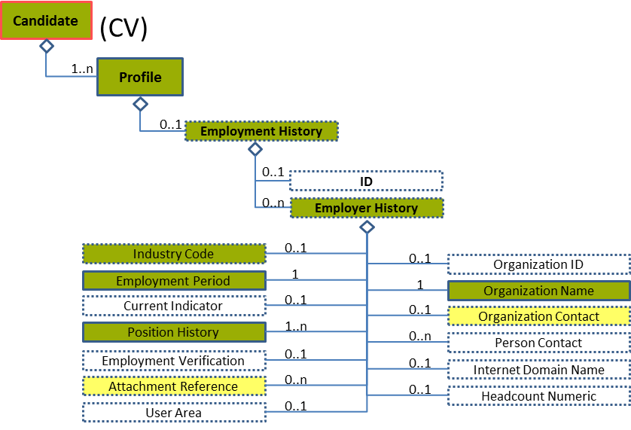
Figure 82: Employer History Level 3 Entity Diagram
Element | Description | Layer /  Cardinality |  | Rule | Examples
Employer History | Details about a person's tenure while working for an employer.  This element is optional as there could be candidates without work experience.  If it is not filled out, it means that the candidate does not have work experience, or he/she does not want to fill it out. |  | EURES Conformant Optional  /  0..n | N/A | N/A
Sub-elements
Organization Name | Usually an official or legal name by which to refer to an organisation |  | EURES Conformant  /  1 | N/A | “Wellness Healthcare”, “Police Department”, etc.
Organization Contact | An Organisation’s contact information |  | EURES Optional  /  0..1 | N/A | N/A
 | See section “4.16.4 Sub-element: /Employer History/Organization Contact (level 4)” for more information
Industry Code | A code classifying the industry of the related organisation, position, or other entity. |  | EURES Conformant Optional  /  0..1 | BR-COM-20: Compulsory use of the “NACE-CodeList.gc” list defined by EURES. This is based on EU NACE. | “01” = Agriculture,  “02” = Forestry, etc.  Full code list: “4.28.20 NACE Codes [CL31] ”
Employment Period | Provides flexible options for representing employment period data |  | EURES Conformant  /  1 | N/A | N/A
 | See section “4.16.5 Sub-element: /Employer History/Employment Period (level 4)” for more information
Position History | Details about the person’s tenure within the position |  | EURES Conformant  /  1..n | N/A | N/A
 | See section “4.16.8 Sub-element: /Employer History/Position History (level 4)” for more information
Attachment Reference | Reference to external documents attached |  | EURES Optional  /  0..n | N/A | N/A
 | See section “4.16.14 Sub-element: /Employer History/Attachment Reference (level 4)” for more information

Employer History Attributes
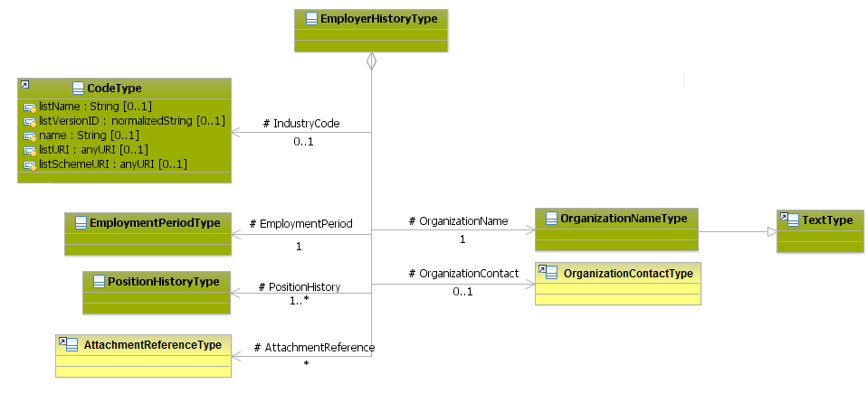
Figure 83: Employer History Attributes Schema
Attributes | Description | Card. | Rule
This element has no attributes.
OrganizationName sub-element
Attributes | Description | Card. | Rule
This element has no attributes.
OrganizationContact sub-element
Attributes | Description | Card. | Rule
See section “4.16.4.2 Organization Contact Attributes” for more information
IndustryCode sub-element
Attributes | Description | Card. | Rule
listName | The code list name. | 0..1 | N/A
listVersionID | The code list identification. | 0..1 | N/A
name | The text equivalent of the code content component. | 0..1 | N/A
listURI | The Uniform Resource Identifier that identifies where the code list is located. | 0..1 | N/A
listSchemeURI | The Uniform Resource Identifier that identifies where the code list scheme is located. | 0..1 | N/A
EmploymentPeriod sub-element
Attributes | Description | Card. | Rule
See section “4.16.5.2 Employment Period Attributes” for more information
PositionHistory sub-element
Attributes | Description | Card. | Rule
See section “4.16.8.2 Position History Attributes” for more information
AttachmentReference sub-element
Attributes | Description | Card. | Rule
See section “4.16.14.2 Attachment Reference Attributes” for more information

Employer History Examples
This is an example of two job experiences for the same candidate.
<Candidate xmlns="http://www.hr-xml.org/3" xsi:schemaLocation="http://www.hr-xml.org/3 ../Developer/Nouns/Candidate.xsd" >
<CandidateProfile languageCode="en">
<EmploymentHistory>
<!-- Past job experience. -->
<EmployerHistory>
<OrganizationName>EIfEL</OrganizationName>
<OrganizationContact>
<ContactName>Richard Dubois</ContactName>
</OrganizationContact>

<IndustryCode listName="NACE_r2" name="Hospital activities" listURI="http://ec.europa.eu/esco/ConceptScheme/NACErev2/cs" listVersionID="" name="Computer programming activities">
86.1</IndustryCode>

<EmploymentPeriod>
<StartDate>
<FormattedDateTime>2008-06-01</FormattedDateTime>
</StartDate>
<EndDate>
<FormattedDateTime>2012-12-31</FormattedDateTime>
</EndDate>
</EmploymentPeriod>
</EmployerHistory>

<!-- Current job experience. -->
<EmployerHistory>
<OrganizationName>Wellness Healthcare</OrganizationName>
<OrganizationContact>
<ContactName>Richard Dubois</ContactName>
<Communication>
<ChannelCode>Web</ChannelCode>
<UseCode>Business</UseCode>
<oa:URI>fake-account@aol.es</oa:URI>
</Communication>
</OrganizationContact>

<IndustryCode listName="NACE_r2" listVersionID="" name="Human Health activities" listURI="http://ec.europa.eu/esco/ConceptScheme/NACErev2/cs" >86.9</IndustryCode>

<EmploymentPeriod>
<StartDate>
<FormattedDateTime>2013-01-15</FormattedDateTime>
</StartDate>
<CurrentIndicator>true</CurrentIndicator>
</EmploymentPeriod>
</EmployerHistory>
</EmploymentHistory>
</CandidateProfile>
</Candidate>

Sub-element: /Employer History/Organization Contact (level 4)

Organization Contact Element Description
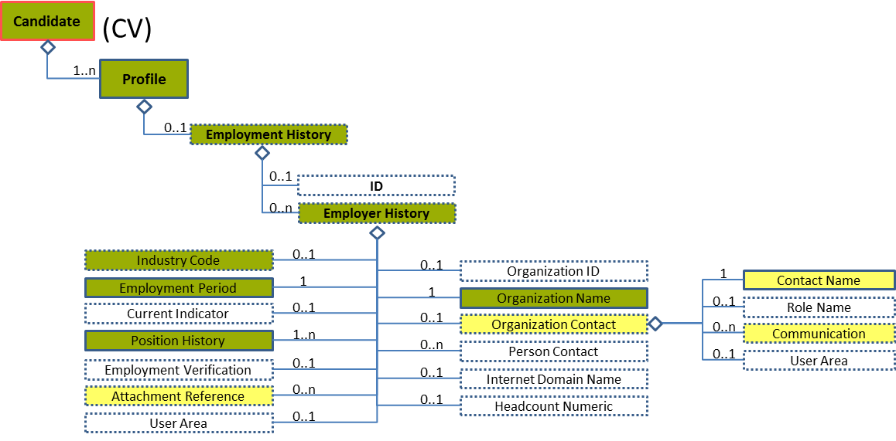
Figure 84: Organization Contact Level 4 Entity Diagram
Element | Description | Layer /  Cardinality |  | Rule | Examples
Organization Contact | Contact information for the organization |  | EURES Optional  /  0..1 | N/A | N/A
Sub-elements
Contact Name | Name of the organization’s contact person |  | EURES Optional  /  1 | N/A | “Lidia Smith”
Communication | Contact data of the organization’s contact person |  | EURES Optional  /  0..n | N/A | N/A
 | See section “4.9.1 Communication Element Description” for more information

Organization Contact Attributes
Figure 85: Organization Contact Attributes Schema
Attributes | Description | Card. | Rule
This element has no attributes.
ContactName sub-element
Attributes | Description | Card. | Rule
This sub-element has no attributes
Communication sub-element
Attributes | Description | Card. | Rule
See section “4.9.2 Communication Attributes” for more information

Sub-element: /Employer History/Employment Period (level 4)

Employment Period Element Description
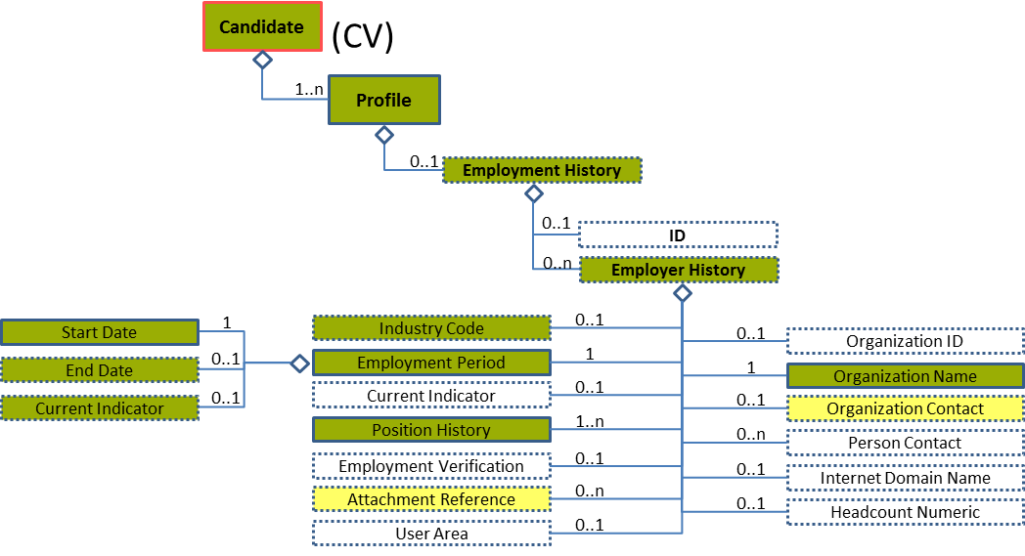
Figure 86: Employment Period Level 4 Entity Diagram
Element | Description | Layer /  Cardinality |  | Rule | Examples
Employment Period | Provides flexible options for representing employment period data |  | EURES Conformant  /  1 | N/A | N/A
Sub-elements
Start Date | A timestamp marking the beginning of employment period data |  | EURES Confromant  /  1 | N/A | N/A
 | See section “4.16.6 Sub-element: /Employer History/Employment Period/Start Date (level 5)” for more information
End Date | A timestamp marking the end of employment period data |  | EURES Conformant Optional  /  0..1 | N/A | N/A
 | See section “4.16.7 Sub-element: /Employer History/Employment Period/End Date (level 5)” for more information
Current Indicator | Indicates whether the position is currently held or if employment or other status was current when reported |  | EURES Conformant Optional  /  0..1 | N/A | “true” = The position is currently held  “false” = The position is not currently held

Employment Period Attributes
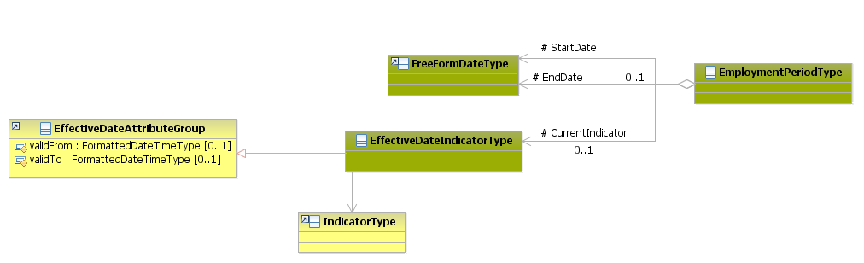
Figure 87: Employment Period Attributes Schema
Attributes | Description | Card. | Rule
This element has no attributes
StartDate sub-element
Attributes | Description | Card. | Rule
See section “4.16.6.2 Start Date Attributes” for more information
EndDate sub-element
Attributes | Description | Card. | Rule
See section “4.16.7.2 End Date Attributes” for more information
CurrentIndicator sub-element
Attributes | Description | Card. | Rule
validFrom | Validity start date for this entity’s information. | 0..1 | BR-COM-06: Compulsory Date Format is: YYYY-MM-DD, YYYY-MM, YYYY or YYYY-MM-DDThh:mm:ss.
validTo | Validity end date for this entity’s information. | 0..1 | BR-COM-06: Compulsory Date Format is: YYYY-MM-DD, YYYY-MM, YYYY or YYYY-MM-DDThh:mm:ss.

Sub-element: /Employer History/Employment Period/Start Date (level 5)

Start Date Element Description
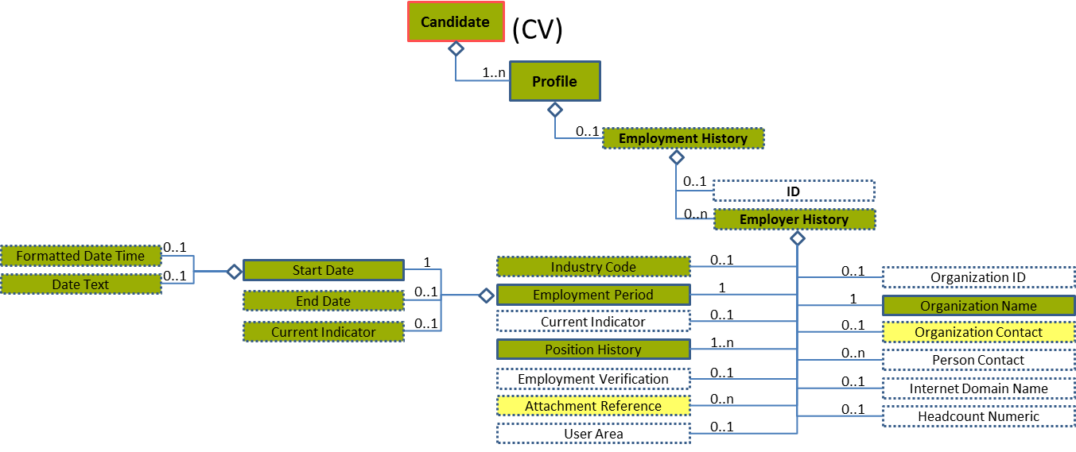
Figure 88: Start Date Level 5 Entity Diagram
Element | Description | Layer /  Cardinality |  | Rule | Examples
Start Date | A timestamp marking the beginning of the employment period data |  | EURES Conformant  /  1 | N/A | N/A
Sub-elements
The same as “4.13.8
Sub-element: /Organization Attendance/Attendance Period/Start Date (level 5)

”

Start Date Attributes
Figure 89: Start Date Attributes Schema
Attributes | Description | Card. | Rule
The same as “4.13.8.2 Start Date Attributes”

Sub-element: /Employer History/Employment Period/End Date (level 5)

End Date Element Description
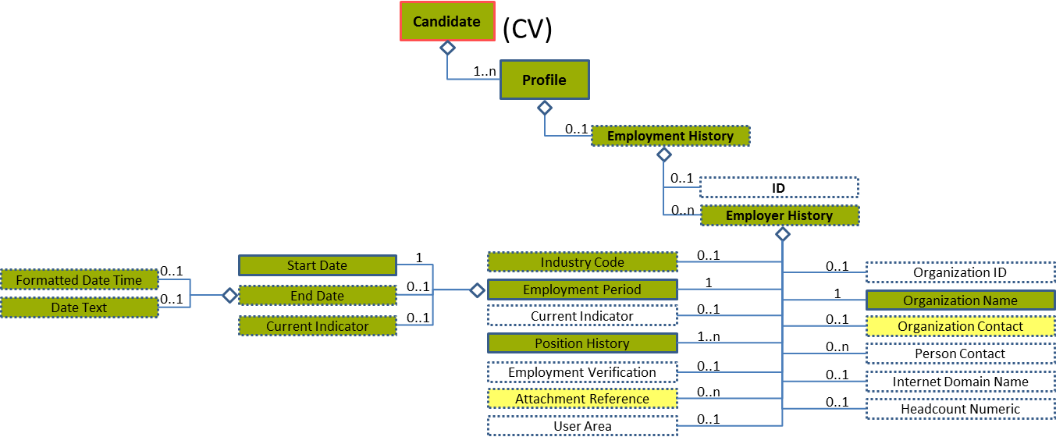
Figure 90: End Date Level 5 Entity Diagram
Element | Description | Layer /  Cardinality |  | Rule | Examples
End Date | A timestamp marking the end of the employment period data |  | EURES Conformant Optional  /  0..1 | N/A | N/A
Sub-elements
The same as “4.13.9 Sub-element: /Organization Attendance/Attendance Period/End Date (level 5)”

End Date Attributes
Figure 91: End Date Attributes Schema
Attributes | Description | Card. | Rule
The same as “4.13.8.2 Start Date Attributes”

Sub-element: /Employer History/Position History (level 4)

Position History Element Description
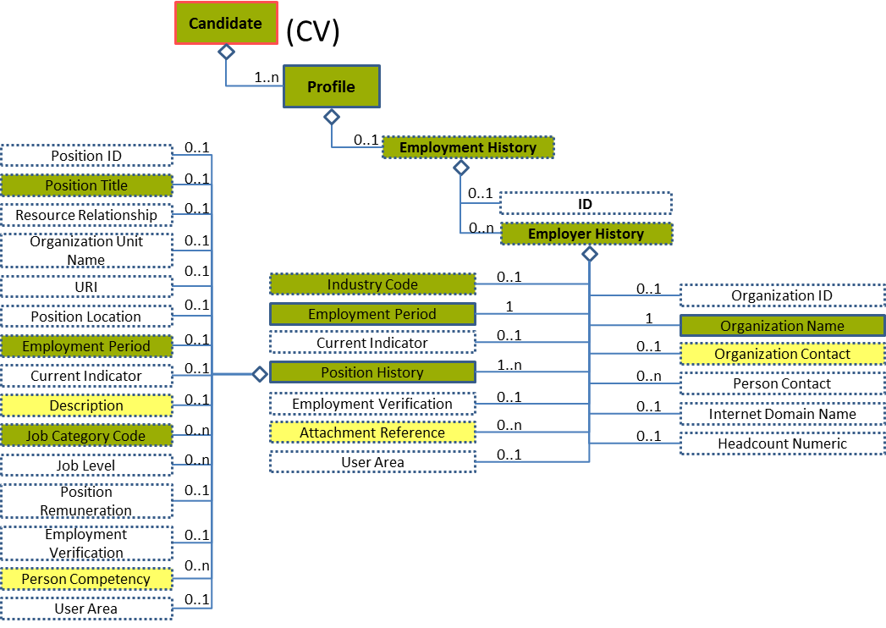
Figure 92: Position History Level 4 Entity Diagram
Element | Description | Layer /  Cardinality |  | Rule | Examples
Position History | The details about the person’s tenure within the position |  | EURES Conformant  /  1..n | N/A | N/A
Sub-elements
Position Title | A short phrase describing the position as it would be listed on a business card or in a company directory. OED: An appellation attached to a position in virtue of rank, function or office. |  | EURES Conformant Optional  /  0..1 | N/A | “President”, “Chief Executive Officer”, etc.
Employment Period | Provides flexible options for representing employment period data |  | EURES Conformant Optional  /  0..1 | N/A | N/A
 | See section “4.16.9 Sub-element: /Employer History/Position History/Employment Period (level 5)” for more information
Description | Description of the position |  | EURES Optional  /  0..1 | N/A | “Description of the position”, etc.
Job Category Code | A code classifying the job type or category. This may be used for occupational classification of the job. The JobCategoryCode will usually be repeatable so that a single job can be classified across multiple dimensions.  The JobCategoryCode can be used to classify the job by industry, but note that an explicit IndustryCode is available in contexts such as PositionOrganizationDetails. |  | EURES Conformant Optional  /  0..n | BR-COM-29: Compulsory use of the “ISCO2008-CodeList.gc” list defined by EURES and based on ISCO-08. Alternatively, use of ESCO Occupations – version 1.0.  BR-COM-44: One value for each code list is allowed.  BR-COM-55: Compulsory use of the attributes “listVersionID”, “listName” and “listURI”. | “1” – Managers,  “12” – Administrative, etc.  Full code list: “4.28.16 Job Category Codes [CL20] ”
Person Competency | A specified person competency is a skill within the context of a personal record (profile, appraisal and assessment) that is assessed or asserted at specified level of proficiency. |  | EURES Optional  /  0..n | N/A | N/A
 | See section “4.16.10 Sub-element: /Employer History/Position History/Person Competency (level 5)” for more information

Position History Attributes
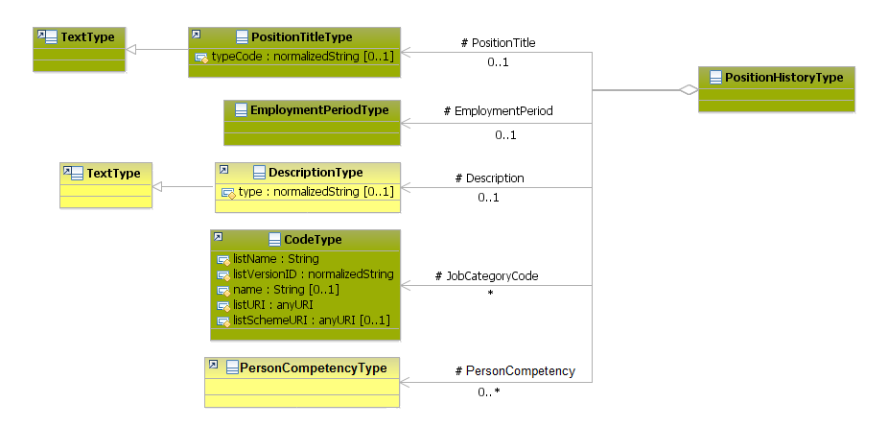
Figure 93: PositionHistory Attributes Schema
Attributes | Description | Card. | Rule
This element has no attributes
PositionTitle sub-element
Attributes | Description | Card. | Rule
typeCode | The type of the date text | 0..1 | N/A
EmploymentPeriod sub-element
Attributes | Description | Card. | Rule
See section “4.16.9.2 Employment Period Attributes” for more information
Description sub-element
Attributes | Description | Card. | Rule
type | The comment type | 0..1 | N/A
JobCategoryCode sub-element
Attributes | Description | Card. | Rule
listName | The code list name. | 1 | N/A
listVersionID | The code list identification. | 1 | N/A
name | The text equivalent of the code content component. | 0..1 | N/A
listURI | The Uniform Resource Identifier that identifies where the code list is located. | 1 | N/A
listSchemeURI | The Uniform Resource Identifier that identifies where the code list scheme is located. | 0..1 | N/A
PersonCompetency sub-element
Attributes | Description | Card. | Rule
See section “4.16.10.2 Person Competency Attributes” for more information

Position History Examples
This is an example of two different positions for the same job experience.
<Candidate xmlns="http://www.hr-xml.org/3" xsi:schemaLocation="http://www.hr-xml.org/3 ../Developer/Nouns/Candidate.xsd" >
<CandidateProfile languageCode="en">
<EmploymentHistory>
<!-- Current job experience. -->
<EmployerHistory>
<OrganizationName>Wellness Healthcare</OrganizationName>
<OrganizationContact>
<ContactName>Richard Dubois</ContactName>
<Communication>
<ChannelCode>Web</ChannelCode>
<UseCode>Business</UseCode>
<oa:URI>fake-account@aol.es</oa:URI>
</Communication>
</OrganizationContact>
<IndustryCode listName="NACE_r2" listVersionID="PENDING" name="Human Health activities" listURI="http://ec.europa.eu/esco/ConceptScheme/NACErev2/cs" >86.9</IndustryCode>
<EmploymentPeriod>
<StartDate>
<FormattedDateTime>2013-01-15</FormattedDateTime>
</StartDate>
<CurrentIndicator>true</CurrentIndicator>
</EmploymentPeriod>

<!-- Old position -->
<PositionHistory>
<PositionTitle>Chief Technical Officer</PositionTitle>
<EmploymentPeriod>
<StartDate><FormattedDateTime>2008-01-06</FormattedDateTime></StartDate>
<EndDate><FormattedDateTime>2010-08-31</FormattedDateTime></EndDate>
</EmploymentPeriod>
<oa:Description>Determine, formulate, advise on and direct the implementation of policies of national, state, regional or local governments or communities, and of special interest organizations.</oa:Description>
<JobCategoryCode listName="ISCO2008" listVersionID="2008" name="Chief technical officer" listURI="http://ec.europa.eu/esco/ConceptScheme/ISCO2008"
>1111</JobCategoryCode>
</PositionHistory>

<!-- Current position -->
<PositionHistory>
<PositionTitle>Chief Technical Officer</PositionTitle>
<EmploymentPeriod>
<StartDate><FormattedDateTime>2010-09-01</FormattedDateTime></StartDate>
<CurrentIndicator>true</CurrentIndicator>
</EmploymentPeriod>
<oa:Description>Determine, formulate, advise on and direct the implementation of policies of national, state, regional or local governments or communities, and of special interest organizations.</oa:Description>
<JobCategoryCode listName="ISCO2008" listVersionID="2008" name="Chief technical officer" listURI="http://ec.europa.eu/esco/ConceptScheme/ISCO2008"
>1112</JobCategoryCode>
</PositionHistory>
</EmployerHistory>
</EmploymentHistory>
</CandidateProfile>
</Candidate>

Sub-element: /Employer History/Position History/Employment Period (level 5)

Employment Period Element Description
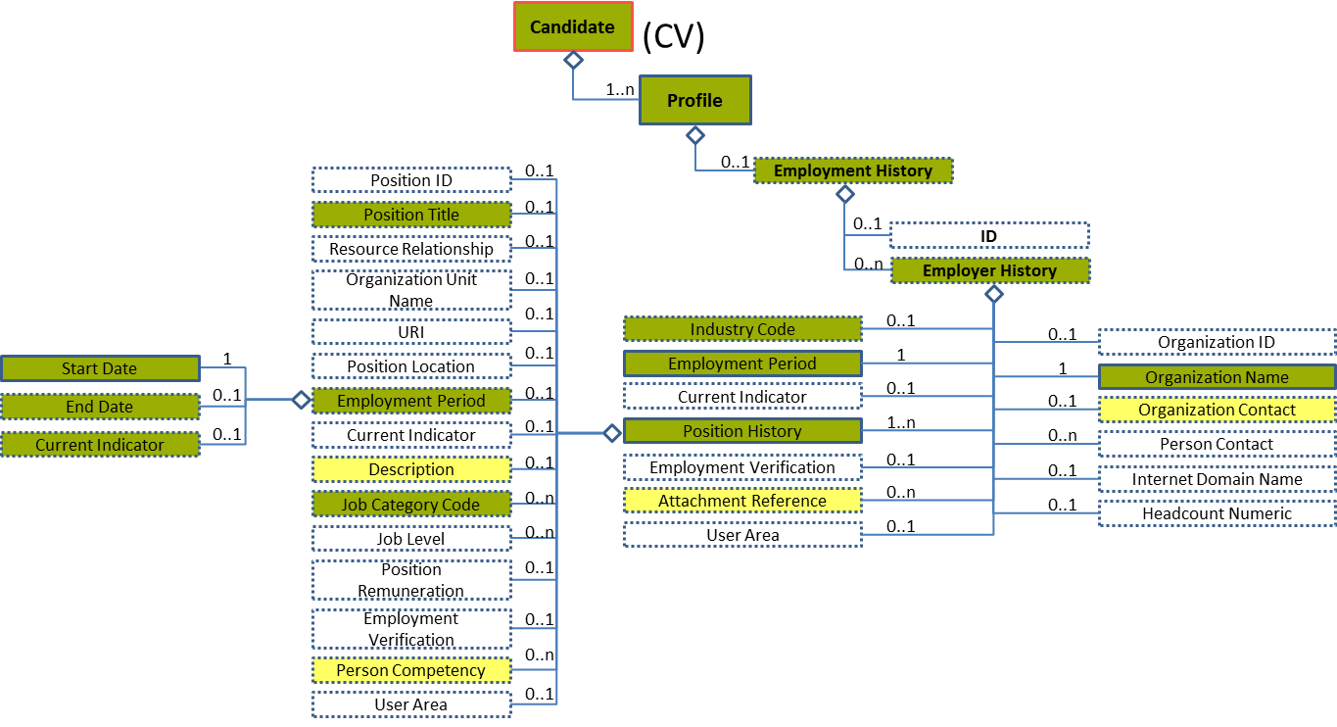
Figure 94: Employment Period Level 5 Entity Diagram
Element | Description | Layer /  Cardinality |  | Rule | Examples
Employment Period | Provides flexible options for representing employment period data |  | EURES Conformant Optional  /  0..1 | N/A | N/A
Sub-elements
The same as “4.16.5 Sub-element: /Employer History/Employment Period (level 4)”

Employment Period Attributes
Figure 95: Employment Period Attributes Schema
Attributes | Description | Card. | Rule
The same as “4.16.5.2 Employment Period Attributes”

Sub-element: /Employer History/Position History/Person Competency (level 5)

Person Competency Description
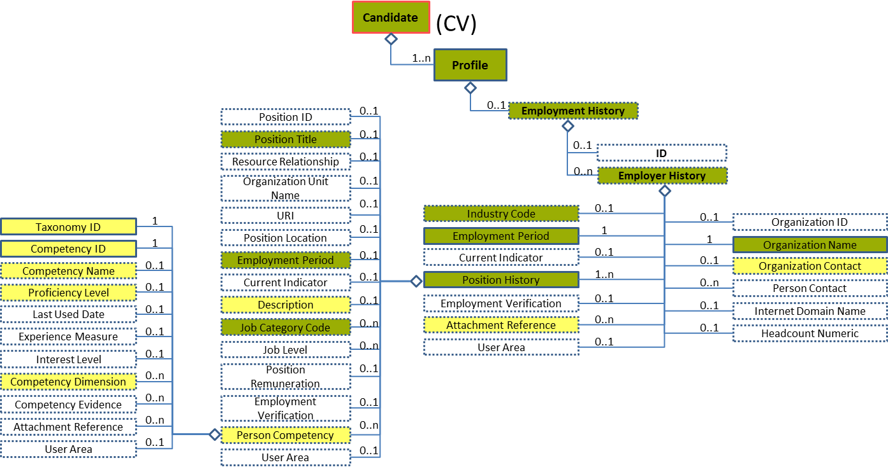
Figure 96: Person Competency Level 5 Entity Diagram
Element | Description | Layer /  Cardinality |  | Rule | Examples
Person Competency | A specified person competency is a skill within the context of a personal record (profile, appraisal and assessment) that is assessed or asserted at specified level of proficiency. |  | EURES Optional  /  0..n | N/A | N/A
Sub-elements
Competency ID | Unique identifier for a skill or competency that depends on the taxonomy used.  Taxonomy information is included in the ID attributes. |  | EURES Optional  /  1 | BR-COM-46: Compulsory use of Language Code [CL24], based on ISO-639-1:2002 Alpha 2 (ISO), if TaxonomyID’s value is “language”. Or the Skills and Competences Codes defined by ESCO, if TaxonomyID’s value is “other”. | “EN”, “FR”, etc.  Full code list: “4.28.17 Language Codes [CL24]”  Or,  “Aircraft Assembly”, “Aircraft Elecronics”, etc.  Full code list: “4.28.35 Skills and Competences Codes [CL58]”
Taxonomy ID | Unique identifier for the type of competency. |  | EURES Optional  /  1 | BR-COM-54: TaxonomyID’s value should be “language” if the CompetencyID is a language or “other”, in the other competencies. | “language”, “other”
Competency Name | A legible, descriptive name for a given competency |  | EURES Optional  /  0..1 | N/A | “English-Language”, “Social skills”, etc.
Proficiency Level | The state or degree of mastery or adeptness obtained or achieved for a given competency. Proficiency levels are expressed as a score, a point scale, or a mark in a range of values. |  | EURES Optional  /  0..1 | N/A | N/A
 | See section “4.16.11 Sub-element: /Employer History/Position History/Person Competency/Proficiency Level (level 6)” for more information
Competency Dimension | A measurable characteristic of a competency |  | EURES Optional  /  0..n | N/A | N/A
 | See section “4.16.12 Sub-element: /Employer History/Position History/Person Competency/Competency Dimension (level 6)” for more information

Person Competency Attributes
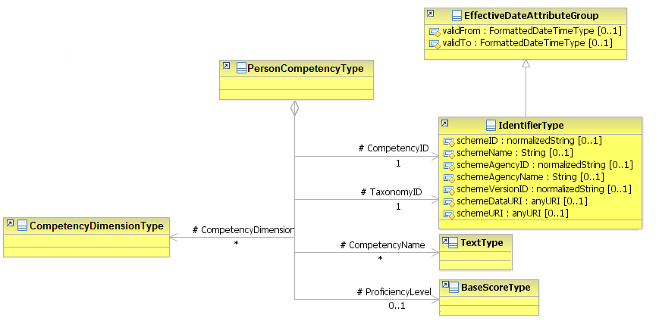
Figure 97: Person Competency Attributes Schema
Attributes | Description | Card. | Rule
This element has no attributes.
CompetencyID sub-element
Attributes | Description | Card. | Rule
schemeID | Identification of the identifier scheme | 0..1
schemeName | The identification scheme name | 0..1
schemeAgencyID | Identification of the agency that maintains the scheme | 0..1
schemeAgencyName | The name of the agency that maintains the scheme | 0..1
schemeVersionID | The identification scheme version | 0..1
schemeDataURI | The Uniform Resource Identifier that identifies where the data scheme is located | 0..1
schemeURI | The Uniform Resource Identifier that identifies where the scheme is located | 0..1
validFrom | Validity start date for this entity’s information | 0..1 | BR-COM-06: Compulsory Date Format is: YYYY-MM-DD, YYYY-MM, YYYY or YYYY-MM-DDThh:mm:ss.
validTo | Validity end date for this entity’s information | 0..1 | BR-COM-06: Compulsory Date Format is: YYYY-MM-DD, YYYY-MM, YYYY or YYYY-MM-DDThh:mm:ss.
TaxonomyID sub-elements
Attributes | Description | Card. | Rule
schemeID | Identification of the identifier scheme | 0..1 | N/A
schemeName | The identification scheme name | 0..1 | N/A
schemeAgencyID | Identification of the agency that maintains the scheme | 0..1 | N/A
schemeAgencyName | The name of the agency that maintains the scheme | 0..1 | N/A
schemeVersionID | The identification scheme version | 0..1 | N/A
schemeDataURI | The Uniform Resource Identifier that identifies where the data scheme is located | 0..1 | N/A
schemeURI | The Uniform Resource Identifier that identifies where the scheme is located | 0..1 | N/A
validFrom | Validity start date for this entity’s information | 0..1 | BR-COM-06: Compulsory Date Format is: YYYY-MM-DD, YYYY-MM, YYYY or YYYY-MM-DDThh:mm:ss.
validTo | Validity end date for this entity’s information | 0..1 | BR-COM-06: Compulsory Date Format is: YYYY-MM-DD, YYYY-MM, YYYY or YYYY-MM-DDThh:mm:ss.
CompetencyName sub-element
Attributes | Description | Card. | Rule
This sub-element has no attributes.
ProficiencyLevel sub-element
Attributes | Description | Card. | Rule
See section “4.16.11.2 Proficiency Level Attributes” for more information
CompetencyDimension sub-element
Attributes | Description | Card. | Rule
See section “4.16.12.2 Competency Dimension Attributes” for more information

Person Competency Examples
This is an example of how to add language skills into the Position History. In this case, it adds English language skills, as defined by CEFR, with the proficiency level and competency dimension:
<Candidate xmlns="http://www.hr-xml.org/3" xsi:schemaLocation="http://www.hr-xml.org/3 ../Developer/Nouns/Candidate.xsd" >
<CandidateProfile languageCode="en">
<EmploymentHistory>
<!-- Current job experience with the EURES conformant fields. -->
<EmployerHistory>
<OrganizationName>Wellness Healthcare</OrganizationName>

<EmploymentPeriod>
<StartDate>
<FormattedDateTime>2013-01-15</FormattedDateTime>
</StartDate>
<CurrentIndicator>true</CurrentIndicator>
</EmploymentPeriod>

<!-- Current position with the EURES conformant fields. -->
<PositionHistory>
<PersonCompetency>
<CompetencyID schemeID="ISO-639-1/2-Languages" schemeAgencyID="ISO" schemeAgencyName="ISO" schemeVersionID="639-1:2002 Alpha 2" schemeDataURI="http://www.loc.gov">EN</CompetencyID>

<TaxonomyID>language</TaxonomyID>

<CompetencyName>French</CompetencyName>

<ProficiencyLevel>
<ScoreText>A2</ScoreText>
</ProficiencyLevel>

<CompetencyDimension>
<CompetencyDimensionTypeCode listName="EURES_Dimension" listVersionID="1.0" name="Understanding listening" listURI="http://www.coe.int">CEF-Understanding-Listening
</CompetencyDimensionTypeCode>

<Score>
<ScoreText>B1</ScoreText>
</Score>
</CompetencyDimension>

</PersonCompetency>

</PositionHistory>

</EmployerHistory>
</EmploymentHistory>
</CandidateProfile>
</Candidate>

Sub-element: /Employer History/Position History/Person Competency/Proficiency Level (level 6)

Proficiency Level Description
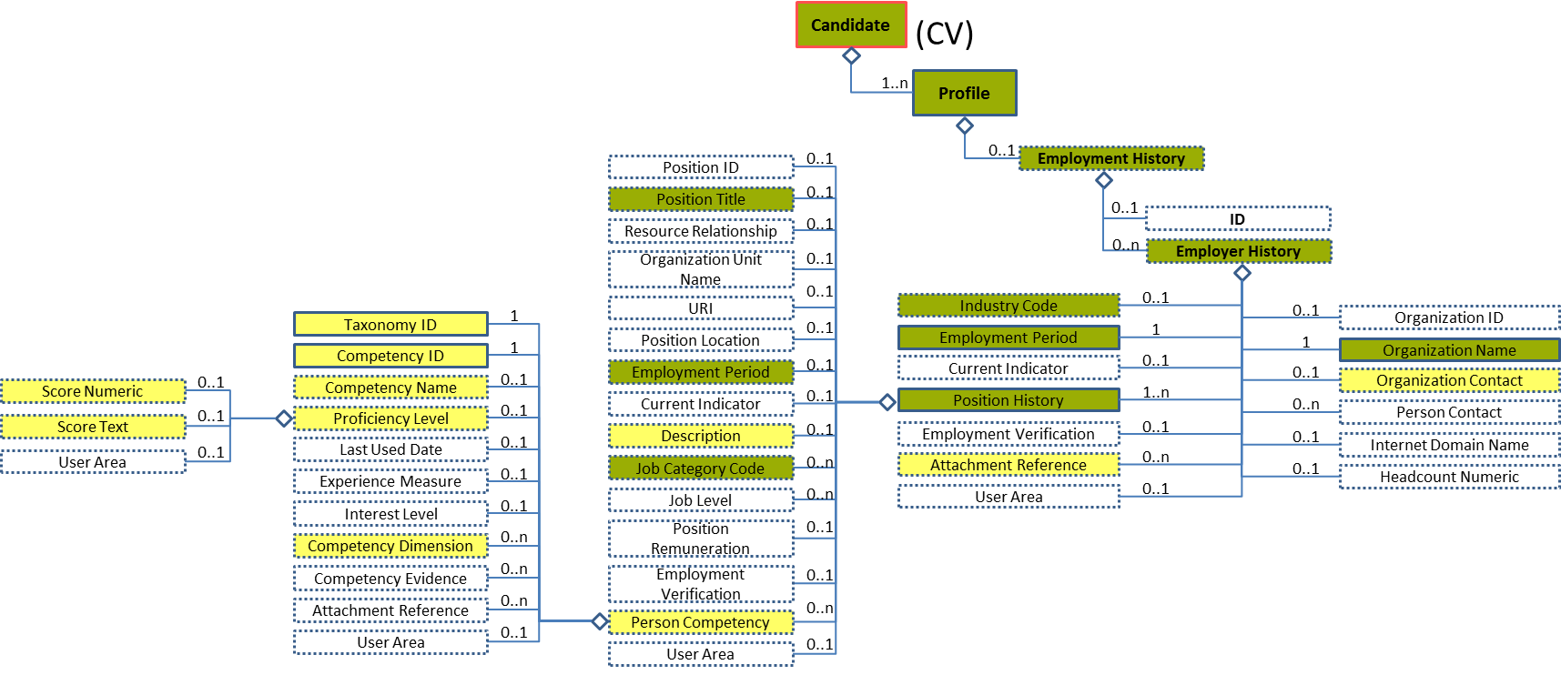
Figure 98: Proficiency Level 6 Entity Diagram
Element | Description | Layer /  Cardinality |  |  | Rule | Examples
Proficiency Level | The state or degree of mastery or adeptness obtained or achieved for a given competency. A proficiency level is expressed as a score a point scale or a mark among range of values. |  | EURES Optional  /  0..1 |  | BR-COM-49: If “CompetencyDimension / TypeCode” is specified, “ProficiencyLevel” is mandatory. | N/A
Sub-elements
Score Numeric | A numerical record of the marks allotted to individuals in the measurement of abilities, capacity to learn, personality assessment, or in other measurable characteristics (e.g. credit worthiness), including a set of attributes to identify the scoring scheme and its characteristics |  | EURES Optional  /  0..1 | N/A |  | “1”, “2”, “3”, etc.
Score Text | A non-numerical or text representation of a score. A record of the marks allotted to an individual in measuring his/her abilities, capacity to learn, personality assessment, or in other measurable characteristics (e.g., credit worthiness). It represents either the total number of points awarded, or a general standard achieved, including a set of attributes to identify the scoring scheme |  | EURES Optional  /  0..1 | BR-COM-47: Compulsory use of Language Proficiency Codes [CL25], if TaxonomyID’s value is “language”. |  | “A1”, “A2”, “B1”, etc.  Full code list: “4.28.18 Language Proficiency Codes [CL25]”

Proficiency Level Attributes
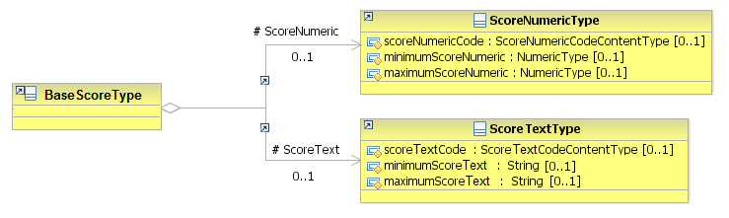
Figure 99: Proficiency Level Attributes Schema
Attributes | Description | Card. | Rule
This element has no attributes.
ScoreText sub-element
Attributes | Description | Card. | Rule
scoreTextCode | The score text | 0..1 | N/A
minimumScoreText | The minimum score | 0..1 | N/A
maximumScoreText | The maximum score | 0..1 | N/A
ScoreNumeric sub-element
Attributes | Description | Card. | Rule
scoreNumericCode | The numeric type of scoring scheme | 0..1 | N/A
minimumScoreNumeric | The minimum score | 0..1 | N/A
maximumScoreNumeric | The maximum score | 0..1 | N/A

Sub-element: /Employer History/Position History/Person Competency/Competency Dimension (level 6)

Competency Dimension Description
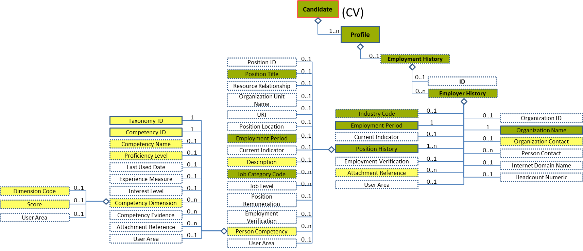
Figure 100: Competency Dimension Level 6 Entity Diagram
Element | Description | Layer /  Cardinality |  | Rule | Examples
Competency Dimension | A measurable characteristic of a skill or competency |  | EURES Optional  /  0..n | Only used for language skills  BR-COM-48: If "CompetencyDimension" element is specified, "TypeCode" and "Score" are mandatory elements.  BR-COM-49: If “CompetencyDimension / TypeCode” is specified, “ProficiencyLevel” is mandatory. | N/A
Sub-elements
Dimension Code | A code classifying the type of competency dimension described |  | EURES Optional  /  0..1 | BR-COM-37: Compulsory use of the “EURES_Dimension-CodeList.gc” list defined by EURES. This is based on CEFR, if TaxonomyID’s value is “language”. | “CEF-Understanding-Reading”, “CEF-Understanding-Listening”, etc.  Full code list: “4.28.9 Dimension Codes [CL11] ”
Score | Details regarding the student's scores at a specific dimension |  | EURES Optional  /  0..1 | N/A | N/A
 | See section “4.16.13 Sub-element: /Employer History/Position History/Person Competency/Competency Dimension/Score (level 7)” for more information

Competency Dimension Attributes
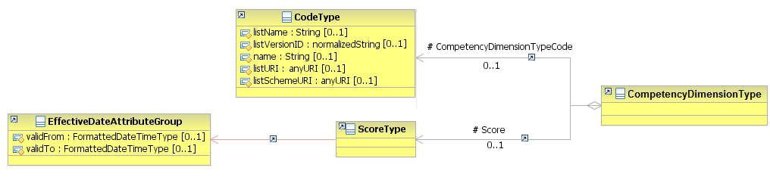
Figure 101: Competency Dimension Attributes Schema
Attributes | Description | Card. | Rule
This element has no attributes.
CompetencyDimensionTypeCode sub-element
Attributes | Description | Card. | Rule
listName | The code list name | 0..1 | N/A
listVersionID | The code list identification | 0..1 | N/A
name | The text equivalent of the code content component | 0..1 | N/A
language | The language of the text | 0..1 | N/A
listURI | The Uniform Resource Identifier that identifies where the code list is located | 0..1 | N/A
listSchemeURI | The Uniform Resource Identifier that identifies where the code list scheme is located | 0..1 | N/A
Score sub-element
Attributes | Description | Card. | Rule
See section “4.16.13.2 Score Description” for more information

Sub-element: /Employer History/Position History/Person Competency/Competency Dimension/Score (level 7)

Score Element Description
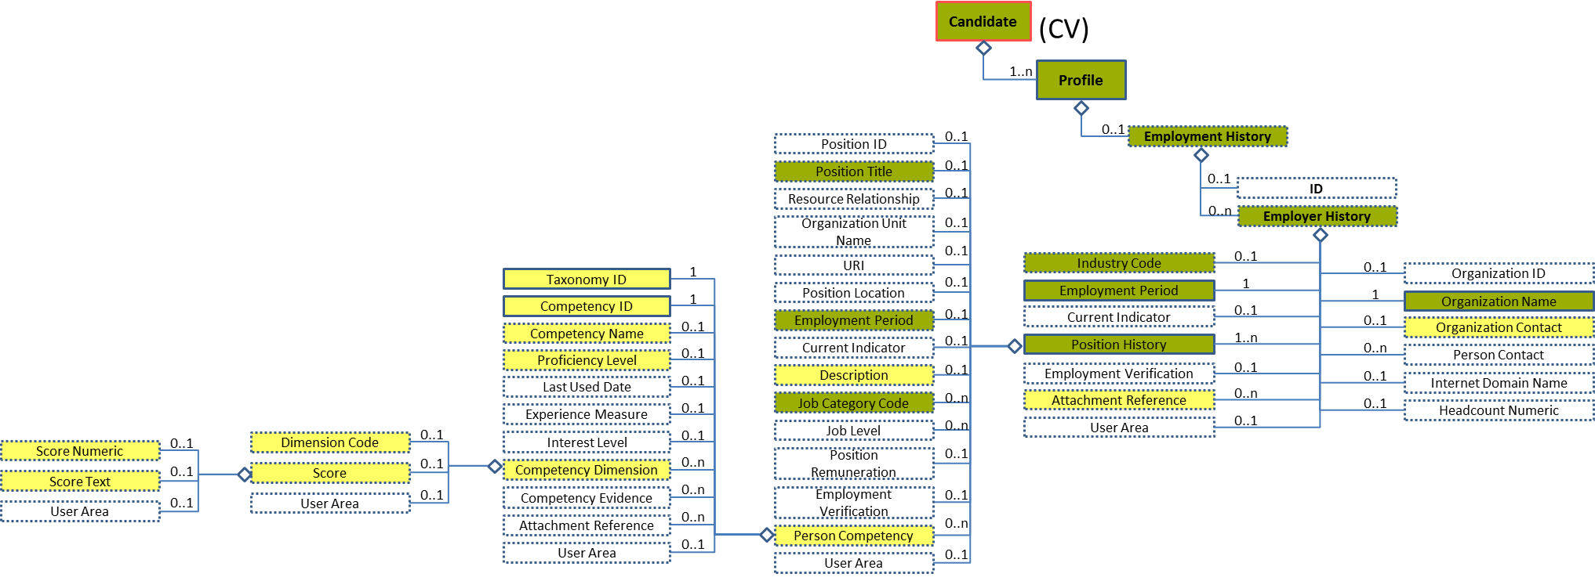
Figure 102: Score Level 7 Entity Diagram
Element | Description | Layer /  Cardinality |  | Rule | Examples
Score | Details regarding the student's scores at a specific dimension |  | EURES Optional  /  0..1 | N/A | N/A
Sub-elements
The same as “4.16.11.1 Proficiency Level Description”

Score Description
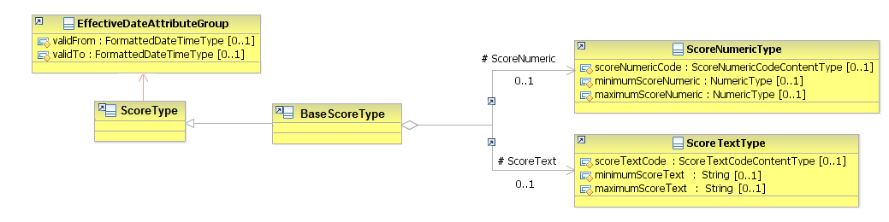
Figure 103: Score Attributes Schema
Attributes | Description | Card. | Rule
This element has no attributes.
Sub-elements
Attributes | Description | Card. | Rule
The same as "4.16.11.2 Proficiency Level Attributes”

Sub-element: /Employer History/Attachment Reference (level 4)

Attachment Reference Element Description
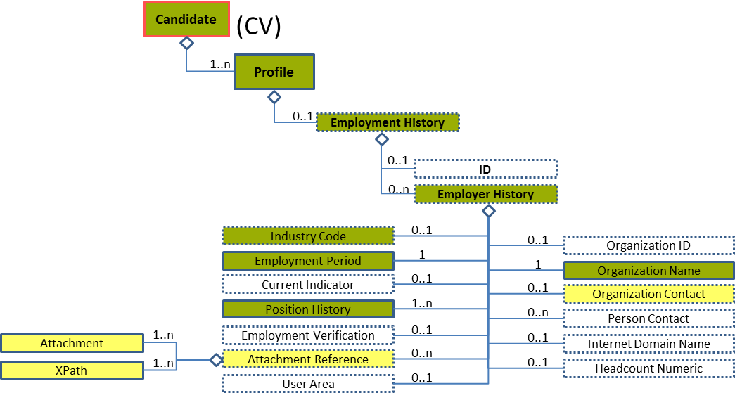
Figure 104: Attachment Reference Level 4 Entity Diagram
Element | Description | Layer /  Cardinality |  | Rule | Examples
Attachment Reference | Reference to the external documents attached |  | EURES Optional  /  0..n | N/A | N/A
Sub-elements
XPath | Reference to an embedded document located in another element of the schema |  | EURES Optional  /  1..n | N/A | “/Candidate /CandidateProfile /EducationHistory /HistoryID [text()='HST-123']”
Description | Narrative details of the external document attached |  | EURES Optional  /  1..n | N/A | “Education History”

Attachment Reference Attributes
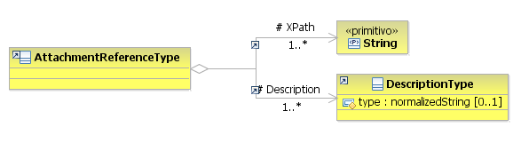
Figure 105: Attachment Reference Attributes Schema
Attributes | Description | Card. | Rule
This element has no attributes.
XPath sub-element
Attributes | Description | Card. | Rule
This sub-element has no attributes.
Description sub-element
Attributes | Description | Card. | Rule
type | The description type | 0..1 | N/A

Attachment Reference Examples
This is an example of how to reference to another element of the schema through XPath. In this case, it is to the embedded file in Attachment element, whose identifier is PositionDescription.
<Candidate xmlns="http://www.hr-xml.org/3" xsi:schemaLocation="http://www.hr-xml.org/3 ../Developer/Nouns/Candidate.xsd">
<CandidatePerson>
<EmploymentHistory>
<!-- Past job experience. -->
<EmployerHistory>
<OrganizationName>EIfEL</OrganizationName>
<OrganizationContact>
<ContactName>Richard Dubois</ContactName>
</OrganizationContact>
<IndustryCode listName="NACE_r2" listVersionID="2008" name="Hospital activities" listURI="http://ec.europa.eu/esco/ConceptScheme/NACErev2/cs" >86.1</IndustryCode>
<EmploymentPeriod>
<StartDate>
<FormattedDateTime>2008-06-01</FormattedDateTime>
</StartDate>
<EndDate>
<FormattedDateTime>2012-12-31</FormattedDateTime>
</EndDate>
</EmploymentPeriod>

<AttachmentReference>
<oa:Description>Diploma</oa:Description>
<XPath>/Candidate/CandidateProfile/Attachment/AttachmentID[text()='PositionDescription']</XPath>
</AttachmentReference>
</EmployerHistory>
</CandidatePerson>

<!-- This is the attachment referenced by the AttachmentReference -->
<CandidateProfile languageCode="en">
<Attachment>
<AttachmentID>PositionDescription</AttachmentID>
<!-- Other elements are filled in this Attachment element, please see the Attachment Element Description -->
</Attachment>
</CandidateProfile>
<Candidate/>

/Profile/Employment References (level 2)

Employment References Element Description
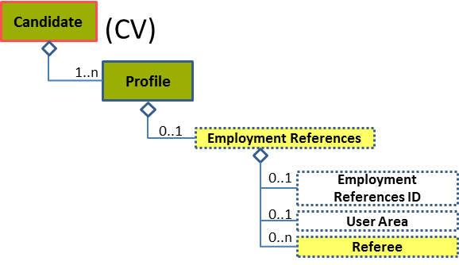
Figure 106: Employment References Level 2 Entity Diagram
Element | Description | Layer /  Cardinality |  | Rule | Examples
Employment References | Contains information on one or more people who are or may be a source of information about a person’s skills, prior employment, character, or suitability for employment |  | EURES Optional  /  0..1 | N/A | N/A
Sub-elements
Referee | A person who may be referred to for information or guidance on a person’s character or other qualities, specifically an applicant for employment, for an academic or other award, or the like. |  | EURES Optional  /  0..n | N/A | N/A
 | See section “4.17.3 Sub-element: /Referee (level 3)” for information

Employment References Attributes
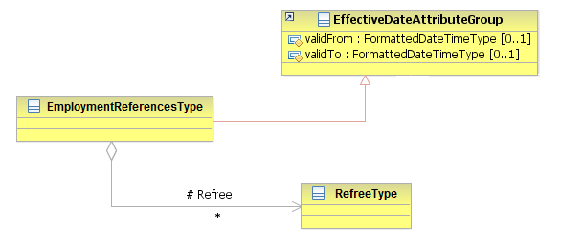
Figure 107: Employment References Attributes Schema
Attributes | Description | Card. | Rule
validFrom | Validity start date for this entity’s information. | 0..1 | BR-COM-05: If not specified, the “validFrom” date will default to “assigned by EURES on reception”.  BR-COM-06: Compulsory Date Format is: YYYY-MM-DD, YYYY-MM, YYYY or YYYY-MM-DDThh:mm:ss.
validTo | Validity end date for this entity’s information. | 0..1 | BR-COM-07: If not specified, the “validTo” date will be decided by EURES depending on the transaction context.  BR-COM-06: Compulsory Date Format is: YYYY-MM-DD, YYYY-MM, YYYY or YYYY-MM-DDThh:mm:ss.
Referee sub-element
Attributes | Description | Card. | Rule
See section “4.17.3.2 Referee Attributes” for more information

Sub-element: /Referee (level 3)

Referee Element Description
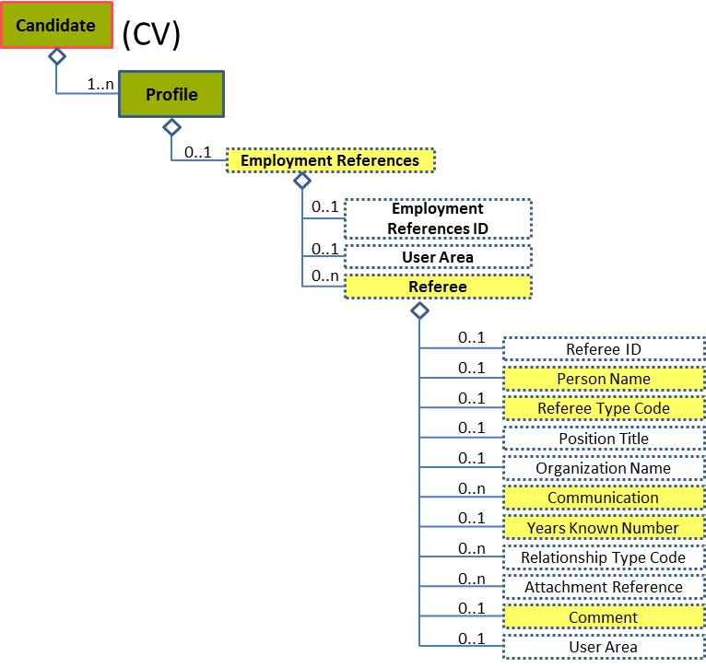
Figure 108: Referee Level 3 Entity Diagram
Element | Description | Layer /  Cardinality |  | Rule | Examples
Referee | A person who may be referred to for information or guidance on a person’s character or other qualities, specifically of an applicant for employment, for an academic or other award, or the like. |  | EURES Optional  /  0..n | N/A | N/A
Sub-elements
Person Name | A component for capturing summary or fine-grain data that makes up a person’s name |  | EURES Optional  /  0..1 | N/A | “Mr. John L Smith III, Phd”, “Dr. Martin White”, etc.
Referee Type Code | A code classifying the reference type  This is an HR-Open Standards open list. |  | EURES Optional  /  0..1 | BR-CV-22: The HR-Open Standards Code List “RefereeTypeCode”. | “Professional”, “Personal”, “Verification”  Full code list: “4.28.31 Referee Enum-Type Codes [CL46]”
Communication | Communication of the referee |  | EURES Optional  /  0..n | N/A | N/A
 | See section “4.17.5 Sub-element: /Referee/Communication (level 4)” for more information
Years Known Number | Number of years known |  | EURES Optional  /  0..1 | N/A | “1”, “2”, “3”, etc.
Comment | Referee Comment |  | EURES Optional  /  0..1 | N/A | “Comment about the referee”

Referee Attributes
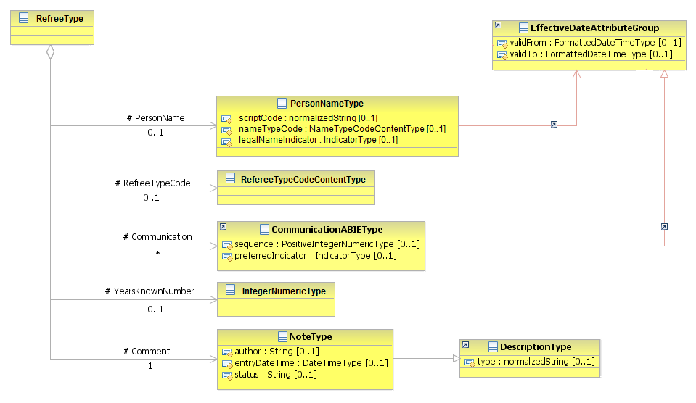
Figure 109: Referee Attributes Schema
Attributes | Description | Card. | Rule
This element has no attributes.
PersonName sub-element
Attributes | Description | Card. | Rule
scriptCode | Type of alphabet that the name is written with, such as “Roman”, “Kenji”, etc. | 0..1 | N/A
nameTypeCode | A code classifying the type of name; enumerations include “CurrentName”, “FormerName”, “BirthName”, and “Alias”. | 0..1 | N/A
legalNameIndicator | Boolean indicating if it is the legal name or not | 0..1 | N/A
validFrom | Validity start date for this Person Name | 0..1 | BR-COM-06: Compulsory Date Format is: YYYY-MM-DD, YYYY-MM, YYYY or YYYY-MM-DDThh:mm:ss.
validTo | Validity end date for this Person Name | 0..1 | BR-COM-06: Compulsory Date Format is: YYYY-MM-DD, YYYY-MM, YYYY or YYYY-MM-DDThh:mm:ss.
RefereeTypeCode sub-element
Attributes | Description | Card. | Rule
This sub-element has no attributes.
Communication sub-element
Attributes | Description | Card. | Rule
See section “4.17.5.2 Communication Attributes” for more information
YearsKnownNumber sub-element
Attributes | Description | Card. | Rule
This sub-element has no attributes.
Comment sub-element
Attributes | Description | Card. | Rule
author | The author of the comment | 0..1 | N/A
entryDateTime | The date when the comment was entered or last modified | 0..1 | N/A
status | The status of the comment | 0..1 | N/A
type | The comment type | 0..1 | N/A

Sub-element: /Referee/Person Name (level 4)

Person Name Element Description
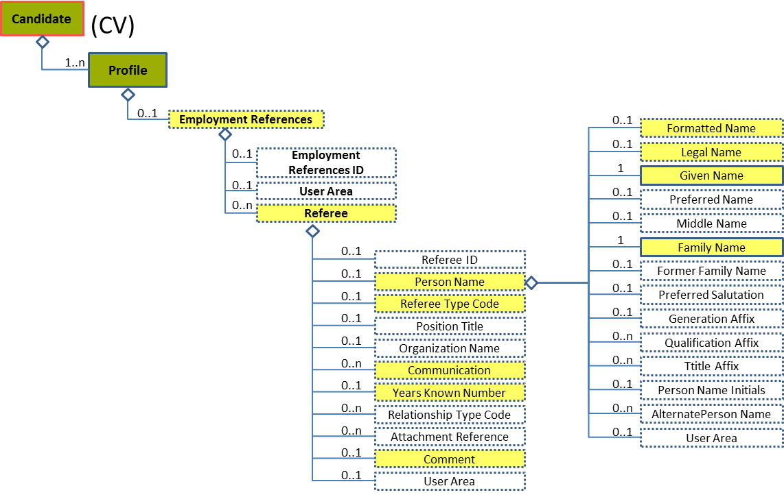
Figure 110: Person Name Level 4 Entity Diagram
Element | Description |  | Layer /  Cardinality |  | Rule | Examples
Person Name | A component for capturing summary or fine-grain data that makes up a person’s name |  |  | EURES Optional  /  0..1 | N/A | N/A
Sub-elements
Formatted Name |  | This is a formatted presentation of a name (for example, a Person Name) that might alternatively be presented as discretely fielded components, or it could be a name with alternative formatted representations.  The formatCode is an optional available attribute for specifying the applicable "mask" or type of format presentation to which the content conforms. |  | EURES Optional  /  0..1 | N/A | “Paula Cook”, “James Black”, etc.
Legal Name |  | The name that an individual is given at birth and/or is recognised by a government or other legal entity, or that appears on a birth certificate |  | EURES Optional  /  0..1 | N/A | “Paula Cook”, “James Black”, etc.
Given Name |  | A people given name or first name. |  | EURES Optional  /  1 | N/A | “Mark”, “Silvia”, etc.
Family Name |  | Contains a non-given name. This is an inherited name or one representing a family relationship, or in some cultural contexts a "Place Name" (where someone is from). In some cultural contexts, a single family name is typical, while in others there may be multiple family names. A "primary" attribute may be used in the case where there are multiple last names. A family name can have a "prefix," such as Von, De, Van, Al, etc. These can be represented using the FamilyName "prefix" attribute. Not all implementers may find it necessary to separate prefixes from the family name itself. Capturing the prefix and FamilyName as discrete fields can become important when formatting, or appearance may vary based on context. For example, in some cultural contexts it may be common to use a blank space as the delimiter between the prefix and the family name, while in others, a hyphen might be used. Separating the prefix from the FamilyName allows such formatting requirements to be handled flexibly. |  | EURES Optional  /  1 | N/A | “Smith”, “Santos Tavares”, “Van der Meyde”, etc.

Person Name Attributes
Figure 111: PersonName Attributes Schema
Attributes | Description | Card. | Rule
scriptCode | Type of alphabet that the name is written with such as “Roman”, “Kenji”, etc. | 0..1 | N/A
nameTypeCode | A code classifying the type of name, such as “CurrentName” or “FormerName” (full code list “4.28.21 Name Enum-Type Codes [CL32] ”)  This is an HR-Open Standards open list. | 0..1 | BR-COM-09: Compulsory use of the Name Enum Type Codes [CL32].
legalNameIndicator | Boolean indicating if it is the legal name or not | 0..1 | N/A
validFrom | Validity start date for this Person Name | 0..1 | BR-COM-06: Compulsory Date Format is: YYYY-MM-DD, YYYY-MM, YYYY or YYYY-MM-DDThh:mm:ss.
validTo | Validity end date for this Person Name | 0..1 | BR-COM-06: Compulsory Date Format is: YYYY-MM-DD, YYYY-MM, YYYY or YYYY-MM-DDThh:mm:ss.
LegalName sub-element
Attributes | Description | Card. | Rule
formatCode | Type of format shown | 0..1 | N/A
FormattedName sub-element
Attributes | Description | Card. | Rule
The same as the “LegalName” sub-element
GivenName sub-element
Attributes | Description | Card. | Rule
sequence | Establishes the name order as an integer | 0..1 | N/A
sequenceName | Establishes the name order as a string | 0..1 | N/A
FamilyName sub-element
Attributes | Description | Card. | Rule
primaryIndicator | Boolean indicating that it is a single name | 0..1 | N/A
sequence | Establishes the name order as an integer | 0..1 | N/A
prefix | A family name’s prefix | 0..1 | N/A

Sub-element: /Referee/Communication (level 4)

Communication Element Description
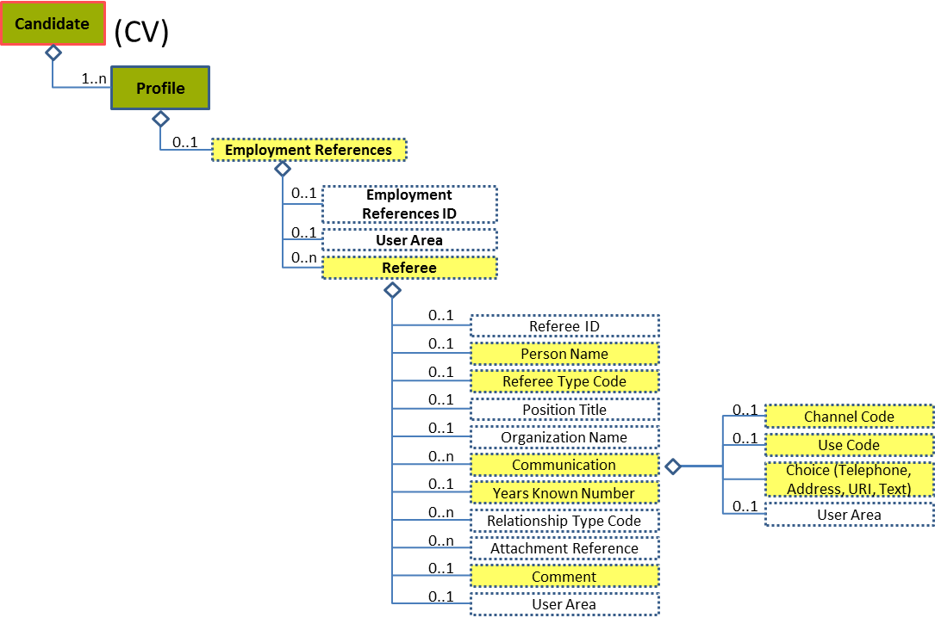
Figure 112: Communication Level 4 Entity Diagram
Element | Description | Layer /  Cardinality |  | Rule | Examples
Communication | Communication of the referee |  | EURES Optional  /  0..n | N/A | N/A
Sub-elements
The same as “4.6.4 Sub-element: /Communication (level 3)”

Communication Attributes
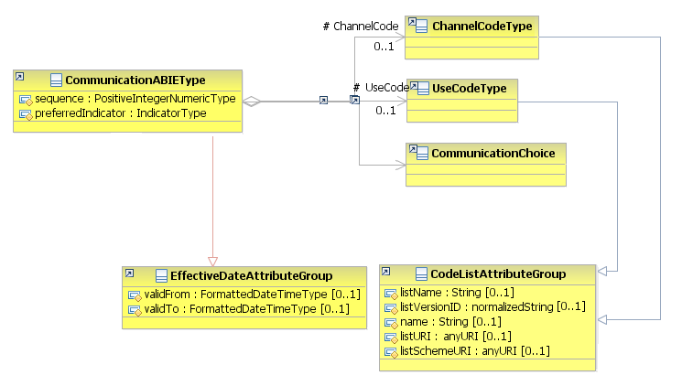
Figure 113: Communication Attributes Schema
Attributes | Description | Card. | Rule
The same as “4.6.4.2 Communication Attributes”

/Profile/Certifications (level 2)

Certifications Element Description
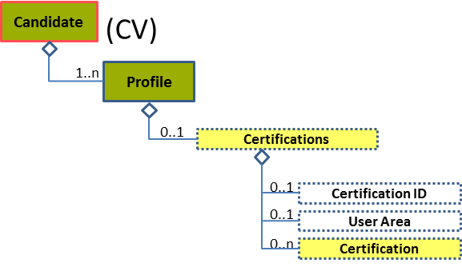
Figure 114: Certifications Level 2 Entity Diagram
Element | Description | Layer /  Cardinality |  | Rule | Examples
Certifications | A collection of information about one or more certifications. Certifications are formal statements by an issuing authority that the certification holder has met educational or testing requirements associated with the certification. |  | EURES Optional  /  0..1 | N/A | N/A
Sub-elements
Certification | A document certifying the status or acquirements of the bearer, or his/her fulfilment of conditions authorizing him/her to act or practise in a specified way and which is therefore often equal to a licence. |  | EURES Optional  /  0..n | N/A | N/A
 | See section “4.18.3 Sub-element: /Certification (level 3)” for more information

Certifications Attributes
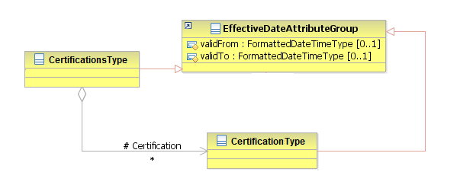
Figure 115: Certifications Attributes Schema
Attributes | Description | Card. | Rule
validFrom | Validity start date for this entity’s information | 0..1 | BR-COM-05: If not specified, the “validFrom” date will default to “assigned by EURES on reception”.  BR-COM-06: Compulsory Date Format is: YYYY-MM-DD, YYYY-MM, YYYY or YYYY-MM-DDThh:mm:ss.
validTo | Validity enddate for this entity’s information | 0..1 | BR-COM-07: If not specified, the “validTo” date will be decided by EURES depending on the transaction context.  BR-COM-06: Compulsory Date Format is: YYYY-MM-DD, YYYY-MM, YYYY or YYYY-MM-DDThh:mm:ss.
Certification sub-element
Attributes | Description | Card. | Rule
See section “4.18.3.2 Certification Attributes” for more information

Sub-element: /Certification (level 3)

Certification Element Description
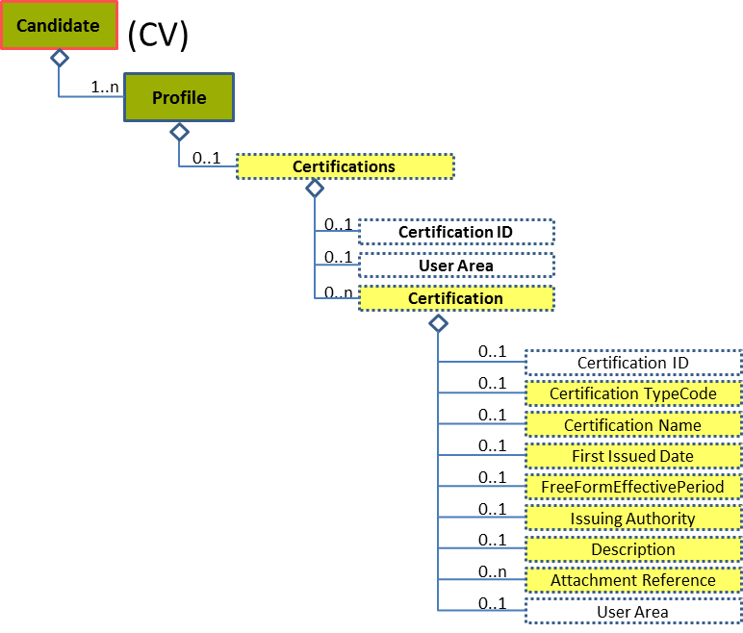
Figure 116: Certification Level 3 Entity Diagram
Element | Description | Layer /  Cardinality |  | Rule | Examples
Certification | A document certifying the status or acquirements of the bearer, or his/her fulfilment of conditions authorizing him/her to act or practise in a specified way and which is therefore often equal to a licence. |  | EURES Optional  /  0..n | N/A | N/A
Sub-elements
Certification Type Code | A code classifying the type of credential |  | EURES Optional  /  0..1 | N/A | “Appeal-Standard”, “Certification Not Required”, etc.
Certification Name | Name of the certification |  | EURES Optional  /  0..1 | N/A | “Transmission System Operators”, etc.
First Issued Date | First date issued |  | EURES Optional  /  0..1 | N/A | N/A
 | See section “4.18.4 Sub-element: /Certification/First Issued Date (level 4)” for more information
Free Form Effective Period | Indicates the period in which the associated component is effective. Based on the same TimePeriodType UN/CEFACT ABIE (except that the start date is optional). The xsd:choice between an EndDate and Duration was also removed for processing simplicity. Generally, an EndDate or Duration would appear, but not both. This usage rule is not enforced by the schema. |  | EURES Optional  /  0..1 | N/A | N/A
 | See section “4.18.5 Sub-element: /Certification/Free Form Effective Period (level 4)” for more information
Issuing Authority | An agency, bureau, or other organization issuing an associated identifier, license, or certificate; the body or people exercising power or command. An issuing authority is often a government agency or official authority, but can sometimes be a private organization. |  | EURES Optional  /  0..1 | N/A | N/A
 | See section “4.18.6 Sub-element: /Certification/Issuing Authority (level 4)” for more information
Description | Description of the certification |  | EURES Optional  /  0..1 | N/A | “Certification of Transmission System Operators at EU”, etc.
Attachment Reference | Reference to the external documents attached |  | EURES Optional  /  0..n | N/A | N/A
 | See section “4.18.7 Sub-element: /Certification/Attachment Reference (level 4)” for more information

Certification Attributes
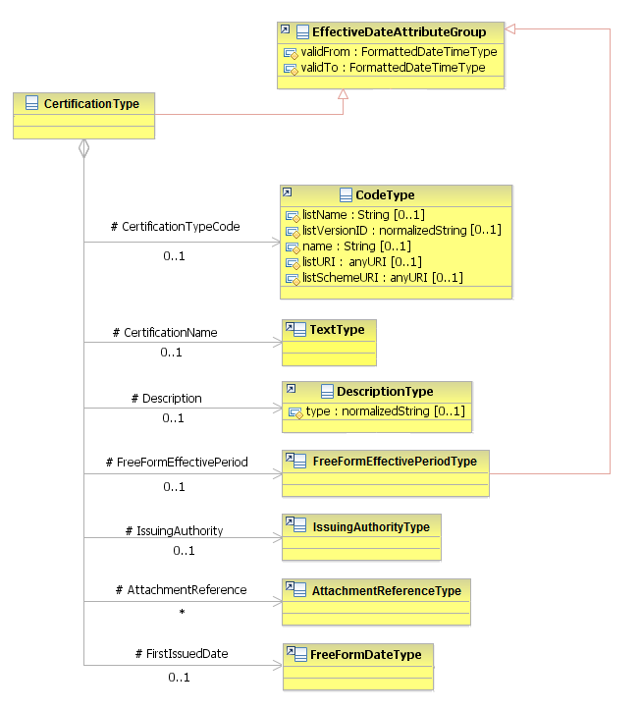
Figure 117: Certification Attributes Schema
Attributes | Description | Card. | Rule
validFrom | Validity start date for this entity’s information. | 0..1 | BR-COM-06: Compulsory Date Format is: YYYY-MM-DD, YYYY-MM, YYYY or YYYY-MM-DDThh:mm:ss.
validTo | Validity end date for this entity’s information. | 0..1 | BR-COM-06: Compulsory Date Format is: YYYY-MM-DD, YYYY-MM, YYYY or YYYY-MM-DDThh:mm:ss.
CertificationTypeCode sub-element
Attributes | Description | Card. | Rule
listName | The code list name | 0..1 | N/A
listVersionID | The code list identification | 0..1 | N/A
name | The text equivalent of the code content component | 0..1 | N/A
listURI | The Uniform Resource Identifier that identifies where the code list is located | 0..1 | N/A
listSchemeURI | The Uniform Resource Identifier that identifies where the code list scheme is located | 0..1 | N/A
CertificationName sub-element
Attributes | Description | Card. | Rule
This sub-element has no attributes.
Description sub-element
Attributes | Description | Card. | Rule
type | The type of date text | 0..1
FreeFormEffectivePeriod sub-element
Attributes | Description | Card. | Rule
See section “4.18.5.2 Free Form Effective Period Attributes” for more information
IssuingAuthority sub-element
Attributes | Description | Card. | Rule
See section “4.18.6.2 Issuing Authority Attributes” for more information
AttachmentReference sub-element
Attributes | Description | Card. | Rule
See section “4.18.7.2 Attachment Reference ” for more information
FirstIssuedDate sub-element
Attributes | Description | Card. | Rule
See section “4.18.4.2 First Issued Date Attributes” for more information

Sub-element: /Certification/First Issued Date (level 4)

First Issued Date Element Description
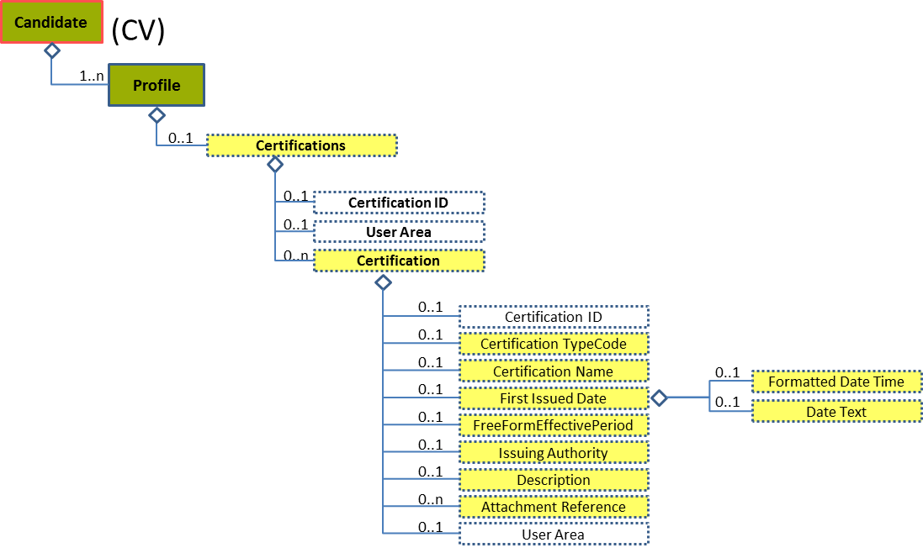
Figure 118: First Issued Date Level 4 Entity Diagram
Element | Description | Layer /  Cardinality |  | Rule | Examples
First Issued Date | First date issued |  | EURES Optional  /  0..1 | N/A | N/A
Sub-elements
The same as “4.13.5
Sub-element: /Organization Attendance/Education Degree/Degree Date (level 5)

”

First Issued Date Attributes
Figure 119: First Issued Date Attributes Schema
Attributes | Description | Card. | Rule
The same as “4.13.5.2 Degree Date Attributes”

Sub-element: /Certification/Free Form Effective Period (level 4)

Free Form Effective Period Element Description
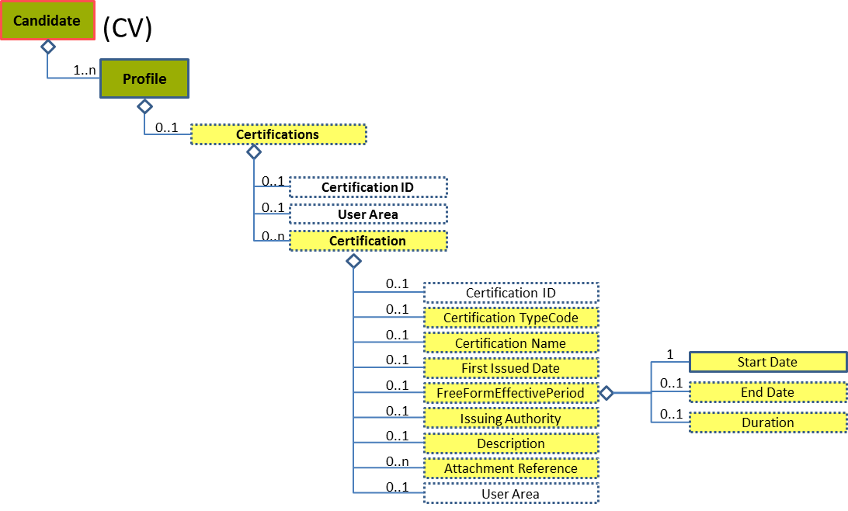
Figure 120: Free Form Effective Period Level 4 Entity Diagram
Element | Description | Layer /  Cardinality |  | Rule | Examples
Free Form Effective Period | Indicates the date period in which the associated component is effective, based on the same TimePeriodType UN/CEFACT ABIE (except that the start date is optional). The xsd:choice between an EndDate and Duration was also removed for processing simplicity. Generally, an EndDate or Duration would appear, but not both. This usage rule is not enforced by the schema. |  | EURES Optional  /  0..1 | N/A | N/A
Sub-elements
Start Date | A timestamp marking the beginning of the attendance period |  | EURES Optional  /  1 | N/A | N/A
See section “4.13.8
Sub-element: /Organization Attendance/Attendance Period/Start Date (level 5)

” for more information
End Date | A timestamp marking the end of the attendance period |  | EURES Optional  /  0..1 | N/A | N/A
 | See section “4.13.9 Sub-element: /Organization Attendance/Attendance Period/End Date (level 5)” for more information
Duration | Indicates the duration of time as represented by ISO 8601, where the value space is a six dimensional space in which the coordinates designate the Gregorian year, month, day, hour, minute, and second. The number of seconds can include decimal digits for arbitrary precision. |  | EURES Optional  /  0..1 | N/A | “2010-09-02”, “2011-07”, etc.

Free Form Effective Period Attributes
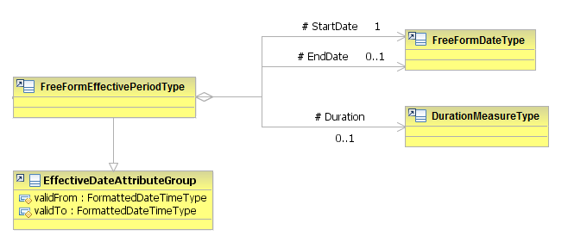
Figure 121: FreeFormEffectivePeriod Attributes Schema
Attributes | Description | Card. | Rule
validFrom | Validity start date for this entity’s information | 0..1 | BR-COM-06: Compulsory Date Format is: YYYY-MM-DD, YYYY-MM, YYYY or YYYY-MM-DDThh:mm:ss.
validTo | Validity end date for this entity’s information | 0..1 | BR-COM-06: Compulsory Date Format is: YYYY-MM-DD, YYYY-MM, YYYY or YYYY-MM-DDThh:mm:ss.
StartDate sub-element
Attributes | Description | Card. | Rule
See section “4.13.8.2 Start Date Attributes” for more information
EndDate sub-element
Attributes | Description | Card. | Rule
See section “4.13.9.2 End Date Attributes” for more information
DurationMeasure sub-element
Attributes | Description | Card. | Rule
This sub-element has no attributes.

Sub-element: /Certification/Issuing Authority (level 4)

Issuing Authority Element Description
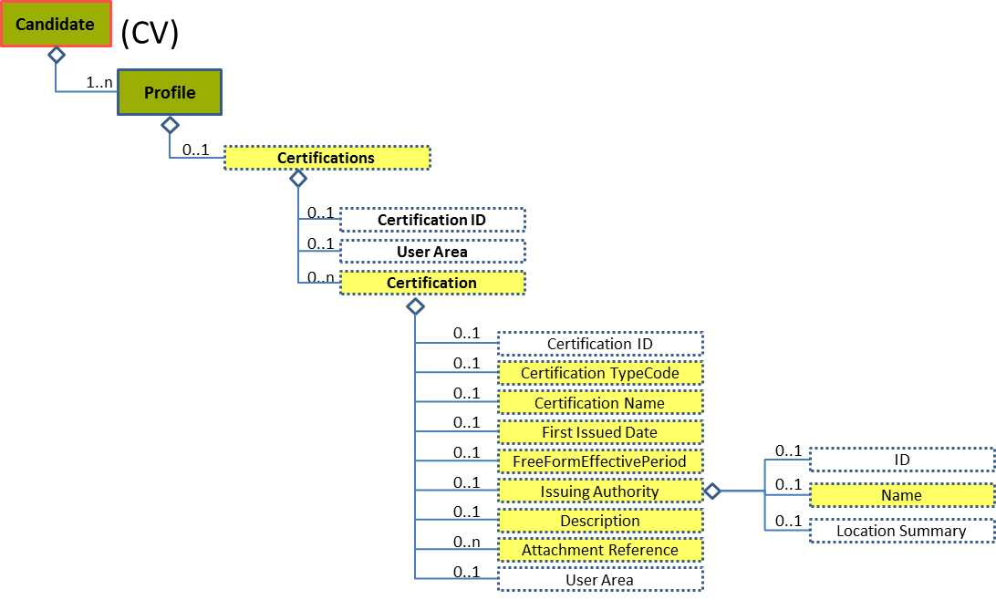
Figure 122: Issuing Authority Level 4 Entity Diagram
Element | Description | Layer /  Cardinality |  | Rule | Examples
Issuing Authority | An agency, bureau, or other organization issuing an associated identifier, license, or certificate; the body or people exercising power or command. An issuing authority is often a government agency or official authority, but can sometimes be a private organization. |  | EURES Optional  /  0..1 | N/A | N/A
Sub-elements
Name | Identifies the Name of the associated object |  | EURES Optional  /  0..1 | N/A | “Organization”, etc.

Issuing Authority Attributes
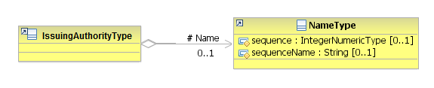
Figure 123: Issuing Authority Attributes Schema
Attributes | Description | Card. | Rule
This element has no attributes.
Name sub-element
Attributes | Description | Card. | Rule
sequence | Establishes the order of the contact data | 0..1 | N/A
sequenceName | Establishes the order of the contact data | 0..1 | N/A

Sub-element: /Certification/Attachment Reference (level 4)

Attachment Reference Element Description
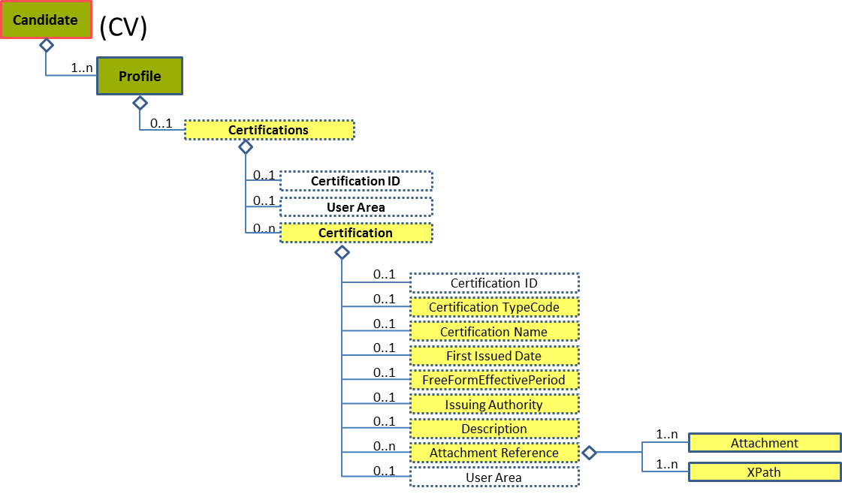
Figure 124: Attachment Reference Level 4 Entity Diagram
Element | Description | Layer /  Cardinality |  | Rule | Examples
Attachment Reference | Reference to external documents attached |  | EURES Optional  /  0..n | N/A | N/A
Sub-elements
The same as “4.16.14.1 Attachment Reference Element Description”

Attachment Reference Attributes
Figure 125: Attachment Reference Attributes Schema
Attributes | Description | Card. | Rule
The same as “4.16.14.2 Attachment Reference Attributes”

/Profile/Employer Preferences (level 2)

Employer Preferences Element Description
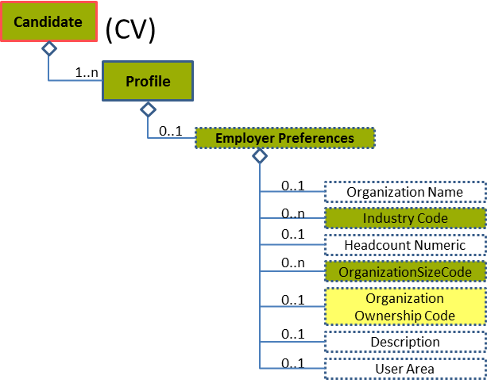
Figure 126: Employer Preferences Level 2 Entity Diagram
Element | Description | Layer /  Cardinality |  | Rule | Examples
Employer Preferences | Information about a candidate’s preferences in an employer |  | EURES Conformant Optional  /  0..1 | N/A | N/A
Sub-elements
Industry Code | A code classifying the industry of the related organization, position, or other entity |  | EURES Conformant Optional  /  0..n | BR-COM-20: Compulsory use of the “NACE-CodeList.gc” list defined by EURES. This is based on EU NACE.  BR-COM-43: Multiple entries of this code list are allowed. | “01” = Agriculture,  “02” = Forestry, etc.  Full code list: “4.28.20 NACE Codes [CL31]”
Organization Size Code | Contains a code classifying an organization’s size or business scope |  | EURES Conformant Optional  /  0..n | BR-COM-26: Compulsory use of the “EURES_OrganizationSize-CodeList.gc” list defined by EURES. This is based on EU – C (2003) 1422, including Large enterprises.  BR-COM-43: Multiple entries of this code list are allowed. | “MicroEnterprise”, “SmallEnterprise”, etc.  Full code list: “4.28.24 Organization Size Codes [CL35]”
Organization Ownership Code | Code of the ownership organisation  This is an HR-Open Standards open list. |  | EURES Optional  /  0..1 | BR-COM-27: Compulsory use of the “OrganizationOwnershipTypeCodeContentType” list. | “Public”, “Private”, “Non-profit”,  “Government”  Full code list: “4.28.23 Organization Ownership Codes [CL34]”

Employer Preferences Attributes
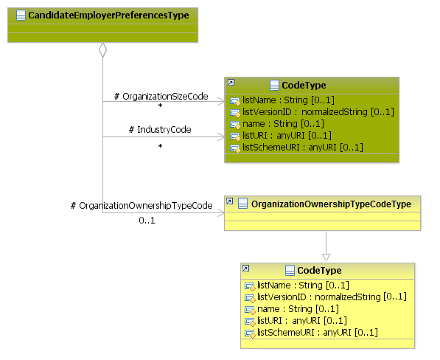
Figure 127: Employer Preferences Attributes Schema
Attributes | Description | Card. | Rule
This element has no attributes.
OrganizationName sub-element
Attributes | Description | Card. | Rule
validFrom | Validity start date for this entity’s information | 0..1 | BR-COM-06: Compulsory Date Format is: YYYY-MM-DD, YYYY-MM, YYYY or YYYY-MM-DDThh:mm:ss.
validTo | Validity end date for this entity’s information | 0..1 | BR-COM-06: Compulsory Date Format is: YYYY-MM-DD, YYYY-MM, YYYY or YYYY-MM-DDThh:mm:ss.
IndustryCode sub-element
Attributes | Description | Card. | Rule
listName | The code list name | 0..1 | N/A
listVersionID | The code list identification | 0..1 | N/A
name | The text equivalent of the code content component | 0..1 | N/A
listURI | The Uniform Resource Identifier that identifies where the code list is located | 0..1 | N/A
listSchemeURI | The Uniform Resource Identifier that identifies where the code list scheme is located | 0..1 | N/A
Attributes | Description | Card. | Rule
The same as “IndustryCode”
OrganizationOwnershipTypeCode sub-element
Attributes | Description | Card. | Rule
The same as “IndustryCode”

/Profile/Position Preferences (level 2)

Position Preferences Element Description
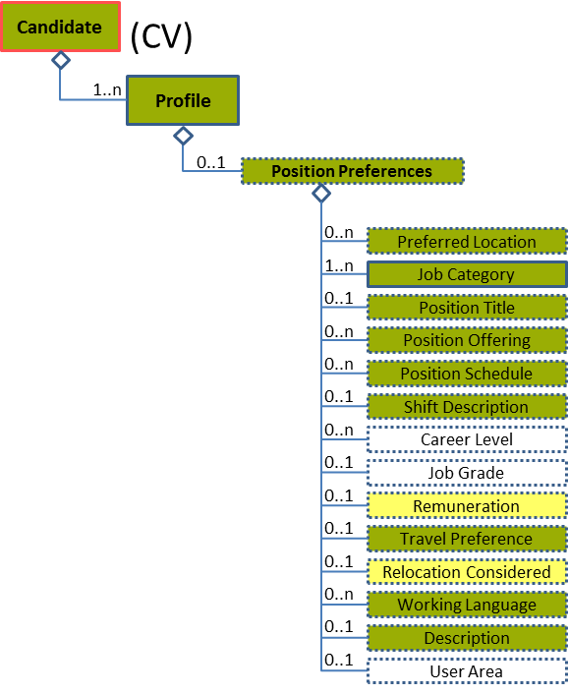
Figure 128: Position Preferences Level 2 Entity Diagram
Element | Description | Layer /  Cardinality |  | Rule | Examples
Position Preferences | Information about a candidate’s preferences in a position |  | EURES Conformant Optional  /  0..1 | N/A | N/A
Sub-elements
Preferred Location | Location of the preferred position |  | EURES Conformant Optional  /  0..n | N/A | N/A
 | See section “4.20.3 Sub-element: /Preferred Location (level 3)” for more information
Job Category | Category of the job |  | EURES Conformant  /  1..n | N/A | N/A
 | See section “4.20.5 Sub-element: /Job Category (level 3)” for more information
Position Title | A short phrase describing the position as it would be listed on a business card or in a company directory |  | EURES Conformant Optional  /  0..1 | N/A | “President”, “Chief Executive Officer”, etc.
Position Offering | These values are descriptive in classifying a position opportunity  This is an HR-Open Standards open list. |  | EURES Conformant Optional  /  0..n | BR-COM-38: Compulsory use of the “PositionOfferingCodeContentType” list.  BR-COM-43: Multiple entries of this code list are allowed. | “DirectorHire”,  “Temporary”,  “TemporaryToHire”,  “ContractToHire”,  Etc.  Full code list: “4.28.26 Position Offering Codes [CL37] ”
Position Schedule | Describes a position’s general schedule  This is an HR-Open Standards open list. |  | EURES Conformant Optional  /  0..n | BR-COM-39: Compulsory use of the “PositionScheduleCodeContentType” list.  BR-COM-43: Multiple entries of this code list are allowed. | “FullTime”,  “PartTime”,  “FlexTime”,  “Any”  Full code list: “4.28.27 Position Schedule Codes [CL38]”
Shift Description | Descriptive information about a work shift. “Shift” refers to a portion or division of time during which employees or resources are scheduled to be engaged or on-duty. |  | EURES Conformant Optional  /  0..1 | N/A | “Description about a work shift”, etc.
Remuneration | Remuneration offered |  | EURES Optional  /  0..1 | N/A | N/A
 | See section “4.20.6 Sub-element: /Offered Remuneration (level 3)” for more information
Travel Preference | Travel Preference details |  | EURES Conformant Optional  /  0..1 | N/A | N/A
 | See section “4.20.10 Sub-element: /Travel Preference (level 3)” for more information
Relocation Considered | Indicates if a candidate would consider moving to a new city or location for a suitable position |  | EURES Optional  /  0..1 | N/A | N/A
 | See section “4.20.11 Sub-element: /Relocation Considered (level 3)” for more information
Working Language | A code classifying the language or languages used within the workplace or associated with work. This is intended to communicate general information about the language(s) used within the work environment or general information about a candidate's specific language preferences. This component might be offered as descriptive "pre-qualification" information on a position announcement. It might appear within the context of a Candidate Profile as a general statement of a candidate's general language capabilities or preferences. WorkingLanguageCode is not intended as a statement of language proficiency or specific requirement relating to language proficiency. Specific information regarding language proficiency should be covered either within PersonCompetency or as may be appropriate. |  | EURES Conformant Optional  /  0..n | BR-COM-11: Compulsory use of the “LanguageCodes-CodeList.gc” list defined by EURES. This is based on ISO-639-1:2002 Alpha-2, which includes all world languages.  BR-COM-43: Multiple entries of this code list are allowed. | “aa” = Afar,  “ab” = Abkhazian, etc.  Full code list: “4.28.17 Language Codes [CL24] ”
Description | Description of position preferences |  | EURES Conformant Optional  /  0..1 | N/A | “Description of the position preferences”, etc.

Position Preferences Attributes
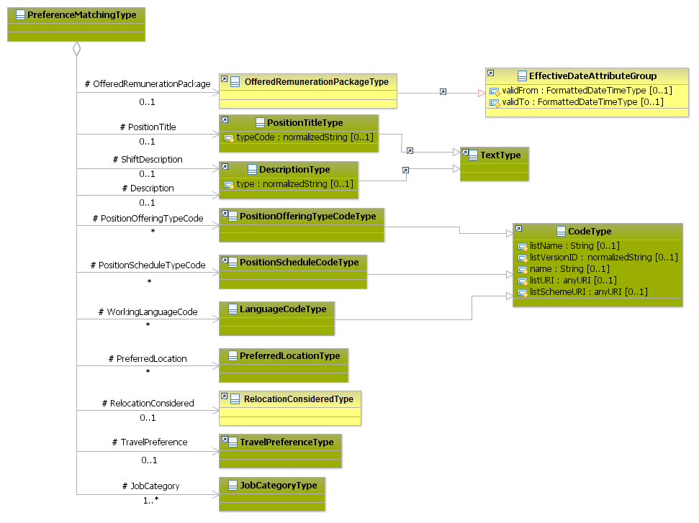
Figure 129: Position Preferences Attributes Schema
Attributes | Description | Card. | Rule
This element has no attributes.
OfferedRemunerationPackage sub-element
Attributes | Description | Card. | Rule
See section “4.20.6.2 Offered Remuneration Attributes” for more information
PositionTitle sub-element
Attributes | Description | Card. | Rule
typeCode | The comment type | 0..1 | N/A
ShiftDescription sub-element
Attributes | Description | Card. | Rule
The same as “PositionTitle”
Description sub-element
Attributes | Description | Card. | Rule
The same as “PositionTitle”
PositionOfferingTypeCode sub-element
Attributes | Description | Card. | Rule
listName | The code list name | 0..1 | N/A
listVersionID | The code list identification | 0..1 | N/A
name | The text equivalent of the code content component | 0..1 | N/A
listURI | The Uniform Resource Identifier that identifies where the code list is located | 0..1 | N/A
listSchemeURI | The Uniform Resource Identifier that identifies where the code list scheme is located | 0..1 | N/A
PositionScheduleTypeCode sub-element
Attributes | Description | Card. | Rule
The same as “PositionOfferingTypeCode”
WorkingLanguageCode sub-element
Attributes | Description | Card. | Rule
The same as “PositionOfferingTypeCode”
PreferredLocation sub-element
Attributes | Description | Card. | Rule
See section “4.20.3.2 Preferred Location Attributes” for more information
RelocationConsidered sub-element
Attributes | Description | Card. | Rule
See section “4.20.11.2 Relocation Considered Attributes” for more information
TravelPreference sub-element
Attributes | Description | Card. | Rule
See section “4.20.10.2 Travel Preference Attributes” for more information
JobCategory sub-element
Attributes | Description | Card. | Rule
See section “4.20.5.2 Job Category Attributes” for more information

Sub-element: /Preferred Location (level 3)

Preferred Location Element Description
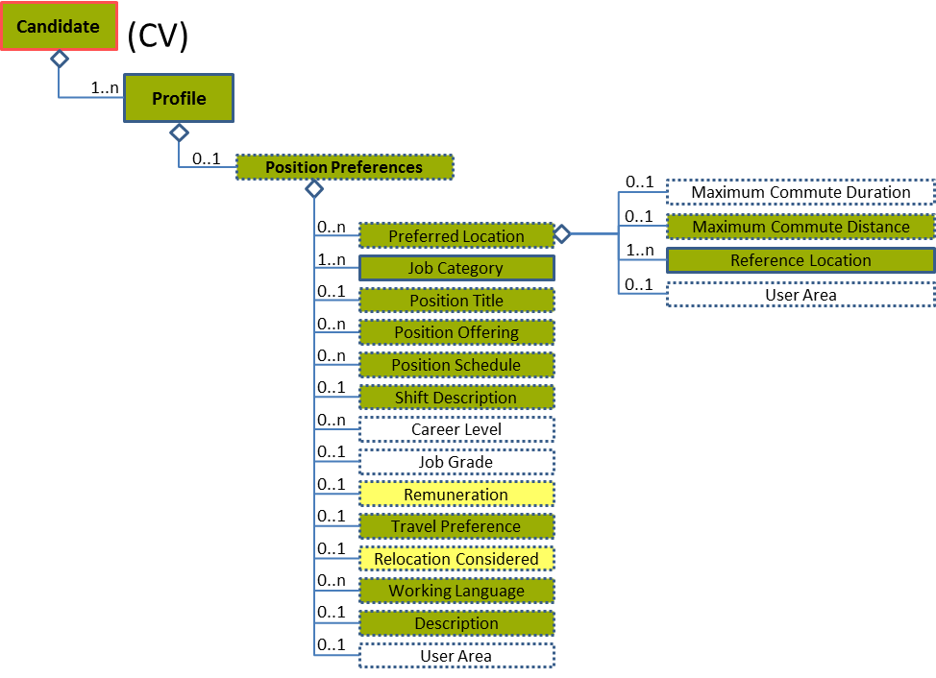
Figure 130: Preferred Location Level 3 Entity Diagram
Element | Description | Layer /  Cardinality |  | Rule | Examples
Preferred Location | Location of the preferred position |  | EURES Conformant Optional  /  0..n | N/A | N/A
Sub-elements
Maximum Commute Distance | The maximum distance required or preferred to commute |  | EURES Conformant Optional  /  0..1 | N/A | “2”, “3”, etc.
Reference Location | A base location from which a distance, commuting time, or travel directions, etc. is calculated |  | EURES Conformant  /  1..n |  | N/A
 | See section “4.20.4 Sub-element: /Preferred Location/Reference Location (level 4)” for more information

Preferred Location Attributes
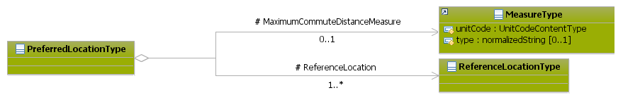
Figure 131: Preferred Location Attributes Schema
Attributes | Description | Card. | Rule
This element has no attributes.
MaximumCommuteDistanceMeasure sub-element
Attributes | Description | Card. | Rule
unitCode | Code indicating the type of unit measure, such as “minutes” or “hours” (full code list “4.28.37 Unit Codes [CL54]”) | 1 | BR-COM-36: Compulsory use of the Unit Codes [CL54].
type | The description type | 0..1 | N/A
ReferenceLocation sub-element
Attributes | Description | Card. | Rule
See section “4.20.4.2 Reference Location Attributes” for more information

Sub-element: /Preferred Location/Reference Location (level 4)

Reference Location Element Description
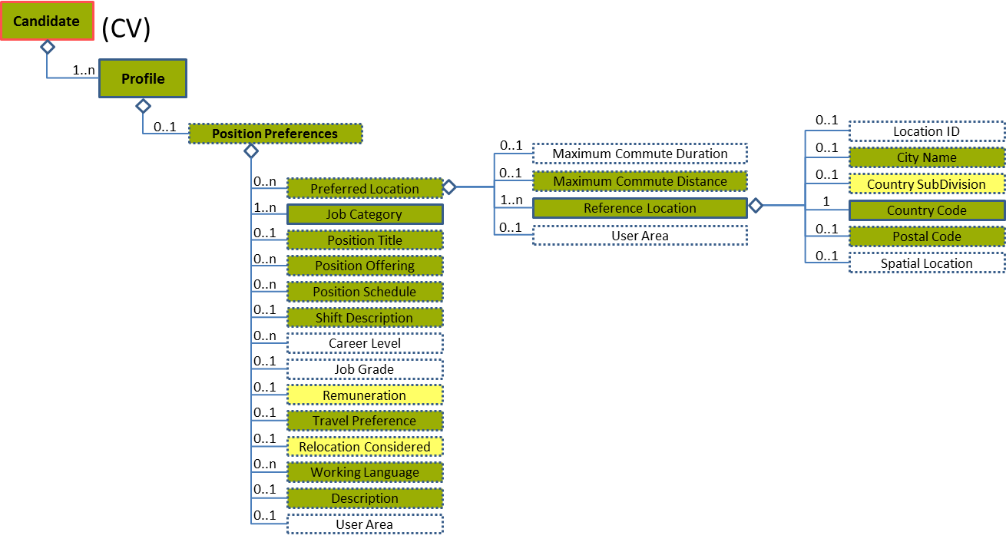
Figure 132: Reference Location Level 3 Entity Diagram
Element | Description | Layer /  Cardinality |  | Rule | Examples
Reference Location | A base location from which a distance, commuting time, or travel directions, etc. is calculated |  | EURES Conformant  /  1..n |  | N/A
Sub-elements
City Name | Identifies the town or the city |  | EURES Conformant Optional  /  0..1 | N/A | “Brussels”, “Barcelona”, “London”, etc.
Country Subdivision | Qualifies the further division of the Member States of Europe, which can be Districts, Regions, States, Provinces etc. |  | EURES Optional  /  0..1 | BR-COM-21: Compulsory use of the “EURES_CountrySubdivisionCodes-CodeList.gc” list defined by EURES. This is based on NUTS 2013 – Level 3.  BR-COM-53: If CountryCode is specified, CountrySubDivisionCode value must correspond to CountryCode value. | “BE07”, “CS01”, etc.  Full code list: “4.28.6 Country Subdivision Codes [CL08]”
Country Code | Code of the country |  | EURES Conformant Optional  /  1 | BR-COM-52: : Compulsory use of the “EURES_MemberCountries-CodeList.gc” list defined by EURES. This is based on ISO 3166-1 Alpha-2, adapted to the Member States and EFTA countries. | , “AT” – Austria, “BE” – Belgium, “BG” – Bulgaria ,etc.  Full code list: “  4.28.19 Members Countries from Europe [CL29]  ”
Postal Code | The Address’ Postal Code. |  | EURES Conformant Optional  /  0..1 | N/A | N/A

Reference Location Attributes
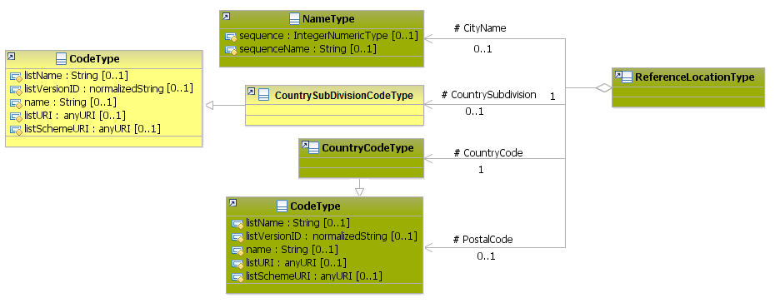
Figure 133: ReferenceLocation Attributes Schema
Attributes | Description | Card. | Rule
This element has no attributes
CityName sub-element
Attributes | Description | Card. | Rule
sequence | Establishes the order of the contact data | 0..1 | N/A
sequenceName | Establishes the order of the contact data | 0..1 | N/A
PostalCode sub-element
Attributes | Description | Card. | Rule
listName | The code list name. | 0..1 | N/A
listVersionID | The code list identification. | 0..1 | N/A
name | The text equivalent of the code content component | 0..1 | N/A
listURI | The Uniform Resource Identifier that identifies where the code list is located | 0..1 | N/A
listSchemeURI | The Uniform Resource Identifier that identifies where the code list scheme is located | 0..1 | N/A
CountrySubdivision sub-element
Attributes | Description | Card. | Rule
The same as “PostalCode”
CountryCode sub-element
Attributes | Description | Card. | Rule
The same as “PostalCode”

Reference Location examples
This is an example of how to add geographical information of the preferred position:
<Candidate xmlns="http://www.hr-xml.org/3" xsi:schemaLocation="http://www.hr-xml.org/3 ../Developer/Nouns/Candidate.xsd" >
<CandidateProfile languageCode="en">
<CandidatePositionPreferences>
<PreferredLocation>
<ReferenceLocation>
<oa:CityName>Stuttgart</oa:CityName>
<oa:CountrySubDivisionCode listName="EURES_CountrySubdivisionCodes" listVersionID="2013-Level-3" listURI="http://ec.europa.eu/eurostat ">DE11</oa:CountrySubDivisionCode>

<CountryCode listName="Countries" listURI="http://ec.europa.eu/esco/ConceptScheme/country" listVersionID="3166-1-alpha-2">DE</CountryCode>

<oa:PostalCode listName="EURES_PostalCodes" listURI=" https://ec.europa.eu/eures " listVersionID="2010">70001</oa:PostalCode>
</ReferenceLocation>

<MaximumCommuteDistanceMeasure unitCode="km">
25
</MaximumCommuteDistanceMeasure>
</PreferredLocation>
</CandidatePositionPreferences>
</CandidateProfile>
</Candidate>

Sub-element: /Job Category (level 3)

Job Category Element Description
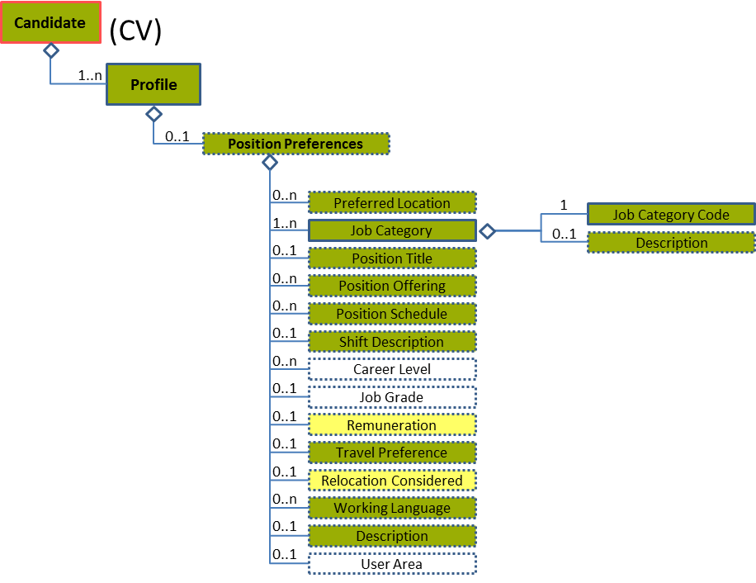
Figure 134: Job Category Level 3 Entity Diagram
Element | Description | Layer /  Cardinality |  | Rule | Examples
Job Category | Category of the job |  | EURES Conformant  /  1..n | N/A | N/A
Sub-elements
Job Category Code | A code classifying the type or category of a job. This may be used for its occupational classification. The JobCategoryCode will usually be repeatable so that a single job could be classified across multiple dimensions.  The JobCategoryCode could be used to classify the job by industry, but note that an explicit IndustryCode is available in contexts such as PositionOrganizationDetails. |  | EURES Conformant  /  1 | BR-COM-29: Compulsory use of the “ISCO2008-CodeList.gc” list defined by EURES and based on ISCO-08. Alternatively, use of ESCO Occupations – version 1.0.  BR-COM-55: Compulsory use of the attributes “listVersionID”, “listName” and “listURI”. | “1” – Managers,  “12” – Administrative, etc.  Full code list: “4.28.16 Job Category Codes [CL20]”
Description | Job category Description |  | EURES Conformant Optional  /  0..1 | N/A | “Description of job category”, etc.

Job Category Attributes
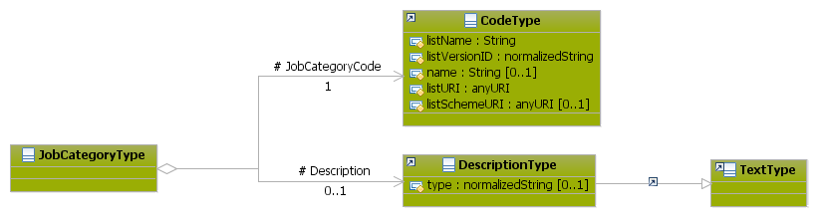
Figure 135: JobCategory Attributes schema
Attributes | Description | Card. | Rule
This element has no attributes.
JobCategoryCode sub-element
Attributes | Description | Card. | Rule
listName | The code list name | 0..1 | N/A
listVersionID | The code list identification | 0..1 | N/A
name | The text equivalent of the code content component | 0..1 | N/A
listURI | The Uniform Resource Identifier that identifies where the code list is located | 0..1 | N/A
listSchemeURI | The Uniform Resource Identifier that identifies where the code list scheme is located | 0..1 | N/A
Description sub-element
Attributes | Description | Card. | Rule
type | The comment type | 0..1 | N/A

Sub-element: /Offered Remuneration (level 3)

Offered Remuneration Element Description
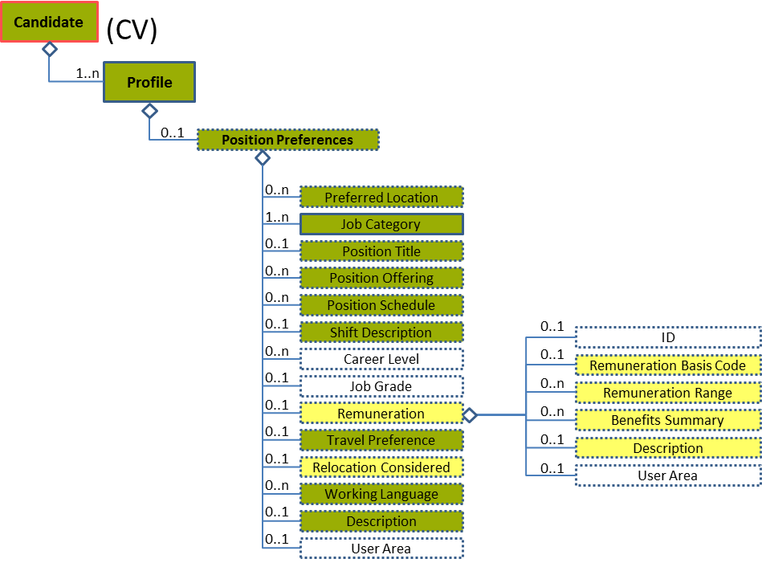
Figure 136: Offered Remuneration Level 3 Entity Diagram
Element | Description | Layer /  Cardinality |  | Rule | Examples
Remuneration | Remuneration offered |  | EURES Optional  /  0..1 | N/A | N/A
Sub-elements
Remuneration Basis Code | A code classifying the primary method of payment for the associated position or employment. This classifies the method by which remuneration for a position is provided or calculated.  This is an HR-Open Standards open list. |  | EURES Optional  /  0..1 | BR-COM-30: Compulsory use of the “RemunerationBasisCodeContentType” list. | “Hourly”, “Salaried”,  “SalariedPlusComission”,  “ComissionOnly”  Full code list: “4.28.32 Remuneration Basis Codes [CL48] ”
Remuneration Range | Remuneration range details |  | EURES Optional  /  0..n | BR-COM-31: All its sub elements must be expressed using the same currency. | N/A
 | See section “4.20.7 Sub-element: /Offered Remuneration/Remuneration Range (level 4)” for more information
Benefits Summary | Summary of benefits |  | EURES Optional  /  0..n | N/A | N/A
 | See section “4.20.8 Sub-element: /Offered Remuneration/Benefits Summary (level 4)” for more information
Description | Description of the remuneration offered |  | EURES Optional  /  0..1 | N/A | “Description of the remuneration offered”, etc.

Offered Remuneration Attributes
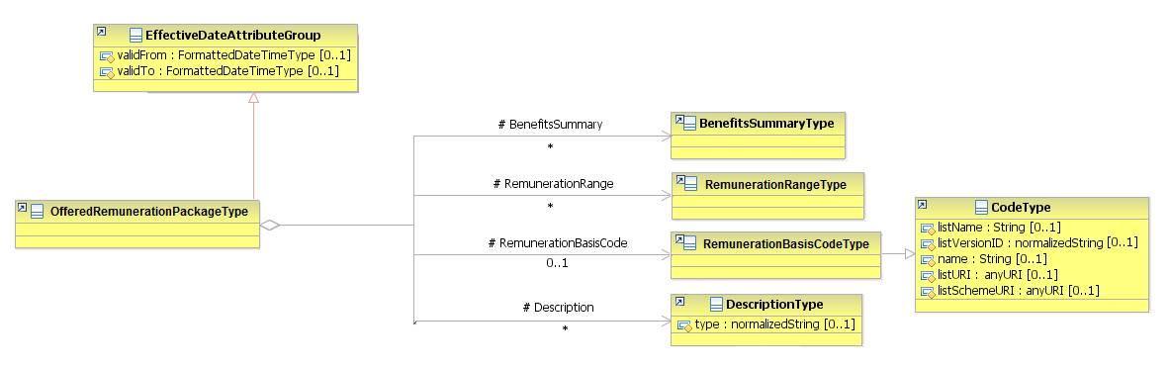
Figure 137: OfferedRemuneration Attributes Schema
Attributes | Description |  | Card. | Rule
validFrom | Validity start date for this entity’s information |  | 0..1 | BR-COM-06: Compulsory Date Format is: YYYY-MM-DD, YYYY-MM, YYYY or YYYY-MM-DDThh:mm:ss.
validTo | Validity end date for this entity’s information |  | 0..1 | BR-COM-06: Compulsory Date Format is: YYYY-MM-DD, YYYY-MM, YYYY or YYYY-MM-DDThh:mm:ss.
BenefitsSummary sub-element
Attributes | Description |  | Card. | Rule
See section “4.20.8.2 Benefits Summary Attributes” for more information
RemunerationRange sub-element
Attributes | Description |  | Card. | Rule
See section “4.20.7.2 Remuneration Range Attributes” for more information
RemnuerationBasisCode sub-element
Attributes | Description | Card. |  | Rule
listName | The code list name | 0..1 |  | N/A
listVersionID | The code list identification | 0..1 |  | N/A
name | The text equivalent of the code content component | 0..1 |  | N/A
listURI | The Uniform Resource Identifier that identifies where the code list is located | 0..1 |  | N/A
listSchemeURI | The Uniform Resource Identifier that identifies where the code list scheme is located | 0..1 |  | N/A
Description sub-element
Attributes | Description | Card. |  | Rule
type | The comment type | 0..1 |  | N/A

Sub-element: /Offered Remuneration/Remuneration Range (level 4)

Remuneration Range Element Description
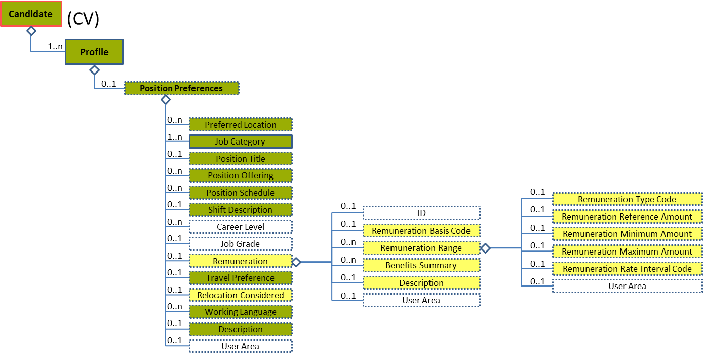
Figure 138: Remuneration Range Level 4 Entity Diagram
Element | Description | Layer / Cardinality |  | Rule | Examples
Remuneration Range | Remuneration range details |  | EURES Optional  /  0..n | BR-COM-31: All its sub elements must be expressed using the same currency. | N/A
Sub-elements
Remuneration Type Code | A code classifying the type of pay or remuneration being described  This is an HR-Open Standards open list. |  | EURES Optional  /  0..1 | BR-COM-32: Compulsory use of the “RemunerationCodeContentType” list. | “BasePay”, “Commission”, “Bonus”,  “ShortTermIncentive”,  “ShiftPremium”  Full code list: “4.28.33 Remuneration Type Codes [CL49] ”
Remuneration Reference Amount | A reference to an associated monetary quantity. An attribute is available to express the currency in which the amount is expressed. |  | EURES Optional  /  0..1 | N/A | “20000”, “35000”, etc.
Remuneration Minimum Amount | The minimum amount a person is willing to accept or an organization is willing to pay for a position. |  | EURES Optional  /  0..1 | N/A | “20000”, “35000”, etc.
Remuneration Maximum Amount | The maximum amount a person is willing to accept or an organization is willing to pay for a position. |  | EURES Optional  /  0..1 | N/A | “20000”, “35000”, etc.
Remuneration Rate Interval Code | An interval of time or other basis used to express a rate of pay or remuneration  This is an HR-Open Standards open list. |  | EURES Optional  /  0..1 | BR-COM-33: Compulsory use of the “RemunerationRateIntervalCodeContentType” list. | “Hour”, “Day”, “Week”, etc.  Full code list: “4.28.34 Remuneration Rate Interval Codes [CL50] ”
Figure 139: Name Attributes Schema

Remuneration Range Attributes
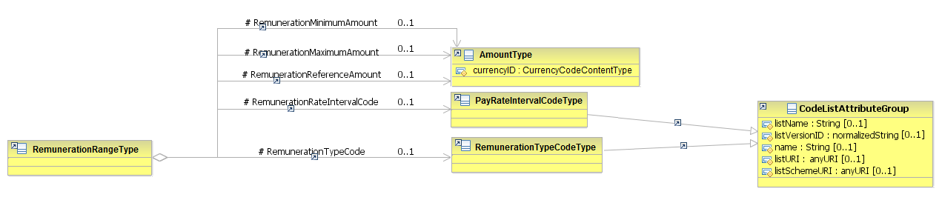
Figure 140: RemunerationRange Attributes Schema
Attributes | Description | Card. | Rule
This element has no attributes.
RemunerationMinimumAmount sub-element
Attributes | Description | Card. | Rule
currencyID | The currency in which the maximal and minimal salary are indicated  Full code list: “4.28.7 Currency Codes [CL09] ” | 1 | BR-COM-34: Compulsory use of the Currency Codes [CL09].
RemunerationMaximumAmount sub-element
Attributes | Description | Card. | Rule
The same as “RemunerationMinimumAmount”
RemunerationReferenceAmount sub-element
Attributes | Description | Card. | Rule
The same as “RemunerationMinimumAmount”
RemunerationRateIntervalCode sub-element
Attributes | Description | Card. | Rule
listName | The code list name | 0..1 | N/A
listVersionID | The code list identification | 0..1 | N/A
name | The text equivalent of the code content component | 0..1 | N/A
listURI | The Uniform Resource Identifier that identifies where the code list is located | 0..1 | N/A
listSchemeURI | The Uniform Resource Identifier that identifies where the code list scheme is located | 0..1 | N/A
RemunerationTypeCode sub-element
Attributes | Description | Card. | Rule
The same as “RemunerationRateIntervalCode”

Remuneration Range Examples
This is an example to indicate the amount of base pay per months in Euros:
<Candidate xmlns="http://www.hr-xml.org/3" xsi:schemaLocation="http://www.hr-xml.org/3 ../Developer/Nouns/Candidate.xsd" >
<CandidateProfile languageCode="en">
<CandidatePositionPreferences>
<OfferedRemunerationPackage>
<RemunerationRange>
<RemunerationTypeCode listName="RemunerationTypeCodeContentType" listVersionID="1.0" listURI="http://www.hr-xml.org/">BasePay</RemunerationTypeCode>
<RemunerationMinimumAmount currencyID="EUR">2000</RemunerationMinimumAmount>
<RemunerationMaximumAmount currencyID="EUR">2500</RemunerationMaximumAmount>
<RemunerationRateIntervalCode listName="PayRateIntervalCodeContentType" listVersionID="1.0" listURI="http://www.hr-xml.org/">
Month</RemunerationRateIntervalCode>
</RemunerationRange>
</OfferedRemunerationPackage>
</CandidatePositionPreferences>
</CandidateProfile>
</Candidate>

Sub-element: /Offered Remuneration/Benefits Summary (level 4)

Benefits Summary Element Description
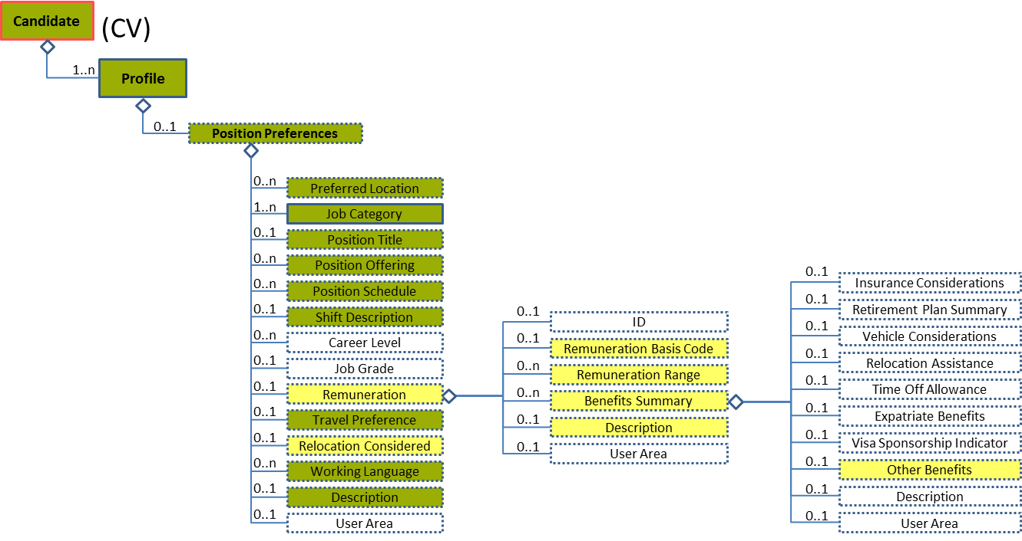
Figure 141: Benefits Summary Level 4 Entity Diagram
Element | Description | Layer /  Cardinality |  | Rule | Examples
Benefits Summary | Summary of benefits |  | EURES Optional  /  0..n | N/A | N/A
Sub-elements
Other Benefits | Details of benefits |  | EURES Optional  /  0..1 | N/A | N/A
 | See section “4.20.8.2 Benefits Summary Attributes” for more information

Benefits Summary Attributes
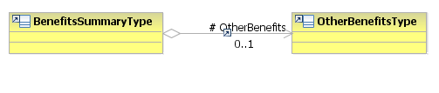
Figure 142: BenefitsSummary Attributes Schema
Attributes | Description | Card. | Rule
This element has no attributes.
OtherBenefits sub-element
Attributes | Description | Card. | Rule
See section “4.20.9.2 Other Benefits Attributes” for more information

Sub-element: /Offered Remuneration/Benefits Summary/Other Benefits (level 5)

Other Benefits Element Description
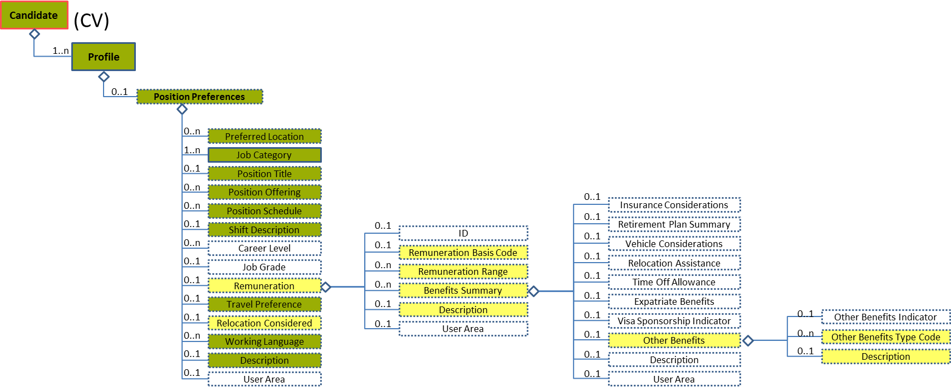
Figure 143: Other Benefits Level 5 Entity Diagram
Element | Description | Cardinality |  | Rule | Examples
Other Benefits | Details of the other benefits |  | EURES Optional  /  0..1 | N/A | N/A
Sub-elements
Other Benefits Type Code | Code of benefits that the candidate would like |  | EURES Optional  /  0..n | BR-COM-40: Compulsory use of the “EURES_SocialBenefitsCodes-CodeList.gc” list defined by EURES.  BR-COM-43: Multiple entries of this code list are allowed. | “0” = Accommodation included,  “1” = Meals included, etc.  Full code list: “4.28.36 Social Benefits Codes [CL52]”
Description | Narrative details of benefits |  | EURES Optional  /  0..1 | N/A | “Description of other benefits”, etc.

Other Benefits Attributes
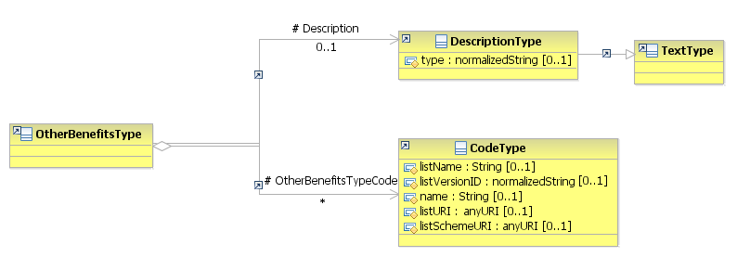
Figure 144: OtherBenefits Attributes Schema
Attributes | Description | Card. | Rule
This element has no attributes.
OtherBenefitsTypeCode sub-element
Attributes | Description | Card. | Rule
listName | The code list name | 0..1 | N/A
listVersionID | The code list identification | 0..1 | N/A
name | The text equivalent of the code content component | 0..1 | N/A
listURI | The Uniform Resource Identifier that identifies where the code list is located | 0..1 | N/A
listSchemeURI | The Uniform Resource Identifier that identifies where the code list scheme is located | 0..1 | N/A
Description sub-element
Attributes | Description | Card. | Rule
type | The comment type | 0..1 | N/A

Sub-element: /Travel Preference (level 3)

Travel Preference Element Description
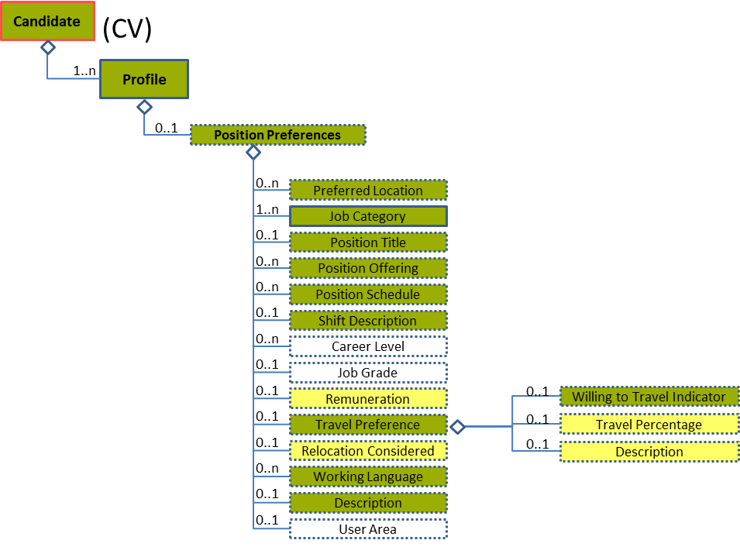
Figure 145: Travel Preference Level 3 Entity Diagram
Element | Description | Layer /  Cardinality |  | Rule | Examples
Travel Preference | Travel Preference Details |  | EURES Conformant  /  0..1 | N/A | N/A
Sub-elements
Willing to Travel Indicator | Indicates that a person is willing to travel within the capacity of his or her position |  | EURES Conformant  /  0..1 | N/A | “True” or “False”
Travel Percentage | A rate, number or proportion per hundred. The percentage of time required for a position or the percentage of time a person is willing to travel for a particular position |  | EURES Optional  /  0..1 | N/A | “25”, “35”, etc.
Description | Description of the travel preference |  | EURES Optional  /  0..1 | N/A | “Description of the travel preference”, etc.

Travel Preference Attributes
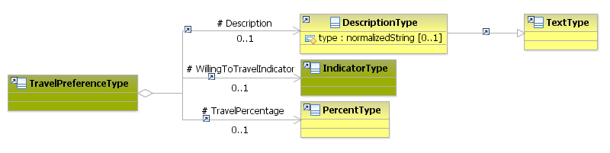
Figure 146: TravelPreference Attributes Schema
Attributes | Description | Card. | Rule
This element has no attributes.
Description sub-element
Attributes | Description | Card. | Rule
type | The comment type | 0..1 | N/A
WillingToTravelIndicator sub-element
Attributes | Description | Card. | Rule
This sub-element has no attributes.
TravelPercentage sub-element
Attributes | Description | Card. | Rule
This sub-element has no attributes.

Sub-element: /Relocation Considered (level 3)

Relocation Considered Element Description
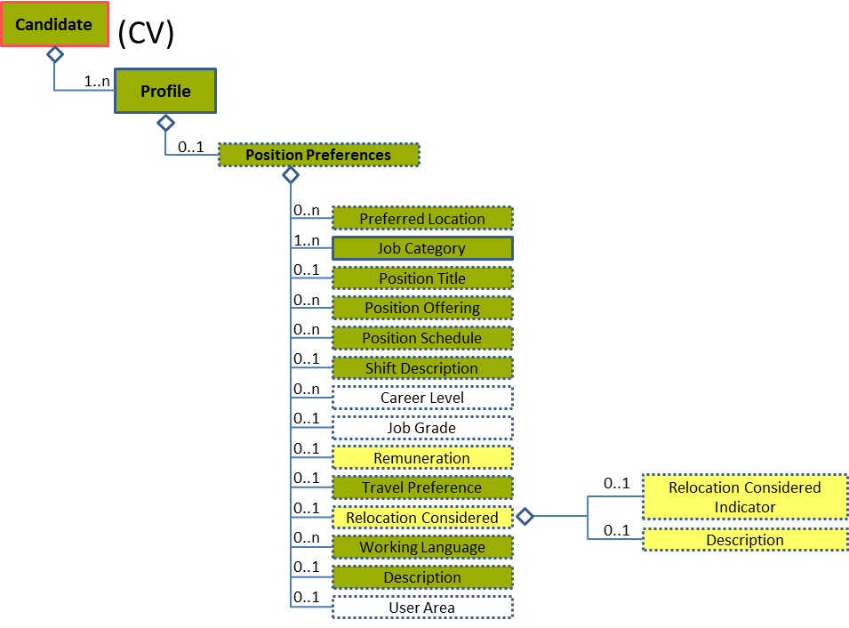
Figure 147: Relocation Considered Level 3 Entity Diagram

Element | Description | Layer /  Cardinality |  | Rule | Examples
Relocation Considered | Indicates if a candidate would consider moving to a new city or location for a suitable position |  | EURES Optional  /  0..1 | N/A | N/A
Sub-elements
Relocation Considered Indicator | Indicates whether relocation is an option for the candidate or considered by the hiring company |  | EURES Optional  /  0..1 | N/A | “True” or “False”
Description | Description of the relocation considered |  | EURES Optional  /  0..1 | N/A | “Description of the relocation considered”, etc.

Relocation Considered Attributes
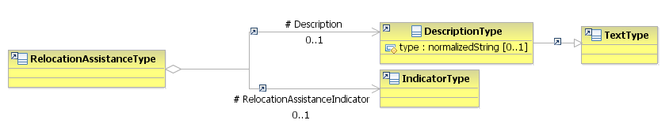
Figure 148: RelocationConsidered Attributes Schema
Attributes | Description | Card. | Rule
This element has no attributes.
Description sub-element
Attributes | Description | Card. | Rule
type | The comment type | 0..1 | N/A
RelocationConsidered sub-element
Attributes | Description | Card. | Rule
This sub-element has no attributes.

/Profile/Licenses (level 2)

Licenses Element Description
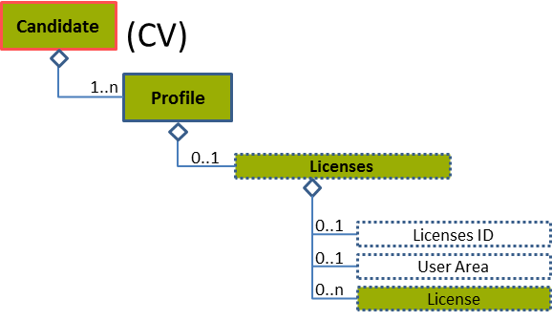
Figure 149: Licenses Level 2 Entity Diagram
Element | Description | Cardinality |  | Rule | Examples
Licenses | Contains details on one or more licenses (driver’s licences) |  | EURES Conformant Optional  /  0..1 | N/A | N/A
Sub-elements
License | Driving permission or authorisation |  | EURES Conformant Optional  /  0..n | N/A | N/A
 | See section “4.21.3 Sub-element: /License (level 3)” for more information

Licenses Attributes
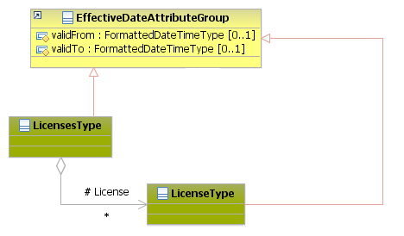
Figure 150: Licenses Attributes Schema
Attributes | Description | Card. | Rule
validFrom | Validity start date for this entity’s information | 0..1 | BR-COM-05: If not specified, the “validFrom” date will default to “assigned by EURES on reception”.  BR-COM-06: Compulsory Date Format is: YYYY-MM-DD, YYYY-MM, YYYY or YYYY-MM-DDThh:mm:ss.
validTo | Validity end date for this entity’s information | 0..1 | BR-COM-07: If not specified, the “validTo” date will be decided by EURES depending on the transaction context.  BR-COM-06: Compulsory Date Format is: YYYY-MM-DD, YYYY-MM, YYYY or YYYY-MM-DDThh:mm:ss.
License sub-element
Attributes | Description | Card. | Rule
See section “4.21.3.2 License Attributes” for more information

Sub-element: /License (level 3)

License Element Description
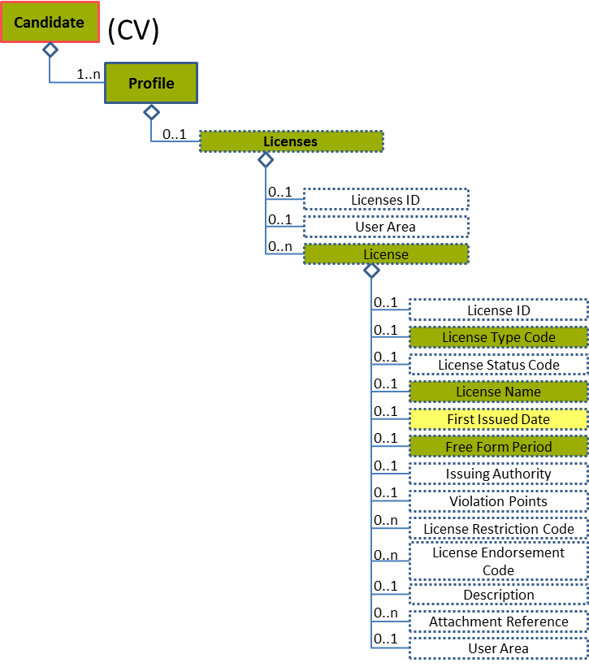
Figure 151: License Level 2 Entity Diagram
Element | Description | Cardinality |  | Rule | Examples
License | Driving permission or authorisation |  | EURES Conformant Optional  /  0..n | N/A | N/A
Sub-elements
License Type Code | A code classifying the type of driving license |  | EURES Conformant Optional  /  0..1 | BR-COM-41: Compulsory use of the “EURES_LicenseTypeCode-CodeList” list. This is based on Directive 2006/126/EC. | “AM”, “A1”, “A2”, “A”, etc.  Full code list: “4.28.11 Drivers License Codes [CL14] ”
License Name | The name of the credential |  | EURES Conformant Optional  /  0..1 | N/A | “A1”, “B”, etc.
First Issued Date | Date of first issuing of the license |  | EURES Optional  /  0..1 | BR-COM-16: At least one of its sub-elements must be provided. | N/A
 | See section “4.21.4 Sub-element: /License/First Issued Date (level 4)” for more information
Free Form Period | Provides Freeform options for representing the period during which a license, credential, or other related entity is effective |  | EURES Conformant Optional  /  0..1 | N/A | N/A
 | See section “4.21.5 Sub-element: /License/Free Form Period (level 4)” for more information

License Attributes
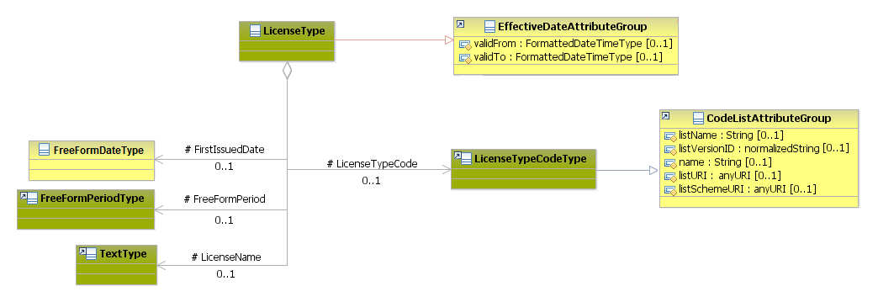
Figure 152: License Attributes Schema
Attributes | Description | Card. | Rule
validFrom | Validity start date for this entity’s information | 0..1 | BR-COM-06: Compulsory Date Format is: YYYY-MM-DD, YYYY-MM, YYYY or YYYY-MM-DDThh:mm:ss.
validTo | Validity end date for this entity’s information | 0..1 | BR-COM-06: Compulsory Date Format is: YYYY-MM-DD, YYYY-MM, YYYY or YYYY-MM-DDThh:mm:ss.
LicenseTypeCode sub-element
Attributes | Description | Card. | Rule
listName | The code list name | 0..1 | N/A
listVersionID | The code list identification | 0..1 | N/A
name | The text equivalent of the code content component | 0..1 | N/A
listURI | The Uniform Resource Identifier that identifies where the code list is located | 0..1 | N/A
listSchemeURI | The Uniform Resource Identifier that identifies where the code list scheme is located | 0..1 | N/A
FirstIssuedDate sub-element
Attributes | Description | Card. | Rule
See section “4.21.4.2 First Issued Date Attributes” for more information
FreeFormPeriod sub-element
Attributes | Description | Card. | Rule
See section “4.21.5.2 Free Form Period Attributes” for more information
LicenseName sub-element
Attributes | Description | Card. | Rule
This sub-element has no attributes.

Sub-element: /License/First Issued Date (level 4)

First Issued Date Element Description
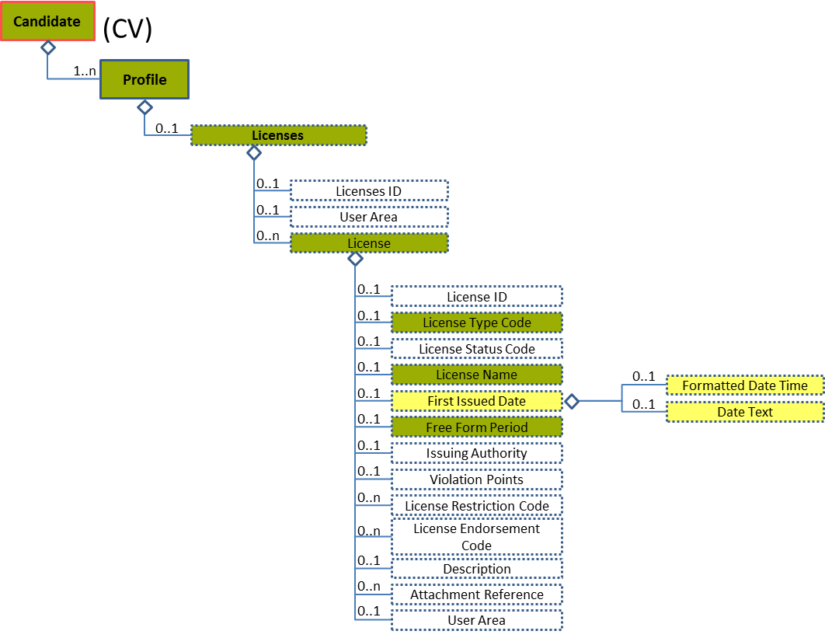
Figure 153: First Issued Date Level 4 Entity Diagram
Element | Description | Layer /  Cardinality |  | Rule | Examples
First Issued Date | The first date issued |  | EURES Optional  /  0..1 | BR-COM-16: At least one of its sub-elements must be provided. | N/A
Sub-elements
The same as “4.13.5.1
Sub-element: /Organization Attendance/Education Degree/Degree Date (level 5)

”

First Issued Date Attributes
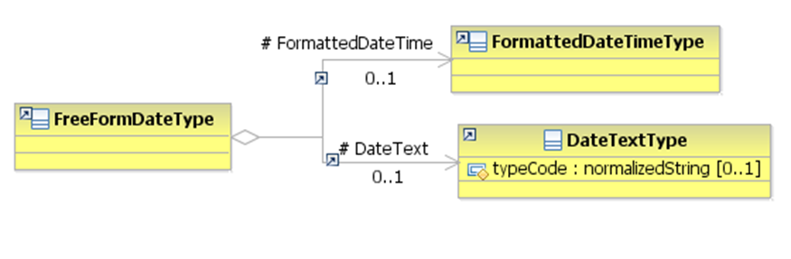
Figure 154: FirstIssuedDate Attributes Schema
Attributes | Description | Card. | Rule
The same as “4.13.5.2 Degree Date Attributes”

Sub-element: /License/Free Form Period (level 4)

Free Form Period Element Description
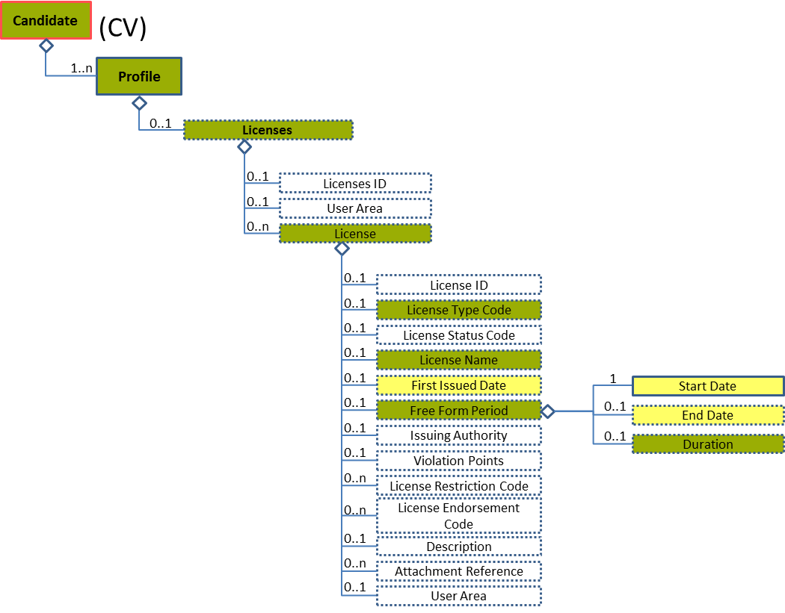
Figure 155: Free Form Period Level 4 Entity Diagram
Element | Description | Layer /  Cardinality |  | Rule | Examples
Free Form Period | Provides freeform options for representing the period during which a license, credential, or other related entity is effective |  | EURES Conformant Optional  /  0..1 | N/A | N/A
Sub-elements
The same as “4.18.5.1 Free Form Effective Period ”

Free Form Period Attributes
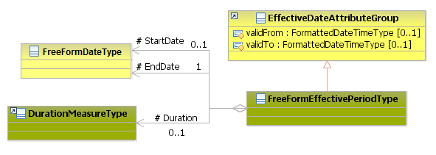
Figure 156: FreeFormPeriod Attributes Schema
Attributes | Description | Card. | Rule
The same as “4.18.5.2 Free Form Effective Period Attributes”

/Profile/Military History (level 2)

Military History Element Description
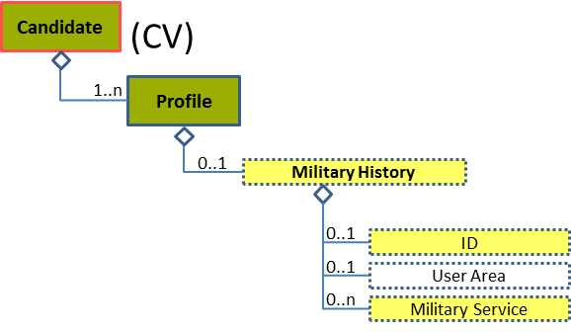
Figure 157: Military History Level 2 Entity Diagram
Element | Description | Layer /  Cardinality |  | Rule | Examples
Military History | Information about the person’s military service |  | EURES Optional  /  0..1 | N/A | N/A
Sub-elements
ID | Identifier of military history |  | EURES Optional  /  0..1 | N/A | “MIL-1234”, “344”, etc.
Military Service | Description of military service |  | EURES Optional  /  0..n | N/A | N/A
 | See section “4.22.3 Sub-element: /Military Service (level 3)” for more information

Military History Attributes
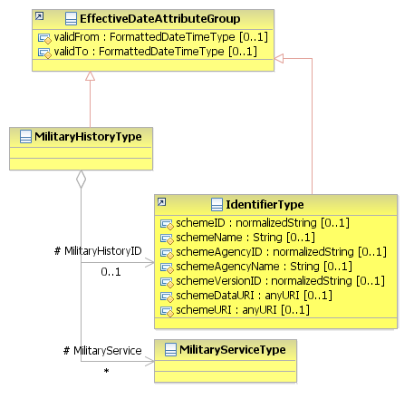
Figure 158: Military History Attributes Schema
Attributes | Description | Card. | Rule
validFrom | Validity start date for this entity’s information | 0..1 | BR-COM-05: If not specified, the “validFrom” date will default to “assigned by EURES on reception”.  BR-COM-06: Compulsory Date Format is: YYYY-MM-DD, YYYY-MM, YYYY or YYYY-MM-DDThh:mm:ss.
validTo | Validity end date for this entity’s information | 0..1 | BR-COM-07: If not specified, the “validTo” date will be decided by EURES depending on the transaction context.  BR-COM-06: Compulsory Date Format is: YYYY-MM-DD, YYYY-MM, YYYY or YYYY-MM-DDThh:mm:ss.
MilitaryHistoryID sub-element
Attributes | Description | Card. | Rule
schemeID | Identification of the identifier scheme | 0..1 | N/A
schemeName | The identification scheme name | 0..1 | N/A
schemeAgencyID | Identification of the agency that maintains the scheme | 0..1 | N/A
schemeAgencyName | The name of the agency that maintains the scheme | 0..1 | N/A
schemeVersionID | The identification scheme version. | 0..1 | N/A
schemeDataURI | The Uniform Resource Identifier that identifies where the data scheme is located | 0..1 | N/A
schemeURI | The Uniform Resource Identifier that identifies where the scheme is located | 0..1 | N/A
validFrom | Validity start date for this entity’s information. | 0..1 | BR-COM-05: If not specified, the “validFrom” date will default to “assigned by EURES on reception”.  BR-COM-06: Compulsory Date Format is: YYYY-MM-DD, YYYY-MM, YYYY or YYYY-MM-DDThh:mm:ss.
validTo | Validity end date for this entity’s information | 0..1 | BR-COM-07: If not specified, the “validTo” date will be decided by EURES depending on the transaction context.  BR-COM-06: Compulsory Date Format is: YYYY-MM-DD, YYYY-MM, YYYY or YYYY-MM-DDThh:mm:ss.
MilitaryService sub-element
Attributes | Description | Card. | Rule
See section “4.22.3.2 Military Service attributes” for more information

Sub-element: /Military Service (level 3)

Military Service Element Description
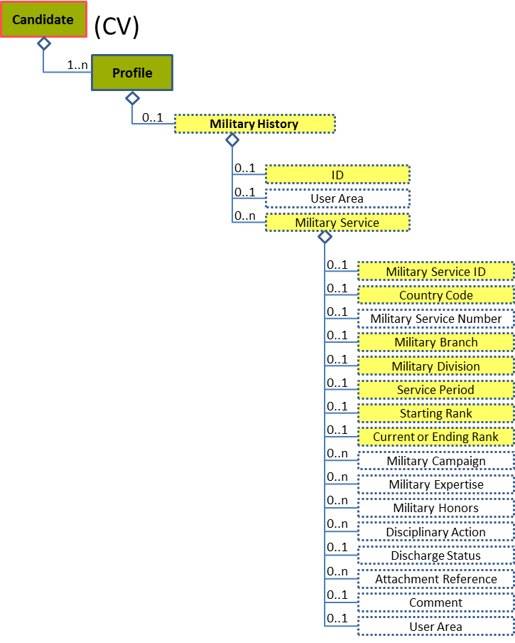
Figure 159: Military Service Level 3 Entity Diagram
Element | Description | Layer /  Cardinality |  | Rule | Examples
Military Service | Description of military service |  | EURES Optional  /  0..n | N/A | N/A
Sub-elements
Military Service ID | Identifier of military service |  | EURES Optional  /  0..1 | N/A | “MS-291”, “MS-121”, etc.
Country Code | A code specifying the country where the candidate did/does military service |  | EURES Optional  /  0..1 | BR-COM-12: Compulsory use of the “Countries-CodeList.gc” list defined by EURES. This is based on ISO 3166-1 Alpha-2, which includes all countries of the world. | “AR” – Argentina, “AU” – Austria, “CS” – Costa Rica, etc.  Full code list: “4.28.5 Country Codes [CL07]”
Military Branch | The military office or department in which the person served |  | EURES Optional  /  0..1 | N/A | “Army”, “Navy”, etc.
Military Division | A portion of an army or fleet, consisting of a definite number of troops or vessels, under one commanding officer; also applied to a definite portion of a squadron or battalion |  | EURES Optional  /  0..1 | N/A | “Air assault”, “Armoured”, “Infantry”, etc.
Service Period | The period of military service |  | EURES Optional  /  0..1 | N/A | N/A
 | See section “4.22.4 Sub-element: /Military Service/Service Period (level 4)” for more information
Starting Rank | Start rank |  | EURES Optional  /  0..1 | N/A | “Subordinate officer”, “Air officer”, etc.
Current or Ending Rank | Current or final rank |  | EURES Optional  /  0..1 | N/A | “Warrant office”, “General”, etc.

Military Service attributes
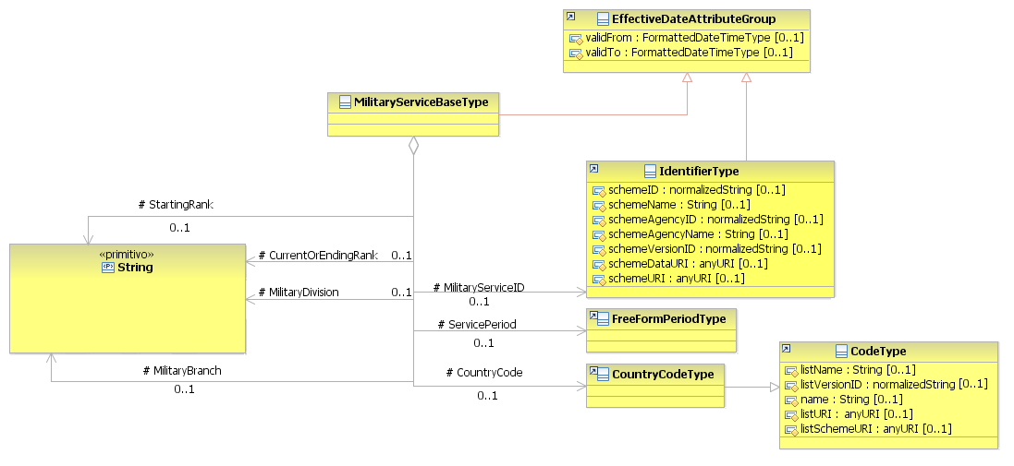
Figure 160: Military Service Attributes schema
Attributes | Description | Card. | Rule
validFrom | Validity start date for this entity’s information | 0..1 | BR-COM-05: If not specified, the “validFrom” date will default to “assigned by EURES on reception”.  BR-COM-06: Compulsory Date Format is: YYYY-MM-DD, YYYY-MM, YYYY or YYYY-MM-DDThh:mm:ss.
validTo | Validity end date for this entity’s information | 0..1 | BR-COM-07: If not specified, the “validTo” date will be decided by EURES depending on the transaction context.  BR-COM-06: Compulsory Date Format is: YYYY-MM-DD, YYYY-MM, YYYY or YYYY-MM-DDThh:mm:ss.
MilitaryServiceID sub-element
Attributes | Description | Card. | Rule
schemeID | Identification of the identifier scheme | 0..1 | N/A
schemeName | The identification scheme name | 0..1 | N/A
schemeAgencyID | Identification of the agency that maintains the scheme | 0..1 | N/A
schemeAgencyName | The name of the agency that maintains the scheme | 0..1 | N/A
schemeVersionID | The identification scheme version | 0..1 | N/A
schemeDataURI | The Uniform Resource Identifier that identifies where the data scheme is located | 0..1 | N/A
schemeURI | The Uniform Resource Identifier that identifies where the scheme is located | 0..1 | N/A
validFrom | Validity start date for this entity’s information. | 0..1 | BR-COM-05: If not specified, the “validFrom” date will default to “assigned by EURES on reception”.  BR-COM-06: Compulsory Date Format is: YYYY-MM-DD, YYYY-MM, YYYY or YYYY-MM-DDThh:mm:ss.
validTo | Validity end date for this entity’s information | 0..1 | BR-COM-07: If not specified, the “validTo” date will be decided by EURES depending on the transaction context.  BR-COM-06: Compulsory Date Format is: YYYY-MM-DD, YYYY-MM, YYYY or YYYY-MM-DDThh:mm:ss.
ServicePeriod sub-element
Attributes | Description | Card. | Rule
See section “4.22.4.2 Service Period Attributes” for more information
CountryCode sub-element
Attributes | Description | Card. | Rule
listName | The code list name. | 0..1 | N/A
listVersionID | The code list identification. | 0..1 | N/A
name | The text equivalent of the code content component | 0..1 | N/A
listURI | The Uniform Resource Identifier that identifies where the code list is located | 0..1 | N/A
listSchemeURI | The Uniform Resource Identifier that identifies where the code list scheme is located | 0..1 | N/A
StartingRank sub-element
Attributes | Description | Card. | Rule
This sub-element has no attributes.
CurrentOrEndingRank sub-element
Attributes | Description | Card. | Rule
This sub-element has no attributes.
MilitaryDivision sub-element
Attributes | Description | Card. | Rule
This sub-element has no attributes.
MilitaryBranch sub-element
Attributes | Description | Card. | Rule
This sub-element has no attributes.

Sub-element: /Military Service/Service Period (level 4)

Service Period Element Description
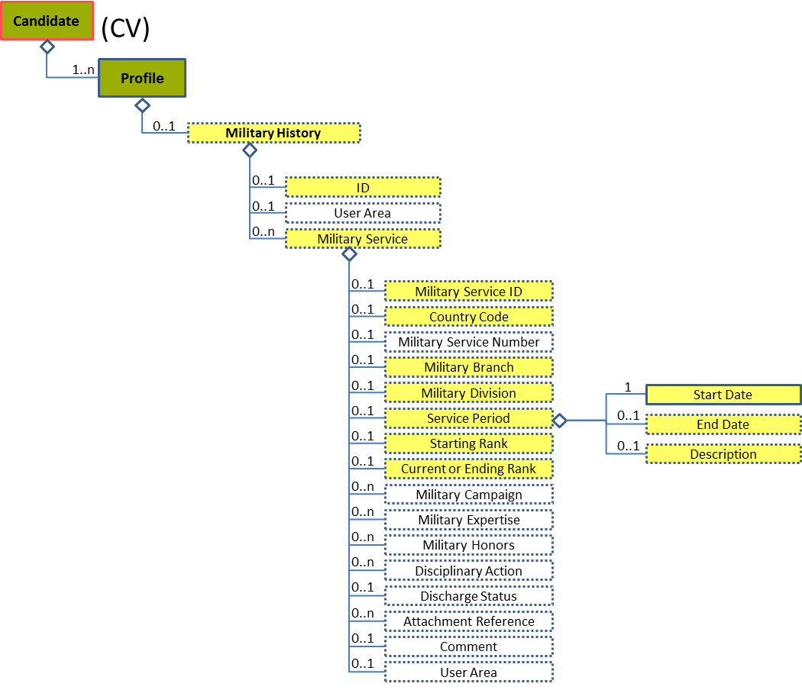
Figure 161: Service Period Level 4 Entity Diagram
Element | Description | Layer /  Cardinality |  | Rule | Examples
Service Period | The period of military service |  | EURES Optional  /  0..1 | N/A | N/A
Sub-elements
The same as “4.13.7 Sub-element: /Organization Attendance/Attendance Period (level 4)”

Service Period Attributes
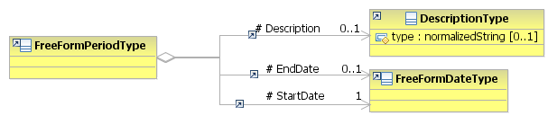
Figure 162: Service Period Attributes Schema
Attributes | Description | Card. | Rule
The same as “4.13.7.2 Attendance Period Attributes”

/Profile/Patent History (level 2)

Patent History Element Description
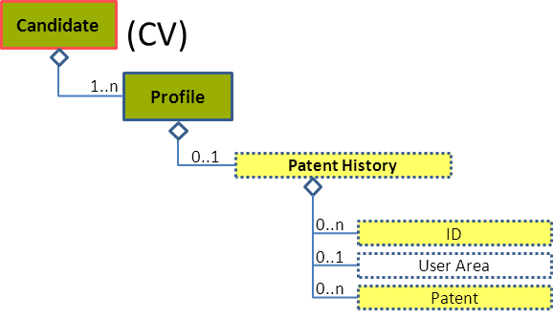
Figure 163: Patent History Level 2 Entity Diagram
Element | Description | Layer /  Cardinality |  |  | Rule | Examples
Patent History | Information about the Patents owned by the Person |  |  | EURES Optional  /  0..1 | N/A | N/A
Sub-elements
ID | Identifier of the patent history |  |  | EURES Optional  /  0..n | N/A | “PT-1234”, “344”, etc.
Patent | A licence from a government conferring for a set period the sole right to make, use, or sell some process or invention |  |  | EURES Optional  /  0..n | N/A | N/A
 | See section “4.23.3 Sub-element: /Patent (level 3)” for more information

Patent History Attributes
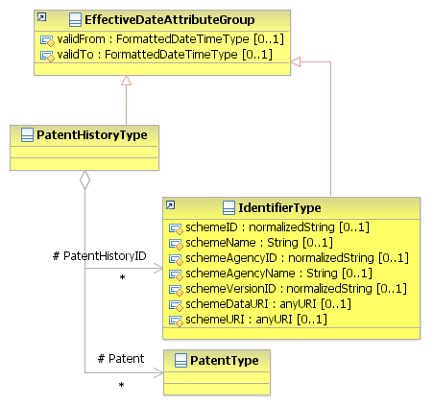
Figure 164: Patent History Attributes Schema
Attributes | Description | Card. | Rule
validFrom | Validity start date for this entity’s information | 0..1 | BR-COM-05: If not specified, the “validFrom” date will default to “assigned by EURES on reception”.  BR-COM-06: Compulsory Date Format is: YYYY-MM-DD, YYYY-MM, YYYY or YYYY-MM-DDThh:mm:ss.
validTo | Validity end date for this entity’s information | 0..1 | BR-COM-07: If not specified, the “validTo” date will be decided by EURES depending on the transaction context.  BR-COM-06: Compulsory Date Format is: YYYY-MM-DD, YYYY-MM, YYYY or YYYY-MM-DDThh:mm:ss.
PatentHistoryID sub-element
Attributes | Description | Card. | Rule
schemeID | Identification of the identifier scheme | 0..1 | N/A
schemeName | The identification scheme name | 0..1 | N/A
schemeAgencyID | Identification of the agency that maintains the scheme | 0..1 | N/A
schemeAgencyName | The name of the agency that maintains the scheme | 0..1 | N/A
schemeVersionID | The identification scheme version | 0..1 | N/A
schemeDataURI | The Uniform Resource Identifier that identifies where the data scheme is located | 0..1 | N/A
schemeURI | The Uniform Resource Identifier that identifies where the scheme is located | 0..1 | N/A
validFrom | Validity start date for this entity’s information | 0..1 | BR-COM-05: If not specified, the “validFrom” date will default to “assigned by EURES on reception”.  BR-COM-06: Compulsory Date Format is: YYYY-MM-DD, YYYY-MM, YYYY or YYYY-MM-DDThh:mm:ss.
validTo | Validity end date for this entity’s information | 0..1 | BR-COM-07: If not specified, the “validTo” date will be decided by EURES depending on the transaction context.  BR-COM-06: Compulsory Date Format is: YYYY-MM-DD, YYYY-MM, YYYY or YYYY-MM-DDThh:mm:ss.
Patent sub-element
Attributes | Description | Card. | Rule
See section “4.23.3.2 Patent Attributes” for more information

Sub-element: /Patent (level 3)

Patent Element Description
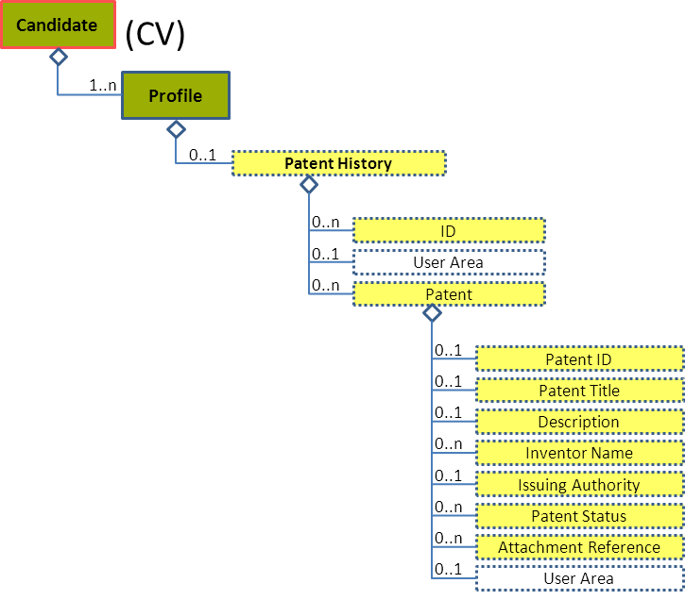
Figure 165: Patent Level 3 Entity Diagram
Element | Description | Layer /  Cardinality |  | Rule | Examples
Patent | A licence from a government conferring for a set period the sole right to make, use, or sell some process or invention |  | EURES Optional  /  0..n | N/A | N/A
Sub-elements
Patent ID | Identifier of the patent |  | EURES Optional  /  0..1 | N/A | “PT-1234”, “344”, etc.
Patent Title | The name of the patent |  | EURES Optional  /  0..1 | N/A | “Tray Device”, “Carton”, etc.
Description | Description of the patent |  | EURES Optional  /  0..1 | N/A | “A tray device applied in a server is provided. The server includes a housing.”, etc.
Inventor Name | The name of the person who devised or produced the patented item |  | EURES Optional  /  0..n | N/A | “John K., Sarah H.”, etc.
Issuing Authority | An agency, bureau, or other organization issuing an associated identifier, license, or certificate; the body or people exercising power or command. An issuing authority is often a government agency or official authority, but can sometimes be a private organization. |  | EURES Optional  /  0..1 | N/A | N/A
 | See section “4.23.4 Sub-element: /Patent/Issuing Authority (level 4)” for more information
Patent Status | The status of the patent. This stages or steps would generally be set by the government agency administering patent applications, for example, "patent pending". |  | EURES Optional  /  0..n | N/A | N/A
 | See section “4.23.5 Sub-element: /Patent/Patent Status (level 4)” for more information
Attachment Reference | Reference to external documents attached |  | EURES Optional  /  0..n | N/A | N/A
 | See section “4.23.6 Sub-element: /Patent/Attachment Reference (level 4)” for more information

Patent Attributes
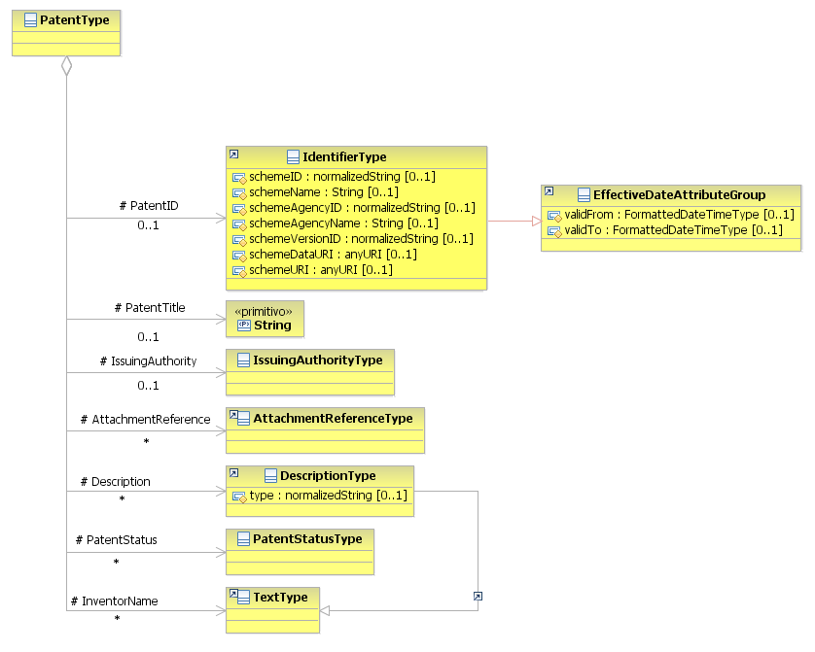
Figure 166: Patent Attributes Schema
Attributes | Description | Card. | Rule
This element has no attributes.
PatentID sub-element
Attributes | Description | Card. | Rule
schemeID | Identification of the identifier scheme | 0..1 | N/A
schemeName | The identification scheme name | 0..1 | N/A
schemeAgencyID | Identification of the agency that maintains the scheme | 0..1 | N/A
schemeAgencyName | The name of the agency that maintains the scheme | 0..1 | N/A
schemeVersionID | The identification scheme version | 0..1 | N/A
schemeDataURI | The Uniform Resource Identifier that identifies where the data scheme is located | 0..1 | N/A
schemeURI | The Uniform Resource Identifier that identifies where the scheme is located | 0..1 | N/A
validFrom | Validity start date for this entity’s information | 0..1 | BR-COM-05: If not specified, the “validFrom” date will default to “assigned by EURES on reception”.  BR-COM-06: Compulsory Date Format is: YYYY-MM-DD, YYYY-MM, YYYY or YYYY-MM-DDThh:mm:ss.
validTo | Validity end date for this entity’s information | 0..1 | BR-COM-07: If not specified, the “validTo” date will be decided by EURES depending on the transaction context.  BR-COM-06: Compulsory Date Format is: YYYY-MM-DD, YYYY-MM, YYYY or YYYY-MM-DDThh:mm:ss.
PatentTitle sub-element
Attributes | Description | Card. | Rule
This sub-element has no attributes.
IssuingAuthority sub-element
Attributes | Description | Card. | Rule
See section “4.23.4.2 Issuing Authority Attributes” for more information
AttachmentReference sub-element
Attributes | Description | Card. | Rule
See section “4.23.6.2 Attachment Reference Attributes” for more information
Description sub-element
Attributes | Description | Card. | Rule
type | The comment type | 0..1 | N/A
PatentStatus sub-element
Attributes | Description | Card. | Rule
See section “4.23.5.2 Patent Status Attributes” for more information
InventorName sub-element
Attributes | Description | Card. | Rule
This sub-element has no attributes.

Sub-element: /Patent/Issuing Authority (level 4)

Issuing Authority Element Description
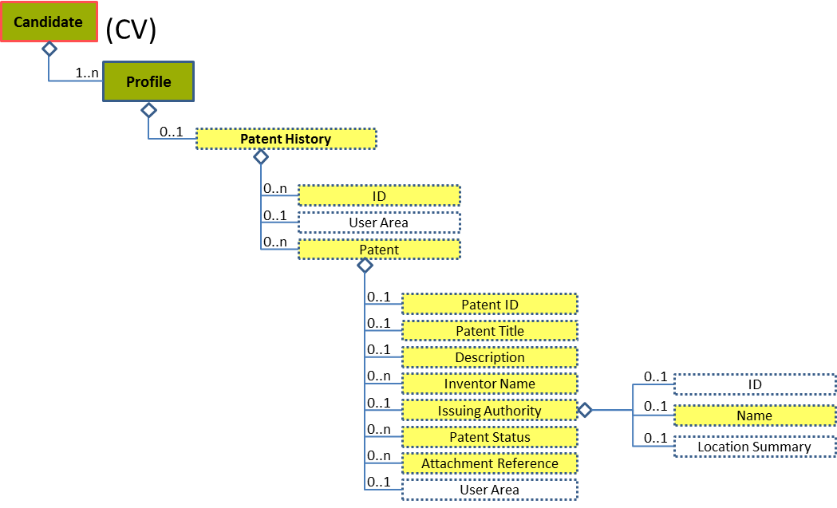
Figure 167: Issuing Authority Level 4 Entity Diagram
Element | Description |  | Layer /  Cardinality |  | Rule | Examples
Issuing Authority | An agency, bureau, or other organization issuing an associated identifier, license, or certificate; the body or people exercising power or command. An issuing authority is often a government agency or official authority, but sometimes might be a private organization. |  |  | EURES Optional  /  0..1 | N/A | N/A
Sub-elements
Name |  | Identifies the Name of the associated object |  | EURES Optional  /  0..1 | N/A | “Organization”, etc.

Issuing Authority Attributes
Figure 168: Issuing Authority Attributes Schema
Attributes | Description | Card. | Rule
This element has no attributes.
Name sub-element
Attributes | Description | Card. | Rule
sequence | Establishes the order of the contact data | 0..1 | N/A
sequenceName | Establishes the order of the contact data | 0..1 | N/A

Sub-element: /Patent/Patent Status (level 4)

Patent Status Element Description
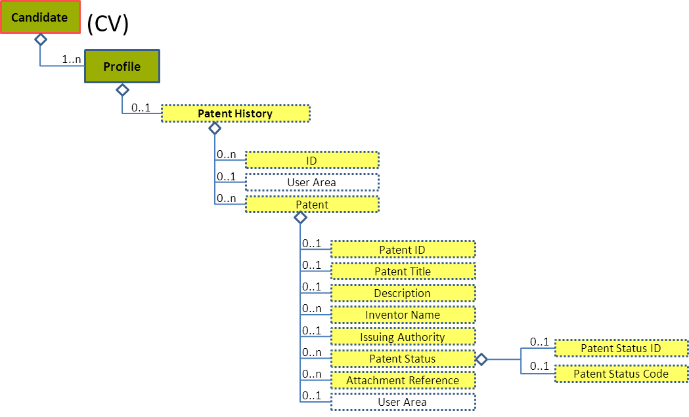
Figure 169: Patent Status 3 Entity Diagram
Element | Description | Layer /  Cardinality |  | Rule | Examples
Patent Status | The status of the patent. These stages or steps would generally be set by the government agency administering patent applications, for example, "patent pending". |  | EURES optional  /  0..n | N/A | N/A
Sub-elements
Patent Status ID | The identifier of the patent status |  | EURES Optional  /  0..1 | N/A | “PS-1234”, “344”, etc.
Patent Status Code | A code classifying the current or reported status of the associated patent  This is an HR-Open Standards open list. |  | EURES Optional  /  0..1 | BR-CV-26: Compulsory use of the “PatentStatusCode” list. | “PatentIssued”, “PatentPending”,  “PatentFiled”  Full code list: “4.28.25 Patent Status Enum-Type Codes [CL36] ”

Patent Status Attributes
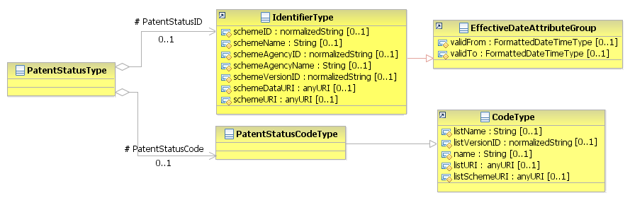
Figure 170: PatentStatus Attributes Schema
Attributes | Description | Card. | Rule
This element has no attributes.
PatentStatusID sub-element
Attributes | Description | Card. | Rule
schemeID | Identification of the identifier scheme | 0..1 | N/A
schemeName | The identification scheme name | 0..1 | N/A
schemeAgencyID | Identification of the agency that maintains the scheme | 0..1 | N/A
schemeAgencyName | The name of the agency that maintains the scheme | 0..1 | N/A
schemeVersionID | The identification scheme version | 0..1 | N/A
schemeDataURI | The Uniform Resource Identifier that identifies where the data scheme is located | 0..1 | N/A
schemeURI | The Uniform Resource Identifier that identifies where the scheme is located | 0..1 | N/A
validFrom | Validity start date for this entity’s information. | 0..1 | BR-COM-05: If not specified, the “validFrom” date will default to “assigned by EURES on reception”.  BR-COM-06: Compulsory Date Format is: YYYY-MM-DD, YYYY-MM, YYYY or YYYY-MM-DDThh:mm:ss.
validTo | Validity end date for this entity’s information | 0..1 | BR-COM-07: If not specified, the “validTo” date will be decided by EURES depending on the transaction context.  BR-COM-06: Compulsory Date Format is: YYYY-MM-DD, YYYY-MM, YYYY or YYYY-MM-DDThh:mm:ss.
PatentStatusCode sub-element
Attributes | Description | Card. | Rule
listName | The code list name | 0..1 | N/A
listVersionID | The code list identification | 0..1 | N/A
name | The text equivalent of the code content component | 0..1 | N/A
listURI | The Uniform Resource Identifier that identifies where the code list is located | 0..1 | N/A
listSchemeURI | The Uniform Resource Identifier that identifies where the code list scheme is located | 0..1 | N/A

Sub-element: /Patent/Attachment Reference (level 4)

Attachment Reference Element Description
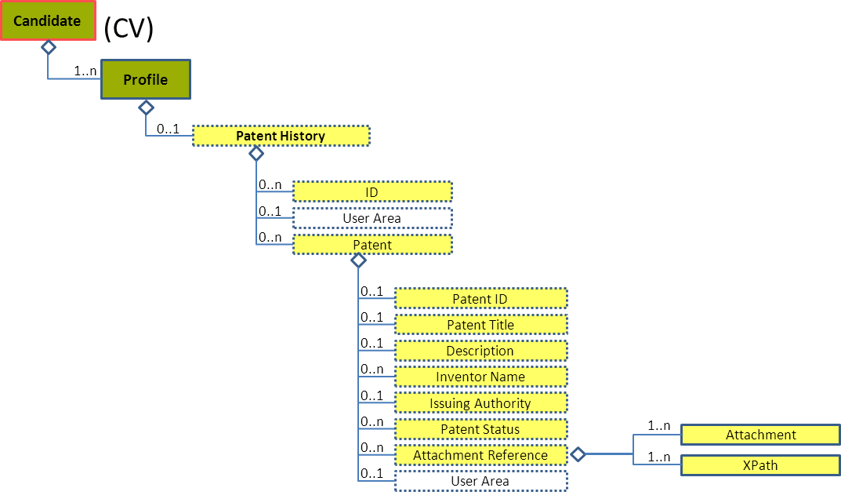
Figure 171: Attachment Reference Level 4 Entity Diagram
Element | Description | Layer /  Cardinality |  | Rule | Examples
Attachment Reference | Reference to the external documents attached |  | EURES Optional  /  0..n | N/A | N/A
Sub-elements
The same as “4.16.14.1 Attachment Reference Element Description”

Attachment Reference Attributes
Figure 172: Attachment Reference Attributes Schema
Attributes | Description | Card. | Rule
The same as “4.16.14.2 Attachment Reference Attributes”.

/Profile/Publication History (level 2)

Publication History Element Description
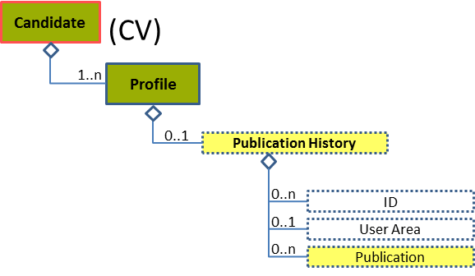
Figure 173: Publication History Level 2 Entity Diagram
Element | Description | Layer /  Cardinality |  | Rule | Examples
Publication History | A collection of information about one or more text publications by the Candidate |  | EURES Optional  /  0..1 | N/A | N/A
Sub-elements
Publication | A book, map, engraving, photograph, piece of music, or other work |  | EURES Optional  /  0..n | N/A | N/A
 | See section “4.24.3 Sub-element: /Publication (level 3)” for more information

Publication History Attributes
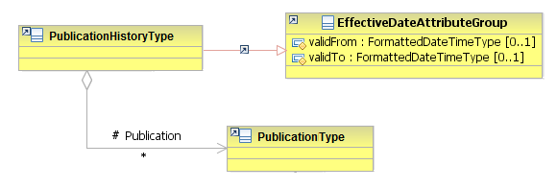
Figure 174: Publication History Attributes Schema
Attributes | Description | Card. | Rule
validFrom | Validity start date for this entity’s information | 0..1 | BR-COM-05: If not specified, the “validFrom” date will default to “assigned by EURES on reception”.  BR-COM-06: Compulsory Date Format is: YYYY-MM-DD, YYYY-MM, YYYY or YYYY-MM-DDThh:mm:ss.
validTo | Validity end date for this entity’s information | 0..1 | BR-COM-07: If not specified, the “validTo” date will be decided by EURES depending on the transaction context.  BR-COM-06: Compulsory Date Format is: YYYY-MM-DD, YYYY-MM, YYYY or YYYY-MM-DDThh:mm:ss.
Publication sub-element
Attributes | Description | Card. | Rule
See section “4.24.3.2 Publication Attributes” for more information

Sub-element: /Publication (level 3)

Publication Element Description
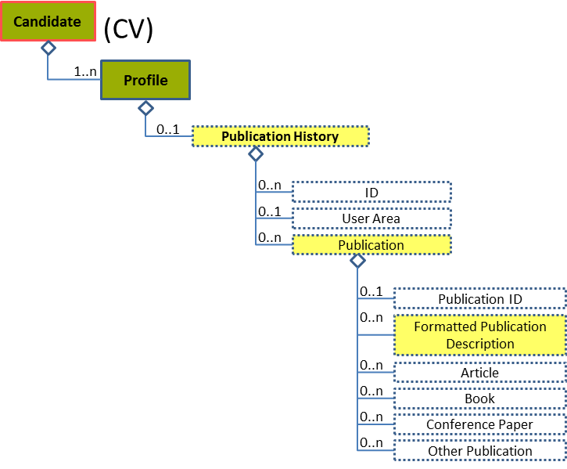
Figure 175: Publication Level 3 Entity Diagram
Element | Description | Layer /  Cardinality |  | Rule | Examples
Publication | A book, map, engraving, photograph, piece of music, or other work |  | EURES Optional  /  0..n | N/A | N/A
Sub-elements
Formatted Publication Description | An unfiled or formatted description of a publication |  | EURES Optional  /  0..n | N/A | “Article about Machine Learning in the Weekend Magazine”

Publication Attributes
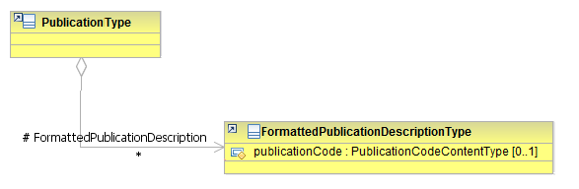
Figure 176: Publication Attributes Schema
Attributes | Description | Card. | Rule
This element has no attributes.
FormattedPublicationDescription sub-element
Attributes | Description | Card. | Rule
publicationCode | Code to describe the type of publication  This is an HR-Open Standards code list (full code list “4.28.30 Publication Enum-Type Codes [CL59]”) | 0..1 | BR-CV-27: Compulsory use of the “PulblicationCode” list.

/Profile/Organization Affiliations (level 2)

Organization Affiliations Element Description
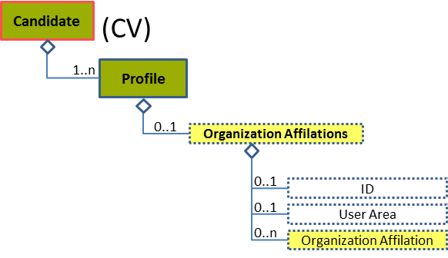
Figure 177: Organization Affiliations Level 2 Entity Diagram
Element | Description | Layer /  Cardinality |  | Rule | Examples
Organization Affiliations | Contains details on one or more organization affiliations. For example, membership in a trade or civic organization, seat on an organization’s board of directors, membership in a union, etc. |  | EURES Optional  /  0..1 | N/A | N/A
Sub-elements
Organization Affiliation | Contains information about a person's affiliation with a trade, professional, or similar organization or group formed around a common purpose or cause |  | EURES Optional  /  0..n | N/A | N/A
 | See section “4.25.3 Sub-element: /Organization Affiliation (level 3)” for more information

Organization Affiliations Attributes
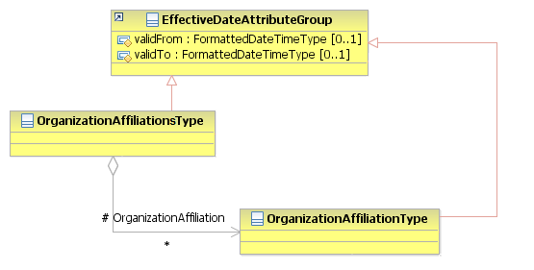
Figure 178: Organization Affiliations Attributes Schema
Attributes | Description | Card. | Rule
validFrom | Validity start date for this entity’s information | 0..1 | BR-COM-06: Compulsory Date Format is: YYYY-MM-DD, YYYY-MM, YYYY or YYYY-MM-DDThh:mm:ss.
validTo | Validity end date for this entity’s information | 0..1 | BR-COM-06: Compulsory Date Format is: YYYY-MM-DD, YYYY-MM, YYYY or YYYY-MM-DDThh:mm:ss.
OrganizationAffiliations sub-element
Attributes | Description | Card. | Rule
See section “4.25.3 Sub-element: /Organization Affiliation (level 3)” for more information

Sub-element: /Organization Affiliation (level 3)

Organization Affiliation Element Description
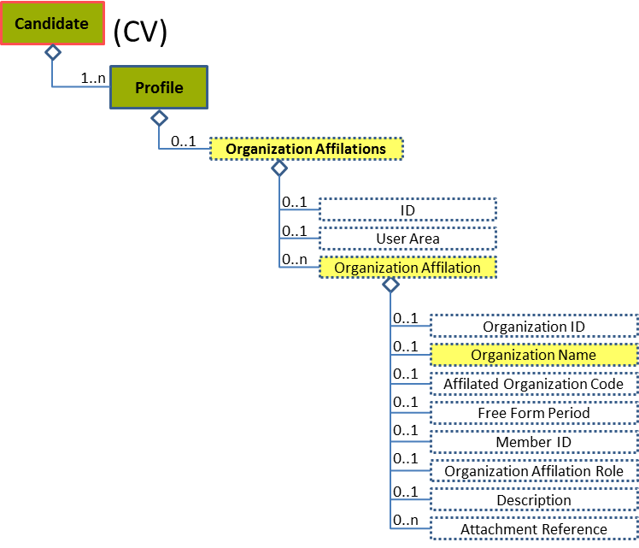
Figure 179: Organization Affiliation Level 3 Entity Diagram
Element | Description | Layer /  Cardinality |  | Rule | Examples
Organization Affiliation | Contains information about a person's affiliation with a trade, professional, or similar organization or group formed around a common purpose or cause |  | EURES Optional  /  0..n | N/A | N/A
Sub-elements
Organization Name | Usually an official or legal name by which to refer to an organization |  | EURES Optional  /  0..1 | N/A | “Name”, etc.

Organization Affiliation Attributes
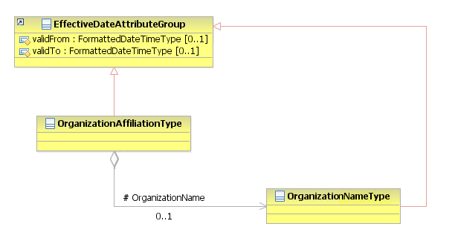
Figure 180: Organization Affiliation Attributes Schema
Attributes | Description | Card. | Rule
This element has no attributes.
OrganizationName sub-element
Attributes | Description | Card. | Rule
validFrom | Validity start date for this entity’s information | 0..1 | BR-COM-06: Compulsory Date Format is: YYYY-MM-DD, YYYY-MM, YYYY or YYYY-MM-DDThh:mm:ss.
validTo | Validity end date for this entity’s information | 0..1 | BR-COM-06: Compulsory Date Format is: YYYY-MM-DD, YYYY-MM, YYYY or YYYY-MM-DDThh:mm:ss.

/Profile/Speaking History (level 2)

Speaking History Element Description
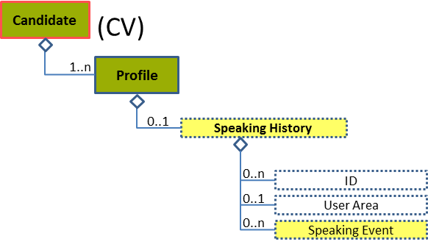
Figure 181: Speaking History Level 2 Entity Diagram
Element | Description | Layer /  Cardinality |  | Rule | Examples
Speaking History | A collection of information about one or more speaking events (as keynotes, for example) given by the person |  | EURES Optional  /  0..1 | N/A | N/A
Sub-elements
Speaking Event | Contains a set of details about an event in which the person was a lecturer or presenter |  | EURES Optional  /  0..n | N/A | N/A
 | See section “4.26.3 Sub-element: /Speaking Event (level 3)” for more information

Speaking History Attributes
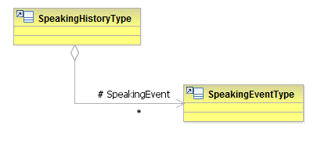
Figure 182: Speaking History Attributes Schema
Attributes | Description | Card. | Rule
This element has no attributes.
OrganizationAffiliations sub-element
Attributes | Description | Card. | Rule
See section “4.26.3.2 Speaking Event Attributes” for more information

Sub-element: /Speaking Event (level 3)

Speaking Event Element Description
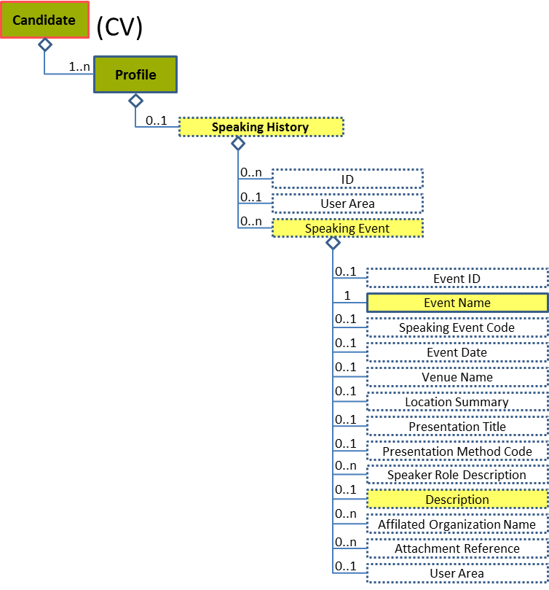
Figure 183: Speaking Event Level 3 Entity Diagram
Element | Description | Layer /  Cardinality |  | Rule | Examples
Speaking Event | Contains a set of details about an event in which the associated person was a lecturer or presenter. |  | EURES Optional  /  0..n | N/A | N/A
Sub-elements
Event Name | The name of the speaking event |  | EURES Optional  /  1 | N/A | “Event’s name”, etc.
Description | Description of the speaking event |  | EURES Optional  /  0..1 | N/A | “Description of the speaking event”

Speaking Event Attributes
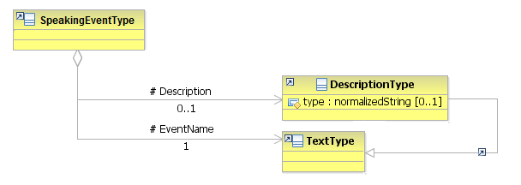
Figure 184: Speaking Event Attributes Schema
Attributes | Description | Card. | Rule
This element has no attributes.
Description sub-element
Attributes | Description | Card. | Rule
type | The comment type. | 0..1 | N/A
EventName sub-element
Attributes | Description | Card. | Rule
This sub-element has no attributes.

/Profile/Attachment (level 2)

Attachment Element Description
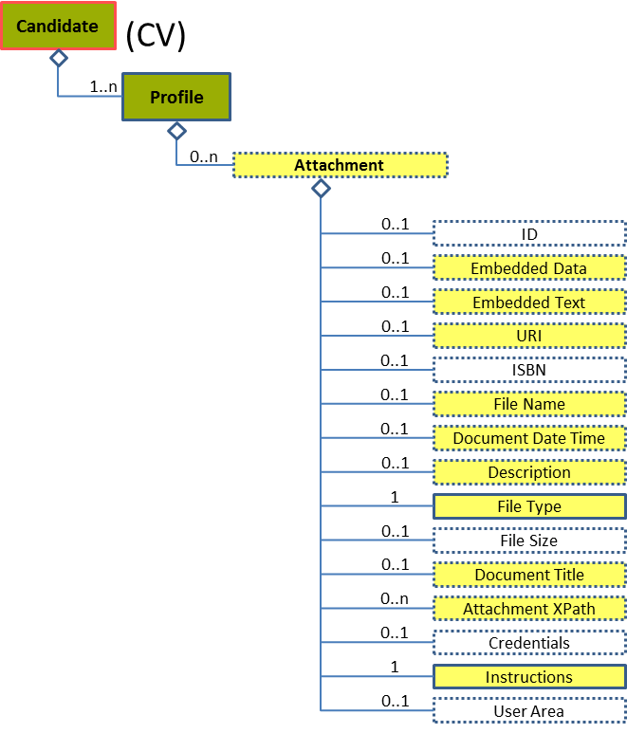
Figure 185: Attachment Level 2 Entity Diagram
Element | Description | Layer /  Cardinality |  | Rule | Examples
Attachment | Allows for embedding or referencing external documents or digital objects |  | EURES Optional  /  0..n | BR-COM-42: An Attachment shall not embed and simultaneously refer to an URI that contains the same document. External references to documents, using the URI element, are the recommended method (when possible) for attaching documents. | N/A
Sub-elements
Embedded Data | Allows the data to be embedded directly into the BOD instance |  | EURES Optional  /  0..1 | N/A | -
Embedded Text | Embedded text |  | EURES Optional  /  0..1 | N/A | “Embedded text”
URI | Represents a Uniform Resource Identifier Reference (URI). An URI value can be absolute or relative, and may have an optional fragment identifier (i.e., it may be a URI Reference). This type should be used to specify the intention that the value fulfils the role of a URI, as defined by [RFC 2396] and as amended by [RFC 2732]. |  | EURES Optional  /  0..1 | N/A | “http://uri.org”, etc.
File Name | Indicates the name of the File being referenced |  | EURES Optional  /  0..1 | N/A | “File Name”
Document Date Time | The date and/or time associated with the current or referenced version of a document |  | EURES Optional  /  0..1 | N/A | “2012/12/23”, etc.
Description | Description of the attachment |  | EURES Optional  /  0..1 | N/A | “Description of the attachment”
File Type | Identifies the type of the file type of the attachment |  | EURES Conformant Optional  /  1 | BR-COM-35: Compulsory use of the “EURES_FileTypeCode-CodeList.gc” list defined by EURES. | “PDF”, “DOC”, etc.  Full code list: “4.28.13 File-Type Codes [CL17] ”
Document Title | The name of the associated document |  | EURES Optional  /  0..1 | N/A | “Photo”, “Europass CV”, etc.
Attachment XPath | Path to the external documents attached |  | EURES Optional  /  0..n | N/A | “/Candidate/CandidatePerson”, etc.
Instructions | Identifies the type of attachment uploaded |  | EURES Conformant Optional  /  1 | BR-CV-29: Compulsory use of the “EURES_AttachmentInstructionCVCode” list defined by EURES. | “CV”, “ProfilePicture”, “Other”, etc.  Full code list: “4.28.1 Attachment Instruction Codes [CL61]”

Attachment Attributes
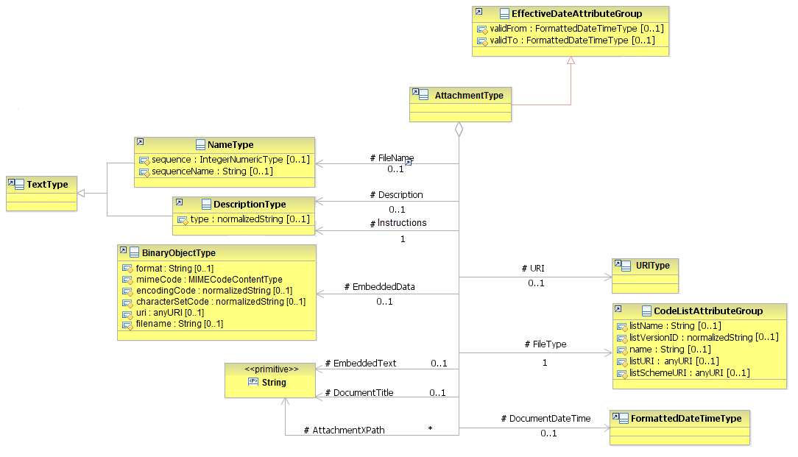
Figure 186: Attachment Attributes Schema
Attributes | Description | Card. | Rule
validFrom | Validity start date for this entity’s information | 0..1 | BR-COM-06: Compulsory Date Format is: YYYY-MM-DD, YYYY-MM, YYYY or YYYY-MM-DDThh:mm:ss.
validTo | Validity end date for this entity’s information | 0..1 | BR-COM-06: Compulsory Date Format is: YYYY-MM-DD, YYYY-MM, YYYY or YYYY-MM-DDThh:mm:ss.
EmbeddedData sub-element
Attributes | Description | Card. | Rule
mimeCode | Codes that specify the data mime code | 1 | BR-COM-50: Compulsory use of Mime Codes [CL56].
encodingCode | The data encoding type | 1 | BR-COM-51: Only ‘base64Binary’ is allowed. If not present it is considered as encoded in base64Binary.
uri | The URI of the file. | 0..1 | N/A
filename | The name of the file. | 0..1 | N/A
URI sub-element
Attributes | Description | Card. | Rule
This sub-element has no attributes.
FileName sub-element
Attributes | Description | Card. | Rule
sequence | Establishes the order of the contact data | 0..1 | N/A
sequenceName | Establishes the order of the contact data | 0..1 | N/A
DocumentDateTime sub-element
Attributes | Description | Card. | Rule
This sub-element has no attributes.
Description sub-element
Attributes | Description | Card. | Rule
type | The comment type | 0..1 | N/A
FileType sub-element
Attributes | Description | Card. | Rule
listName | The code list name | 0..1 | N/A
listVersionID | The code list identification | 0..1 | N/A
name | The text equivalent of the code content component | 0..1 | N/A
listURI | The Uniform Resource Identifier that identifies where the code list is located | 0..1 | N/A
listSchemeURI | The Uniform Resource Identifier that identifies where the code list scheme is located | 0..1 | N/A
Instructions sub-element
Attributes | Description | Card. | Rule
The same as “Description”

Attachment Examples
This is an example of how to fill in the elements of an attached document:
<Candidate xmlns="http://www.hr-xml.org/3" xsi:schemaLocation="http://www.hr-xml.org/3 ../Developer/Nouns/Candidate.xsd" >
<CandidateProfile languageCode="en">
<Attachment>
<oa:URI>http://europass.cedefop.europa.eu/es/documents/curriculum-vitae/examples/pdf_en_GB-a.pdf</oa:URI>
<oa:Description>CV in PDF format</oa:Description>
<oa:FileType listName="EURES_FileTypeCode" listVersionID="1.0" name="PDF document" listURI="https://ec.europa.eu/eures">PDF</oa:FileType>
<DocumentTitle>pdf_en_GB-a</DocumentTitle>
<Instructions>CV</Instructions>
</Attachment>
</CandidateProfile>
</Candidate>

This is an example of how to fill in an embedded document:
<Candidate xmlns="http://www.hr-xml.org/3" xsi:schemaLocation="http://www.hr-xml.org/3 ../Developer/Nouns/Candidate.xsd" >
<CandidateProfile languageCode="en">
<Attachment>
<oa:EmbeddedData mimeCode="image/jpeg" encodingCode="base64Binary">/9j/4AAQSkZJRgABAQAAAQABAAD//gA7Q1JFQVRPUjog</oa:EmbeddedData>
<oa:FileName>candidate_photo.jpg</oa:FileName>
<DocumentDateTime>2013-01-30</DocumentDateTime>
<oa:Description>Candidate's photo</oa:Description>
<oa:FileType listName="EURES_FileTypeCode" listVersionID="1.0" name="photo" listURI="https://ec.europa.eu/eures">photo</oa:FileType>
<DocumentTitle>Photo</DocumentTitle>
<AttachmentXPath>/Candidate/CandidatePerson</AttachmentXPath>
<Instructions>ProfilePicture</Instructions>
</Attachment>
</CandidateProfile>
</Candidate>

Code Lists
Code Lists are tables containing codes or values representing concepts that have been agreed amongst several parties as having exactly the same meaning for all.
HR-Open Standards 3.1 provides many Code Lists for many different concepts. HR-Open Standards Code Lists are based on W3C XSD Enumeration Schemas. The new EURES CV specifications re-use a large bunch of these Code Lists.
In addition to the HR-Open Standards Code Lists, EURES also defines several different Code Lists based on the OASIS Code Lists specification, another representation method that is compatible with the HR-Open Standards specification. Detailed information about this specification can be found here:
https://www.oasis-open.org/committees/tc_home.php?wg_abbrev=codelist
Thus, these code lists could be defined as:
- HR-Open Standards: code lists defined and maintained by HR-Open Standards organisation.
- EURES standards: code lists defined and maintained by international entities, such as NUTS or ISO.
- EURES standards new: code lists defined and maintained by EURES, and therefore, they are only used by EURES.
A set of attributes might be filled in for each code list not representing the HR-Open Standards.
Attributes | Description
listName | Code list name
listVersionID | Code list identification
name | Text equivalent of the code content component
listURI | The Uniform Resource Identifier that identifies where the code list is located
listSchemeURI | The Uniform Resource Identifier that identifies where the code list scheme is located
The following is an explanation of the code lists, including the standard version used, the values of the attributes and some examples. Identification is also added in order to relate the same codes with the EURES-JV-StandardStaticModel (RD01 – “EURES Job Vacancy Data Standard description”).
All values from the code lists are case insensitive.

Attachment Instruction Codes [CL61]
These codes classify the type of the attachment uploaded.
The New EURES Standard is used.
Code | Description
CV | CV of the candidate
CoverLetter | Cover letter of the candidate
ProfilePicture | Picture of the candidate
Other | Other type of attachment

This example fills in Profile Picture in the instructions element:
<Instructions>ProfilePicture</Instructions>

Candidate Source Type Codes [CL04]
These codes classify the source that supplied the CV’s candidate.
The values come from a HR-Open Standards list, and the values can be:
Code | Description
JobBoard | Website advertising job vacancies
StaffingAgency | Employment Services
Intermediary | Intermediary supplier
Referrer | Recommendation supplier
The code attribute values are as follows:
Attributes | Value
listName | CandidateSourceCodeType
listVersionID | 1.0
name | {Code name or description}
listURI | http://www.hr-xml.org/
listSchemeURI | http://www.hr-xml.org/3 ../Developer/Common/CodeLists.xsd
This example fills in candidate source as an intermediary code:
<CandidateSourceCode listName="CandidateSourceCodeType" listVersionID="1.0" name="Intermediary supplier" listURI="http://www.hr-xml.org/" listSchemeURI="http://www.hr-xml.org/3 ../Developer/Common/CodeLists.xsd"
>intermediary</CandidateSourceCode>

Channel Type Codes [CL05]
These codes classify the communication channel used to contact a person or organisation.
Their values come from a HR-Open Standards list, and the values could be:
Code | Description
Telephone | The communication channel is the telephone number.
MobileTelephone | The communication channel is the cell phone number.
Fax | The communication channel is the fax number.
Email | The communication channel is the email address.
InstantMessage | The communication channel is the instant message.
Web | The communication channel is the web address.
The code attribute values are as follows:
Attributes | Value
listName | ChannelCodeContentType
listVersionID | 1.0
name | {Code name or description}
listURI | http://www.hr-xml.org/
listSchemeURI | http://www.hr-xml.org/3 ../Developer/Common/CodeLists.xsd
This example fills in the communication channel as a telephone code:
<ChannelCode listName="ChannelCodeContentType" listVersionID="1.0" name="Telephone" listURI="http://www.hr-xml.org/" listSchemeURI="http://www.hr-xml.org/3 ../Developer/Common/CodeLists.xsd"
>telephone</ChannelCode>

Contact Use Type Codes [CL06]
These codes classify the type of use given to the communication channel to contact a person or an organisation.
Their values come from a HR-Open Standards list, and the values could be:
Code | Description
personal | The communication channel is for personal use.
business | The communication channel is for business communication.
The code attribute values are as follows:
Attributes | Value
listName | ContactUseCodeContentType
listVersionID | 1.0
name | {Code name or description}
listURI | http://www.hr-xml.org/
listSchemeURI | http://www.hr-xml.org/3 ../Developer/Common/CodeLists.xsd
This example fills in the communication use as a personal code:
<UseCode listName="ContactUseCodeContentType" listVersionID="1.0" name="Personal" listURI="http://www.hr-xml.org/" listSchemeURI="http://www.hr-xml.org/3 ../Developer/Common/CodeLists.xsd"
>Personal</UseCode>

Country Codes [CL07]

The standard used is EURES Standards: ISO 3166-1-alpha-2 code (ISO adapted to EC codification).
The Country codes are given in the following file: EURES ReferenceData File [RD02]

The code attribute values are as follows:
Attributes | Value
listName | Countries
listVersionID | 3166-1-alpha-2
name | {Code name or description}
listURI | http://ec.europa.eu/esco/ConceptScheme/country
listSchemeURI | PENDING DEFINITION
This example fills in the country as Belgium code:
<CountryCode listName="Countries" listVersionID="3166-1-alpha-2" name="Belgium" listURI="http://ec.europa.eu/esco/ConceptScheme/country"
>BE</CountryCode>

Country Subdivision Codes [CL08]
These codes are the regions of the European Union countries and the European Free Trade Association (EFTA) countries.
The standard used is the EURES Standards: NUTS 2013 – Level 3.
The Country Subdivision codes are given in the following file: EURES ReferenceData File [RD02]

The code attribute values are as follows:
Attributes | Value
listName | EURES_CountrySubdivisionCodes
listVersionID | 2013-Level-3
name | {Code name or description}
listURI | http://ec.europa.eu/eurostat
listSchemeURI | PENDING DEFINITION
This example fills in the country subdivision as Arr. Antwerpen code:
<oa:CountrySubDivisionCode listName="EURES_CountrySubdivisionCodes" listVersionID="2013-Level-3" name="Arr. Antwerpen" listURI="http://ec.europa.eu/eurostat"
>BE211</oa:CountrySubDivisionCode>

Currency Codes [CL09]
These codes specify the types of currency in the EEA / EFTA and Switzerland.
The standard used is the EURES Standards: ISO 4217:2008, adapted to EEA/EFTA and including Switzerland.
Code | Description
EUR | Euro
BGN | Lev
CHF | Swiss franc
CZK | Czech koruna
DKK | Danish krone
GBP | Pound sterling
HRK | Kuna
HUF | Forint
ISK | Króna
LTL | Litas
NOK | Norwegian krone
PLN | Zloty
RON | Romanian leu
SEK | Krona
The code attribute values are as follows:
Attributes | Value
listName | EURES_CurrencyCodes
listVersionID | 4217:2008
name | {Code name or description}
listURI | http://www.iso.org/iso/
listSchemeURI | PENDING DEFINITION
As currency is filled in as attribute, it is filled in differently:
<RemunerationReferenceAmount currencyID="EUR">25000</RemunerationReferenceAmount>

Degree Codes [CL10]
Codes used to specify the degree certification obtained.
EURES Standards: ESCO Qualifications are the standard used. The values are in the ESCO official website:
- https://ec.europa.eu/esco/portal/browse?type=Qualification
The code attribute values are as follows:
Attributes | Value
listName | ESCO_Qualifications
listVersionID | ESCOv1
name | {Code name or description}
listURI | https://ec.europa.eu/esco/portal
listSchemeURI | https://ec.europa.eu/esco/portal
This example fills in the PMP qualification:
<DegreeTypeCode listName="ESCO_Qualifications" listVersionID="ESCOv1" name="PMP" listURI="https://ec.europa.eu/esco/portal"
>http://ec.europa.eu/esco/qualification/23847</DegreeTypeCode>

Dimension Codes [CL11]
These are the codes used to classify the language competency dimension

The EURES Standard, based on CEFR:
Code | Description
CEF-Understanding-Listening | Listening comprehension
CEF-Understanding-Reading | Reading comprehension
CEF-Speaking-Interaction | Spoken interaction
CEF-Speaking-Production | Spoken production
CEF-Writing-Interaction | Written interaction
CEF-Writing-Production | Written production
The code attribute values are as follows:
Attributes | Value
listName | EURES_Dimension
listVersionID | 1.0
name | {Code name or description}
listURI | http://www.coe.int
listSchemeURI | PENDING DEFINITION
This example fills in the Spoken interaction skill:
<CompetencyDimensionTypeCode listName="EURES_Dimension" listVersionID="1.0" name="Spoken interaction" listURI="http://www.coe.int" listSchemeURI="PENDING"
>CEF-Speaking-Interaction</CompetencyDimensionTypeCode>

Disability Level Code [CL12]
These are the codes used to classify the level of disability.
The New EURES Standard is used.
Code | Description
1 | Needs another person's assistance with daily life tasks
2 | Inability to perform one or more sensory or physical functions
3 | Experiences difficulties in multiple sensory or physical functions
4 | Experiences difficulty in just one function
5 | No limitations in functioning
The code attribute values are as follows:
Attributes | Value
listName | EURES_DisabilityLevelCode
listVersionID | 1.0
name | {Code name or description}
listURI | https://ec.europa.eu/eures
listSchemeURI | PENDING DEFINITION
This example fills in No limitations in functioning in the disability level:
<DisabilityLevelCode listName="EURES_DisabilityLevelCode" listVersionID="1.0" name="No limitations" listURI="https://ec.europa.eu/eures"
>5</DisabilityLevelCode>

Drivers License Codes [CL14]
Codes used to specify a type of drivers licence.
The EURES Standards: Directive 2006/126/EC (EU) standard is used.
Code | Description
AM | Mopeds
A1 | Motorcycles and motor tricycles not exceeding a certain power level  The minimum age for category A1 is 16 years.
A2 | Motorcycles not exceeding a certain power level  The minimum age for category A2 is 18 years.
A | Motor tricycles not exceeding a certain power level and a minimum age of 21 years.
B1 | Quadricycles  The minimum age for category B1 is 16 years,
B | Motor vehicles not exceeding certain authorised mass.  The minimum age for category B is 18 years.
BE | A combination of vehicles consisting of a tractor vehicle in category B and a trailer or semi-trailer not exceeding a certain mass  The minimum age for category BE is 18 years.
C1 | Motor vehicles which are between mass  The minimum age for category C1 is 18 years.
C1E | A combination of vehicles consisting of a tractor vehicle in category B or C1 and a trailer or semi-trailer which are between mass  The minimum age for category C1E is 18 years.
C | Motor vehicles whose maximum authorised exceed a mass and carriage of no more than eight passengers, including the driver  Motor vehicles in this category may be combined with a trailer not exceeding a maximum authorised mass.  The minimum age for category C is 21 years.
CE | A combination of vehicles where the tractor vehicle is category C and its trailer or semi-trailer does not exceed a maximum authorised mass  The minimum age for categories CE is 21 years.
D | Motor vehicles designed and constructed for the carriage of more than eight passengers in addition to the driver.  Motor vehicles which may be driven with a category D licence may be combined with a trailer having a maximum authorised mass which does not exceed 750 kg.
D1 | Motor vehicles or carriage of no more than 16 passengers including the driver and with a maximum length  Motor vehicles in this category may be combined with a trailer not exceeding a maximum authorised mass.  The minimum age for categories D1 is 21 years.
D1E | A combination of vehicles where the tractor vehicle is category C1 and its trailer does not exceed a maximum authorised mass.  The minimum age for categories D1E is fixed at 21 years.
DE | Combination of vehicles where the tractor vehicle is in category D and its trailer not exceeds a maximum authorised mass.  The minimum age for categories DE is fixed at 24 years.
The code attribute values are as follows:
Attributes | Value
listName | EURES_LicenceTypeCode
listVersionID | 2006/126/EC
name | {Code name or description}
listURI | https://ec.europa.eu/eures
listSchemeURI | Placeholder
This example fills in the A1 driver’s license:
<LicenseTypeCode listName="EURES_LicenceTypeCode" listVersionID="2006/126/EC" name="A1" listURI="https://ec.europa.eu/eures"
>A1</LicenseTypeCode>

Education Level Codes [CL15]
The Education level the jobseeker has completed.
Two standards can be used to classify the education level:
- The EURES Standards: ISCED-2011 (UNESCO).
Code | Description
0 | Early childhood education
1 | Primary education
2 | Lower secondary education
3 | Upper secondary education
4 | Post-secondary non-tertiary education
5 | Short-cycle tertiary education
6 | Bachelor or equivalent level
7 | Masters or equivalent level
8 | Doctoral or equivalent level
The code attribute values are as follows:
Attributes | Value
listName | EURES_ISCEDEducationLevel
listVersionID | 2011
name | {Code name or description}
listURI | https://ec.europa.eu/eures
listSchemeURI | Placeholder
This example fills in Master’s code:
<EducationLevelCode listName="EURES_ISCEDEducationLevel" listVersionID="2011" name="Master" listURI="https://ec.europa.eu/eures"
>7</EducationLevelCode>

- The EURES Standards: EQF (European Qualifications Framework)
Code | Description
1 | Basic general knowledge.  Basic skills required to carry out simple tasks.  Work or study under direct supervision in a structured context.
2 | Basic factual knowledge of a field of work or study.  Basic cognitive and practical skills required to use relevant information in order to carry out tasks and to solve routine problems using simple rules and tools.  Work or study under supervision with some autonomy.
3 | Knowledge of facts, principles, processes and general concepts, in a field of work or study.  A range of cognitive and practical skills required to accomplish tasks and solve problems by selecting and applying basic methods, tools, materials and information.  Take responsibility for completion of tasks in work or study; adapt own behaviour to circumstances in solving problems.
4 | Factual and theoretical knowledge in broad contexts within a field of work or study.  A range of cognitive and practical skills required to generate solutions to specific problems in a field of work or study.  Exercise self-management within the guidelines of work or study contexts that are usually predictable, but are subject to change; supervise the routine work of others, taking some responsibility for the evaluation and improvement of work or study activities.
5 | Comprehensive, specialised, factual and theoretical knowledge within a field of work or study and an awareness of the boundaries of that knowledge.  A comprehensive range of cognitive and practical skills required to develop creative solutions to abstract problems.  Exercise management and supervision in contexts of work or study activities where there is unpredictable change review and develop performance of self and others.
6 | Advanced knowledge of a field of work or study, involving a critical understanding of theories and principles.  Advanced skills, demonstrating mastery and innovation, required to solve complex and unpredictable problems in a specialised field of work or study.  Manage complex technical or professional activities or projects, taking responsibility for decision making in unpredictable work or study contexts; take responsibility for managing professional development of individuals and groups.
7 | Highly specialised knowledge, some of which is at the forefront of knowledge in a field of work or study, as the basis for original thinking and/or research; critical awareness of knowledge issues in a field and at the interface between different fields.  Specialised problem-solving skills required in research and/or innovation in order to develop new knowledge and procedures and to integrate knowledge from different fields.  Manage and transform work or study contexts that are complex, unpredictable and require new strategic approaches; take responsibility for contributing to professional knowledge and practice and/or for reviewing the strategic performance of teams.
8 | Knowledge at the most advanced frontier of a field of work or study and at the interface between fields.  The most advanced and specialised skills and techniques, including synthesis and evaluation, required to solve critical problems in research and/or innovation and to extend and redefine existing knowledge or professional practice.  Demonstrate substantial authority, innovation, autonomy, scholarly and professional integrity and sustained commitment to the development of new ideas or processes at the forefront of work or study contexts including research.
The code attribute values are as follows:
Attributes | Value
listName | EURES_EQF
listVersionID | 2008/C11/01
name | {Code name or description}
listURI | http://ec.europa.eu/esco/ConceptScheme/EQF2012/ConceptScheme
listSchemeURI | http://ec.europa.eu/esco/ConceptScheme/EQF2012/ConceptScheme
This example fills in the Masters code:
<EducationLevelCode listName="EURES_EQF" listVersionID="2008/C11/01" name="Master" listURI="http://ec.europa.eu/esco/ConceptScheme/EQF2012/ConceptScheme" listSchemeURI="http://ec.europa.eu/esco/ConceptScheme/EQF2012/ConceptScheme"
>7</EducationLevelCode>
The relationship between these code lists is as follows:
EQF | 1 | 2 | 3 | 4 | 5 | 6 | 7 | 8
ISCED 2011 | - | - | - | - | 5 | 6 | 7 | 8
As can be seen, the ISCED 2011 codes from 0 to 4 do not match the EQF.

File-Type Codes [CL17]
Codes used to identify the file type of the attachment
The EURES Standard is used.
Code | Description
photo | Image
doc | Word document
pdf | Adobe PDF
The code attribute values are as follows:
Attributes | Value
listName | EURES_FileTypeCode
listVersionID | 1.0
name | {Code name or description}
listURI | https://ec.europa.eu/eures
listSchemeURI | Placeholder
This example fills in the certificate as evidence:
<oa:FileType listName="EURES_FileTypeCode" listVersionID="1.0" name="Image" listURI="https://ec.europa.eu/eures"
>photo</oa:FileType>

Gender Enum-Type Codes [CL18]
These codes classify the candidate’s gender.
Their values come from a HR OS-Standards list:
Code | Description
NotKnown | The gender is not provided.
Male | The candidate is a man.
Female | The candidate is a woman.
NotSpecified | The gender is not applicable.
The code attribute values are as follows:
Attributes | Value
listName | GenderEnumType
listVersionID | 1.0
name | {Code name or description}
listURI | http://www.hr-xml.org/
listSchemeURI | http://www.hr-xml.org/3 ../Developer/Common/CodeLists.xsd
This example fills in the jobseeker’s gender:
<GenderCode listName="GenderEnumType" listVersionID="1.0" name="Woman" listURI="http://www.hr-xml.org/" listSchemeURI="http://www.hr-xml.org/3 ../Developer/Common/CodeLists.xsd"
>Female</GenderCode>

ISCED Education Field [CL60]
These are the codes classifying the fields of education and training for degree specialisation.
The EURES Standards: ISCED-F 2013 is the standard used.
The ISCED Education Field codes are given in the following file: EURES ReferenceData File [RD02]

The correspondence between ISCED 1997 (fields) and ISCED-F 2013 is described in the following website: http://ec.europa.eu/eurostat/statistics-explained/index.php/International_Standard_Classification_of_Education_(ISCED)#ISCED_1997_.28fields.29_and_ISCED-F_2013
The code attribute values are as follows:
Attributes | Value
listName | EURES_ISCEDEducationField
listVersionID | 2013
name | {Code name or description}
listURI | https://ec.europa.eu/eures
listSchemeURI | Placeholder
This example fills in “Education” code:
<ProgramConcentration>011</ProgramConcentration>

Job Category Codes [CL20]
These are the codes classifying the type of job, which may be used for occupational classification.
The Job Category codes are given in the following file: EURES ReferenceData File [RD02]
Two standards can be use to classify the education level:
- The EURES Standards: ISCO-08 (ISCO) taxonomy

The code attribute values are as follows:
Attributes | Value
listName | ISCO2008
listVersionID | 2008
name | {Code name or description}
listURI | http://ec.europa.eu/esco/ConceptScheme/ISCO2008
listSchemeURI | http://ec.europa.eu/esco/ConceptScheme/ISCO2008
This example fills in the job category as an ISCO code:
<JobCategoryCode listName="ISCO2008" listVersionID="2008" name="Legislators" listURI="http://ec.europa.eu/esco/ConceptScheme/ISCO2008" listSchemeURI="http://ec.europa.eu/esco/ConceptScheme/ISCO2008"
>1111</JobCategoryCode>

- The EURES Standards: ESCO Occupations taxonomy

The code attribute values are as follows:
Attributes | Value
listName | ESCO_Occupations
listVersionID | ESCOv1
name | {Code name or description}
listURI | https://ec.europa.eu/esco/portal
listSchemeURI | https://ec.europa.eu/esco/portal
This example fills in the job category as an ESCO code:
<JobCategoryCode listName="ESCO_Occupations" listVersionID="ESCOv1" name="Head of division" listURI="https://ec.europa.eu/esco/portal" listSchemeURI="https://ec.europa.eu/esco/portal"
>http://data.europa.eu/esco/occupation/01484951-15e6-4b88-a20f-1201868d36a0</JobCategoryCode>

Language Codes [CL24]
These codes include all languages of the world, because the candidate can speak any of them.

The standard used is EURES Standards: ISO-639-1:2002 Alpha 2 (ISO), because:
- It is more restrictive
- It focuses on languages for which specialized terminologies have been developed.
The Language codes are given in the following file: EURES ReferenceData File [RD02]

- If the element is CompetencyID, the code attribute values are as follows:
Attributes | Value
schemeID | ISO-639-1/2-Languages
schemeAgencyID | ISO
schemeAgencyName | ISO
schemeVersionID | 639-1:2002 Alpha 2
schemeDataURI | http://www.loc.gov
This example fills in the English language:
<CompetencyID schemeID="ISO-639-1/2-Languages" schemeAgencyID="ISO" schemeAgencyName="ISO" schemeVersionID="639-1:2002 Alpha 2" schemeDataURI="http://www.loc.gov">EN</CompetencyID>

- If the element is PrimaryLanguageCode, the code attribute values are as follows:
Attributes | Value
listName | ISO-639-1/2-Languages
listVersionID | 639-1:2002 Alpha 2
name | {Code name or description}
listURI | http://www.loc.gov
listSchemeURI | Placeholder
This example fills in the English language:
<PrimaryLanguageCode listName="ISO-639-1/2-Languages" listVersionID="639-1:2002 Alpha 2" name="English" listURI="http://www.loc.gov"
>EN</PrimaryLanguageCode>

Language Proficiency Codes [CL25]
Language Proficiency is the level of proficiency in a language.
The standard used is the EURES Standards: CEFR (Common European Framework of Reference for Language).
Code | Description
A1 | Beginner
A2 | Elementary
B1 | Intermediate
B2 | Upper intermediate
C1 | Advanced
C2 | Proficiency
The code attribute values are as follows:
Attributes | Value
listName | EURES_ProficiencyLevel
listVersionID | 1.0
name | {Code name or description}
listURI | http://www.coe.int
listSchemeURI | Placeholder
As currency is filled in as an attribute, it is filled in differently:
<ScoreText minimumScoreText="C2" maximumScoreText="A1">

Members Countries from Europe [CL29]
These codes are the European Union countries and the European Free Trade Association (EFTA) countries.
The standard used is the European Union countries based on EURES Standards: ISO 3166 alpha-2, adapted to Member States. Note that, for two countries (Greece (EL) and United Kingdom (UK)) the code used differs from the ISO code.
Code | Description
AT | Austria
BE | Belgium
BG | Bulgaria
CY | Cyprus
CZ | Czech Republic
DK | Denmark
EE | Estonia
FI | Finland
FR | France
DE | Germany
EL | Greece
HR | Croatia
HU | Hungary
IS | Iceland
IE | Ireland
IT | Italy
LV | Latvia
LI | Liechtenstein
LT | Lithuania
LU | Luxembourg
MT | Malta
NL | Netherlands
NO | Norway
PL | Poland
PT | Portugal
RO | Romania
SK | Slovakia
SI | Slovenia
ES | Spain
SE | Sweden
CH | Switzerland
UK | United Kingdom
The code attribute values are as follows:
Attributes | Value
listName | EURES_MemberCountries
listVersionID | 3166-1-alpha-2
name | {Code name or description}
listURI | http://www.iso.org/iso/
listSchemeURI | PENDING DEFINITION
This example fills in the country as Belgium code:
<CountryCode listName="EURES_MemberCountries" listVersionID="3166-1-alpha-2" name="Belgium" listURI="http://www.iso.org/iso/"
>BE</CountryCode>

NACE Codes [CL31]
NACE Codes (Statistical classification of economic activities in the European Community) identify the current or past job’s business sector or industry.

The EURES Standards: EU is the standard used.
The NACE codes are given in the following file: EURES ReferenceData File [RD02]

The code attribute values are as follows:
Attributes | Value
listName | NACE_r2
listVersionID | NACE REVISION 2
name | {Code name or description}
listURI | http://ec.europa.eu/esco/ConceptScheme/NACErev2/cs
listSchemeURI | Placeholder
This example fills in industry code as central banking:
<IndustryCode listName="NACE_r2" listVersionID="NACE REVISION 2" name="central banking" listURI="http://ec.europa.eu/esco/ConceptScheme/NACErev2/cs"
>K64.1.1</IndustryCode>

Name Enum-Type Codes [CL32]
These codes classify the type of name.
Their values come from an HR-Open Standards list, and it is an enumeration:
Code | Description
CurrentName | The name indicated is the current name.
FormerName | The name indicated is prior to marriage.
BirthName | The name indicated is the name given at birth.
Alias | The name indicated is a pseudonym.
The code attribute values are as follows:
Attributes | Value
listName | NameTypeCodeEnumType
listVersionID | 1.0
name | {Code name or description}
listURI | http://www.hr-xml.org/
listSchemeURI | http://www.hr-xml.org/3 ../Developer/Common/CodeLists.xsd
This example fills in with the jobseeker’s name as the birthName:
<PersonName nameTypeCode="BirthName"/>

Official Languages in European Country Codes [CL33]
These codes are only the official languages in European Countries.
The standard used is EURES Standards: ISO-639-1:2002 Alpha 2 (ISO) because:
- It is more restrictive
- It focuses on languages for which specialized terminologies have been developed.
Code | Description |  | Code | Description
bg | Bulgarian |  | is | Icelandic
cs | Czech |  | it | Italian
da | Danish |  | lt | Lithuanian
de | German |  | lv | Latvian
el | Greek |  | mt | Maltese
en | English |  | nl | Dutch
es | Spanish |  | no | Norwegian
et | Estonian |  | pl | Polish
fi | Finnish |  | pt | Portuguese
fr | French |  | ro | Romanian
ga | Irish |  | sk | Slovak
hr | Croatian |  | sl | Slovenian
hu | Hungarian |  | sv | Swedish
The code attribute values are as follows:
Attributes | Value
listName | EURES_EULanguageCodes
listVersionID | 639-1:2002
name | {Code name or description}
listURI | http://www.loc.gov
listSchemeURI | PENDING DEFINITION
This example fills in the English language:
<CandidateProfile languageCode="en">

Organization Ownership Codes [CL34]
These codes classify the organisation ownership.
Their values come from an HR-Open Standards list:
Code | Description
public
private
non-profit
government
The code attribute values are as follows:
Attributes | Value
listName | OrganizationOwnershipTypeCodeContentType
listVersionID | 1.0
name | {Code name or description}
listURI | http://www.hr-xml.org/
listSchemeURI | http://www.hr-xml.org/3 ../Developer/Common/CodeLists.xsd
This example fills in the preferred organisation ownership as private:
<OrganizationOwnershipTypeCode listName="OrganizationOwnershipTypeCodeContentType" listVersionID="1.0" name="private" listURI="http://www.hr-xml.org/" listSchemeURI="http://www.hr-xml.org/3 ../Developer/Common/CodeLists.xsd"
>private</OrganizationOwnershipTypeCode>

Organization Size Codes [CL35]
These codes classify an organisation’s size or business scope.
The standards used to classify small and medium-sized enterprises are EURES Standards: EU – C (2003) 1422. Large enterprises have been added, as described in Eurostat, to cover all sizes.
Code | Description
microenterprise | 0 to 9 people
smallenterprise | 10 to 49 people
medium-sizedenterprise | 50 to 249 people
largeenterprise | More than 250 people
The code attribute values are as follows:
Attributes | Value
listName | EURES_OrganizationSize
listVersionID | (2003)1422
name | {Code name or description}
listURI | https://ec.europa.eu/eures
listSchemeURI | Placeholder
This example fills in the preferred organisation size as a small enterprise:
<OrganizationSizeCode listName="EURES_OrganizationSize" listVersionID="(2003)1422" name="small enterprise" listURI="https://ec.europa.eu/eures"
>smallenterprise</OrganizationSizeCode>

Patent Status Enum-Type Codes [CL36]
These codes describe the status of the patent.
Their values come from an HR-Open Standards list, and it is an enumeration:
Code | Description
PatentIssued | The patent has been issued.
PatentPending | The patent’s processing is pending.
PatentFiled | The patent has been filed.
This example fills in the patent status as issued:
<PatentStatus>PatentIssued</PatentStatus>

Position Offering Codes [CL37]
These codes classify the preferred contract type.
Their values come from an HR-Open Standards list and EURES Standard:
Code | Description
DirectHire | Hired directly by the employee, without any external staffing
Temporary | Position only for certain period
TemporaryToHire | Position starting as a temporary job, with the option of a permanent job
ContractToHire | Position starting as a contract job, with the option of a permanent job
Contract | Contract hire
Internship | Period of job training
Apprenticeship | Combines job training with academic education
Seasonal | Temporary and short-term job
OnCall | Position on an “as needed” basis
RecruitmentReserve | Candidate is on the waiting list for the job vacancy
SelfEmployed | Self-employed person
Volunteer | Volunteer work
The code attribute values are as follows:
Attributes | Value
listName | PositionOfferingTypeCodeContentType
listVersionID | 1.0
name | {Code name or description}
listURI | http://www.hr-xml.org/
listSchemeURI | http://www.hr-xml.org/3 ../Developer/Common/CodeLists.xsd
This example fills in the jobseeker’s preferred contract type as temporary:
<PositionOfferingTypeCode listName="PositionOfferingTypeCodeContentType" listVersionID="1.0" name="temporary job" listURI="http://www.hr-xml.org/" listSchemeURI="http://www.hr-xml.org/3 ../Developer/Common/CodeLists.xsd"
>Temporary</PositionOfferingTypeCode>

Position Schedule Codes [CL38]
These codes classify the general schedule.
Their values come from an HR-Open Standards list:
Code | Description
FullTime | Minimum number of hours defined by the employer
PartTime | Fewer hours per week than a full-time job
FlexTime | Variable work schedule
Any | Any type of schedule is allowed
The code attribute values are as follows:
Attributes | Value
listName | PositionScheduleCodeContentType
listVersionID | 1.0
name | {Code name or description}
listURI | http://www.hr-xml.org/
listSchemeURI | http://www.hr-xml.org/3 ../Developer/Common/CodeLists.xsd
This example fills in the jobseeker’s preferred schedule as part time:
<PositionScheduleTypeCode listName="PositionScheduleCodeContentType" listVersionID="1.0" name="part time job" listURI="http://www.hr-xml.org/" listSchemeURI="http://www.hr-xml.org/3 ../Developer/Common/CodeLists.xsd"
>PartTime</PositionOfferingTypeCode>

Position Seeking Status Enum Type [CL39]
The position seeking statuses are given in the following table.
These values come from an HR-Open Standards list:
Code | Description
Active | The candidate is actively engaged in a job search.
Passive | The candidate is passively considering opportunities.
NotConsideringPositions | The candidate is not considering job opportunities.
The code attribute values are as follows:
Attributes | Value
listName | PositionSeekingCodeContentType
listVersionID | 1.0
name | {Code name or description}
listURI | http://www.hr-xml.org/
listSchemeURI | http://www.hr-xml.org/3 ../Developer/Common/CodeLists.xsd
This example fills in with the jobseeker’s position status as active:
<PositionSeekingStatusCode listName="PositionSeekingCodeContentType" listVersionID="1.0" name="active" listURI="http://www.hr-xml.org/" listSchemeURI="http://www.hr-xml.org/3 ../Developer/Common/CodeLists.xsd"
>Active</PositionSeekingSeekingCode>

Precedence Enum-Type Codes [CL41]
This enumeration indicates the priority of the supplier, among others.
Its values come from an HR-Open Standards list:
Code | Description
1 | Primary
2 | Secondary
3 | Tertiary
4 | Quaternary
5 | Quinary
This example fills in the precedence code as primary:
<PrecedenceCode>1</PrecedenceCode>

Publication Enum-Type Codes [CL59]
This enumeration indicates the type of publication.
Its values come from an HR-Open Standards list:
Code | Description
Article | Article
Book | Book
Conference | Conference
Other | Other type of publication
This example fills in the publication type as Article:
<FormattedPublicationDescription publicationCode="Article">Article about Machine Learning in the Weekend Magazine</FormattedPublicationDescription>

Referee Enum-Type Codes [CL46]
These codes classify the references.
Their values come from an HR-Open Standards list, and it is an enumeration:
Code | Description
Professional | It is a professional reference.
Personal | It is a personal reference.
Verification | It verifies the CV.
This example fills in the employer reference as professional:
<RefereeTypeCode>Personal</RefereeTypeCode>

Remuneration Basis Codes [CL48]
These codes classify the primary or fundamental basis upon which pay is calculated for the position.
Their values come from an HR-Open Standards list:
Code | Description
Hourly | The candidate is paid according to the work done.
Salaried | Fix base paid
SalariedPlusCommission | Fix base paid, plus commission
CommissionOnly | Commissions paid
The code attribute values are as follows:
Attributes | Value
listName | RemunerationBasisCodeContentType
listVersionID | 1.0
name | {Code name or description}
listURI | http://www.hr-xml.org/
listSchemeURI | http://www.hr-xml.org/3 ../Developer/Common/CodeLists.xsd
This example fills in the remuneration basis as salaried:
<RemunerationBasisCode listName="RemunerationBasisCodeContentType" listVersionID="1.0" name="salaried" listURI="http://www.hr-xml.org/" listSchemeURI="http://www.hr-xml.org/3 ../Developer/Common/CodeLists.xsd"
>Salaried</RemunerationBasisCode>

Remuneration Type Codes [CL49]
These codes classify the type of pay or remuneration.
Their values come from an HR-Open Standards list:
Code | Description
BasePay | Initial rate of compensation
Commission | Commission paid
Bonus | Extra salary paid
ShortTermIncentive | Bonus to encourage the employee
ShfitPremium | Additional pay for working split shifts
The code attribute values are as follows:
Attributes | Value
listName | RemunerationTypeCodeContentType
listVersionID | 1.0
name | {Code name or description}
listURI | http://www.hr-xml.org/
listSchemeURI | http://www.hr-xml.org/3 ../Developer/Common/CodeLists.xsd
This example fills in the remuneration type as base pay:
<RemunerationTypeCode listName="RemunerationTypeCodeContentType" listVersionID="1.0" name="base pay" listURI="http://www.hr-xml.org/" listSchemeURI="http://www.hr-xml.org/3 ../Developer/Common/CodeLists.xsd"
>BasePay</RemunerationTypeCode>

Remuneration Rate Interval Codes [CL50]
An interval of time is used to express a rate of pay or remuneration.
Their values come from a HR-Open Standards list:
Code | Description
Hour | Remuneration per hour.
Day | Remuneration per day.
Week | Remuneration per week.
TwoWeeks | Remuneration per two weeks.
FourWeeks | Remuneration per four weeks.
HalfMonth | Remuneration per half month.
Month | Remuneration per month.
TwoMonths | Remuneration per two months.
Quarter | Remuneration per quarter.
SeasonalTerm | Remuneration per seasonal term.
HalfYear | Remuneration per half year.
Year | Remuneration per year.
QuarterToDate | Remuneration per quarter to date.
YearToDate | Remuneration per year to date.
Once | Whole remuneration.
The code attribute values are as follows:
Attributes | Value
listName | PayRateIntervalCodeContentType
listVersionID | 1.0
name | {Code name or description}
listURI | http://www.hr-xml.org/
listSchemeURI | http://www.hr-xml.org/3 ../Developer/Common/CodeLists.xsd
This example fills in with an interval of payment per year:
<RemunerationRateIntervalCode listName="PayRateIntervalCodeContentType" listVersionID="1.0" name="per year" listURI="http://www.hr-xml.org/" listSchemeURI="http://www.hr-xml.org/3 ../Developer/Common/CodeLists.xsd"
>Year</RemunerationRateIntervalCode>

Skills and Competences Codes [CL58]
Skills and competences relevant to a board range of jobs and occupations and within a specific economic sector, context or occupation.

The standard used in the EURES Standards: ESCO Skills and Competences.
The Skills and Competences codes are given in the following file: EURES ReferenceData File [RD02]

The code attribute values are as follows:
Attributes | Value
schemeID | ESCO_Skills
schemeVersionID | ESCOv1
This example fills in the Competency ID as base pay:
<CompetencyID schemeID="ESCO_Skills" schemeVersionID="ESCOv1">
http://data.europa.eu/esco/skill/e2d0daae-2aa1-40cc-99e2-b340b02f97d3
</CompetencyID>

Social Benefits Codes [CL52]
Social benefits codes specify an additional benefit beyond the salary.
The EURES standard New is used:
Code | Description
1 | Accommodation included
2 | Meals included
3 | Relocation assisted
4 | Travel expenses
5 | Medical insurance
6 | Dental insurance
7 | Vision insurance
8 | Life insurance
9 | Short-term disability insurance
10 | Long-term disability insurance
11 | Retirement plan
12 | Vehicle consideration
13 | Relocation assistance
14 | Expatriate benefits
15 | Other benefits
The code attribute values are as follows:
Attributes | Value
listName | EURES_SocialBenefitsCodes
listVersionID | 1.0
name | {Code name or description}
listURI | https://ec.europa.eu/eures
listSchemeURI | PENDING DEFINITION
This example fills in a benefit of life insurance:
<OtherBenefitsTypeCode listName="EURES_SocialBenefitsCodes" listVersionID="1.0" name="life insurance" listURI="https://ec.europa.eu/eures" listSchemeURI="PENDING"
>8</OtherBenefitsTypeCode>

Unit Codes [CL54]
These codes classify the type of unit measurement.
The standard used is EU – Units of Measurement:
Code | Description
km | Kilometre
day | Day
week | Week
month | Month
year | Year
The code attribute values are as follows:
Attributes | Value
listName | EURES_UnitCodes
listVersionID | 1.0
name | {Code name or description}
listURI | https://ec.europa.eu/eures
listSchemeURI | PENDING DEFINITION
This example fills in a year as a unit code:
<Measure unitCode="year">5</Measure>

Version Codes [CL63]
These codes classify the EURES HR Standard version.
Code | Description
1.0 | 1.0
1.1 | 1.1
1.2 | 1.2
1.3 | 1.3

Mime Codes [CL56]
These codes specify the data mime code of an attachment.
The EURES standard New is used:
Code | Description
application/msword | Mime type for Word documents (.doc)
application/vnd.openxmlformats-officedocument.wordprocessingml.document | Mime type for Word documents (.docx)
application/pdf | Mime type for PDF documents
image/gif | Mime type for GIF’s images
image/jpeg | Mime type for JPEG’s images
image/png | Mime type for PNG’s images
image/tiff | Mime type for TIFF’s images
image/bmp | Mime type for BPM’s images

The code attribute values are as follows:
Attributes | Value
listName | EURES_MimeCodes
listVersionID | 1.0
name | {Code name or description}
listURI | https://ec.europa.eu/eures
listSchemeURI
This example fills in the year as unit code:
<oa:EmbeddedData mimeCode="image/jpeg" encodingCode="base64Binary"
>/9j/4AAQSkZJRgABAQAAAQABAAD//gA7Q1JFQVRPUjog</oa:EmbeddedData>

Annex 1. Ordered List With all Code Lists
This annex provides an ordered list with all code lists and pages referenced. Each reference corresponds to an element reference.
Rules
Candidate Source Type Codes [CL04] 27, 183
Channel Type Codes [CL05] 34, 45, 184
Contact Use Type Codes [CL06] 34, 45, 184
Country Codes [CL07] 39, 185
Currency Codes [CL09] 144, 186
Degree Codes [CL10] 70, 186
Dimension Codes [CL11] 86, 111, 187, 209
Disability Level Code [CL12] 54, 187
Drivers License Codes [CL14] 152, 188
Education Level Codes [CL15] 67, 73, 189
File-Type Codes [CL17] 180, 190
Gender Enum-Type Codes [CL18] 39, 191
Job Category Codes [CL20] 90, 192
Language Codes [CL24] 39, 193, 208, 210
Language Proficiency Codes [CL25] 194
Members Countries from Europe [CL29] 137, 194
NACE Codes [CL31] 93, 195
Name Enum-Type Codes [CL32] 33, 43, 119, 195
Organization Ownership Codes [CL34] 197
Organization Size Codes [CL35] 130, 197
Patent Status Enum-Type Codes [CL36] 168, 198
Position Offering Codes [CL37] 133, 198
Position Schedule Codes [CL38] 198
Position Seeking Status Enum Type [CL39] 20, 199
Precedence Enum-Type Codes [CL41] 27, 199
Publication Enum-Type Codes [CL59] 173, 200
Referee Enum-Type Codes [CL46] 116, 200
Remuneration Basis Codes [CL48] 141, 200
Remuneration Rate Interval Codes [CL50] 143, 201
Remuneration Type Codes [CL49] 143, 201
Social Benefits Codes [CL52] 146, 202
Unit Codes [CL54] 63, 203

Annex 2. Ordered List With all Elements of CV Schema
This annex provides an ordered list with all elements of CV schema. Also, it is shown in which page are located.
Cases
Address /Choice 50
Attachment 58, 179
Attachment Reference 165, 170
Attendance Period 74, 161
Authority not available. 130
Availability Dates 62, 63
Benefits Summary 141, 145
Candidate 19
Certification 121, 122
Certifications 57, 121
Communication 31, 34, 39, 44, 117, 120
Communication/Choice 31, 32, 34, 36, 45, 46
Competency Dimension 82, 86
Contact 27, 31
Degree Date 70, 71, 126, 154
Degree Major 70, 73
Disability 39, 53
Disability/Summary 53, 54
Education Degree 67, 69
Education History 57, 64
Employer History 92, 93
Employer Preferences 57, 130
Employment History 57, 92
Employment Period 93, 97, 101, 104
Employment References 58, 115
End Date 74, 76, 98, 100, 127
Experience Category 89, 90
Experience Summary 57, 89
First Issued Date 123, 125, 153, 154
Free Form Effective Period 123, 126
Free Form Period 153, 155
ID 17, 19, 22
Issuing Authority 123, 128, 165, 167
Job Category 132, 139
License 151, 152
Licenses 57, 150
Military History 57, 156
Military Service 157, 158
Name 38, 42
Offered Remuneration 133, 141
Organization Affiliation 173, 174
Organization Affiliations 58, 173
Organization Attendance 65, 66
Other Benefits 146
Patent 162, 164
Patent History 58, 162
Patent Status 165, 168
Person 20, 38
Person Availability 57, 62
Person Competency 80, 81
Person Name 118
Position History 94, 101
Position Preferences 57, 132
Preferred Location 132, 135
Proficiency Level 82, 84
Profile 20, 56
Publication 171, 172
Publication History 58, 171
Qualifications 58, 79
Referee 115, 116
Reference Location 136
Relocation Considered 133, 149
Remuneration Range 141, 143
Service Period 159, 161
Speaking Event 176, 177
Speaking History 58, 175
Start Date 74, 75, 77, 98, 99, 127
Travel Preference 133, 148

Annex 3. Treatment of Unfulfilled Business Rules
This annex provides that an action be carried out for each Business Rule that is not met:
Business Rule | Treatment of the BR unfulfilled
- : If not otherwise specified, “EN” (English) is used as the default language. | English is taken as the default language.
- : Multiple profiles are allowed, but it must be expressed in different languages. | The document is rejected.
- : Compulsory use of the “EURES_EULanguageCodes-CodeList.gc” list defined by EURES. Adapted EU countries only are used, based on ISO 639-1:2002 Alpha-2.  Reference: Use Code List Official Languages in European Country Codes [CL33] | The value is not saved. If the element belongs to the EURES Technical minimum layer, the document is rejected.
- : If not specified, the “validFrom” date will default to “assigned by EURES on reception”. | The date is assigned by EURES on reception.
- : Compulsory Date Format is: YYYY-MM-DD, YYYY-MM, YYYY or YYYY-MM-DDThh:mm:ss. | The value is not saved. If the element belongs to EURES Technical minimum layer, the document is rejected. The timezone considered is always UTC=0;
- : If not specified, the “validTo” date will be decided by EURES depending on the transaction context. | The date is assigned by EURES on reception.
- : Compulsory use of the Name Enum Type Codes [CL32].  Reference: Use Code List Name Enum-Type Codes [CL32] | The value is not saved. If the element belongs to EURES Technical minimum layer, the document is rejected.
- : If the Communication element is filled in, at least one of its sub elements should be filled in too. | The Communication element and its sub elements are not saved.
- : Compulsory use of the “LanguageCodes-CodeList.gc” list defined by EURES. This is based on ISO-639-1:2002 Alpha-2, which includes all world languages.  Reference: Use Code List Language Codes [CL24] | The value is not saved. If the element belongs to EURES Technical minimum layer, the document is rejected.
- : Compulsory use of the “Countries-CodeList.gc” list defined by EURES. This is based on ISO 3166-1 Alpha-2, which includes all countries of the world.  Reference: Use Code List Country Codes [CL07] | The value is not saved. If the element belongs to EURES Technical minimum layer, the document is rejected.
- : The Open HR-Open Standards Code List “ChannelCodeContentType” must be used to codify the /ChannelCode element.  Reference: Use Code List Channel Type Codes [CL05] | The value is not saved. If the element belongs to EURES Technical minimum layer, the document is rejected.
- : The Open HR-Open Standards Code List “ContactUseCodeContentType” must be used to codify the /UseCode element.  Reference: Use Code List Contact Use Type Codes [CL06] | The value is not saved. If the element belongs to EURES Technical minimum layer, the document is rejected.
- : Compulsory use of the “EURES_ISCEDEducationLevel-CodeList.gc” list defined by EURES. This is based on ISCED-2011 (UNESCO). Or “EURES_EQF-CodeList.gc”, list defined by EURES and based on EQF (EU).  Reference: Use Code List Education Level Codes [CL15] | The value is not saved. If the element belongs to EURES Technical minimum layer, the document is rejected.
- : At least one of its sub-elements must be provided. | The value is not saved. If the element belongs to EURES Technical minimum layer, the document is rejected.
- : Compulsory use of the “EURES_DegreeType-CodeList.gc” list defined by EURES. This is based on ESCO Qualifications – version 1.0.  Reference: Use Code List Degree Codes [CL10] | The value is not saved. If the element belongs to EURES Technical minimum layer, the document is rejected.
- : Compulsory use of the “NACE-CodeList.gc” list defined by EURES. This is based on EU NACE.  Reference: Use Code List NACE Codes [CL31] | The value is not saved. If the element belongs to EURES Technical minimum layer, the document is rejected.
- : Compulsory use of the “EURES_CountrySubdivisionCodes-CodeList.gc” list defined by EURES. This is based on NUTS 2013 – Level 3.  Reference: Use Code List Country Subdivision Codes [CL08] | The value is not saved. If the element belongs to EURES Technical minimum layer, the document is rejected.
- : Compulsory use of the “EURES_OrganizationSize-CodeList.gc” list defined by EURES. This is based on EU – C (2003) 1422, including Large enterprises.  Reference: Use Code List Organization Size Codes [CL35] | The value is not saved. If the element belongs to EURES Technical minimum layer, the document is rejected.
- : Compulsory use of the “OrganizationOwnershipTypeCodeContentType” list.  Reference: Use Code List Organization Ownership Codes [CL34] | The value is not saved. If the element belongs to EURES Technical minimum layer, the document is rejected.
- : Compulsory use of the “ISCO2008-CodeList.gc” list defined by EURES and based on ISCO-08. Alternatively, use of ESCO Occupations – version 1.0.  Reference: Use Code List Job Category Codes [CL20] | The value is not saved. If the element belongs to EURES Technical minimum layer, the document is rejected.
- : Compulsory use of the “RemunerationBasisCodeContentType” list.  Reference: Use Code List Remuneration Basis Codes [CL48] | The value is not saved. If the element belongs to EURES Technical minimum layer, the document is rejected.
- : All its sub elements must be expressed using the same currency. | The value is not saved. If the element belongs to EURES Technical minimum layer, the document is rejected.
- : Compulsory use of the “RemunerationCodeContentType” list.  Reference: Use Code List Remuneration Type Codes [CL49] | The value is not saved. If the element belongs to EURES Technical minimum layer, the document is rejected.
- : Compulsory use of the “RemunerationRateIntervalCodeContentType” list.  Reference: Use Code List Remuneration Rate Interval Codes [CL50] | The value is not saved. If the element belongs to EURES Technical minimum layer, the document is rejected.
- : Compulsory use of the Currency Codes [CL09].  Reference: Use Code List Currency Codes [CL09] | The value is not saved. If the element belongs to EURES Technical minimum layer, the document is rejected.
- : Compulsory use of the “EURES_FileTypeCode-CodeList.gc” list defined by EURES.  Reference: Use Code List File-Type Codes [CL17] | The value is not saved. If the element belongs to EURES Technical minimum layer, the document is rejected.
- : Compulsory use of the Unit Codes [CL54].  Reference: Use Code List Unit Codes [CL54] | The value is not saved. If the element belongs to EURES Technical minimum layer, the document is rejected.
- : Compulsory use of the “EURES_Dimension-CodeList.gc” list defined by EURES. This is based on CEFR, if TaxonomyID’s value is “language”.  Reference: Use Code List Dimension Codes [CL11] | The value is not saved. If the element belongs to EURES Technical minimum layer, the document is rejected.
- : Compulsory use of the “PositionOfferingCodeContentType” list.  Reference: Use Code List Position Offering Codes [CL37] | The value is not saved. If the element belongs to EURES Technical minimum layer, the document is rejected.
- : Compulsory use of the “PositionScheduleCodeContentType” list.  Reference: Use Code List Position Schedule Codes [CL38] | The value is not saved. If the element belongs to EURES Technical minimum layer, the document is rejected.
- : Compulsory use of the “EURES_SocialBenefitsCodes-CodeList.gc” list defined by EURES.  Reference: Use Code List Social Benefits Codes [CL52] | The value is not saved. If the element belongs to EURES Technical minimum layer, the document is rejected.
- : Compulsory use of the “EURES_LicenseTypeCode-CodeList” list. This is based on Directive 2006/126/EC.  Reference: Use Code List Drivers License Codes [CL14] | The value is not saved. If the element belongs to EURES Technical minimum layer, the document is rejected.
- : An Attachment shall not embed and simultaneously refer to an URI that contains the same document. External references to documents, using the URI element, are the recommended method (when possible) for attaching documents. | The value is not saved. If the element belongs to EURES Technical minimum layer, the document is rejected.
- : Multiple entries of this code list are allowed. | If the values come from a different code list, they will not be saved.  If the element belongs to EURES Technical minimum layer, the document will be rejected.
- : One value for each code list is allowed. | If multiple entries for the same code list are added, only the first value of that code list will be saved.
- : Compulsory use of EURES HR Standard version Version Codes [CL63]  Reference: Use Code List Version Codes [CL63] | The document is rejected.
- : Compulsory use of Language Code [CL24], based on ISO-639-1:2002 Alpha 2 (ISO), if TaxonomyID’s value is “language”. Or the Skills and Competences Codes defined by ESCO, if TaxonomyID’s value is “other”.  Reference: If taxanomy is language, use Code List Language Codes [CL24] . Else, use Code List Skills and Competences Codes [CL58] | The value is not saved. If the element belongs to EURES Technical minimum layer, the document is rejected.
- : Compulsory use of Language Proficiency Codes [CL25], if TaxonomyID’s value is “language”.  Reference: Use Code List Language Proficiency Codes [CL25] | The value is not saved. If the element belongs to EURES Technical minimum layer, the document is rejected.
- : If "CompetencyDimension" element is specified, "TypeCode" and "Score" are mandatory elements. | The document is rejected.
- : If “CompetencyDimension / TypeCode” is specified, “ProficiencyLevel” is mandatory. | The document is rejected.
- : Compulsory use of Mime Codes [CL56].  Reference: Use Code List Mime Codes [CL56] | The document is rejected.
- : Only ‘base64Binary’ is allowed. If not present it is considered as encoded in base64Binary. | ‘base64Binary’ is taken as the default encoding type.
- : Compulsory use of the “EURES_MemberCountries-CodeList.gc” list defined by EURES. This is based on ISO 3166-1 Alpha-2, adapted to the Member States and EFTA countries.  Reference: Use Code List Members Countries from Europe [CL29] | The value is not saved. If the element belongs to EURES Technical minimum layer, the document is rejected.
- : If CountryCode is specified, CountrySubDivisionCode value must correspond to CountryCode value. | The value is not saved. If the element belongs to EURES Technical minimum layer, the document is rejected.
- : TaxonomyID’s value should be “language” if the CompetencyID is a language or “other”, in the other competencies. | The value is not saved. If the element belongs to EURES Technical minimum layer, the document is rejected.
- : Compulsory use of the attributes “listVersionID”, “listName” and “listURI”. | The document is rejected.
- : The attributes “majorVersionID” and “minorVersionID” are mandatory. | The document is rejected.
- : Compulsory use of the version 3.2 of HR-OS (“majorVersionID” is 3 and “minorVersionID” is 2). | The document is rejected.
- : Only One Candidate (CV) per XML document instance is allowed. | The document is rejected.
- : The “PositionSeekingCodeContentType” HR-Open Standards Code List must be used to codify the /Candidate /Position Seeking Status.  Reference: Use Code List Position Seeking Status Enum Type [CL39] | The value is not saved. If the element belongs to EURES Technical minimum layer, the document is rejected.
- : The HR-Open Standards Code List “CandidateSourceCodeType” must be used to codify the /Candidate /Supplier /Source.  Reference: Use Code List Candidate Source Type Codes [CL04] | The value is not saved. If the element belongs to EURES Technical minimum layer, the document is rejected.
- : The HR-Open Standards Code List “PrecedenceEnumType” must be used to codify the /Candidate /Supplier /Precedence.  Reference: Use Code List Precedence Enum-Type Codes [CL41] | The value is not saved. If the element belongs to EURES Technical minimum layer, the document is rejected.
- : If the identifier is not provided an automatic ID will be provided by the Interoperability Platform. | The identifier is provided by the Interoperability Platform.
- : Compulsory use of HR-Open Standards “GenderEnumType” to specify a Person’s Gender.  Reference: Use Code List Gender Enum-Type Codes [CL18] | The value is not saved. If the element belongs to EURES Technical minimum layer, the document is rejected.
- : Compulsory use of the “EURES_DisabilityLevelCode-CodeList.gc” list defined by EURES.  Reference: Use Code List Disability Level Code [CL12] | The value is not saved. If the element belongs to EURES Technical minimum layer, the document is rejected.
- : The HR-Open Standards Code List “RefereeTypeCode”.  Reference: Use Code List Referee Enum-Type Codes [CL46] | The value is not saved. If the element belongs to EURES Technical minimum layer, the document is rejected.
- : Compulsory use of the “PatentStatusCode” list.  Reference: Use Code List Patent Status Enum-Type Codes [CL36] | The value is not saved. If the element belongs to EURES Technical minimum layer, the document is rejected.
- : Compulsory use of the “PulblicationCode” list.  Reference: Use Code List Publication Enum-Type Codes [CL59] | The value is not saved. If the element belongs to EURES Technical minimum layer, the document is rejected.
- : Compulsory use of the “EURES_ISCEDEducationField” list defined by EURES.  Reference: Use Code List ISCED Education Field [CL60] | The value is not saved. If the element belongs to EURES Technical minimum layer, the document is rejected.
- : Compulsory use of the “EURES_AttachmentInstructionCVCode” list defined by EURES.  Reference: Use Code List Attachment Instruction Codes [CL61] | The value is not saved. If the element belongs to EURES Technical minimum layer, the document is rejected.
- : At least one of the following sub-elements (either Address or URI or DialNumber) must be provided. | The value is not saved. If the element belongs to EURES Technical minimum layer, the document is rejected.
- : If URI element is provided, ChannelCode element must contain either "Email" or "Web". | The value is not saved. If the element belongs to EURES Technical minimum layer, the document is rejected.
- : The Xpath must be valid  Trigger: The Xpath is considered invalid when  - It does not respect the syntax of the XPath language;  - It returns anything else than a node or a list of nodes (e.g. a number);  - It does not return any node present in the XML  - It returns a node part of the Technical Minimum layer, or its ancestors  (!) The Xpath must not contain any namespace references. The Xpath will be considered as invalid if it is the case. For example: “Candidate/CandidatePerson/Communication/oa:DialNumber” is invalid, it must be written as “/CandidatePerson/Communication/DialNumber” to be valid. | The value is not saved. The document is rejected.

Annex 4. Examples

Example 1 [EX-01]
Example of the XML with the mandatory elements.
The example has passed the XML validation using Schematron. For each element, there is the description of the applied business rule(s).
<?xml version="1.0" encoding="UTF-8"?>
<!-- BR-CV-02: Only One Candidate (CV) per XML document instance is allowed.
BR-COM-01: If not otherwise specified, “EN” (English) is used as the default language.
BR-COM-02: If the master is not mentioned, it will take the first instance of the CV.
BR-COM-56: The attributes “majorVersionID” and “minorVersionID” are mandatory.
BR-COM-57: Compulsory use of the version 3.2 of HR-OS (“majorVersionID” is 3 and “minorVersionID” is 2). -->
<Candidate xsi:schemaLocation="http://www.hr-xml.org/3 ../Developer/Nouns/Candidate.xsd" xmlns="http://www.hr-xml.org/3" xmlns:oa="http://www.openapplications.org/oagis/9" xmlns:xsi="http://www.w3.org/2001/XMLSchema-instance" majorVersionID="3" minorVersionID="2">
<!-- /ID (level 1): This only identifies a document within the Candidate’s supplier organisation. -->
<!-- Information: The Document ID identifier must be a UUID and it must be provided by the first sender of the document. -->
<DocumentID schemeID="Test-0001" schemeName="DocumentIdentifier" schemeAgencyID="EURES" schemeAgencyName="EURES" schemeVersionID="1.3" validFrom="2015-12-10">DOC-1828217</DocumentID>

<!-- /Supplier (level 1): Information about the supplier of the candidate details. This can be the candidate through the EURES Portal, or a third party. -->
<CandidateSupplier>
<!-- Information: The /PositionOpening /PartyID must be an UUID provided by the sender system. -->
<PartyID schemeID="TestParty-01" schemeAgencyID="EURES" schemeAgencyName="EURES" schemeVersionID="1.0" validFrom="2015-12-10">Supplier01</PartyID>
<!-- The name of the company supplying the candidate. -->
<PartyName>Supplier01</PartyName>
<!-- Contact person of the company supplying the candidate. -->
<PersonContact>
<PersonName>
<oa:GivenName>Johan</oa:GivenName>
<FamilyName>Garcia</FamilyName>
</PersonName>
<Communication>
<!-- BR-CV-30: At least one of the following sub-elements (either Address or URI or DialNumber) must be provided.
BR-CV-31: If URI element is provided, ChannelCode element must contain either "Email" or "Web". -->
<ChannelCode>Email</ChannelCode>
<oa:URI>fake@no-reply.com</oa:URI>
</Communication>
</PersonContact>
<!-- As more than one supplier can be provided, this set of enumerations indicates the identifiers’ order of arrival.
BR-CV-08: The HR-Open Standards Code List “PrecedenceEnumType” must be used to codify the /Candidate /Supplier /Precedence. -->
<PrecedenceCode>1</PrecedenceCode>
</CandidateSupplier>

<!-- /Person (level 1): Personal details of the person seeking a job, such as the name, age, gender, and so on. -->
<CandidatePerson>
<!-- /Person /Name (level 2): A detailed set of data about the names of the person’s names. -->
<PersonName>
<!-- A people given name or first name. -->
<oa:GivenName>John</oa:GivenName>
<!-- This is an inherited name or one representing a family relationship. -->
<FamilyName>Smith</FamilyName>
</PersonName>

<!-- /Person /Communication (level 2): A person’s contact information.
BR-COM-10: If the Communication element is filled in, at least one of its sub elements should be filled in too. -->
<Communication>
<!-- The communication channel used to contact a person or an organisation.
BR-COM-13: The Open HR-Open Standards Code List “ChannelCodeEnumType” must be used to codify the /ChannelCode element. -->
<ChannelCode>Telephone</ChannelCode>
<!-- /Choice (level 3) -->
<oa:CountryDialing>+34</oa:CountryDialing>
<oa:AreaDialing>93</oa:AreaDialing>
<oa:DialNumber>554446776</oa:DialNumber>
</Communication>
<Communication>
<Address>
<!-- BR-COM-12: Compulsory use of the “Countries.gc” list defined by EURES. This is based on ISO 3166-1 Alpha-2, which includes all countries of the world. -->
<CountryCode>BE</CountryCode>
</Address>
</Communication>

<!-- Code specifying the country where the Candidate usually lives.
BR-COM-12: Compulsory use of the “Countries.gc” list defined by EURES. This is based on ISO 3166-1 Alpha-2, which includes all countries of the world. -->
<ResidencyCountryCode>BE</ResidencyCountryCode>
<!-- Code specifying the candidate’s nationality.
BR-COM-12: Compulsory use of the “Countries.gc” list defined by EURES. This is based on ISO 3166-1 Alpha-2, which includes all countries of the world.
BR-COM-43: Multiple entries of this code list are allowed. -->
<NationalityCode>FR</NationalityCode>
<NationalityCode>CA</NationalityCode>
<!-- The person’s date of birth.
BR-COM-06: Compulsory Date Format is: YYYY-MM-DD, YYYY-MM, YYYY or YYYY-MM-DDThh:mm:ss. -->
<BirthDate>1967-08-13</BirthDate>
<!-- Code indicating the candidate’s gender.
BR-CV-10: Compulsory use of HR-Open Standards “GenderEnumType” to specify a Person’s Gender. -->
<GenderCode>Male</GenderCode>
<!-- The candidate’s primary or preferred language or languages.
BR-COM-11: Compulsory use of the “EURES_LanguageCodes.gc” list defined by EURES. This is based on ISO-639-1:2002 Alpha-2, which includes all world languages.
BR-COM-43: Multiple entries of this code list are allowed. -->
<PrimaryLanguageCode>fr</PrimaryLanguageCode>
</CandidatePerson>

<!-- /Profile (level 1): A structured set of candidate characteristics. More than one profile is allowed, in order to provide different information in each profile. Thus the need for cardinality 1..n. -->
<CandidateProfile languageCode="en">
<!-- /Profile /Education History (level 2): A collection of information documenting a person’s education. -->
<EducationHistory>
<EducationOrganizationAttendance>
<!-- The official or legal name by which to refer to an organisation. -->
<OrganizationName>UFR Amiens</OrganizationName>
<!-- A code classifying the level of educational organisation.
BR-COM-15: Compulsory use of the “EURES_ISCEDEducationLevel.gc” list defined by EURES. This is based on ISCED-2011 (UNESCO). Or “EURES_EQFEducationLevel.gc”, list defined by EURES and based on EQF (EU).
BR-COM-44: One value for each code list is allowed.
BR-COM-55: Compulsory use of the attributes “listVersionID”, “listName” and “listURI”. -->
<EducationLevelCode listName="EURES_EQF" listURI="http://ec.europa.eu/esco/ConceptScheme/EQF2012/ConceptScheme" listVersionID="2008/C11/01">5</EducationLevelCode>
<!-- Free form options for representing attendance period data. -->
<AttendancePeriod>
<!-- BR-COM-16: At least one of its sub-elements must be informed. -->
<StartDate>
<FormattedDateTime>2005-09</FormattedDateTime>
</StartDate>
<!-- BR-COM-16: At least one of its sub-elements must be informed. -->
<EndDate>
<FormattedDateTime>2010-07</FormattedDateTime>
</EndDate>
</AttendancePeriod>
</EducationOrganizationAttendance>
</EducationHistory>
</CandidateProfile>
</Candidate>

Example 2 [EX-02]
Example of the XML with the conformant elements.
The example has passed the XML validation using Schematron. For each element, there is the description of the applied business rule(s).
<?xml version="1.0" encoding="UTF-8"?>
<!-- BR-CV-02: Only One Candidate (CV) per XML document instance is allowed.
BR-COM-01: If not otherwise specified, “EN” (English) is used as the default language.
BR-COM-02: If the master is not mentioned, it will take the first instance of the CV.
BR-COM-56: The attributes “majorVersionID” and “minorVersionID” are mandatory.
BR-COM-57: Compulsory use of the version 3.2 of HR-OS (“majorVersionID” is 3 and “minorVersionID” is 2). -->
<Candidate xsi:schemaLocation="http://www.hr-xml.org/3 ../Developer/Nouns/Candidate.xsd" xmlns="http://www.hr-xml.org/3" xmlns:oa="http://www.openapplications.org/oagis/9" xmlns:xsi="http://www.w3.org/2001/XMLSchema-instance" majorVersionID="3" minorVersionID="2">
<!-- /ID (level 1): This only identifies a document within the Candidate’s supplier organisation. -->
<!-- Information: The Document ID identifier must be a UUID and it must be provided by the first sender of the document. -->
<DocumentID schemeID="Test-0001" schemeName="DocumentIdentifier" schemeAgencyID="EURES" schemeAgencyName="EURES" schemeVersionID="1.3" validFrom="2015-12-10">DOC-1828217</DocumentID>

<!-- /Supplier (level 1): Information about the supplier of the candidate details. This can be the candidate through the EURES Portal, or a third party. -->
<CandidateSupplier>
<!-- Information: The /PositionOpening /PartyID must be an UUID provided by the sender system. -->
<PartyID schemeID="TestParty-01" schemeAgencyID="PES01" schemeAgencyName="PES01" schemeVersionID="1.0" validFrom="2015-12-10">Supplier01</PartyID>
<!-- The name of the company supplying the candidate. -->
<PartyName>Supplier01</PartyName>
<PersonContact>
<PersonName>
<oa:GivenName>Johan</oa:GivenName>
<FamilyName>Garcia</FamilyName>
</PersonName>
<Communication>
<!-- BR-CV-30: At least one of the following sub-elements (either Address or URI or DialNumber) must be provided. -->
<oa:CountryDialing>+34</oa:CountryDialing>
<oa:AreaDialing>93</oa:AreaDialing>
<oa:DialNumber>554446776</oa:DialNumber>
</Communication>
</PersonContact>

<!-- As more than one supplier can be provided, this set of enumerations indicates the identifiers’ order of arrival.
BR-CV-08: The HR-Open Standards Code List “PrecedenceEnumType” must be used to codify the /Candidate /Supplier /Precedence. -->
<PrecedenceCode>1</PrecedenceCode>
</CandidateSupplier>

<!-- BR-CV-04: The “PositionSeeking StatusEnumType” HR-Open Standards Code List must be used to codify the /Candidate /Position Seeking Status. -->
<PositionSeekingStatusCode>Active</PositionSeekingStatusCode>

<!-- /Person (level 1): Personal details of the person seeking a job, such as the name, age, gender, and so on. -->
<CandidatePerson>
<!-- /Person /Name (level 2): A detailed set of data about the names of the person’s names. -->
<PersonName>
<!-- A people given name or first name. -->
<oa:GivenName>John</oa:GivenName>
<!-- This is an inherited name or one representing a family relationship. -->
<FamilyName primaryIndicator="true">Smith</FamilyName>
</PersonName>

<!-- /Person /Communication (level 2): A person’s contact information.
BR-COM-10: If the Communication element is filled in, at least one of its sub elements should be filled in too. -->
<Communication>
<!-- The communication channel used to contact a person or an organisation.
BR-COM-13: The Open HR-Open Standards Code List “ChannelCodeEnumType” must be used to codify the /ChannelCode element. -->
<ChannelCode>Telephone</ChannelCode>
<!-- /Choice (level 3) -->
<oa:CountryDialing>+34</oa:CountryDialing>
<oa:AreaDialing>93</oa:AreaDialing>
<oa:DialNumber>554446776</oa:DialNumber>
</Communication>
<Communication>
<!-- /Choice /Address (level 4) -->
<Address currentAddressIndicator="true" type="Residence">
<oa:CityName>Brussels</oa:CityName>
<!-- BR-COM-12: Compulsory use of the “Countries.gc” list defined by EURES. This is based on ISO 3166-1 Alpha-2, which includes all countries of the world. -->
<CountryCode>BE</CountryCode>

<oa:PostalCode>1000</oa:PostalCode>
</Address>
</Communication>

<!-- Code specifying the country where the Candidate usually lives.
BR-COM-12: Compulsory use of the “Countries.gc” list defined by EURES. This is based on ISO 3166-1 Alpha-2, which includes all countries of the world. -->
<ResidencyCountryCode>BE</ResidencyCountryCode>
<!-- Code specifying the candidate’s nationality.
BR-COM-12: Compulsory use of the “Countries.gc” list defined by EURES. This is based on ISO 3166-1 Alpha-2, which includes all countries of the world.
BR-COM-43: Multiple entries of this code list are allowed. -->
<NationalityCode>FR</NationalityCode>
<NationalityCode>CA</NationalityCode>
<!-- The person’s date of birth.
BR-COM-06: Compulsory Date Format is: YYYY-MM-DD, YYYY-MM, YYYY or YYYY-MM-DDThh:mm:ss. -->
<BirthDate>1967-08-13</BirthDate>
<!-- Code indicating the candidate’s gender.
BR-CV-10: Compulsory use of HR-Open Standards “GenderEnumType” to specify a Person’s Gender. -->
<GenderCode>Male</GenderCode>
<!-- The candidate’s primary or preferred language or languages.
BR-COM-11: Compulsory use of the “EURES_LanguageCodes.gc” list defined by EURES. This is based on ISO-639-1:2002 Alpha-2, which includes all world languages.
BR-COM-43: Multiple entries of this code list are allowed. -->
<PrimaryLanguageCode>fr</PrimaryLanguageCode>
</CandidatePerson>

<!-- /Profile (level 1): A structured set of candidate characteristics. More than one profile is allowed, in order to provide different information in each profile. Thus the need for cardinality 1..n. -->
<CandidateProfile languageCode="en">
<!-- /Profile /Person Availability (level 2): Detailed set of data about the person’s availability. -->
<PersonAvailability>
<!-- /Availability dates (level 3): Start and end dates of availability. -->
<AvailabilityDates>
<!-- BR-COM-06: Compulsory Date Format is: YYYY-MM-DD, YYYY-MM, YYYY or YYYY-MM-DDThh:mm:ss. -->
<StartDateTime>2015-12-13</StartDateTime>
</AvailabilityDates>
<!-- An indicator as to whether the person is available to start immediately. -->
<ImmediateStartIndicator>false</ImmediateStartIndicator>
</PersonAvailability>

<!-- Narrative description of the candidate’s overall intentions. -->
<CandidateObjective>Softwaer engineer / Programmer</CandidateObjective>
<!-- Narrative summary on the person and his/her competencies normally used as the CV presentation. -->
<ExecutiveSummary>Highly motivated Technical Support professional. Strong verbal, listening and written skills. Comfortable in interacting with all levels of the organization and public. Able to negotiate and problem solve quickly, accurately, and efficiently. Adept at multitasking to achieve individual and team goals. Diverse background includes sales, customer service and supervision. Committed to quality and excellence.</ExecutiveSummary>

<!-- /Profile /Employer preferences (level 2): Information about a candidate’s preferences in an employer. -->
<CandidateEmployerPreferences>
<!-- A code classifying the industry of the related organization, position, or other entity.
BR-COM-20: Compulsory use of the “NACE r2.gc” list defined by EURES. This is based on EU NACE.
BR-COM-43: Multiple entries of this code list are allowed. -->
<IndustryCode>J62.0.1</IndustryCode>
<!-- Contains a code classifying an organization’s size or business scope.
BR-COM-26: Compulsory use of the “EURES_OrganizationSize.gc” list defined by EURES. This is based on EU – C (2003) 1422, including Large enterprises.
BR-COM-43: Multiple entries of this code list are allowed. -->
<OrganizationSizeCode>smallEnterprise</OrganizationSizeCode>
</CandidateEmployerPreferences>

<!-- /Profile /Prosition preferences (level 2): Information about a candidate’s preferences in a position. -->
<CandidatePositionPreferences>
<!-- /Preferred location (level 3): Location of the preferred position. -->
<PreferredLocation>
<!-- The maximum distance required or preferred to commute. -->
<MaximumCommuteDistanceMeasure unitCode="km">25</MaximumCommuteDistanceMeasure>
<!-- /Preferred location /Reference location (level 4): A base location from which a distance is calculated. -->
<ReferenceLocation>
<oa:CityName>Antwerpen</oa:CityName>
<!-- BR-COM-12: Compulsory use of the “Countries.gc” list defined by EURES. This is based on ISO 3166-1 Alpha-2, which includes all countries of the world. -->
<CountryCode>BE</CountryCode>

<oa:PostalCode>2000</oa:PostalCode>
</ReferenceLocation>
</PreferredLocation>

<!-- /Job category (level 3): Category of the job. -->
<JobCategory>
<!-- BR-COM-29: Compulsory use of the “ISCO2008-CodeList.gc” list defined by EURES and based on ISCO-08.
BR-COM-55: Compulsory use of the attributes “listVersionID”, “listName” and “listURI”. -->
<JobCategoryCode listName="ISCO2008" listURI="http://ec.europa.eu/esco/ConceptScheme/ISCO2008" listVersionID="2008">251</JobCategoryCode>
<oa:Description>Position related to the software and applications developing and analysing.</oa:Description>
</JobCategory>
<JobCategory>
<JobCategoryCode listName="ISCO2008" listURI="http://ec.europa.eu/esco/ConceptScheme/ISCO2008" listVersionID="2008">2521</JobCategoryCode>
<oa:Description>Database designer and administrator.</oa:Description>
</JobCategory>

<!-- A short phrase describing the position. -->
<PositionTitle>Analyst programmer</PositionTitle>

<!-- BR-COM-38: Compulsory use of the “PositionOfferingEnumType” list.
BR-COM-43: Multiple entries of this code list are allowed. -->
<PositionOfferingTypeCode>Contract</PositionOfferingTypeCode>

<!-- BR-COM-39: Compulsory use of the “PositionScheduleEnumType” list.
BR-COM-43: Multiple entries of this code list are allowed. -->
<PositionScheduleTypeCode>FullTime</PositionScheduleTypeCode>
<ShiftDescription>Shifts between Monday to Friday.</ShiftDescription>

<TravelPreference>
<WillingToTravelIndicator>true</WillingToTravelIndicator>
</TravelPreference>

<!-- BR-COM-11: Compulsory use of the “EURES_LanguageCodes.gc” list defined by EURES. This is based on ISO-639-1:2002 Alpha-2, which includes all world languages.
BR-COM-43: Multiple entries of this code list are allowed. -->
<WorkingLanguageCode>en</WorkingLanguageCode>
<WorkingLanguageCode>fr</WorkingLanguageCode>
</CandidatePositionPreferences>

<!-- /Profile /Employment history (level 2): The prior and current details of a person’s employment, work, or relevant experience. -->
<EmploymentHistory>
<EmployerHistory>
<!-- Usually an official or legal name by which to refer to an organisation. -->
<OrganizationName>EIfEL</OrganizationName>
<!-- A code classifying the industry of the related position.
BR-COM-20: Compulsory use of the “NACE r2.gc” list defined by EURES. This is based on EU NACE. -->
<IndustryCode>J62.0.1</IndustryCode>

<!-- /Employer history /Position history (level 4): Provides flexible options for representing employment period data. -->
<EmploymentPeriod>
<StartDate>
<!-- BR-COM-06: Compulsory Date Format is: YYYY-MM-DD, YYYY-MM, YYYY or YYYY-MM-DDThh:mm:ss.
BR-COM-16: At least one of its sub-elements must be informed. -->
<FormattedDateTime>2008-06-01</FormattedDateTime>
</StartDate>
<EndDate>
<!-- BR-COM-06: Compulsory Date Format is: YYYY-MM-DD, YYYY-MM, YYYY or YYYY-MM-DDThh:mm:ss.
BR-COM-16: At least one of its sub-elements must be informed. -->
<FormattedDateTime>2012-12-31</FormattedDateTime>
</EndDate>
</EmploymentPeriod>

<!-- /Employer history /Employment period (level 4): Details about the person’s tenure within the position. -->
<PositionHistory>
<PositionTitle>Junior Software developer</PositionTitle>
<EmploymentPeriod>
<StartDate>
<FormattedDateTime>2008-06-01</FormattedDateTime>
</StartDate>
<EndDate>
<FormattedDateTime>2010-08-31</FormattedDateTime>
</EndDate>
</EmploymentPeriod>

<!-- BR-COM-29: Compulsory use of the “ISCO2008-CodeList.gc” list defined by EURES and based on ISCO-08.
BR-COM-55: Compulsory use of the attributes “listVersionID”, “listName” and “listURI”. -->
<JobCategoryCode listName="ISCO2008" listURI="http://ec.europa.eu/esco/ConceptScheme/ISCO2008" listVersionID="2008" name="Software developers">2512</JobCategoryCode>
</PositionHistory>
<PositionHistory>
<PositionTitle>Junior software analyst</PositionTitle>
<EmploymentPeriod>
<StartDate>
<FormattedDateTime>2010-09-01</FormattedDateTime>
</StartDate>
<EndDate>
<FormattedDateTime>2012-12-31</FormattedDateTime>
</EndDate>
</EmploymentPeriod>
<JobCategoryCode listName="ISCO2008" listURI="http://ec.europa.eu/esco/ConceptScheme/ISCO2008" listVersionID="2008" name="Software and applications developers and analysts">251</JobCategoryCode>
</PositionHistory>
</EmployerHistory>

<EmployerHistory>
<OrganizationName>Wellness Healthcare</OrganizationName>
<IndustryCode name="Computer programming activities">J62.0.3</IndustryCode>
<EmploymentPeriod>
<StartDate>
<FormattedDateTime>2013-01-15</FormattedDateTime>
</StartDate>
<CurrentIndicator>true</CurrentIndicator>
</EmploymentPeriod>
<PositionHistory>
<PositionTitle>Software analyst</PositionTitle>
<EmploymentPeriod>
<StartDate>
<FormattedDateTime>2013-01-15</FormattedDateTime>
</StartDate>
<CurrentIndicator>true</CurrentIndicator>
</EmploymentPeriod>
<JobCategoryCode listName="ISCO2008" listURI="http://ec.europa.eu/esco/ConceptScheme/ISCO2008" listVersionID="2008" name="Software and applications developers and analysts">251</JobCategoryCode>
</PositionHistory>
</EmployerHistory>
</EmploymentHistory>

<!-- /Profile /Education history (level 2): A collection of information documenting a person’s education. -->
<EducationHistory>
<EducationOrganizationAttendance>
<OrganizationName>UFR Amiens</OrganizationName>
<ProgramName>Modern Literature</ProgramName>
<!-- A code classifying the level of educational organisation. In this case, the standard used could be EQF or ISCED.
BR-COM-15: Compulsory use of the “EURES_ISCEDEducationLevel.gc” list defined by EURES. This is based on ISCED-2011 (UNESCO). Or “EURES_EQFEducationLevel.gc”, list defined by EURES and based on EQF (EU).
BR-COM-44: One value for each code list is allowed.
BR-COM-55: Compulsory use of the attributes “listVersionID”, “listName” and “listURI”. -->
<EducationLevelCode listName="EURES_EQF" listURI="http://ec.europa.eu/esco/ConceptScheme/EQF2012/ConceptScheme" listVersionID="2008/C11/01">5</EducationLevelCode>
<AttendancePeriod>
<StartDate>
<!-- BR-COM-06: Compulsory Date Format is: YYYY-MM-DD, YYYY-MM, YYYY or YYYY-MM-DDThh:mm:ss.
BR-COM-16: At least one of its sub-elements must be informed. -->
<FormattedDateTime>2005-09</FormattedDateTime>
</StartDate>
<EndDate>
<!-- BR-COM-06: Compulsory Date Format is: YYYY-MM-DD, YYYY-MM, YYYY or YYYY-MM-DDThh:mm:ss.
BR-COM-16: At least one of its sub-elements must be informed. -->
<FormattedDateTime>2010-07</FormattedDateTime>
</EndDate>
</AttendancePeriod>

<!-- /Organization attendance /Education degree (level 4): Contains details about the student's degree. -->
<EducationDegree>
<DegreeName>PhD</DegreeName>

<DegreeTypeCode>Master</DegreeTypeCode>
</EducationDegree>

</EducationOrganizationAttendance>
</EducationHistory>

<!-- /Profile /Licenses (level 2): Contains details on one or more licenses (driver’s licences). -->
<Licenses>
<License>
<!-- BR-COM-41: Compulsory use of the “LicenseTypeCode” list. This is based on Directive 2006/126/EC. -->
<LicenseTypeCode>B</LicenseTypeCode>
<LicenseName>Driving license B - Motor vehicles</LicenseName>
<!-- BR-COM-16: At least one of its sub-elements must be informed. -->
<FreeFormPeriod>
<StartDate><FormattedDateTime>2008-10-10</FormattedDateTime></StartDate>
</FreeFormPeriod>
</License>
</Licenses>

<!-- /Profile /Qualifications (level 2): Information related to matching capacities, knowledge, skills, abilities, awards and other resource deployment-related characteristics (including “competencies”) offered by a candidate. -->
<PersonQualifications>
<QualificationsSummary>More than six years of senior software engineering experience, with strong analytical skills and a broad range of computer expertise.</QualificationsSummary>
<!-- BR-COM-18: The mandatory elements depend on the skills added. -->
<PersonCompetency>
<!-- Unique identifier for a skill or competency that depends on the taxonomy used. Taxonomy information is included in the ID attributes.
BR-COM-46: Compulsory use of Language Code [CL24], based on ISO-639-1:2002 Alpha 2 (ISO), if TaxonomyID’s value is “language”. Or the Skills and Competences Codes defined by ESCO, if TaxonomyID’s value is “other”. -->
<CompetencyID schemeID="ISO-639-1/2-Languages" schemeAgencyID="ISO" schemeAgencyName="ISO" schemeVersionID="639-1:2002 Alpha 2" schemeDataURI="http://www.loc.gov">EN</CompetencyID>

<!-- BR-COM-54: TaxonomyID’s value should be “language” if the CompetencyID is a language or “other”, in the other competencies. -->
<TaxonomyID>language</TaxonomyID>

<!-- The state or degree of mastery or adeptness obtained or achieved for a given competency.
BR-COM-49: If “CompetencyDimension / TypeCode” is specified, “ProficiencyLevel” is mandatory. -->
<ProficiencyLevel>
<!-- BR-COM-47: Compulsory use of Language Proficiency Codes [CL25], if TaxonomyID’s value is “language”. -->
<ScoreText>A2</ScoreText>
</ProficiencyLevel>

<!-- BR-COM-48: If "CompetencyDimension" element is specified, "TypeCode" and "Score" are mandatory elements.
BR-COM-49: If “CompetencyDimension / TypeCode” is specified, “RequiredProficiencyLevel” or “DesiredProficiencyLevel” is mandatory. -->
<CompetencyDimension>
<!-- BR-COM-37: Compulsory use of the “EURES_Dimension-CodeList.gc” list defined by EURES. This is based on CEFR.
BR-COM-55: Compulsory use of the attributes “listVersionID”, “listName” and “listURI”. -->
<CompetencyDimensionTypeCode listName="EURES_Dimension" listVersionID="1.0" listURI="http://www.coe.int">CEF-Speaking-Interaction</CompetencyDimensionTypeCode>
<Score>
<ScoreText>B2</ScoreText>
</Score>
</CompetencyDimension>
</PersonCompetency>
<PersonCompetency>
<CompetencyID>http://data.europa.eu/esco/skill/19a8293b-8e95-4de3-983f-77484079c389</CompetencyID>
<TaxonomyID>other</TaxonomyID>
</PersonCompetency>
<PersonCompetency>
<CompetencyID>http://data.europa.eu/esco/skill/edd6a6bc-139c-45de-8f1a-d0ea353f45ab</CompetencyID>
<TaxonomyID>other</TaxonomyID>
</PersonCompetency>
</PersonQualifications>
</CandidateProfile>
</Candidate>

Example 3 [EX-03]
Example of the XML with the optional elements.
The example has passed the XML validation using Schematron. For each element, there is the description of the applied business rule(s).
<?xml version="1.0" encoding="UTF-8"?>
<!-- BR-CV-02: Only One Candidate (CV) per XML document instance is allowed.
BR-COM-01: If not otherwise specified, “EN” (English) is used as the default language.
BR-COM-02: If the master is not mentioned, it will take the first instance of the CV.
BR-COM-56: The attributes “majorVersionID” and “minorVersionID” are mandatory.
BR-COM-57: Compulsory use of the version 3.2 of HR-OS (“majorVersionID” is 3 and “minorVersionID” is 2). -->
<Candidate xsi:schemaLocation="http://www.hr-xml.org/3 ../Developer/Nouns/Candidate.xsd" xmlns="http://www.hr-xml.org/3" xmlns:oa="http://www.openapplications.org/oagis/9" xmlns:xsi="http://www.w3.org/2001/XMLSchema-instance" majorVersionID="3" minorVersionID="2">
<!-- /ID (level 1): This only identifies a document within the Candidate’s supplier organisation. -->
<!-- Information: The Document ID identifier must be a UUID and it must be provided by the first sender of the document. -->
<DocumentID schemeID="Test-0001" schemeName="DocumentIdentifier" schemeAgencyID="EURES" schemeAgencyName="EURES" schemeVersionID="1.3" validFrom="2015-12-10">DOC-1828217</DocumentID>

<!-- Additional identifiers for this document. -->
<AlternateDocumentID schemeID="EuresID" schemeName="DocumentIdentifier" schemeAgencyID="TestPES01" schemeAgencyName="TestPES01" schemeVersionID="1.0" validFrom="2015-06-01" validTo="2015-12-09">DOC-0055741</AlternateDocumentID>
<AlternateDocumentID schemeID="EuresID" schemeName="DocumentIdentifier" schemeAgencyID="TestPES02" schemeAgencyName="TestPES02" schemeVersionID="1.0" validFrom="2015-01-01" validTo="2015-05-31">DOC-0055741</AlternateDocumentID>

<!-- /Processing information (level 1): Carry “visibility” and “data protection” instructions to the Interoperability Portal.
Information: If the /Candidate /Processing Information element is not present in a Candidate’s XML document instance, no visibility restrictions concerning this CV will be applied (i.e., all fields will be visible). -->
<ProcessingInformation>
<!-- Information: If the /Candidate /Processing Information element is not present in a Candidate’s XML document instance, no visibility restrictions concerning this CV will be applied (i.e., all fields will be visible). -->
<ProcessingInstructionCode>Candidate/CandidatePerson/PersonName</ProcessingInstructionCode>
<ProcessingInstructionCode>Candidate/CandidatePerson/PersonName/LegalName</ProcessingInstructionCode>
<ProcessingInstructionCode>Candidate/CandidatePerson/NationalityCode[1]</ProcessingInstructionCode>
<ProcessingInstructionCode>Candidate/CandidatePerson/Communication/Address/@type</ProcessingInstructionCode>
</ProcessingInformation>

<!-- /Supplier (level 1): Information about the supplier of the candidate details. This can be the candidate through the EURES Portal, or a third party. -->
<CandidateSupplier>
<!-- Information: The /PositionOpening /PartyID must be an UUID provided by the sender system. -->
<PartyID schemeID="TestParty-01" schemeAgencyID="EURES" schemeAgencyName="EURES" schemeVersionID="1.0" validFrom="2015-12-10">Supplier01</PartyID>
<!-- The name of the company supplying the candidate. -->
<PartyName>Supplier01</PartyName>

<!-- /Supplier /Contact (level 2): A detailed set of data about one or more people who should be contacted in order to communicate with the supplier of the candidate. -->
<PersonContact>
<!-- /Person /Name (level 2): Name of the contact of the supplier. -->
<PersonName>
<!-- This is a formatted presentation of a name that might alternatively be presented as discretely fielded components.
formatCode attribute: Type of format shown. -->
<FormattedName formatCode="Family Name, Given Name">Van Whye, Rose</FormattedName>
<!-- The name that an individual is given at birth and/or is recognised by a government or other legal entity. -->
<LegalName formatCode="Given Name Family Name">Rose VAN WHYE</LegalName>
<!-- A people given name or first name. -->
<oa:GivenName>Rose</oa:GivenName>
<!-- This is an inherited name or one representing a family relationship. -->
<FamilyName prefix="Van">Whye</FamilyName>
</PersonName>

<!-- /Person /Communication (level 2): A person’s contact information.
BR-COM-10: If the Communication element is filled in, at least one of its sub elements should be filled in too. -->
<Communication>
<!-- The communication channel used to contact a person or an organisation.
BR-COM-13: The Open HR-Open Standards Code List “ChannelCodeEnumType” must be used to codify the /ChannelCode element.
BR-CV-30: At least one of the following sub-elements (either Address or URI or DialNumber) must be provided.
BR-CV-31: If URI element is provided, ChannelCode element must contain either "Email" or "Web".-->
<ChannelCode listName="ChannelCodeContentType" listVersionID="1.0" listURI="http://www.hr-xml.org/">Email</ChannelCode>
<!-- BR-COM-14: The Open HR-Open Standards Code List “ContactUseCodeEnumType” must be used to codify the /UseCode element. -->
<UseCode listName="ContactUseCodeContentType" listURI="http://www.hr-xml.org/" listVersionID="1.0">Business</UseCode>
<!-- /Choice (level 3) -->
<oa:URI>no-reply@no-reply.com</oa:URI>
</Communication>
</PersonContact>

<!-- A code classifying the source that supplied the candidate.
BR-CV-07: The HR-Open Standards Code List “CandidateSourceEnumType” must be used to codify the /Candidate /Supplier /Source. -->
<CandidateSourceCode listName="CandidateSourceCodeType" listURI="http://www.hr-xml.org/" listVersionID="1.0">Intermediary</CandidateSourceCode>

<!-- As more than one supplier can be provided, this set of enumerations indicates the identifiers’ order of arrival.
BR-CV-08: The HR-Open Standards Code List “PrecedenceEnumType” must be used to codify the /Candidate /Supplier /Precedence. -->
<PrecedenceCode>1</PrecedenceCode>
</CandidateSupplier>

<!-- BR-CV-04: The “PositionSeeking StatusEnumType” HR-Open Standards Code List must be used to codify the /Candidate /Position Seeking Status. -->
<PositionSeekingStatusCode listName="PositionSeekingCodeContentType" listVersionID="1.0" listURI="http://www.hr-xml.org/">Active</PositionSeekingStatusCode>

<!-- /Person (level 1): Personal details of the person seeking a job, such as the name, age, gender, and so on. -->
<CandidatePerson>
<!-- Systemic identifiers only for this person.
BR-CV-09: If the identifier is not provided an automatic ID will be provided by the Interoperability Platform. -->
<PersonID schemeID="TestPerson-1122" schemeAgencyID="EURES" schemeAgencyName="EURES" schemeVersionID="1.0"></PersonID>

<!--An identifier issued to a person by a governmental organisation. -->
<PersonLegalID schemeID="TestPerson-1122" schemeAgencyID="EURES" schemeAgencyName="EURES" schemeVersionID="1.0">BE0999999999</PersonLegalID>

<!-- /Person /Name (level 2): A detailed set of data about the names of the person’s names. -->
<PersonName>
<FormattedName formatCode="Family Name, Given Name">Smith, John</FormattedName>
<LegalName formatCode="Given Name Family Name">SMITH, John</LegalName>
<!-- A people given name or first name. -->
<oa:GivenName>John</oa:GivenName>
<!-- This is an inherited name or one representing a family relationship. -->
<FamilyName primaryIndicator="true">Smith</FamilyName>
</PersonName>

<!-- /Person /Communication (level 2): A person’s contact information.
BR-COM-10: If the Communication element is filled in, at least one of its sub elements should be filled in too. -->
<Communication>
<!-- The communication channel used to contact a person or an organisation.
BR-COM-13: The Open HR-Open Standards Code List “ChannelCodeEnumType” must be used to codify the /ChannelCode element. -->
<ChannelCode listName="ChannelCodeContentType" listVersionID="1.0" listURI="http://www.hr-xml.org/">Telephone</ChannelCode>
<!-- BR-COM-14: The Open HR-Open Standards Code List “ContactUseCodeEnumType” must be used to codify the /UseCode element. -->
<UseCode listName="ContactUseCodeContentType" listURI="http://www.hr-xml.org/" listVersionID="1.0">Personal</UseCode>
<!-- /Choice (level 3) -->
<!-- The country dialling code for a contact number. -->
<oa:CountryDialing>+34</oa:CountryDialing>
<!-- The area dialling code for a contact number. -->
<oa:AreaDialing>93</oa:AreaDialing>
<!-- The contact number, not including country dialling or area dialling codes. -->
<oa:DialNumber>554446776</oa:DialNumber>
</Communication>
<Communication>
<Address currentAddressIndicator="true" type="Residence">
<oa:BuildingNumber>25</oa:BuildingNumber>
<oa:StreetName>Rue Louis Hap</oa:StreetName>
<oa:Unit>Local 480</oa:Unit>
<oa:CityName>Brussels</oa:CityName>
<!-- BR-COM-21: Compulsory use of the “EURES_CountrySubdivisionCodes.gc” list defined by EURES. This is based on NUTS 2013 – Level 3.
BR-COM-53: If CountryCode is specified, CountrySubDivisionCode value must correspond to CountryCode value. -->
<oa:CountrySubDivisionCode listName="EURES_CountrySubdivisionCodes" listURI="http://ec.europa.eu/eurostat" listVersionID="2013-Level-3">BE100</oa:CountrySubDivisionCode>
<!-- BR-COM-12: Compulsory use of the “Countries.gc” list defined by EURES. This is based on ISO 3166-1 Alpha-2, which includes all countries of the world. -->
<CountryCode listName="Countries" listURI="http://ec.europa.eu/esco/ConceptScheme/country" listVersionID="3166-1-alpha-2">BE</CountryCode>

<oa:PostalCode listName="NUTS 2013" listURI="http://epp.eurostat.ec.europa.eu/portal/page/portal/nuts_nomenclature/introduction" listVersionID="2010">1000</oa:PostalCode>
</Address>
</Communication>

<!-- Code specifying the country where the Candidate usually lives.
BR-COM-12: Compulsory use of the “Countries.gc” list defined by EURES. This is based on ISO 3166-1 Alpha-2, which includes all countries of the world. -->
<ResidencyCountryCode>BE</ResidencyCountryCode>

<!-- Code specifying the candidate’s nationality.
BR-COM-12: Compulsory use of the “Countries.gc” list defined by EURES. This is based on ISO 3166-1 Alpha-2, which includes all countries of the world.
BR-COM-43: Multiple entries of this code list are allowed. -->
<NationalityCode listName="Countries" listURI="http://ec.europa.eu/esco/ConceptScheme/country" listVersionID="3166-1-alpha-2">FR</NationalityCode>
<NationalityCode listName="Countries" listURI="http://ec.europa.eu/esco/ConceptScheme/country" listVersionID="3166-1-alpha-2">CA</NationalityCode>

<!-- The person’s date of birth.
BR-COM-06: Compulsory Date Format is: YYYY-MM-DD, YYYY-MM, YYYY or YYYY-MM-DDThh:mm:ss. -->
<BirthDate>1967-08-13</BirthDate>

<!-- Code indicating the candidate’s gender.
BR-CV-10: Compulsory use of HR-Open Standards “GenderEnumType” to specify a Person’s Gender. -->
<GenderCode listName="GenderEnumType" listURI="http://www.hr-xml.org/" listVersionID="1.0">Male</GenderCode>

<!-- The candidate’s primary or preferred language or languages.
BR-COM-11: Compulsory use of the “EURES_LanguageCodes.gc” list defined by EURES. This is based on ISO-639-1:2002 Alpha-2, which includes all world languages.
BR-COM-43: Multiple entries of this code list are allowed. -->
<PrimaryLanguageCode listName="ISO-639-1/2-Languages" listURI="http://www.loc.gov" listVersionID="639-1:2002 Alpha 2">fr</PrimaryLanguageCode>

<Disability>
<DisabilitySummary>
<!-- BR-CV-17: Compulsory use of the “EURES_DisabilityLevelCode.gc” list defined by EURES. -->
<DisabilityLevelCode listName="EURES_DisabilityLevelCode" listURI="https://ec.europa.eu/eures" listVersionID="1.0">4</DisabilityLevelCode>
<Comment>Experience difficulty in movement impairment.</Comment>
</DisabilitySummary>
</Disability>
</CandidatePerson>

<!-- /Profile (level 1): A structured set of candidate characteristics. More than one profile is allowed, in order to provide different information in each profile. Thus the need for cardinality 1..n. -->
<CandidateProfile languageCode="en">
<!-- Unique systemic identifiers for this Profile.
BR-CV-09: If the identifier is not provided an automatic ID will be provided by the Interoperability Platform. -->
<ID schemeID="Test-0001" schemeName="CandidateProfileID" schemeAgencyID="EURES" schemeAgencyName="EURES" schemeVersionID="1.0">TestProfile-11223</ID>

<ProfileName>IT Profile - English version</ProfileName>

<!-- /Profile /Person Availability (level 2): Detailed set of data about the person’s availability. -->
<PersonAvailability>
<!-- /Availability dates (level 3): Start and end dates of availability. -->
<AvailabilityDates>
<!-- BR-COM-06: Compulsory Date Format is: YYYY-MM-DD, YYYY-MM, YYYY or YYYY-MM-DDThh:mm:ss. -->
<StartDateTime>2015-12-13</StartDateTime>
</AvailabilityDates>

<NoticePeriodMeasure unitCode="week">2</NoticePeriodMeasure>
<ImmediateStartIndicator>false</ImmediateStartIndicator>
</PersonAvailability>

<!-- Narrative description of the candidate’s overall intentions. -->
<CandidateObjective>Softwaer engineer / Programmer</CandidateObjective>
<!-- Narrative summary on the person and his/her competencies normally used as the CV presentation. -->
<ExecutiveSummary>Highly motivated Technical Support professional. Strong verbal, listening and written skills. Comfortable in interacting with all levels of the organization and public. Able to negotiate and problem solve quickly, accurately, and efficiently. Adept at multitasking to achieve individual and team goals. Diverse background includes sales, customer service and supervision. Committed to quality and excellence. </ExecutiveSummary>

<!-- /Profile /Employer preferences (level 2): Information about a candidate’s preferences in an employer. -->
<CandidateEmployerPreferences>
<!-- A code classifying the industry of the related organization, position, or other entity.
BR-COM-20: Compulsory use of the “NACE r2.gc” list defined by EURES. This is based on EU NACE.
BR-COM-43: Multiple entries of this code list are allowed. -->
<IndustryCode listName="NACE_r2" listURI="http://ec.europa.eu/esco/ConceptScheme/NACErev2/cs" listVersionID="" name="Computer programming activities">J62.0.1</IndustryCode>
<!-- Contains a code classifying an organization’s size or business scope.
BR-COM-26: Compulsory use of the “EURES_OrganizationSize.gc” list defined by EURES. This is based on EU – C (2003) 1422, including Large enterprises.
BR-COM-43: Multiple entries of this code list are allowed. -->
<OrganizationSizeCode listName="EURES_OrganizationSize" listURI="https://ec.europa.eu/eures" listVersionID="(2003)1422">smallEnterprise</OrganizationSizeCode>
<!-- BR-COM-27: Compulsory use of the “OrganizationOwnershipEnumType” list. -->
<OrganizationOwnershipTypeCode listName="OrganizationOwnershipTypeCodeContentType" listVersionID="1.0" listURI="http://www.hr-xml.org/">Public</OrganizationOwnershipTypeCode>
</CandidateEmployerPreferences>

<!-- /Profile /Prosition preferences (level 2): Information about a candidate’s preferences in a position. -->
<CandidatePositionPreferences>
<!-- /Preferred location (level 3): Location of the preferred position. -->
<PreferredLocation>
<!-- The maximum distance required or preferred to commute. -->
<MaximumCommuteDistanceMeasure unitCode="km">25</MaximumCommuteDistanceMeasure>
<!-- /Preferred location /Reference location (level 4): A base location from which a distance is calculated. -->
<ReferenceLocation>
<oa:CityName>Antwerpen</oa:CityName>
<!-- BR-COM-21: Compulsory use of the “EURES_CountrySubdivisionCodes.gc” list defined by EURES. This is based on NUTS 2013 – Level 3.
BR-COM-53: If CountryCode is specified, CountrySubDivisionCode value must correspond to CountryCode value. -->
<oa:CountrySubDivisionCode listName="EURES_CountrySubdivisionCodes" listURI="http://ec.europa.eu/eurostat" listVersionID="2013-Level-3">BE100</oa:CountrySubDivisionCode>
<!-- BR-COM-12: Compulsory use of the “Countries.gc” list defined by EURES. This is based on ISO 3166-1 Alpha-2, which includes all countries of the world. -->
<CountryCode listName="EURES_MemberCountries" listVersionID="3166-1-alpha-2" name="Belgium" listURI="http://www.iso.org/iso/">BE</CountryCode>

<oa:PostalCode listName="NUTS 2013" listURI="http://epp.eurostat.ec.europa.eu/portal/page/portal/nuts_nomenclature/introduction" listVersionID="2010">2000</oa:PostalCode>
</ReferenceLocation>
</PreferredLocation>

<!-- /Job category (level 3): Category of the job. -->
<JobCategory>
<!-- BR-COM-29: Compulsory use of the “ISCO2008-CodeList.gc” list defined by EURES and based on ISCO-08.
BR-COM-55: Compulsory use of the attributes “listVersionID”, “listName” and “listURI”. -->
<JobCategoryCode listName="ISCO2008" listSchemeURI="http://ec.europa.eu/esco/ConceptScheme/ISCO2008" listURI="http://ec.europa.eu/esco/ConceptScheme/ISCO2008" listVersionID="2008" name="Software and applications developers and analysts">251</JobCategoryCode>
<oa:Description>Position related to the software and applications developing and analysing.</oa:Description>
</JobCategory>
<JobCategory>
<JobCategoryCode listName="ESCO_Occupations" listVersionID="ESCOv1" listURI="https://ec.europa.eu/esco/portal">http://data.europa.eu/esco/occupation/8d9ec84d-cf2d-4179-87bc-335cda54a427</JobCategoryCode>
<oa:Description>Database designer and administrator.</oa:Description>
</JobCategory>

<!-- A short phrase describing the position. -->
<PositionTitle>Analyst programmer</PositionTitle>

<!-- BR-COM-38: Compulsory use of the “PositionOfferingEnumType” list.
BR-COM-43: Multiple entries of this code list are allowed. -->
<PositionOfferingTypeCode listName="PositionOfferingTypeCodeContentType" listVersionID="1.0" listURI="http://www.hr-xml.org/">Contract</PositionOfferingTypeCode>

<!-- BR-COM-39: Compulsory use of the “PositionScheduleEnumType” list.
BR-COM-43: Multiple entries of this code list are allowed. -->
<PositionScheduleTypeCode listName="PositionScheduleCodeContentType" listVersionID="1.0" listURI="http://www.hr-xml.org/">FullTime</PositionScheduleTypeCode>
<ShiftDescription>Shifts between Monday to Friday.</ShiftDescription>

<OfferedRemunerationPackage>
<!-- BR-COM-30: Compulsory use of the “RemunerationBasisEnumType” list. -->
<RemunerationBasisCode listName="RemunerationBasisCodeContentType" listVersionID="1.0" listURI="http://www.hr-xml.org/">Salaried</RemunerationBasisCode>
<!-- BR-COM-31: All its sub elements must be expressed using the same currency. -->
<RemunerationRange>
<!-- BR-COM-32: Compulsory use of the “RemunerationEnumType” list. -->
<RemunerationTypeCode listName="RemunerationTypeCodeContentType" listVersionID="1.0" listURI="http://www.hr-xml.org/">BasePay</RemunerationTypeCode>
<RemunerationReferenceAmount currencyID="EUR">30000</RemunerationReferenceAmount>
<!-- BR-COM-33: Compulsory use of the “RemunerationRateIntervalEnumType” list. -->
<RemunerationRateIntervalCode listName="PayRateIntervalCodeContentType" listVersionID="1.0" listURI="http://www.hr-xml.org/">Year</RemunerationRateIntervalCode>
</RemunerationRange>
<BenefitsSummary>
<OtherBenefits>
<!-- BR-COM-40: Compulsory use of the “EURES_SocialBenefitsCode.gc” list defined by EURES.
BR-COM-43: Multiple entries of this code list are allowed. -->
<OtherBenefitsTypeCode listName="EURES_SocialBenefitsCodes" listVersionID="1.0" listURI="https://ec.europa.eu/eures">1</OtherBenefitsTypeCode>
<OtherBenefitsTypeCode listName="EURES_SocialBenefitsCodes" listVersionID="1.0" listURI="https://ec.europa.eu/eures">2</OtherBenefitsTypeCode>
<oa:Description>Accommodation and meals are included.</oa:Description>
</OtherBenefits>
</BenefitsSummary>
</OfferedRemunerationPackage>

<TravelPreference>
<WillingToTravelIndicator>true</WillingToTravelIndicator>
<TravelPercentage>20</TravelPercentage>
</TravelPreference>

<RelocationConsidered>
<RelocationConsideredIndicator>true</RelocationConsideredIndicator>
</RelocationConsidered>

<!-- BR-COM-11: Compulsory use of the “EURES_LanguageCodes.gc” list defined by EURES. This is based on ISO-639-1:2002 Alpha-2, which includes all world languages.
BR-COM-43: Multiple entries of this code list are allowed. -->
<WorkingLanguageCode listName="ISO-639-1/2-Languages" listVersionID="639-1:2002 Alpha 2" listURI="http://www.loc.gov">en</WorkingLanguageCode>
<WorkingLanguageCode listName="ISO-639-1/2-Languages" listVersionID="639-1:2002 Alpha 2" listURI="http://www.loc.gov">fr</WorkingLanguageCode>
</CandidatePositionPreferences>

<ExperienceSummary>
<ExperienceCategory>
<!-- BR-COM-55: Compulsory use of the attributes “listVersionID”, “listName” and “listURI”. -->
<CategoryCode listName="ISCO2008" listVersionID="2008" listURI="http://ec.europa.eu/esco/ConceptScheme/ISCO2008">2512</CategoryCode>
<Measure unitCode="month">26</Measure>
<oa:Description>More than 2 years of experience in software development</oa:Description>
</ExperienceCategory>
</ExperienceSummary>

<!-- /Profile /Employment history (level 2): The prior and current details of a person’s employment, work, or relevant experience. -->
<EmploymentHistory>
<EmployerHistory>
<!-- Usually an official or legal name by which to refer to an organisation. -->
<OrganizationName>EIfEL</OrganizationName>

<!-- A code classifying the industry of the related position.
BR-COM-20: Compulsory use of the “NACE r2.gc” list defined by EURES. This is based on EU NACE. -->
<IndustryCode listName="NACE_r2" listURI="http://ec.europa.eu/esco/ConceptScheme/NACErev2/cs" listVersionID="" name="Computer programming activities">J62.0.1</IndustryCode>
<!-- /Employer history /Position history (level 4): Provides flexible options for representing employment period data. -->
<EmploymentPeriod>
<StartDate>
<FormattedDateTime>2008-06-01</FormattedDateTime>
</StartDate>
<EndDate>
<FormattedDateTime>2012-12-31</FormattedDateTime>
</EndDate>
</EmploymentPeriod>
<!-- /Employer history /Employment period (level 4): Details about the person’s tenure within the position. -->
<PositionHistory>
<PositionTitle>Junior Software developer</PositionTitle>
<EmploymentPeriod>
<StartDate>
<FormattedDateTime>2008-06-01</FormattedDateTime>
</StartDate>
<EndDate>
<FormattedDateTime>2010-08-31</FormattedDateTime>
</EndDate>
</EmploymentPeriod>
<!-- BR-COM-29: Compulsory use of the “ISCO2008-CodeList.gc” list defined by EURES and based on ISCO-08.
BR-COM-55: Compulsory use of the attributes “listVersionID”, “listName” and “listURI”. -->
<JobCategoryCode listName="ISCO2008" listURI="http://ec.europa.eu/esco/ConceptScheme/ISCO2008" listVersionID="2008" name="Software developers">2512</JobCategoryCode>
</PositionHistory>
<PositionHistory>
<PositionTitle>Junior software analyst</PositionTitle>
<EmploymentPeriod>
<StartDate>
<FormattedDateTime>2010-09-01</FormattedDateTime>
</StartDate>
<EndDate>
<FormattedDateTime>2012-12-31</FormattedDateTime>
</EndDate>
</EmploymentPeriod>
<JobCategoryCode listName="ISCO2008" listURI="http://ec.europa.eu/esco/ConceptScheme/ISCO2008" listVersionID="2008" name="Software and applications developers and analysts">251</JobCategoryCode>
<PersonCompetency>
<CompetencyID> http://data.europa.eu/esco/skill/19a8293b-8e95-4de3-983f-77484079c389</CompetencyID>
<TaxonomyID>other</TaxonomyID>
</PersonCompetency>
<PersonCompetency>
<CompetencyID> http://data.europa.eu/esco/skill/edd6a6bc-139c-45de-8f1a-d0ea353f45ab</CompetencyID>
<TaxonomyID>other</TaxonomyID>
</PersonCompetency>
</PositionHistory>
<AttachmentReference>
<oa:Description>Document that describes the position.</oa:Description>
<XPath>/Candidate/CandidateProfile/Attachment/oa:URI[text()='http://europass.cedefop.europa.eu/es/documents/curriculum-vitae/examples/pdf_en_GB-a.pdf']</XPath>
</AttachmentReference>
</EmployerHistory>
<EmployerHistory>
<OrganizationName>Wellness Healthcare</OrganizationName>
<IndustryCode listName="NACE_r2" listURI="http://ec.europa.eu/esco/ConceptScheme/NACErev2/cs" listVersionID="" name="Computer facilities management activities">J62.0.3</IndustryCode>
<EmploymentPeriod>
<StartDate>
<FormattedDateTime>2013-01-15</FormattedDateTime>
</StartDate>
<CurrentIndicator>true</CurrentIndicator>
</EmploymentPeriod>
<PositionHistory>
<PositionTitle>Software analyst</PositionTitle>
<EmploymentPeriod>
<StartDate>
<FormattedDateTime>2013-01-15</FormattedDateTime>
</StartDate>
<CurrentIndicator>true</CurrentIndicator>
</EmploymentPeriod>
<JobCategoryCode listName="ISCO2008" listURI="http://ec.europa.eu/esco/ConceptScheme/ISCO2008" listVersionID="2008" name="Software and applications developers and analysts">251</JobCategoryCode>
</PositionHistory>
</EmployerHistory>
</EmploymentHistory>

<!-- /Profile /Education history (level 2): A collection of information documenting a person’s education. -->
<EducationHistory>
<EducationOrganizationAttendance>
<OrganizationName>UFR Amiens</OrganizationName>
<OrganizationContact>
<ContactName>John</ContactName>
<Communication>
<ChannelCode>Email</ChannelCode>
<UseCode>Business</UseCode>
<oa:URI>no-reply@no-reply.com</oa:URI>
</Communication>
</OrganizationContact>
<ProgramName>Modern Literature</ProgramName>
<!-- A code classifying the level of educational organisation. In this case, the standard used could be EQF or ISCED.
BR-COM-15: Compulsory use of the “EURES_ISCEDEducationLevel.gc” list defined by EURES. This is based on ISCED-2011 (UNESCO). Or “EURES_EQFEducationLevel.gc”, list defined by EURES and based on EQF (EU).
BR-COM-44: One value for each code list is allowed.
BR-COM-55: Compulsory use of the attributes “listVersionID”, “listName” and “listURI”. -->
<EducationLevelCode listName="EURES_EQF" listURI="http://ec.europa.eu/esco/ConceptScheme/EQF2012/ConceptScheme" listVersionID="2008/C11/01">5</EducationLevelCode>
<AttendancePeriod>
<StartDate>
<!-- BR-COM-06: Compulsory Date Format is: YYYY-MM-DD, YYYY-MM, YYYY or YYYY-MM-DDThh:mm:ss.
BR-COM-16: At least one of its sub-elements must be informed. -->
<FormattedDateTime>2005-09</FormattedDateTime>
</StartDate>
<EndDate>
<!-- BR-COM-06: Compulsory Date Format is: YYYY-MM-DD, YYYY-MM, YYYY or YYYY-MM-DDThh:mm:ss.
BR-COM-16: At least one of its sub-elements must be informed. -->
<FormattedDateTime>2010-07</FormattedDateTime>
</EndDate>
</AttendancePeriod>

<!-- /Organization attendance /Education degree (level 4): Contains details about the student's degree. -->
<EducationDegree>
<DegreeName>PhD</DegreeName>
<DegreeTypeCode listName="DegreeListName" listVersionID="1.0" listURI="https://ec.europa.eu/eures">Master</DegreeTypeCode>

<!-- BR-COM-16: At least one of its sub-elements must be informed. -->
<DegreeDate>
<!-- BR-COM-06: Compulsory Date Format is: YYYY-MM-DD, YYYY-MM, YYYY or YYYY-MM-DDThh:mm:ss. -->
<FormattedDateTime>2010-07</FormattedDateTime>
</DegreeDate>

<DegreeMajor>
<!-- BR-CV-28: Compulsory use of the “EURES_ISCEDEducationField” list defined by EURES. -->
<ProgramConcentration>023</ProgramConcentration>
</DegreeMajor>
</EducationDegree>
</EducationOrganizationAttendance>
</EducationHistory>

<!-- /Profile /Licenses (level 2): Contains details on one or more licenses (driver’s licences). -->
<Licenses>
<License>
<!-- BR-COM-41: Compulsory use of the “LicenseTypeCode” list. This is based on Directive 2006/126/EC. -->
<LicenseTypeCode listName="EURES_LicenceTypeCode" listURI="https://ec.europa.eu/eures" listVersionID="2006/126/EC">B</LicenseTypeCode>
<LicenseName>Driving license B - Motor vehicles</LicenseName>
<FirstIssuedDate><FormattedDateTime>1998-10-10</FormattedDateTime></FirstIssuedDate>
<FreeFormPeriod>
<StartDate>
<FormattedDateTime>2008-10-10</FormattedDateTime>
</StartDate>
</FreeFormPeriod>
</License>
</Licenses>

<Certifications>
<Certification>
<CertificationTypeCode>Appeal-Standard</CertificationTypeCode>
<CertificationName>Transmission System Operators</CertificationName>
<FirstIssuedDate>
<FormattedDateTime>2013-07</FormattedDateTime>
</FirstIssuedDate>
<FreeFormEffectivePeriod>
<StartDate><FormattedDateTime>2013-07</FormattedDateTime></StartDate>
</FreeFormEffectivePeriod>
<AttachmentReference>
<oa:Description>Certification: Transmission System Operator</oa:Description>
<XPath>/Candidate/CandidateProfile/Attachment/oa:FileName[text()='certification.jpg']</XPath>
</AttachmentReference>
</Certification>
</Certifications>

<MilitaryHistory>
<MilitaryService>
<!-- BR-COM-12: Compulsory use of the “Countries.gc” list defined by EURES. This is based on ISO 3166-1 Alpha-2, which includes all countries of the world. -->
<CountryCode listName="Countries" listURI="http://ec.europa.eu/esco/ConceptScheme/country" listVersionID="3166-1-alpha-2">BE</CountryCode>
<MilitaryBranch>Army</MilitaryBranch>
<MilitaryDivision>Infrantry</MilitaryDivision>
<ServicePeriod>
<StartDate><FormattedDateTime>1999-09</FormattedDateTime></StartDate>
<EndDate><FormattedDateTime>2001-07</FormattedDateTime></EndDate>
</ServicePeriod>
</MilitaryService>
</MilitaryHistory>

<PatentHistory>
<Patent>
<PatentTitle>Computer-based data processing system</PatentTitle>
<InventorName>John K., Sarah H.</InventorName>
<IssuingAuthority>
<oa:Name>EPO</oa:Name>
</IssuingAuthority>
<PatentStatus>
<!-- BR-CV-26: Compulsory use of the “PatentStatusCode” list. -->
<PatentStatusCode>PatentIssued</PatentStatusCode>
</PatentStatus>
</Patent>
</PatentHistory>

<PublicationHistory>
<Publication>
<FormattedPublicationDescription>Article about Machine Learning in the Weekend Magazine</FormattedPublicationDescription>
</Publication>
</PublicationHistory>

<SpeakingHistory>
<SpeakingEvent>
<EventName>Software Development Challenges</EventName>
</SpeakingEvent>
</SpeakingHistory>

<!-- /Profile /Qualifications (level 2): Information related to matching capacities, knowledge, skills, abilities, awards and other resource deployment-related characteristics (including “competencies”) offered by a candidate. -->
<PersonQualifications>
<QualificationsSummary>More than six years of senior software engineering experience, with strong analytical skills and a broad range of computer expertise.</QualificationsSummary>
<!-- BR-COM-18: The mandatory elements depend on the skills added. -->
<PersonCompetency>
<!-- Unique identifier for a skill or competency that depends on the taxonomy used. Taxonomy information is included in the ID attributes.
BR-COM-46: Compulsory use of Language Code [CL24], based on ISO-639-1:2002 Alpha 2 (ISO), if TaxonomyID’s value is “language”. Or the Skills and Competences Codes defined by ESCO, if TaxonomyID’s value is “other”. -->
<CompetencyID schemeID='ISO-639-1/2-Languages'>EN</CompetencyID>
<!-- BR-COM-54: TaxonomyID’s value should be “language” if the CompetencyID is a language or “other”, in the other competencies. -->
<TaxonomyID>language</TaxonomyID>
<!-- The state or degree of mastery or adeptness obtained or achieved for a given competency.
BR-COM-16: At least one of its sub-elements must be informed. -->
<ProficiencyLevel>
<ScoreText>A2</ScoreText>
</ProficiencyLevel>
<!-- A measurable characteristic of a competency. -->
<!-- BR-COM-48: If "CompetencyDimension" element is specified, "TypeCode" and "Score" are mandatory elements.
BR-COM-49: If “CompetencyDimension / TypeCode” is specified, “RequiredProficiencyLevel” or “DesiredProficiencyLevel” is mandatory. -->
<CompetencyDimension>
<!-- BR-COM-37: Compulsory use of the “EURES_Dimension-CodeList.gc” list defined by EURES. This is based on CEFR.
BR-COM-55: Compulsory use of the attributes “listVersionID”, “listName” and “listURI”. -->
<CompetencyDimensionTypeCode listName="EURES_Dimension" listURI="http://www.coe.int" listVersionID="1.0">CEF-Understanding-Listening</CompetencyDimensionTypeCode>
<Score>
<ScoreText scoreTextCode="B1" minimumScoreText="A1">B1</ScoreText>
</Score>
</CompetencyDimension>
</PersonCompetency>
<PersonCompetency>
<CompetencyID> http://data.europa.eu/esco/skill/19b04a30-2e1d-4893-a86c-bde277765c7f</CompetencyID>
<TaxonomyID>other</TaxonomyID>
<CompetencyName>Java</CompetencyName>
</PersonCompetency>
</PersonQualifications>

<OrganizationAffiliations>
<OrganizationAffiliation>
<OrganizationName>Affiliated Engineers in Belgium</OrganizationName>
</OrganizationAffiliation>
</OrganizationAffiliations>

<EmploymentReferences>
<Referee>
<!-- BR-CV-22: The HR-Open Standards Code List “RefereeTypeCode”. -->
<RefereeTypeCode>Professional</RefereeTypeCode>
<PersonName>
<oa:GivenName>Mark</oa:GivenName>
<FamilyName>John</FamilyName>
</PersonName>
<!-- BR-COM-10: If the Communication element is filled in, at least one of its sub elements should be filled in too. -->
<Communication>
<!-- The communication channel used to contact a person or an organisation.
BR-COM-13: The Open HR-Open Standards Code List “ChannelCodeEnumType” must be used to codify the /ChannelCode element. -->
<ChannelCode listName="ChannelCodeContentType" listVersionID="1.0" listURI="http://www.hr-xml.org/">Telephone</ChannelCode>
<oa:URI>no-replyl@test.com</oa:URI>
</Communication>
<Comment>He did an excellent job in this position and was an asset to our organization during her tenure with the office. He has excellent written and verbal communication skills, is extremely organized, can work independently and is able to follow through to ensure that the job gets done.</Comment>
</Referee>
</EmploymentReferences>

<Attachment>
<oa:URI>http://europass.cedefop.europa.eu/es/documents/curriculum-vitae/examples/pdf_en_GB-a.pdf</oa:URI>
<oa:Description>Document that describes the CV</oa:Description>
<!-- BR-COM-35: Compulsory use of the “EURES_FileTypeCode.gc” list defined by EURES.
BR-COM-43: Multiple entries of this code list are allowed. -->
<oa:FileType listName="EURES_FileTypeCode" listVersionID="1.0" name="PDF document" listURI="https://ec.europa.eu/eures">PDF</oa:FileType>
<DocumentTitle>pdf_en_GB-a</DocumentTitle>
<!-- BR-CV-29: Compulsory use of the “EURES_AttachmentInstructionCVCode” list defined by EURES. -->
<Instructions>CV</Instructions>
</Attachment>
<Attachment>
<!-- BR-COM-26 : Compulsory use of Mime Codes [CL56].
BR-COM-26 : Only ‘base64Binary’ is allowed. If not present it is considered as encoded in base64Binary. -->
<oa:EmbeddedData mimeCode="image/jpeg" encodingCode="base64Binary">/9j/4AAQSkZJRgABAQAAAQABAAD//gA7Q1JFQVRPUjog</oa:EmbeddedData>
<oa:FileName>certification.jpg</oa:FileName>
<DocumentDateTime>2013-01-30</DocumentDateTime>
<oa:Description>Candidate's certification</oa:Description>
<oa:FileType listName="EURES_FileTypeCode" listVersionID="1.0" name="photo" listURI="https://ec.europa.eu/eures">photo</oa:FileType>
<DocumentTitle>Photo</DocumentTitle>
<AttachmentXPath>/Candidate/CandidateProfile/Certifications/Certification</AttachmentXPath>
<!-- BR-CV-29: Compulsory use of the “EURES_AttachmentInstructionCVCode” list defined by EURES. -->
<Instructions>ProfilePicture</Instructions>
</Attachment>
</CandidateProfile>
</Candidate>

“Candidate” is the HR-Open Standards Noun of the GetCandidate package: http://ns.hr-xml.org/Schemas/org_hr-xml/3_2/Documentation/indexes/index.php
NUTS 2013: http://epp.eurostat.ec.europa.eu/portal/page/portal/nuts_nomenclature/introduction
ISO – ISO-4217:2008: http://www.iso.org/iso/catalogue_detail?csnumber=46121
Official currencies of the Member States of EU: http://publications.europa.eu/code/en/en-370302.htm
There is currently no validation as the list of qualifications is incomplete. The rule may become active only when the ESCO team finalizes the code list.
CEFR: http://www.coe.int/t/dg4/linguistic/CADRE1_EN.asp
EU – Directive 2006/126/EU: http://eur-lex.europa.eu/LexUriServ/LexUriServ.do?uri=OJ:L:2006:403:0018:0060:EN:PDF
UNESCO – ISCED 2011: http://www.uis.unesco.org/EDUCATION/Pages/international-standard-classification-of-education.aspx
EQF: http://ec.europa.eu/eqf/home_en.htm
ISCED-F 2013: http://ec.europa.eu/education/resources/international-standard-classification-education-fields_en
ISCO – ISCO-08: http://www.ilo.org/public/english/bureau/stat/isco/isco08/
ISO – ISO-639-1:2002 Alpha 2: http://www.iso.org/iso/catalogue_detail?csnumber=22109
CEFR: http://www.coe.int/t/dg4/linguistic/CADRE1_EN.asp
ISO-3166 Alpha-2: http://www.iso.org/iso/country_codes/iso_3166_code_lists/country_names_and_code_elements.htm
Member States of the European Union: http://publications.europa.eu/code/en/en-370100.htm
Country names of the Member States of EU: http://publications.europa.eu/code/en/en-370100.htm
EU – NACE: http://ec.europa.eu/competition/mergers/cases/index/nace_all.html
Official languages in EU: http://publications.europa.eu/code/en/en-370200.htm
ISO – ISO-639-1:2002 Alpha 2: http://www.iso.org/iso/catalogue_detail?csnumber=22109
EU – C (2003) 1422: http://publications.europa.eu/code/en/en-5000300.htm
Eurostat – Enterprise size: http://epp.eurostat.ec.europa.eu/statistics_explained/index.php/Glossary:Large_enterprises
There is currently no validation as the list of qualifications is incomplete. The rule may become active only when the ESCO team finalizes the code list.

