EUROPEAN COMMISSION
DG Employment, Social Affairs and Inclusion

Resources, Planning and Communication
Information Technologies

Contact:
EMPL-EURES-INTEROP@ec.europa.eu

EURES formats and standards specification
Part 1: EURES job vacancy data standard description

Subject | EURES formats and standards specification - part 1  Job vacancy data standard description
Version | 1.3.1
Release Date | 14/02/2018
Filename | EFSS_v1.3.1_part_1_JV-v1.01.docx
Document Reference | EFSS_JV

 |  | EURES Job Vacancy Data Standard Description
Abstract

The purpose of this document is to describe in detail the EURES Job Vacancy Data Standard Specification, which is the format used for the exchanges of Job Vacancy between the national partners and the EURES central system. This document defines the structure, the code lists to be used and the Business Rules that apply for each of the elements.

Change log

Version | Description |  | Author | Creation  Date | Required review  date | Reviewed  By | Approval date
0.1 | First draft of the document |  | EVERIS | 04/06/2013
1.0 | Publication of the document |  | ARHS | 09/11/2016
1.1 | Update of inconsistencies |  | ARHS | 28/02/2017 | 28/02/2017 | Sébastien Deru
1.2 | Update of inconsistencies and Change requests logged in PORT-6701, PORT-6702 and PORT-6733 |  | ARHS | 31/07/2017 | 31/07/2017 | Sébastien Deru
1.3 | Update of inconsistencies and Change requests logged in PORT-6865, PORT-6866 and PORT-6867 |  | ARHS | 24/11/2017 | 24/11/2017 | Sébastien Deru
1.3.1 | Update of inconsistencies and Change requests logged in ENR-557 |  | ARHS | 14/02/2018 | 14/02/2018 | Sébastien Deru

History table

Internal  Version | Description | Author | Release Date | Review  date | Reviewed  By
0.01 | Update of inconsistencies and Change requests logged in PORT-6865, PORT-6866 and PORT-6867. Submission for review. | Sébastien Deru | 24/11/2017 | 24/11/2017 | Christophe Duterme
1.01 | Update of inconsistencies and Change requests logged in ENR-557 | Yassin Ouballouk | 14/02/2018 | 14/02/2018 | Sébastien Deru

Table of Contents
1 Introduction 8
2 Background 9
3 JV Model Approach 10
4 EURES JV “Static” Standard Description 16
5 Annex 1. Ordered List With all Code Lists 116
6 Annex 2. Ordered List With all JV Schema Elements 117
7 Annex 3. Treatment of Unfulfilled Business Rules 118
8 Annex 4. Examples 122

Table of Contents: Parts of the Model
1 Introduction 8
1.1 Document Scope 8
1.2 Intended Audience 8
1.3 Document Structure 8
2 Background 9
2.1 Design Approach 9
3 JV Model Approach 10
3.1 Layers Approach 10
3.2 Design Criteria 12
3.3 Specific Topics 14
4 EURES JV “Static” Standard Description 16
4.1 Overall View 17
4.2 /Position Opening (level 0) 18
4.3 /ID (level 1) 20
4.4 /Posting Requester (level 1) 23
4.5 /Position Profile (level 1) 26
4.6 /Position Profile /Position Formatted Description (level 2) 31
4.7 /Position Profile /Position Organization (level 2) 33
4.8 /Position Profile /Posting Instruction (level 2) 38
4.9 /Position Profile /Travel Preferences (level 2) 50
4.10 /Position Profile /Position Location (level 2) 52
4.11 /Position Profile /Position Qualifications (level 2) 58
4.12 /Position Profile /Position Period (level 2) 76
4.13 /Position Profile /Offered Remuneration (level 2) 80
4.14 /Position Profile /Attachment (level 2) 88
4.15 Code Lists 92
5 Annex 1. Ordered List With all Code Lists 116
6 Annex 2. Ordered List With all JV Schema Elements 117
7 Annex 3. Treatment of Unfulfilled Business Rules 118
8 Annex 4. Examples 122
8.1 Example 1 [EX-01] 122
8.2 Example 2 [EX-02] 123
8.3 Example 3 [EX-03] 125

Reference and Applicable Documents
The following contents or documents may be relevant for better understanding the project and the contents of this document.
Reference Documents
Ref. | Title | Reference | Version | Release
 | EURES Job Application Data Standard description | EURES-CV-StandardStaticModel | 1.3.1 | 2018
 | EURES ReferenceData | EURES-ReferenceData | 1.3.1 | 2018

Abbreviations and Acronyms
BR | Business Rule
Card. | Abbreviation of Cardinality
CV | Curriculum Vitæ
CVO | CV Online
EEA | European Economic Area
ES | Employment Services
ESCO | European Skills/Competences, qualifications and Occupations
EURES | EURopean Employment Services
HR-XML | Human Resources Open Standards
JV | Job Vacancy
N/A | Not Applicable (or Not Available)
PES | Public Employment Services
PRES | Private Employment Services
XML | eXtended Markup Language

Introduction

Document Scope
EURES Job Vacancy Data Standard is used to describe data models and business rules that are needed to communicate Job Vacancy information (JV) within EURES Network and are further based on HR Open Standard “PositionOpening” specification version 3.2.
The scope of this document is to provide a detailed description of the EURES Job Vacancy Data Standard “static” model.
The “static” part describes the model as it is, including its elements, cardinality and necessary business rules, without considering its interaction with other external systems. The description of this external interaction is known as the “dynamic” part of the model and is outside the scope of the present document.

Intended Audience
The present document is intended to be read by the following teams, among others:
- The DG EMPL Team
- Technical integrator users from Employment Services (ES) interested in interoperating with the Interoperability Platform, with the responsibilities of adapting the JVs XMLs from the ES to the new standard
- Interoperability Platform developers, responsible for implementing the different scenarios defined

Document Structure
This document is structured in a comprehensible way, in order to facilitate implementation of the new JV standards defined. It includes:
- The JV standard model approach
- A detailed description of the EURES JV “static” standard, including examples of its application

Background

Design Approach
The technical solution is designed to take advantage of the information contained in the JV and CV.
The approach was to:
- Not reinvent the wheel.
- Re-use an existing business language.
- Select an international standard.
- Have an open and royalty-free standard.
- Have, if possible, a HR domain-related standard.
The standards adopted are HR-Open Standards, as:
- It is an open and free international standard
- It is not merely generic business language
- It covers a large part of the EURES business domain
- It is already being used by Employment Services

JV Model Approach
The static defined standard includes a tree of elements, where each element contains the following information:
- Cardinality, which measures the number of possible occurrences of the element (1, 0..n, ..)
- Attributes: indicates the elements’ features. Only the most important attributes are shown in this tree of elements
- Each element of the model tree has a type of layer (see “3.1 Layers Approach”) describing its relationship with the Interoperability Platform
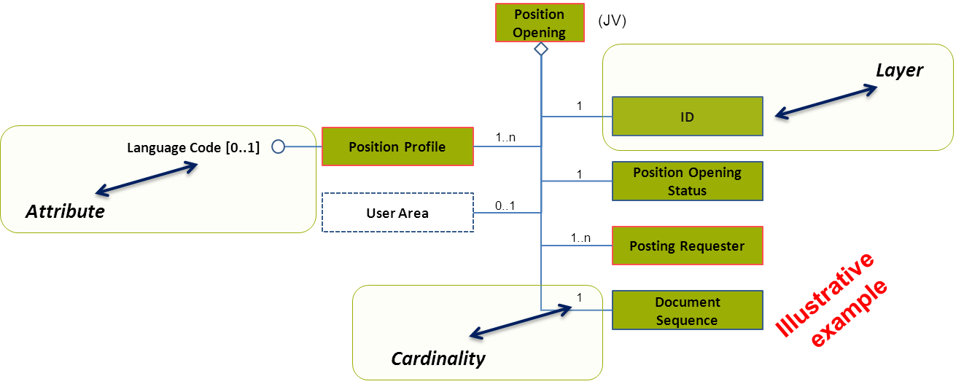
Figure 1: Example of a Tree of Elements Representing the JV Standard

Layers Approach
This model starts from the HR-Open Standards template. This template determines the structure and the number of fields possible. The EURES version of this model considers all elements of this standard template and assigns them in 3 layers. Some of the layers will impose extra requirements for certain fields.
- Green colour: This indicates that this information is essential to the EURES standard, and should be provided by the source of this job vacancy. The information could be essential for job matching and the lack of it can influence our main goal.
- Yellow colour: The information elements in this layer are optional for the use by the EURES system. They will be checked and can be used to display additional information or improve some optional search/matching features. The EURES partners are free to decide if they send in this information. However, when they do so, the information needs to follow the rules of this standard.
- White colour: The remaining part of the template that is there to be fully compliant with the standard, but these elements are not used by the EURES System. Adding white elements in the XML will trigger warinings in the online validator tool.

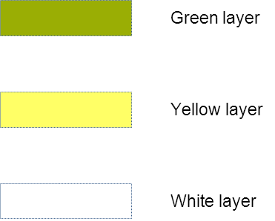
Figure 2: Description of the layer colours
An example:
Employer X can hand over a job vacancy in the HR-Open Standards to an employment agency Y. This EURES partner Y will adapt the information if needed and send it in to the EURES interoperability platform. This means that they will make sure the green and yellow parts are in line with the expectations specified in this document. The white part (information send in by the employer but outside of the matching scope) will not be removed; it just remains in the job vacancy. If the job vacancy would be retrieved by another player, they may still want to use the other layers.

To understand the layers that have been added to this implementation of the HR-Open Standards, you have to consider the 2 main targeted user groups:
- The model is designed to be used by the EURES partners to exchange information and perform matching according to an agreed set of data;
- Next to this, the model will be used by interested industry partners to exchange data beyond the boundaries of the EURES partners. They can benefit from the advantages of the open standard, and a fast exchange opportunity from or to a EURES partner.

Next to this division in 3 layers, the model can represent each element with some special indicators (dotted/solid lines, red border). These details are more important for the technical implementation of validation rules.
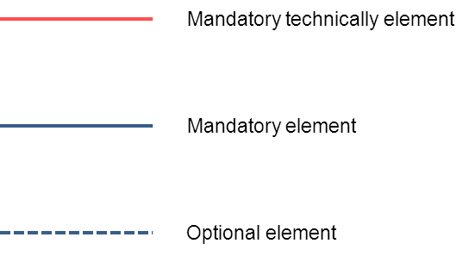
Figure 3: Description of the layer lines types

The diagram below provides a detailed overview:

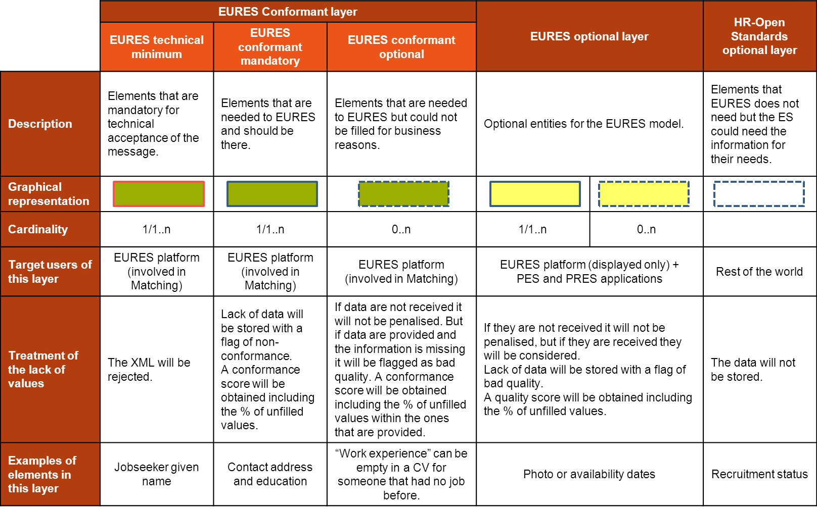
Figure 4: Detailed description of EURES layers
The ES will be able to share JV information with EURES Hub using any of the layers.

Design Criteria
The following design criteria have been followed:
TREE DECOMPOSITION:
- Each diagram will have one decomposed sub-element. This means, that the root element will be repeated (e.g. profiles, languages, etc.), in each decomposed diagram.
ASSIGNMENT OF THE LAYER TYPE:
- The layer type of an element will be constrained by its parent's layer. This is due to a sub-element may have the same layer type that its parent, or a less restrictive one.
- In this example, the root element belongs to the “EURES conformant layer” (green). However, its sub-elements may be “EURES conformant layer” (green), but also they may be “EURES optional layer” (yellow) or “HR-Open Standards optional layer” (white), regardless of their cardinality (i.e. 1, 1..n or 0..n):
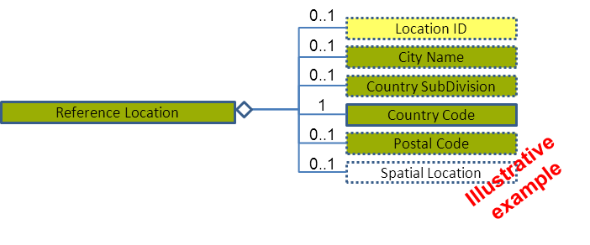
Figure 5: Example of tree of elements applying "EURES conformant layer" design criteria
- The same applies to an element that belongs to the “EURES optional layer” (yellow), which its sub-elements may be “EURES optional layer” (yellow) or “HR-Open Standards optional layer” (white):
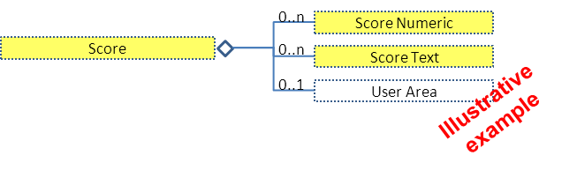
Figure 6: Example of tree of elements applying "EURES optional layer" design criteria
ASSIGNMENT OF THE CARDINALITY:
- An element may be mandatory (cardinality 1 or 1..n) or optional (cardinality 0..1 or 0..n). However, its assignment does not depend on its layer type.
- A mandatory element is required to appear, as long as its parent also appears. According to the layer type, the lack of values of a mandatory element is treated in a different way.
For example, a mandatory element which layer is “EURES conformant layer” (green) may imply:
  - The XML will be rejected if the element is “EURES technical minimum”.
  - “EURES conformant mandatory”: the lack of data will be stored with a flag of non-conformance and a conformance score will be obtained including the % of unfilled values.
On the other hand, a mandatory element as “EURES optional layer” (yellow) implies:
  - Lack of data will be stored with a flag of bad quality. A quality score will be obtained including the % of unfilled values.
- The design criterion implies that a mandatory element should meet one of the criteria in order to not have an empty element:
  - At least one of its sub-elements should be mandatory (cardinality 1 or 1..n):
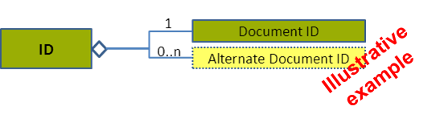
Figure 7: Example of tree of elements applying "EURES mandatory" design criteria
- A Business Rule (BR) will be applied pointing out that at least one of its sub-elements must be filled in:
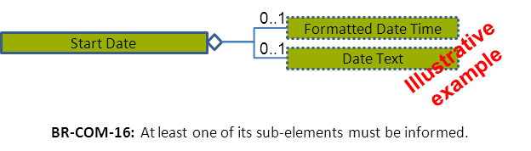
Figure 8: Example of tree of elements applying "EURES mandatory" business rule
MISSING VALUES:
- Information could be missing because of 2 reasons. First because the Employment service does not have this information in its database at all. A second reason is when the database could have the information, but it was not provided by the organisation for this specific JV. The Interoperability Platform will differentiate between these 2 cases by the following rule:
  - Not including the tags of an element in the XML file means that the Employment services do not have this information in their database for all JV’s.
  - Including an element’s tags in the XML file, but leaving them empty (e.g. <TravelPreference> </TravelPreference>) means that the posting organisation did not provide any work experience.
Please note that this differentiation may be used by matching engines in certain rules.

Specific Topics
The following topics impact on the whole model:

JV in Multiple Languages
How should EURES check that an Employment Service has the same JV in different languages?
The agreed solution is that:
- It will be controlled at the Position Profile level and each language will have a profile (see section “4.5.2 Position Profile Attributes”).
- This decision will include the following Business Rules:
  - BR-COM-01: If not otherwise specified, “EN” (English) is used as the default language.
  - BR-COM-02: Multiple profiles are allowed, but it must be expressed in different languages.
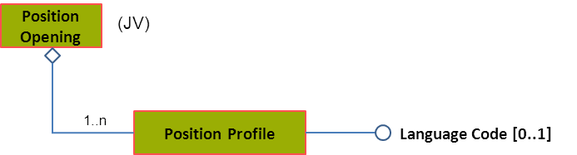
Please, see section “4.5.3 Position Profile Examples” for more examples.

Content Versioning
Versioning is involved at the level of the standard template used for exchanging the data and at the level of changes in the content of a JV (changes in the content of one or more fields of a JV).
- The Interoperability Platform will not store the history of content versions. This means that when a JV is updated (for instance the address of the jobseeker is changed), its old content will be removed and lost inside the interoperability platform storage.
This does NOT mean that the owner of this JV can’t keep a history of all changes in a JV in its own system. However when sending the data to the interoperability platform, it is expected to represent only the most recent information and no history of changes.
- In each exchange also the version of the EURES schema (template) being used needs to be expressed (i.e. 3.1, 3.2).
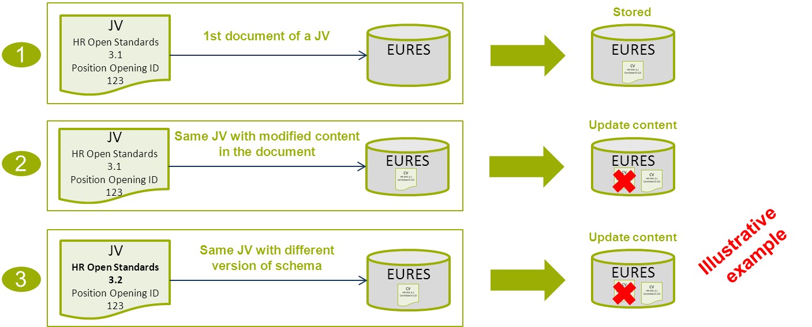

Code List Version
Codes are used to identify concepts. The standard EURES CV and JV use codes intensively, as codes are one of the most powerful solutions for ensuring interoperability.
Which version of these code lists will this standard use?
- For each code list, the latest available version of the standard being designed is used. Only one version for each code list is used.
- However, for specific cases, a code list may be limited or a specific version may be chosen. This will be explained where the code list is specified.

Identifiers
A JV can pass from partner to partner before entering the interoperability platform. Each system may want to add its own identifier to the document for traceability. This way the EURES partner that puts the document on the platform can trace back to the owner when needed for referral. Therefore this document will set the rules to enable all parties to trace back when needed.
The document identifiers are stored in the Document ID:
- The Document ID element will store the original document identifier. Any additional identifiers will be stored in an Alternate Document ID.
- The following attributes establishes the job vacancy’s EURES Partner:
  - The SchemaAgencyID attribute of the DocumentID (or AlternateDocumentID) and PartyID elements must be the same.
Please see sections “4.3 /ID (level 1)” and “4.3.3 ID Examples” for more examples.

EURES JV “Static” Standard Description
The EURES JV model is based on the HR-Open Standards 3.2 “PositionOpening” specification. It has the following characteristics:
- This specification has been customised in order to better meet the information exchange and matching objectives defined in EURES.
- The elements which are not described in this specification are not allowed
- The XSD specifies that the elements of the XML implementation MUST appear in a sequence. One of the validation rules is to check that the sequence of the elements is compliant with the XSD
- Adding white elements in the XML will trigger warinings in the online validator tool
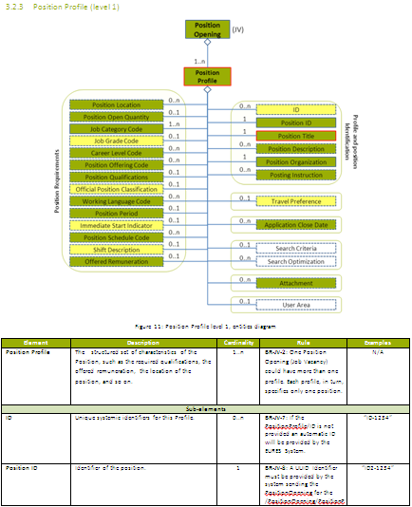
The model is shown in the diagram level by a tree of elements:
- An overall view of the entities diagram
- A description of how the entity diagrams correspond to details of the relevant information elements with business semantics (only when not previously disaggregated)
- Names and descriptions for each of these elements, their restrictions and when relevant Business Rules should be taken into consideration
- An examples column, where some elements are complex (including different sub-elements) and are represented with N/A

Overall View
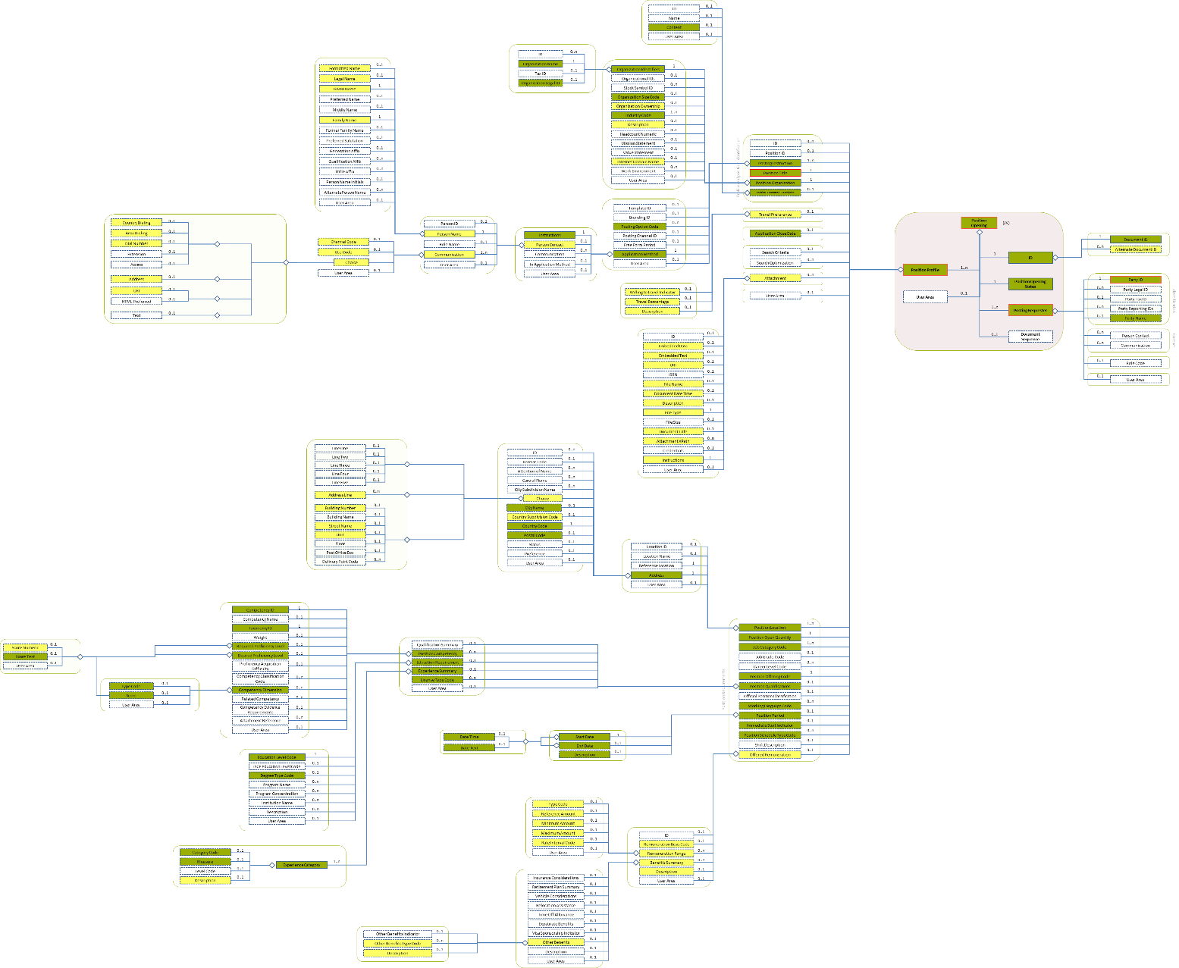
Figure 9: Overall View Entity Diagram

/Position Opening (level 0)

Position Opening Element Description
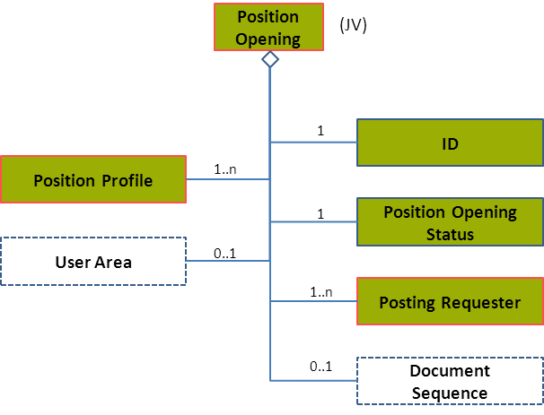
Figure 10: Position Opening Level 0 Entity Diagram
Element | Description | Layer /  Cardinality |  | Rule | Examples
Position Opening | The root element containing the definition of a position opening, i.e., a Job Vacancy that is exchanged between an ES and Interoperability Platform and that is to be matched with Candidate profiles.  Only one position opening (job vacancy) per job vacancy is allowed. |  | EURES Technical Minimum  /  1 |  | N/A
Sub-elements
ID | Provides the Identifier(s) of the document being communicated. It only identifies the Document within the sender organisation. |  | EURES Conformant  /  1 | N/A | N/A
 | See section “4.3 /ID (level 1)” for more information
Position Opening Status | A code classifying the opening status of the position.  This is an HR-Open Standards open list. |  | EURES Conformant  /  1 | BR-JV-03: The “RecruitingDocumentStatusCodeCondentType” HROpen Standards code list must be used to codify the /PositionOpening /PositionOpeningStatusCode. | “active”, “closed”, “incomplete”  Full code list: “4.15.25 Recruiting Document Status Code Enum Type [CL57]”
Posting Requester | Information about the partner placing or communicating the position posting. The party "Requesting" the posting or advertising service.  This can be a EURES Partner registered in the Interoperability Platform or an external PES / PRES that is not a EURES Partner. |  | EURES Technical Minimum  /  1..n | N/A | N/A
 | See section “4.4 /Posting Requester (level 1)” for more information
Position Profile | The position’s structured set of characteristics, such as the required qualifications, the remuneration offered, the location of the position, and so on.  More than one profile is allowed in order to provide the information in different languages. Thus the need for cardinality 1..n.  It is the responsibility of the person who builds up the JV to make sure that a profile is expressed in the same language and those different profile language versions contain exactly the same information. |  | EURES Technical Minimum  /  1..n | BR-COM-01: If not otherwise specified, “EN” (English) is used as the default language.  BR-COM-02: Multiple profiles are allowed, but it must be expressed in different languages. | N/A
 | See section “4.5 /Position Profile (level 1)” for more information

Position Opening Attributes
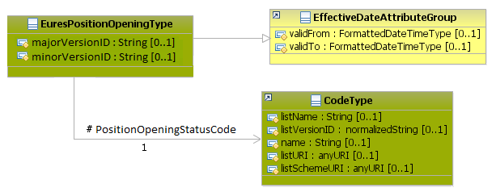
Figure 11: Position Opening Attributes Schema
Attributes | Description | Card. | Rule | Example
majorVersionID | Identifies the major version of the HR-Open Standards schema. | 0..1 | BR-COM-56: The attributes “majorVersionID” and “minorVersionID” are mandatory.  BR-COM-57: Compulsory use of the version 3.2 of HR-OS (“majorVersionID” is 3 and “minorVersionID” is 2). | “3”
minorVersionID | Identifies the minor version of the HR-Open Standards schema. | 0..1 | BR-COM-56: The attributes “majorVersionID” and “minorVersionID” are mandatory.  BR-COM-57: Compulsory use of the version 3.2 of HR-OS (“majorVersionID” is 3 and “minorVersionID” is 2). | “2”
validFrom | Specifies the date of reception of the document in the Interoperability Platform. | 0..1 | BR-COM-06: Compulsory Date Format is: YYYY-MM-DD, YYYY-MM, YYYY or YYYY-MM-DDThh:mm:ss. | “2012-10-10”
PositionOpeningStatusCode sub-element
Attributes | Description | Card. | Rule | Examples
listName | The code list name | 0..1 | N/A | N/A
listVersionID | The code list identification | 0..1 | N/A | N/A
name | The text equivalent of the code content component | 0..1 | N/A | N/A
listURI | The Uniform Resource Identifier that identifies where the code list is located. | 0..1 | N/A | N/A
listSchemeURI | The Uniform Resource Identifier that identifies where the code list scheme is located. | 0..1 | N/A | N/A
Please note that the Schema version is identified in EURES. It is based on the Schema namespace, which contains both the name and the version of a specific Schema. It consists in parsing the Schema namespace and isolating the version identification from the name. Therefore, EURES Schema names are compounded based on a strict compulsory pattern:
https://ec.europa.eu/eures/standards/[Year]/[SchemaName]-[IntegerVersionDigit.DcimalVersionDigit]
as in “https://ec.europa.eu/eures/standards/2012/PositionOpening-1.0”.
The EURES schema uses the following namespace definitions:
- xsi:schemaLocation="http://www.hr-xml.org/3 ../Developer/Nouns/PositionOpening.xsd"
- xmlns="http://www.hr-xml.org/3"
- xmlns:oa="http://www.openapplications.org/oagis/9"
- xmlns:xsi="http://www.w3.org/2001/XMLSchema-instance"

/ID (level 1)

ID Element Description
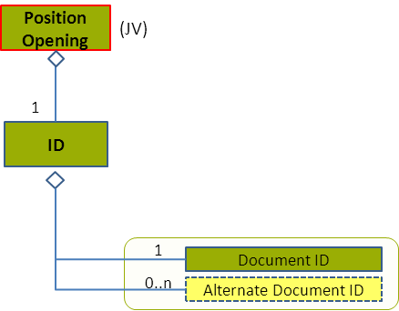
Figure 12: ID Level 1 Entity Diagram
Element | Description | Layer /  Cardinality |  | Rule | Examples
ID | Provides the Identifier(s) of the document being communicated. It only identifies the Document within the sender organisation. |  | EURES Conformant  /  1 | N/A | N/A
Sub-elements
Document ID | Only identifies a document within the sender organisation. Typically there are only documents IDs within supplier organisation systems.  Stores the original document identifier. |  | EURES Conformant  /  1 | Information The Document ID identifier must be a UUID and it must be provided by the first sender of the document. | “DOC-1828217”
Alternate Document ID | Additional identifiers for this document. If EURES has to exchange this document with third parties, a EURES alternate ID (only an identifier within the EURES information system) is added. This construct is designed to allow for these different identifications. |  | EURES Optional  /  0..n | N/A | “ES-DOC-1828217”
Please, see section “3.3.4 Identifiers” for more about how to inform the party of the job vacancy.

ID Attributes
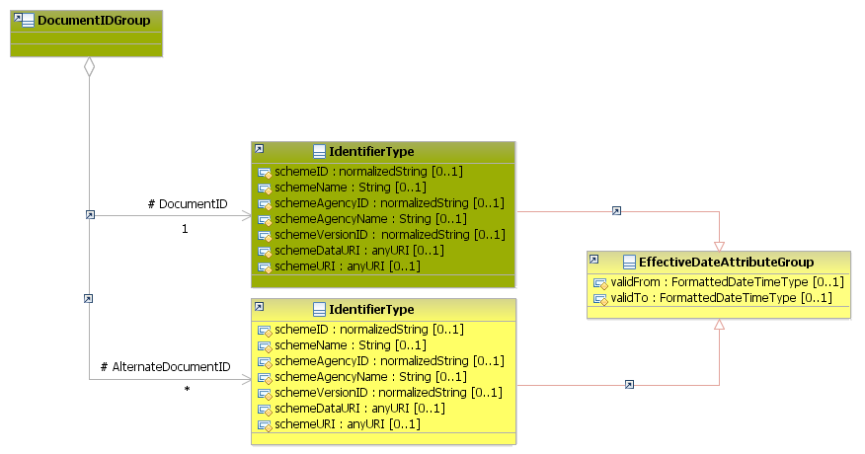
Figure 13: ID Attributes Schema
Attributes | Description | Card. | Rule
This element has no attributes.
DocumentID sub-element
Attributes | Description | Card. | Rule
schemeID | Identification of the identifier scheme | 0..1 | N/A
schemeName | Identification scheme name | 0..1 | N/A
schemeAgencyID | Identification of the agency that maintains the identification scheme | 0..1 | InformationThe SchemeAgencyID attribute of the DocumentID (or AlternateDocumentID) and at least one PartyID elements must be the same.
schemeAgencyName | Name of the agency that maintains the identification scheme | 0..1 | N/A
schemeVersionID | The version of the EURES HR Standards. | 0..1 | BR-COM-45: Compulsory use of EURES HR Standard version Version Codes [CL63]
schemeDataURI | The Uniform Resource Identifier that identifies where the identification scheme data is located | 0..1 | N/A
schemeURI | The Uniform Resource Identifier that identifies where the identification scheme is located | 0..1 | N/A
validFrom | Validity start date for this ID | 0..1 | BR-COM-06: Compulsory Date Format is: YYYY-MM-DD, YYYY-MM, YYYY or YYYY-MM-DDThh:mm:ss.
validTo | Validity end date for this ID | 0..1 | BR-COM-06: Compulsory Date Format is: YYYY-MM-DD, YYYY-MM, YYYY or YYYY-MM-DDThh:mm:ss.
AlternateDocumentID sub-element
Attributes | Description | Card. | Rule
The same as the “DocumentID” sub-element

ID Examples
This example shows that the original document identifier is provided by a EURES Partner, named PES01 in this example, on January 1st 2014 and an additional identifier was provided by another EURES Partner the same day.
<PositionOpening xsi:schemaLocation="http://www.hr-xml.org/3 ../Developer/Nouns/PositionOpening.xsd" xmlns="http://www.hr-xml.org/3" xmlns:xsi="http://www.w3.org/2001/XMLSchema-instance" xmlns:oa="http://www.openapplications.org/oagis/9" majorVersionID="3" minorVersionID="2" >

<!-- Original identifier provided by the PES01 -->
<DocumentID
schemeID="ID-1234"
schemeName="DocumentIdentifier"
schemeAgencyID="PES01"
schemeAgencyName="PublicEmploymentServices01"
schemeVersionID="1.2"
schemeDataURI="https://ec.europa.eu/eures/standards/2014/DOC/Data/ID"
schemeURI="https://ec.europa.eu/eures/standards/2014/DOC/ID"
validFrom="2014-01-01" >
1067482948
</DocumentID>

<!-- Additional identifier provided by another PES -->
<AlternateDocumentID
schemeID="ID-33334"
schemeName="DocumentIdentifier"
schemeAgencyID="PES02"
schemeAgencyName="PublicEmploymentServices02"
schemeVersionID="1.0"
schemeDataURI="https://ec.europa.eu/eures/standards/2014/DOC/Data/ID"
schemeURI="https://ec.europa.eu/eures/standards/2014/DOC/ID"
validFrom="2014-01-01" >
PESID-1233
</AlternateDocumentID>
<PositionOpening/>

/Posting Requester (level 1)

Posting Requester Element Description
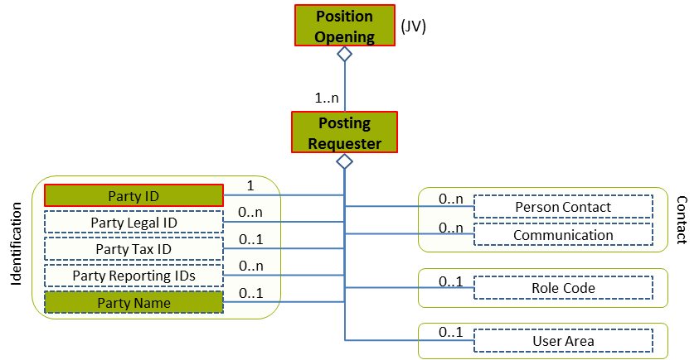
Figure 14: Posting Requester Level 1 Entity Diagram
Element | Description | Layer /  Cardinality |  | Rule | Examples
Posting Requester | Information about the partner placing or communicating the position posting. The party "Requesting" the posting or advertising service.  This can be a EURES Partner registered in the Interoperability Platform or an external PES / PRES that is not a EURES Partner. |  | EURES Technical Minimum  /  1..n | N/A | N/A
Sub-elements
Party ID | Only an identifier that distinguishes a EURES Partner system involved in a transaction.  This identifier must be provided by the Interoperability Platform once registered, and it is unique. |  | EURES Technical Minimum  /  1 | Information | “PARTID-1234”
Party Name | The name of the party supplying the Job Vacancy |  | EURES Conformant Optional  /  0..1 | N/A | “Party name”

Posting Requester Attributes
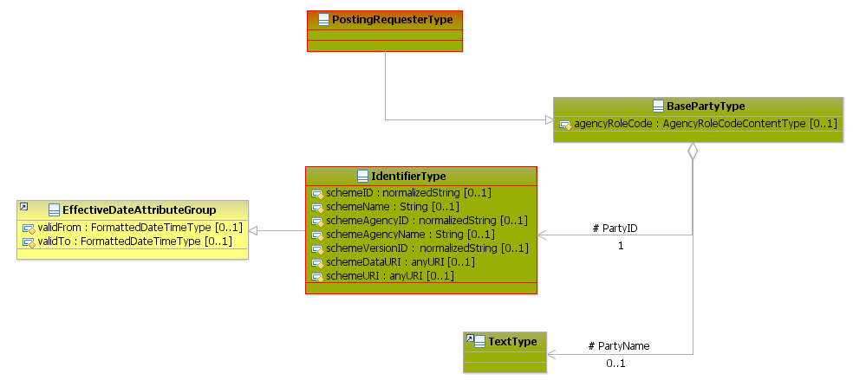
Figure 15: Posting Requester Attributes Schema
Attributes | Description | Card. | Rule
agencyRoleCode | A code classifying the job vacancy role within the organisation, or the role with which that organisation is associated, such as “customer” or “supplier” (full code list “4.15.1 Agency Role Code Enum Type [CL55]”)  This is an HR-Open Standards code list. | 0..1 | BR-JV-06: Compulsory use of the Agency Role Code Enum Type [CL55]
PartyID sub-element
Attributes | Description | Card. | Rule
schemeID | Identification of the identifier scheme | 0..1 | N/A
schemeName | The identification scheme name | 0..1 | N/A
schemeAgencyID | Identification of the agency that maintains the identification scheme | 0..1 | Information: The SchemeAgencyID attribute of the DocumentID (or AlternateDocumentID) and at least one PartyID elements must be the same.
schemeAgencyName | The name of the agency that maintains the identification scheme | 0..1 | N/A
schemeVersionID | The identification scheme version | 0..1 | N/A
schemeDataURI | The Uniform Resource Identifier that explains where the identification scheme data is located | 0..1 | N/A
schemeURI | The Uniform Resource Identifier that explains where the identification scheme is located | 0..1 | N/A
validFrom | Validity start date for this ID | 0..1 | BR-COM-06: Compulsory Date Format is: YYYY-MM-DD, YYYY-MM, YYYY or YYYY-MM-DDThh:mm:ss.
validTo | Validity end date for this ID | 0..1 | BR-COM-06: Compulsory Date Format is: YYYY-MM-DD, YYYY-MM, YYYY or YYYY-MM-DDThh:mm:ss.
PartyName sub-element
Attributes | Description | Card. | Rule
This sub-element has no attributes.

Posting Requester Examples
This example shows 2 posting requesters, one of them is a EURES Partner.
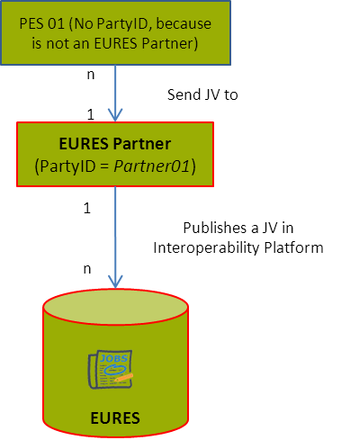 | <PositionOpening xmlns="http://www.hr-xml.org/3" xsi:schemaLocation="http://www.hr-xml.org/3 ../Developer/Nouns/PositionOpening.xsd">  <!-- EURES Partner requester -->  <PostingRequester>  <PartyID  schemeID="Party-IDs"  schemeName="PartyIdentifier"  schemeAgencyID="ID-1234"  schemeAgencyName="PES01"  schemeVersionID="1.00" schemeDataURI="https://ec.europa.eu/eures/standards/2014/Supplier/Data/ID"  schemeURI="http://www.pes01.eu"  validFrom="2014-01-01"  validTo="2016-12-31">Partner01</PartyID>  <PartyName>PES01</PartyName>  </PostingRequester>  <!-- Another requester -->  <PostingRequester agencyRoleCode="Supplier">  <PartyID schemeAgencyID="eures-localpes" schemeAgencyName="eures-localpes" schemeID="eures-localpes" schemeVersionID="1.0" schemeDataURI="https://ec.europa.eu/eures/standards/2014/Supplier/Data/ID">70.00</PartyID>  </PostingRequester>  <PositionOpening/>

This example shows one document identifier provided by a PES, called PES01, and how it is related to a requester.
<PositionOpening xmlns="http://www.hr-xml.org/3" xsi:schemaLocation="http://www.hr-xml.org/3 ../Developer/Nouns/PositionOpening.xsd">

<!-- 1st identifier of the document, send by PES01 1st January 2014 -->
<DocumentID
schemeID="ID-1234"
schemeName="DocumentIdentifier"
schemeAgencyID="PES01"
schemeAgencyName="PublicEmploymentService01"
schemeVersionID="1.2"
schemeDataURI="https://ec.europa.eu/eures/standards/2014/DOC/Data/ID"
schemeURI="https://ec.europa.eu/eures/standards/2014/DOC/ID"
validFrom="2014-01-01">
1067482948
</DocumentID>

<!-- EURES Partner requester, related to DocumentID through schemeAgencyID -->
<PostingRequester>
<PartyID
schemeID="Party-IDs"
schemeName="PartyIdentifier"
schemeAgencyID="PES01"
schemeAgencyName="PublicEmploymentService01"
schemeVersionID="1.00" schemeDataURI="https://ec.europa.eu/eures/standards/2014/Supplier/Data/ID"
schemeURI="http://www.pes01.eu"
validFrom="2014-01-01" validTo="2016-12-31">
Partner01</PartyID>
<PartyName>PES01</PartyName>
</PostingRequester>
<PositionOpening/>

/Position Profile (level 1)

Position Profile Element Description
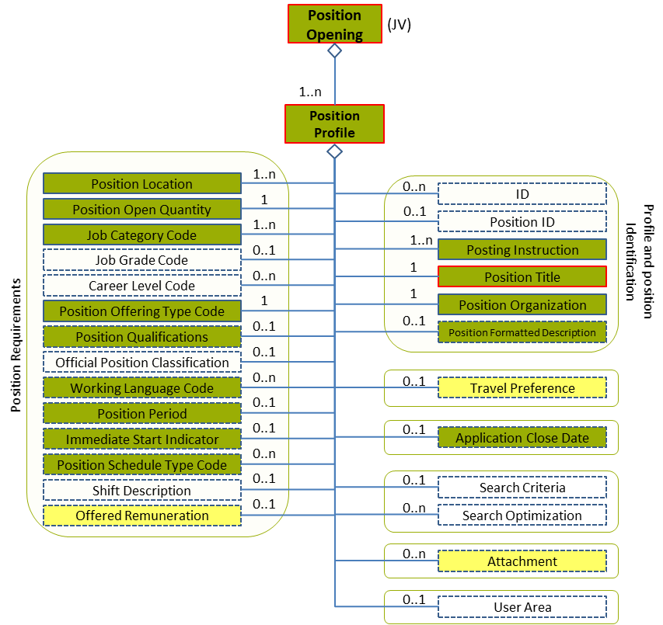
Figure 16: Position Profile Level 1 Entity Diagram
Element | Description | Layer /  Cardinality |  | Rule | Examples
Position Profile | The position’s structured set of characteristics, such as the required qualifications, the remuneration offered, the location of the position, and so on.  More than one profile is allowed in order to provide the information in different languages. Thus the need for cardinality 1..n.  It is the responsibility of the person who builds up the JV to make sure that a profile is expressed in the same language and those different profile language versions contain exactly the same information. |  | EURES Technical Minimum  /  1..n | BR-COM-01: If not otherwise specified, “EN” (English) is used as the default language.  BR-COM-02: Multiple profiles are allowed, but it must be expressed in different languages. | N/A
Sub-elements
Posting Instruction | Information about where and how a posting should be communicated |  | EURES Conformant  /  1..n | N/A | N/A
 | See section “4.8 /Position Profile /Posting Instruction (level 2)” for more information
Position Title | A short phrase describing the position as it would be listed on a business card or in a company directory |  | EURES Technical Minimum  /  1 | N/A | “Business analyst” or “Personal assistance”
Position Location | A description of the physical location of the position |  | EURES Conformant  /  1..n | N/A | N/A
 | See section “4.10 /Position Profile /Position Location (level 2)” for more information
Position Organization | Set of data about the organisation offering the position |  | EURES Conformant  /  1 | N/A | N/A
 | See section “4.7 /Position Profile /Position Organization (level 2)” for more information
Position Open Quantity | The number of posts currently available to be filled |  | EURES Conformant  /  1 | BR-JV-08: The absence of the /PositionOpenQuantity element means that at least 1 position is currently available. | 2, 10, etc.
Job Category Code | A code classifying the job type or category. This may be used for occupational classification of the job. The JobCategoryCode will usually be repeatable so that a single job can be classified across multiple dimensions.  The JobCategoryCode can be used to classify the job by industry, but note that an explicit IndustryCode is available in contexts such as: PositionOrganizationDetails. |  | EURES Conformant  /  1..n | BR-COM-29: Compulsory use of the “ISCO2008-CodeList.gc” list defined by EURES and based on ISCO-08. Alternatively, use of ESCO Occupations – version 1.0.  BR-COM-55: Compulsory use of the attributes “listVersionID”, “listName” and “listURI”. | “1” – Managers,  “12” – Administrative, etc.  Full code list: “4.15.13 Job Category Codes [CL20]”
Position Offering Type Code | Descriptive value classifying a position opportunity.  This is an HR-Open Standards open list. |  | EURES Conformant  /  1 | BR-COM-38: Compulsory use of the “PositionOfferingCodeContentType” list. | “DirectorHire”,  “Temporary”, “TemporaryToHire”, “ContractToHire”, Etc.  Full code list: “4.15.22 Position Offering Codes [CL37]”
Position Qualifications | Information related to matching capacities, knowledge, skills, abilities, awards and other resource deployment-related characteristics (including “competencies”) requested by potential employers or clients. |  | EURES ConformantOptional  /  0..1 | N/A | N/A
 | See section “4.11 /Position Profile /Position Qualifications (level 2)” for more information
Position Formatted Description | A text description of a position |  | EURES ConformantOptional  /  0..1 | N/A | N/A
 | See section “4.6 /Position Profile /Position Formatted Description (level 2)” for more information
Travel Preference | A position’s travel requirements and the percentage of time |  | EURES Optional  /  0..1 | N/A | N/A
 | See section “4.9 /Position Profile /Travel Preferences (level 2)” for more information
Working Language Code | A code classifying the language or languages used within the workplace or associated with work. This is intended to communicate general information about the language(s) used within the work environment, or general information about a candidate's specific language preferences. This component might be offered as descriptive "pre-qualification" information on a position announcement. It might appear within the context of a Candidate Profile as a general statement of a candidate's general language capabilities or preferences. WorkingLanguageCode is not intended as a statement of language proficiency or specific requirement relating to language proficiency. Specific information regarding language proficiency should be covered either within PositionCompetency or as is appropriate. |  | EURES Conformant Optional  /  0..n | BR-COM-11: Compulsory use of the “LanguageCodes-CodeList.gc” list defined by EURES. This is based on ISO-639-1:2002 Alpha-2, which includes all world languages.  BR-COM-43: Multiple entries of this code list are allowed. | “aa” = Afar,  “ab” = Abkhazian, etc.  Full code list: “4.15.14 Language Codes [CL24]”
Position Period | Period of time during which the contract is valid |  | EURES ConformantOptional  /  0..1 | N/A | N/A
 | See section “4.12 /Position Profile /Position Period (level 2)” for more information
Immediate Start Indicator | An indicator as to whether a position is available to start immediately |  | EURES ConformantOptional  /  0..1 | N/A | “true”, “false”
Position Schedule Type Code | Describes a position’s general schedule  This is an HR-Open Standards open list. |  | EURES Conformant Optional  /  0..n | BR-COM-39: Compulsory use of the “PositionScheduleCodeContentType” list.  BR-COM-43: Multiple entries of this code list are allowed. | “FullTime”, “PartTime”, “FlexTime”, “Any”  Full code list: “4.15.23 Position Schedule Codes [CL38]”
Offered Remuneration | Remuneration and benefits offered |  | EURES Optional  /  0..1 | N/A | N/A
 | See section “4.13 /Position Profile /Offered Remuneration (level 2)” for more information
Application Close Date | The specific date after which applications will not be accepted  The typeCode attribute allows the close date to be classified |  | EURES ConformantOptional  /  0..1 | BR-COM-06: Compulsory Date Format is: YYYY-MM-DD, YYYY-MM, YYYY or YYYY-MM-DDThh:mm:ss. | “2013-12-12”
Attachment | External documents or digital objects can be embedded or referenced |  | EURES Optional  /  0..n | N/A | N/A
 | See section “4.14 /Position Profile /Attachment (level 2)” for more information

Position Profile Attributes
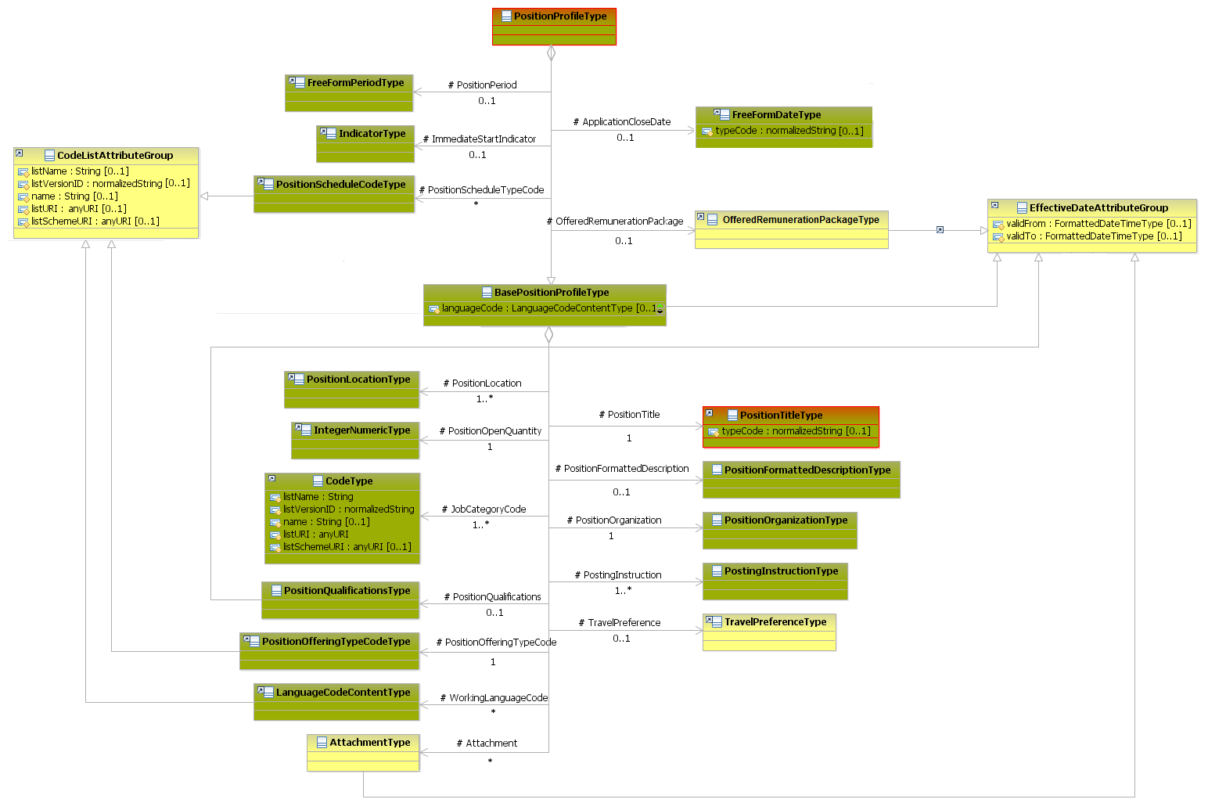
Figure 17: Position Profile Attributes Schema
Attributes | Description | Card. | Rule
languageCode | Language used throughout the whole document.  Only official European Country languages are allowed. | 0..1 | BR-COM-01: If not otherwise specified, “EN” (English) is used as the default language  BR-COM-04: Compulsory use of the “EURES_EULanguageCodes-CodeList.gc” list defined by EURES. Only adapted EU countries are used, based on ISO 639-1:2002 Alpha-2. The full code list is available here: Official Languages in European Countries Codes [CL33]
validFrom | Validity start date for this entity’s information | 0..1 | BR-COM-06: Compulsory Date Format is: YYYY-MM-DD, YYYY-MM, YYYY or YYYY-MM-DDThh:mm:ss.
validTo | Validity end date for this entity’s information | 0..1 | BR-COM-06: Compulsory Date Format is: YYYY-MM-DD, YYYY-MM, YYYY or YYYY-MM-DDThh:mm:ss.
PostingInstruction sub-element
Attributes | Description | Card. | Rule
See section “4.8.2 Posting Instruction Attributes” for more information
PositionTitle sub-element
Attributes | Description | Card. | Rule
The same as “ApplicationCloseDate” sub-element
PositionLocation sub-element
Attributes | Description | Card. | Rule
See section “4.10.2 Position Location Attributes” for more information
PositionOrganization sub-element
Attributes | Description | Card. | Rule
See section “4.7.2 Position Organization Attributes” for more information
PositionOpenQuantity sub-element
Attributes | Description | Card. | Rule
This sub-element has no attributes.
JobCategoryCode sub-element
Attributes | Description | Card. | Rule
listName | The code list name | 0..1 | N/A
listVersionID | The code list identification | 0..1 | N/A
name | The text equivalent of the code content component | 0..1 | N/A
listURI | The Uniform Resource Identifier that identifies where the code list is located. | 0..1 | N/A
listSchemeURI | The Uniform Resource Identifier that identifies where the code list scheme is located. | 0..1 | N/A
PositionOfferingTypeCode sub-element
Attributes | Description | Card. | Rule
The same as the “PositionScheduleTypeCode” sub-element
PositionQualifications sub-element
Attributes | Description | Card. | Rule
See section “4.11.2 Position Qualifications Attributes” for more information
PositionFormattedDescription sub-element
Attributes | Description | Card. | Rule
See section “4.6.2 Position Formatted Description Attributes” for more information
TravelPreference sub-element
Attributes | Description | Card. | Rule
See section “4.9.2 Travel Preferences Attributes” for more information
WorkingLanguageCode sub-element
Attributes | Description | Card. | Rule
listName | The code list name | 0..1 | N/A
listVersionID | The code list identification | 0..1 | N/A
name | The text equivalent of the code content component | 0..1 | N/A
listURI | The Uniform Resource Identifier that identifies where the code list is located. | 0..1 | N/A
listSchemeURI | The Uniform Resource Identifier that identifies where the code list scheme is located. | 0..1 | N/A
PositionPeriod sub-element
Attributes | Description | Card. | Rule
See section “4.12.2 Position Period Attributes” for more information
ImmediateStartIndicator sub-element
Attributes | Description | Card. | Rule
This sub-element has no attributes.
PositionScheduleTypeCode sub-element
Attributes | Description | Card. | Rule
The same as the “WorkingLanguageCode” sub-element
OfferedRemunerationPackage sub-element
Attributes | Description | Card. | Rule
See section “4.13.2 Offered Remuneration Attributes” for more information
ApplicationCloseDate sub-elements
Attributes | Description | Card. | Rule
typeCode | The type of date, such as “Internal Close Date” | 0..1 | N/A
Attachment sub-element
Attributes | Description | Card. | Rule
See section “4.14.2 Attachment Attributes” for more information

Position Profile Examples
The example below shows a JV XML with profiles in different languages, through the LanguageCode attribute.
<PositionOpening xmlns="http://www.hr-xml.org/3" xsi:schemaLocation="http://www.hr-xml.org/3 ../Developer/Nouns/PositionOpening.xsd">
<PositionProfile languageCode="en">
<PositionTitle>Business analyst</PositionTitle>
...
</PositionProfile>

<PositionProfile languageCode="fr">
<PositionTitle>Analyste d'affaires</PositionTitle>
...
</PositionProfile>
</PositionOpening>

/Position Profile /Position Formatted Description (level 2)

Position Formatted Description Element Description
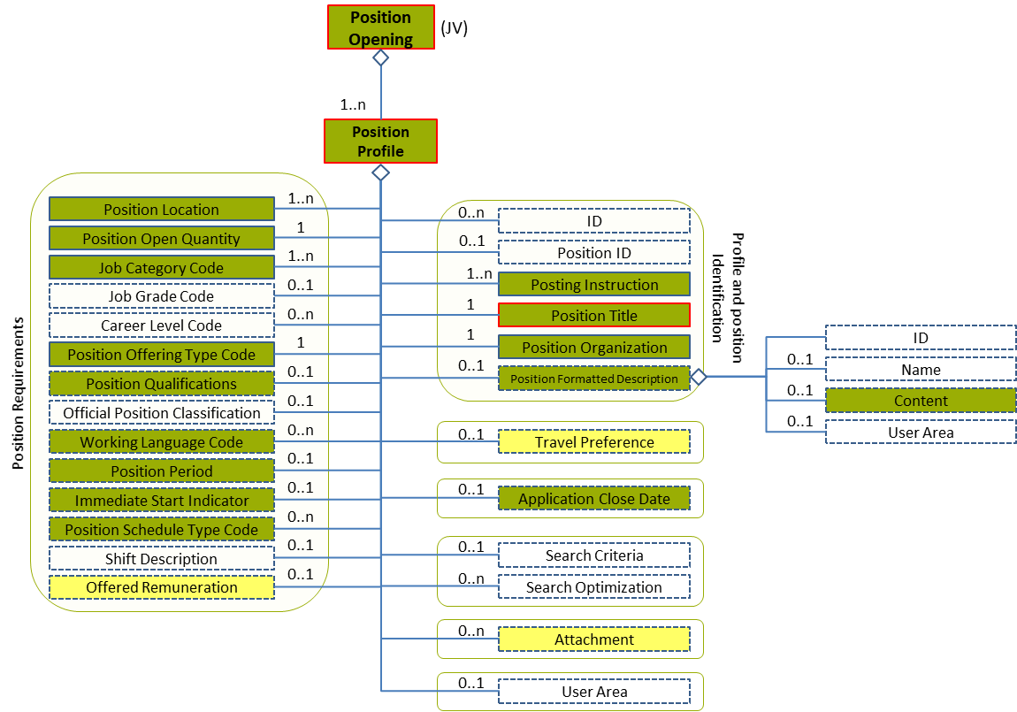
Figure 18: Position Formatted Description Level 2 Entity Diagram
Element | Description | Layer /  Cardinality |  | Rule | Examples
Position Formatted Description | Text description of a position |  | EURES Conformant Optional  /  0..1 | N/A | N/A
Sub-elements
Content | In some cases, content may include a mark-up or might be encoded, for example, HTML content. In such cases, the content might be enclosed within a CDATA section. |  | EURES Conformant Optional  /  0..1 | N/A | “<![CDATA[<br><img src=../images/blank.gif width=2>Management of Security and emergences]]>"

Position Formatted Description Attributes
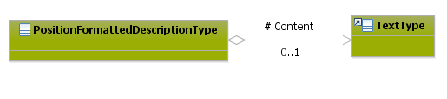
Figure 19: Position Formatted Description Attributes Schema
Attributes | Description | Card. | Rule | Examples
This element has no attributes
Content sub-elements
Attributes | Description | Card. | Rule | Examples
These sub-elements have no attributes.

Position Formatted Description Examples
This example shows how to describe a job through the position formatted description element.
<PositionOpening xmlns="http://www.hr-xml.org/3" xsi:schemaLocation="http://www.hr-xml.org/3 ../Developer/Nouns/PositionOpening.xsd">
<PositionProfile languageCode="en">
<PositionFormattedDescription>
<Content>Support for the professional care of the business units regarding the application and use of the system RCTS.</Content>
</PositionFormattedDescription>
</PositionProfile>
</PositionOpening>

/Position Profile /Position Organization (level 2)

Position Organization Element Description
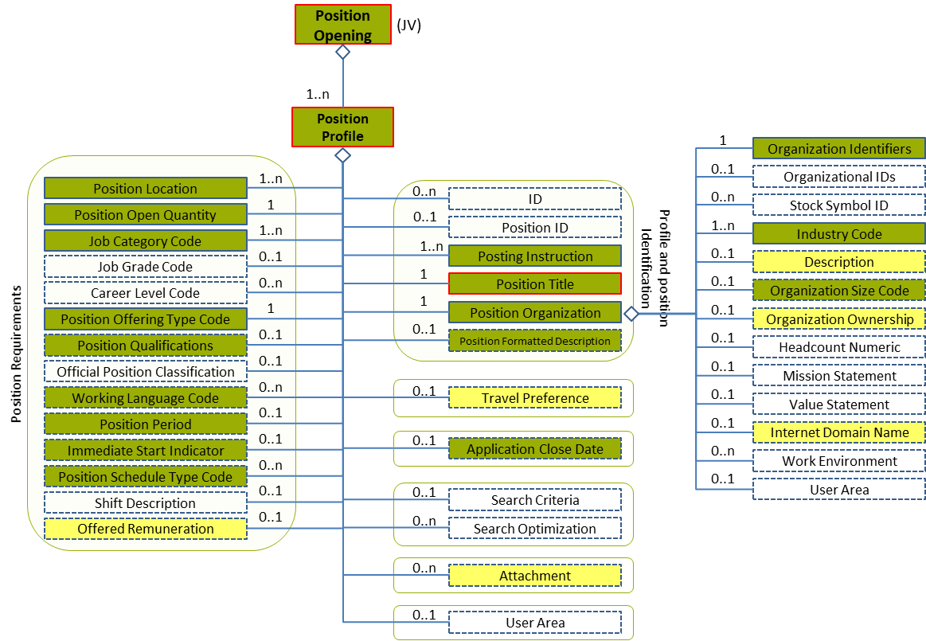
Figure 20: Position Organization Level 2 Entity Diagram
Element | Description | Layer /  Cardinality |  | Rule | Examples
Position Organization | Set of data about the organisation offering this Position |  | EURES Conformant  /  1 | N/A | N/A
Sub-elements
Organization Identifiers | A collection of different identifiers of an organisation |  | EURES Conformant  /  1 | N/A | N/A
 | See section “4.7.4 Sub-element: /Organization Identifiers (level 3)” for more information
Industry Code | A code classifying the industry of the organisation, position, or other entity |  | EURES Conformant  /  1..n | BR-COM-20: Compulsory use of the “NACE-CodeList.gc” list defined by EURES. This is based on EU NACE.  BR-COM-43: Multiple entries of this code list are allowed. | “01” = Agriculture, “02” = Forestry, etc.  Full code list: “4.15.17 NACE Codes [CL31]”
Description | Position organisation description |  | EURES Optional  /  0..1 | N/A | “Electricity and gas supplier”
Organization Size Code | Contains a code classifying an organisation’s size or business scope |  | EURES ConformantOptional  /  0..1 | BR-COM-26: Compulsory use of the “EURES_OrganizationSize-CodeList.gc” list defined by EURES. This is based on EU – C (2003) 1422, including Large enterprises. | “MicroEnterprise”, “SmallEnterprise”, etc.  Full code list: “4.15.21 Organization Size Codes [CL35]”
Organization Ownership | The owner organisation’s code  This is an HR-Open Standards open list. |  | EURES Optional  /  0..1 | BR-COM-27: Compulsory use of the “OrganizationOwnershipTypeCodeContentType” list. | “Public”, “Private”, “Non-profit”, “Government”  Full code list: “4.15.20 Organization Ownership Codes [CL34]”
Internet Domain Name | The unique hostname used to identify a particular host or server on the World Wide Web and in e-mails and other Internet communications |  | EURES Optional  /  0..1 | N/A | “www.domainName.com”

Position Organization Attributes
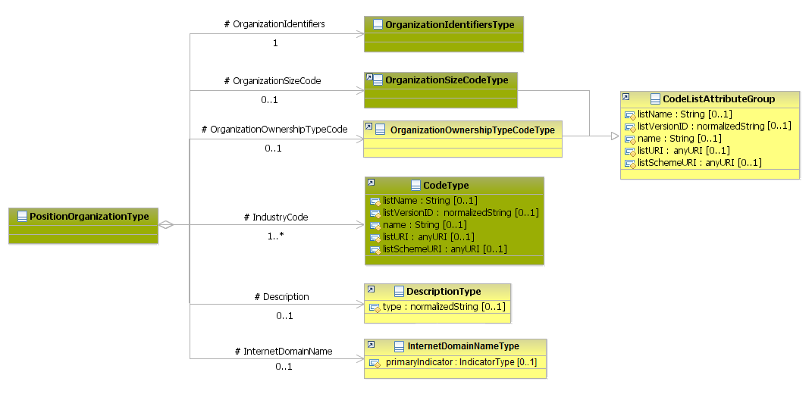
Figure 21: Position Organization Attributes Schema
Attributes | Description | Card. | Rule
This element has no attributes.
OrganizationIdentifiers sub-elements
Attributes | Description | Card. | Rule
See section “4.7.4.2 Organization Identifiers Attributes” for more information
IndustryCode sub-element
Attributes | Description | Card. | Rule
The same as the “OrganizationSizeCode” sub-element
Description sub-element
Attributes | Description | Card. | Rule
type | The type of comment | 0..1 | N/A
OrganizationSizeCode sub-element
Attributes | Description | Card. | Rule
listName | The code list name | 0..1 | N/A
listVersionID | The code list identification | 0..1 | N/A
name | The text equivalent of the code content component | 0..1 | N/A
listURI | The Uniform Resource Identifier that identifies where the code list is located. | 0..1 | N/A
listSchemeURI | The Uniform Resource Identifier that identifies where the code list scheme is located | 0..1 | N/A
OrganizationOwnershipTypeCode sub-elements
Attributes | Description | Card. | Rule
The same as the “OrganizationSizeCode” sub-element
InternetDomainName sub-element
Attributes | Description | Card. | Rule
primaryIndicator | Indicates whether the internet domain name is the primary one or not | 0..1 | N/A

Position Organization Examples
This example shows the description of the employer offering the job.
<PositionOpening xmlns="http://www.hr-xml.org/3" xsi:schemaLocation="http://www.hr-xml.org/3 ../Developer/Nouns/PositionOpening.xsd">
<PositionProfile languageCode="en">
<PositionOrganization>
<OrganizationIdentifiers>
<OrganizationName>Public Administration</OrganizationName>
<OrganizationLegalID schemeID="LegalID" schemeAgencyID="CIF" schemeAgencyName="Codigo Identificacion Fiscal" schemeVersionID="1.0" schemeDataURI="PENDING">CIF A58818501</OrganizationLegalID>
</OrganizationIdentifiers>

<OrganizationSizeCode listName="EURES_OrganizationSize" listVersionID="(2003)1422" name="small enterprise" listURI="https://ec.europa.eu/eures">smallenterprise</OrganizationSizeCode>

<OrganizationOwnershipTypeCode listName="OrganizationOwnershipTypeCodeContentType" listVersionID="1.0" listURI="http://www.hr-xml.org/"
>public</OrganizationOwnershipTypeCode>

<IndustryCode listName="NACE_r2" listVersionID="NACE REVISION 2" name="Hospital activities" listURI="http://ec.europa.eu/esco/ConceptScheme/NACErev2/cs" >86.1</IndustryCode>

<InternetDomainName>http://ec.europa.eu</InternetDomainName>
</PositionOrganization>
</PositionProfile>
</PositionOpening>

Sub-element: /Organization Identifiers (level 3)

Organization Identifiers Element Description
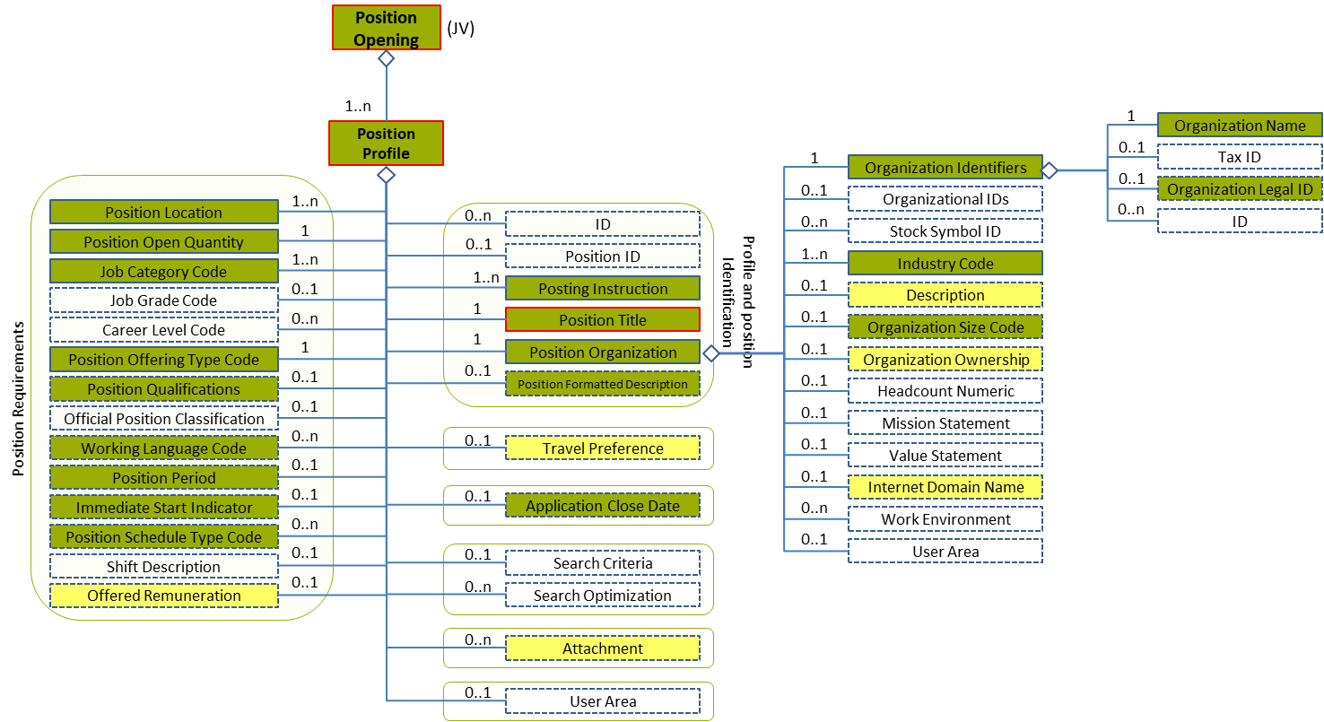
Figure 22: Organization Identifiers Level 3 Entity Diagram
Element | Description | Layer /  Cardinality |  | Rule | Examples
Organization Identifiers | A collection of different identifiers of an organization |  | EURES Conformant  /  1 | N/A | N/A
Sub-elements
Organization Name | Usually an official or legal name used to refer to an organisation |  | EURES Conformant  /  1 | N/A | “Consulting IT”
Organization Legal ID | An identifier issued to an organization by a government organization which identifies it as a legal entity. The schemeName typically would be used to reference the type of identifier and the schemeAgencyID would be used to identify the issuing agency as necessary. |  | EURES Conformant Optional  /  0..1 | N/A | “ID-1234”, “LD-1234”, etc.

Organization Identifiers Attributes
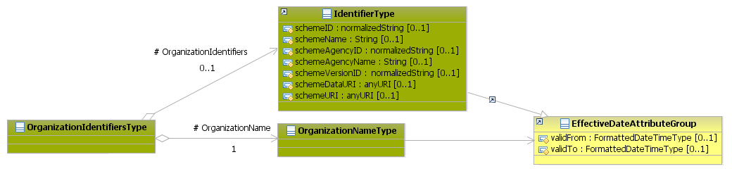
Figure 23: Organization Identifiers Attributes Schema
Attributes | Description | Card. | Rule
This element has no attributes.
OrganizationName sub-elements
Attributes | Description | Card. | Rule
validFrom | Validity start date for this ID | 0..1 | BR-COM-06: Compulsory Date Format is: YYYY-MM-DD, YYYY-MM, YYYY or YYYY-MM-DDThh:mm:ss.
validTo | Validity end date for this ID | 0..1 | BR-COM-06: Compulsory Date Format is: YYYY-MM-DD, YYYY-MM, YYYY or YYYY-MM-DDThh:mm:ss.
OrganizationLegalID sub-elements
Attributes | Description | Card. | Rule
schemeID | Identification of the identifier scheme | 0..1 | N/A
schemeName | The identification scheme name | 0..1 | N/A
schemeAgencyID | Identification of the agency that maintains the identification scheme | 0..1 | N/A
schemeAgencyName | The name of the agency that maintains the identification scheme | 0..1 | N/A
schemeVersionID | The identification scheme version | 0..1 | N/A
schemeDataURI | The Uniform Resource Identifier that identifies where the identification scheme data is located | 0..1 | N/A
schemeURI | The Uniform Resource Identifier that identifies where the identification scheme is located | 0..1 | N/A
validFrom | Validity start date for this ID | 0..1 | BR-COM-06: Compulsory Date Format is: YYYY-MM-DD, YYYY-MM, YYYY or YYYY-MM-DDThh:mm:ss.
validTo | Validity end date for this ID | 0..1 | BR-COM-06: Compulsory Date Format is: YYYY-MM-DD, YYYY-MM, YYYY or YYYY-MM-DDThh:mm:ss.

/Position Profile /Posting Instruction (level 2)

Posting Instruction Element Description
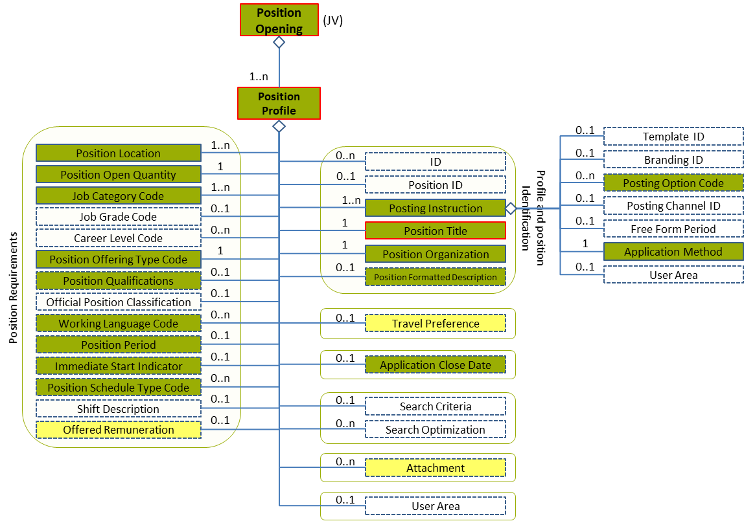
Figure 24: Posting Instruction Level 2 Entity Diagram
Element | Description | Layer /  Cardinality |  | Rule | Examples
Posting Instruction | Information about where and how a posting should be communicated |  | EURES Conformant  /  1..n | N/A | N/A
Sub-elements
Posting Option Code | Used to communicate a choice among options available with respect to the posting |  | EURES Conformant Optional  /  0..n | BR-JV-15: Compulsory use of the “EURES_PostingOptionCodes” list defined by EURES.  BR-COM-43: Multiple entries of this code list are allowed. | “EURES Flag”, etc.  Full code list: “4.15.24 Posting Option Code [CL53]”
Application Method | Instructions on how to apply for the position |  | EURES Conformant  /  1 | N/A | N/A
 | See section “4.8.3 Sub-element: /Application Method (level 3)” for more information

Posting Instruction Attributes
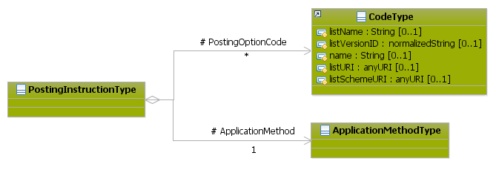
Figure 25: Posting Instruction Attributes Schema
Attributes | Description | Card. | Rule
This element has no attributes.
PostingOptionCode sub-elements
Attributes | Description | Card. | Rule
listName | Code list name | 0..1 | N/A
listVersionID | Code list version | 0..1 | N/A
name | Text equivalent of the code content component | 0..1 | N/A
listURI | The Uniform Resource Identifier that identifies where the code list is located | 0..1 | N/A
listSchemeURI | The Uniform Resource Identifier that identifies where the code list scheme is located | 0..1 | N/A
ApplicationMethod sub-elements
Attributes | Description | Card. | Rule
See section “4.8.3.2 Application Method Attributes” for more information

Sub-element: /Application Method (level 3)

Application Method Element Description
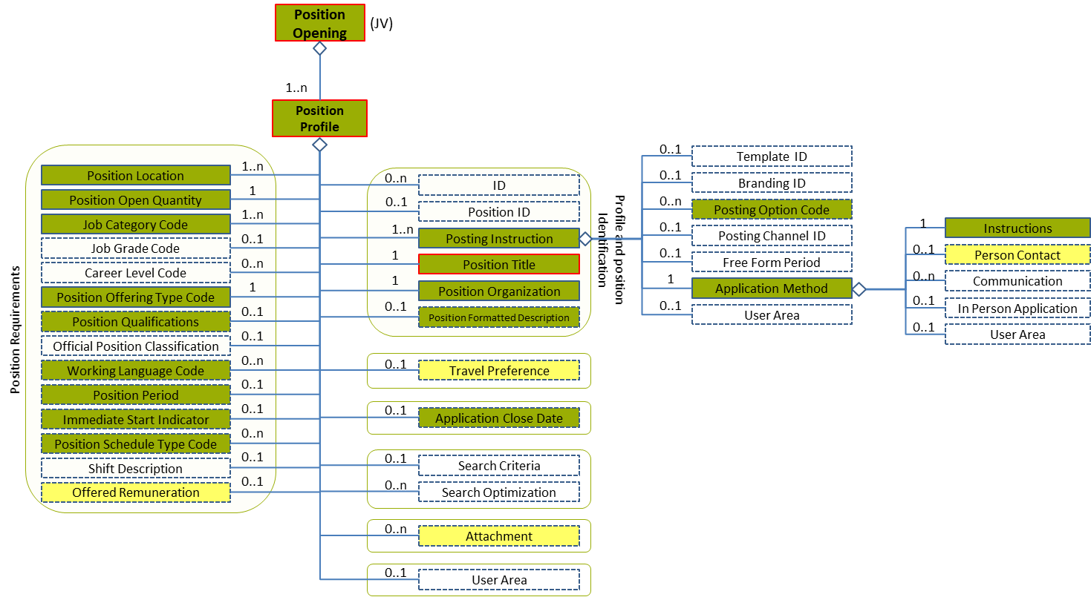
Figure 26: Application Method Level 3 Entity Diagram
Element | Description | Layer /  Cardinality |  | Rule | Examples
Application Method | Instructions on how to apply for the position |  | EURES Conformant  /  1 | N/A | N/A
Sub-elements
Instructions | Description related to the instructions to apply for the position. In some cases, content may include a mark-up or might be encoded, for example, HTML content. In such cases, the content might be enclosed within a CDATA section. |  | EURES Conformant  /  1 | N/A | “To apply the job contact with the hotel”.
Person Contact | The data of one or more people who should be contacted in order to apply for the job |  | EURES Optional  /  0..1 | N/A | N/A
 | See section “4.8.4 Sub-element: /Application Method /Person Contact (level 4)” for more information

Application Method Attributes
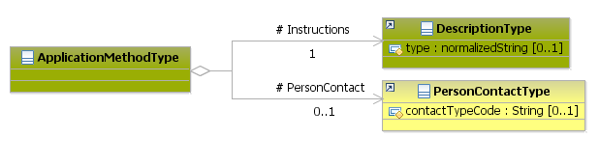
Figure 27: Application Method Attributes Schema
Attributes | Description | Card. | Rule
This element has no attributes.
Instructions sub-elements
Attributes | Description | Card. | Rule
type | The type of the comment | 0..1 | N/A
PersonContact sub-elements
Attributes | Description | Card. | Rule
See section “4.8.4 Sub-element: /Application Method /Person Contact (level 4)” for more information

Sub-element: /Application Method /Person Contact (level 4)

Person Contact Element Description
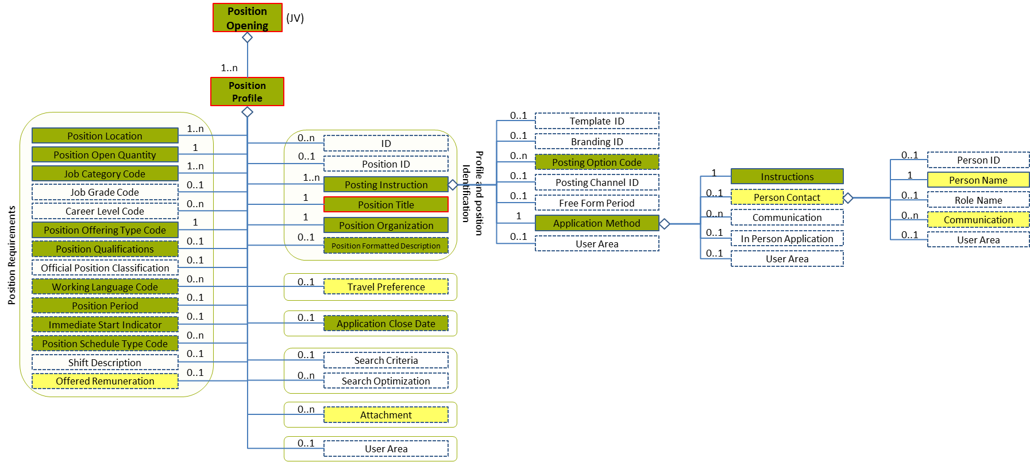
Figure 28: Person Contact Level 4 Entity Diagram
Element | Description | Layer /  Cardinality |  | Rule | Examples
Person Contact | A detailed set of data about one or more people who should be contacted in order apply for the job |  | EURES Optional  /  0..1 | N/A | N/A
Sub-elements
Person Name | Name of the supplier contact person |  | EURES Optional  /  1 | N/A | N/A
 | See section “4.8.5 Sub-element: /Application Method /Person Contact /Person Name (level 4)” for more information
Communication | A person’s contact information: ChannelCode, Address, URI –for email, for instance—, etc. |  | EURES Optional  /  1..n | BR-COM-10: If the Communication element is filled in, at least one of its sub elements should be filled in too. | N/A
 | See section “4.8.6 Sub-element: /Application Method /Person Contact /Communication (level 4)” for more information

Person Contact Attributes
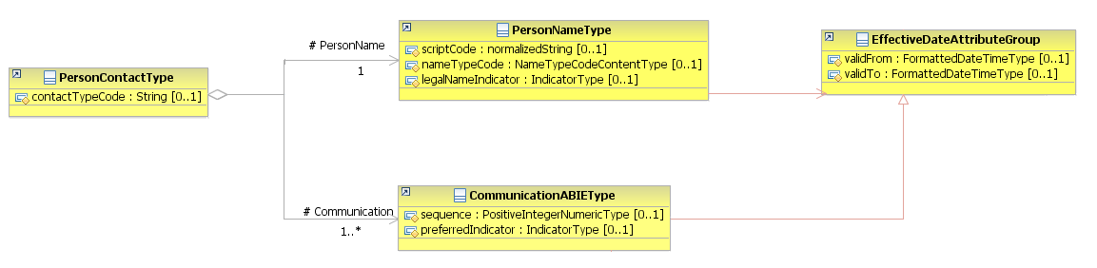
Figure 29: Person Contact Attributes Schema
Attributes | Description | Card. | Rule
contactTypeCode | The person’s type of contact, such as “CompanyManager” or “WorkplaceContact”  This is a free text element. | 0..1 | N/A
PersonName sub-element
Attributes | Description | Card. | Rule
See section “4.8.5.2 Person Name Attributes” for more information
Communication sub-element
Attributes | Description | Card. | Rule
See section “4.8.6.2 Communication Attributes” for more information

Sub-element: /Application Method /Person Contact /Person Name (level 4)

Person Name Element Description
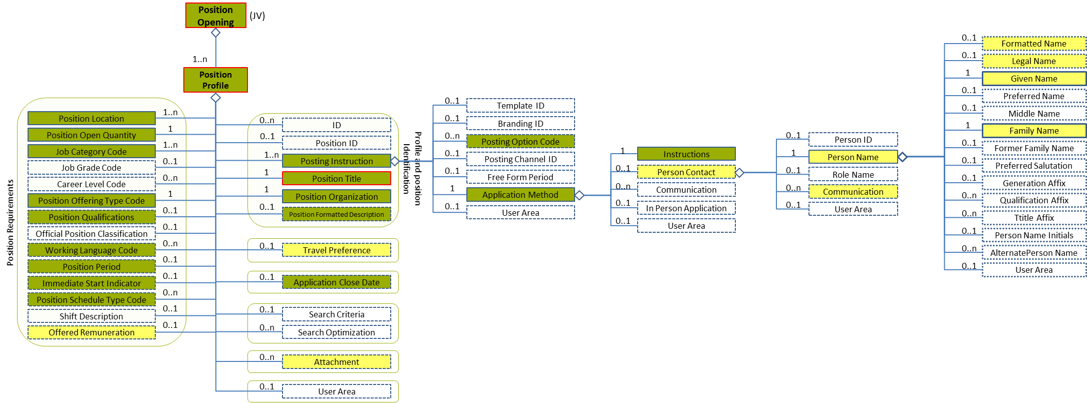
Figure 30: Person Name Level 4 Entity Diagram
Element | Description | Layer /  Cardinality |  | Rule | Examples
Person Name | A detailed set of data about the person’s names, such as his/her GivenName, FamilyName, MiddleName, FormerFamilyName, etc. |  | EURES Optional  /  1 | N/A | N/A
Sub-elements
Formatted Name | This is a formatted presentation of a name (for example, a Person Name) that might alternatively be presented as discretely fielded components, or it could be a name with alternative formatted representations.  The formatCode is an optional available attribute for specifying the applicable "mask" or type of format presentation to which the content conforms. |  | EURES Optional  /  0..1 | N/A | “Paula Cook”, “James Black”, etc.
Legal Name | The name that an individual is given at birth and/or is recognised by a government or other legal entity, or that appears on a birth certificate |  | EURES Optional  /  0..1 | N/A | “Paula Cook”, “James Black”, etc.
Given Name | A people given name or first name. |  | EURES Optional  /  1 | N/A | “Mark”, “Silvia”, etc.
Family Name | Contains a non-given name. This is an inherited name or one representing a family relationship, or in some cultural contexts a "Place Name" (where someone is from). In some cultural contexts, a single family name is typical, while in others there may be multiple family names. A "primary" attribute may be used in the case where there are multiple last names. A family name can have a "prefix," such as Von, De, Van, Al, etc. These can be represented using the FamilyName "prefix" attribute. Not all implementers may find it necessary to separate prefixes from the family name itself. Capturing the prefix and FamilyName as discrete fields can become important when formatting, or appearance may vary based on context. For example, in some cultural contexts it may be common to use a blank space as the delimiter between the prefix and the family name, while in others, a hyphen might be used. Separating the prefix from the FamilyName allows such formatting requirements to be handled flexibly |  | EURES Optional  /  1 | N/A | “Smith”, “Santos Tavares”, “Van der Meyde”, etc.

Person Name Attributes
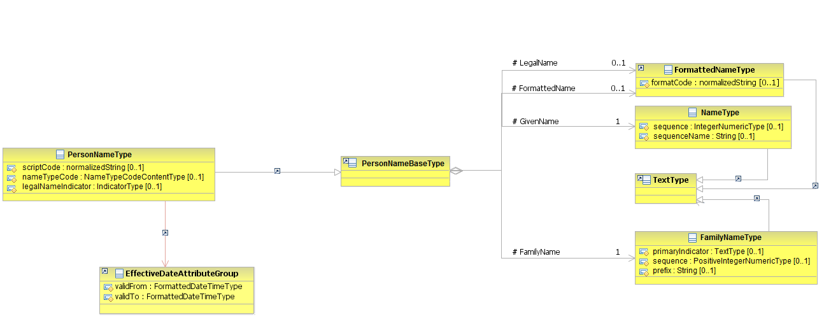
Figure 31: PersonName Attributes Schema
Attributes | Description | Card. | Rule
scriptCode | Type of alphabet in which the name is written with such as “Roman”, “Kenji”, etc. | 0..1 | N/A
nameTypeCode | A code classifying the type of name, such as “CurrentName” or “FormerName” (full code list “4.15.18 Name Enum Type Codes [CL32]”)  This is an HR-Open Standards open list. | 0..1 | BR-COM-09: Compulsory use of the Name Enum Type Codes [CL32].
legalNameIndicator | Boolean indicating if it is the legal name or not | 0..1 | N/A
validFrom | Validity start date for this Person Name | 0..1 | BR-COM-06: Compulsory Date Format is: YYYY-MM-DD, YYYY-MM, YYYY or YYYY-MM-DDThh:mm:ss.
validTo | Validity end date for this Person Name | 0..1 | BR-COM-06: Compulsory Date Format is: YYYY-MM-DD, YYYY-MM, YYYY or YYYY-MM-DDThh:mm:ss.
FormattedName sub-element
Attributes | Description | Card. | Rule
formatCode | Type of format shown | 0..1 | N/A
LegalName sub-element
Attributes | Description | Card. | Rule
The same as the “FormattedlName” sub-element
GivenName sub-element
Attributes | Description | Card. | Rule
sequence | Establishes the name order as an integer | 0..1 | N/A
sequenceName | Establishes the name order as a string | 0..1 | N/A
FamilyName sub-element
Attributes | Description | Card. | Rule
primaryIndicator | Boolean indicating that it is a single name | 0..1 | N/A
sequence | Establishes the name order as an integer | 0..1 | N/A
prefix | A family name’s prefix | 0..1 | N/A

Sub-element: /Application Method /Person Contact /Communication (level 4)

Communication Element Description
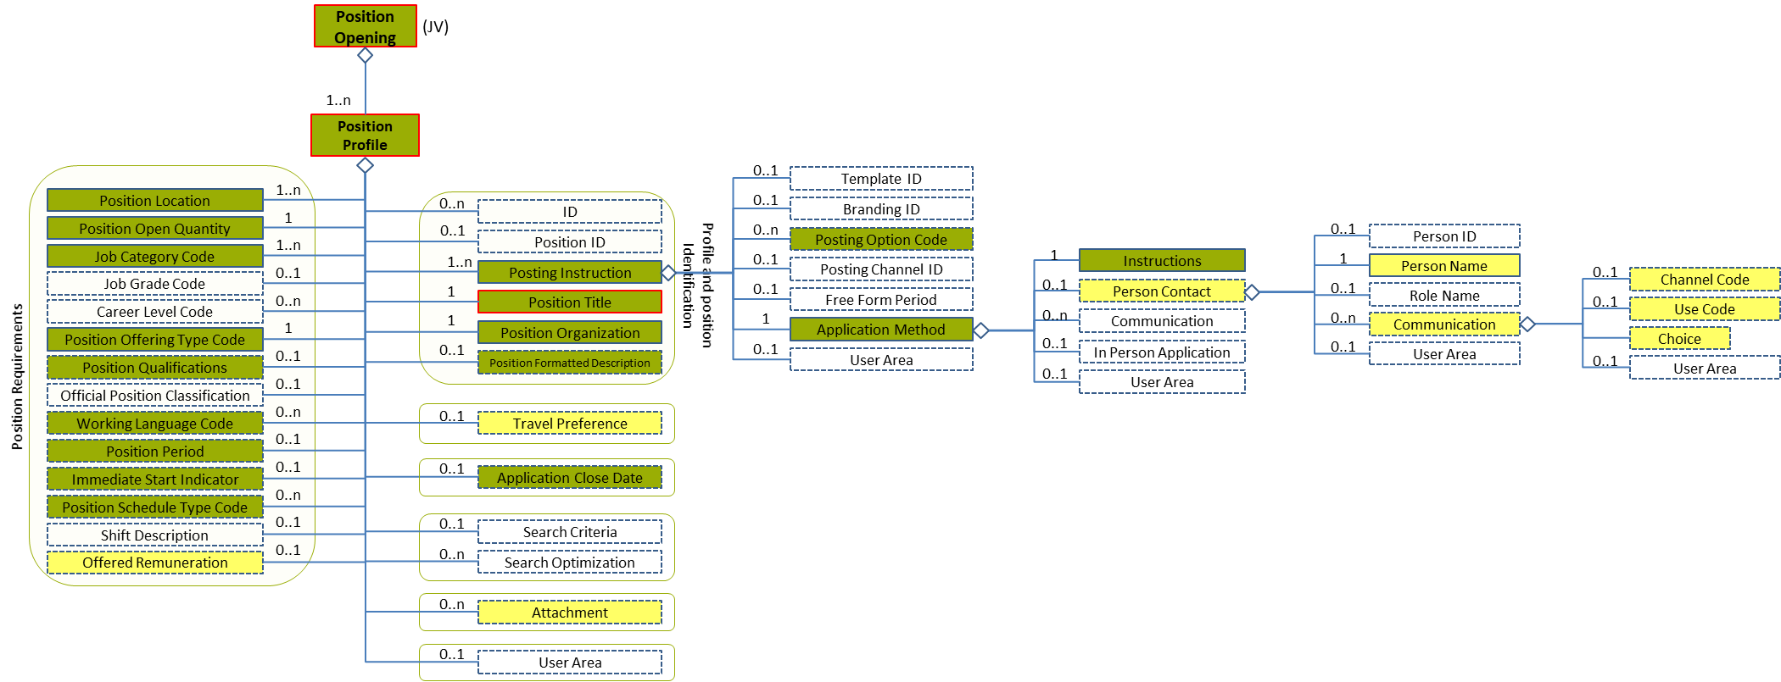
Figure 32: Communication Level 4 Entity Diagram
Element | Description | Layer /  Cardinality |  | Rule | Examples
Communication | A person’s contact information: ChannelCode, Address, URI –for email, for instance—, etc. |  | EURES Optional  /  1..n | BR-COM-10: If the Communication element is filled in, at least one of its sub elements should be filled in too. | N/A
Sub-elements
Channel Code | The communication channel used to contact a person or an organization  This is an HR-Open Standards open list. |  | EURES Optional  /  0..1 | BR-COM-13: The Open HR-Open Standards Code List “ChannelCodeContentType” must be used to codify the /ChannelCode element. | “Telephone”, “MobileTelephone”, “Fax”, “Email”, “InstantMessage”, “Web”  Full code list: “4.15.3 Channel Type Codes [CL05]”
Use Code | The type of use given to the communication channel used to contact a person or an organization  This is an HR-Open Standards open list. |  | EURES Optional  /  0..1 | BR-COM-14: The Open HR-Open Standards Code List “ContactUseCodeContentType” must be used to codify the /UseCode element. | “Personal”, “Business”  Full code list: “4.15.4 Contact Use Type Codes [CL06]”
Choice | Selection between the types of communication channels. | N/A |  | N/A | N/A
 | See section “4.8.7 Sub-element: /Application Method /Person Contact /Communication /Choice (level 5)” for more information

Communication Attributes
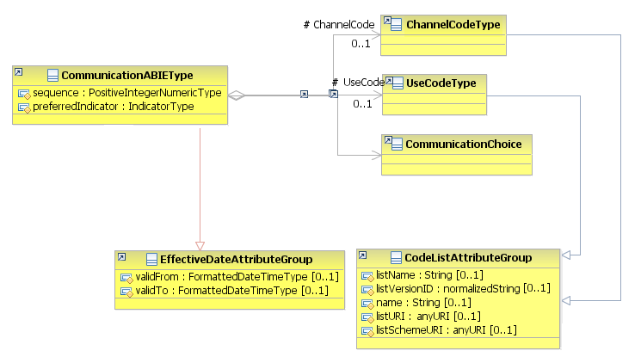
Figure 33: Communication Attributes Schema
Attributes | Description | Card. | Rule
sequence | Establishes the order of the contact data | 0..1 | N/A
preferredIndicator | Boolean indicating if the current contact data is the preferred one | 0..1 | N/A
validFrom | Validity start date for this Communication | 0..1 | BR-COM-06: Compulsory Date Format is: YYYY-MM-DD, YYYY-MM, YYYY or YYYY-MM-DDThh:mm:ss.
validTo | Date up to when the communication channel is available | 0..1 | BR-COM-06: Compulsory Date Format is: YYYY-MM-DD, YYYY-MM, YYYY or YYYY-MM-DDThh:mm:ss.
ChannelCode sub-element
Attributes | Description | Card. | Rule
listName | Code list name | 0..1 | N/A
listVersionID | Code list identification | 0..1 | N/A
name | Text equivalent of the code content component | 0..1 | N/A
listURI | The Uniform Resource Identifier that identifies where the code list is located | 0..1 | N/A
listSchemeURI | The Uniform Resource Identifier that identifies where the code list scheme is located | 0..1 | N/A
UseCode sub-element
Attributes | Description | Card. | Rule
The same as the “ChannelCode” sub-element
CommunicationChoice sub-element
Attributes | Description | Card. | Rule
See section “4.8.7.2 Communication Choice Attributes” for more information

Sub-element: /Application Method /Person Contact /Communication /Choice (level 5)

Communication Choice Element Description
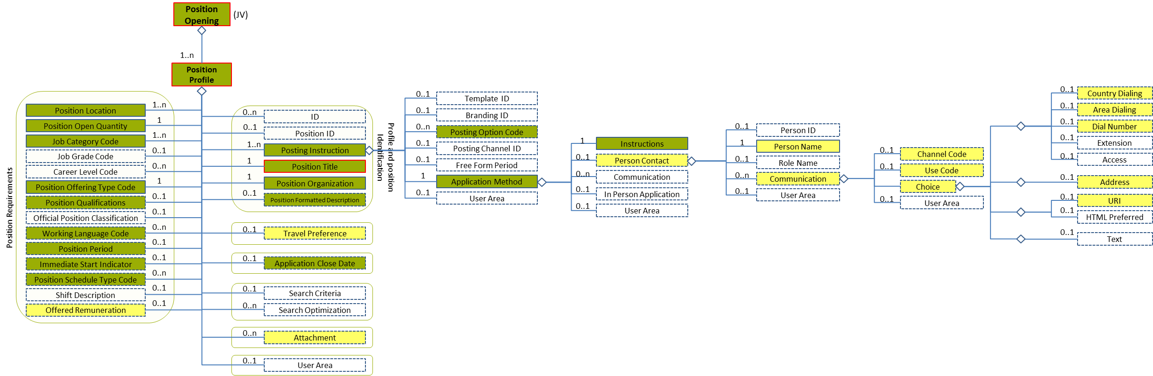
Figure 34: Communication Choice Level 5 Entity Diagram
Element | Description | Layer /  Cardinality |  | Rule | Examples
Choice | Selection between the types of channels  1-Address  2-Telephone  3-URL  4-Text | N/A |  | N/A | N/A
Sub-elements
Country Dialling | The country dialling code for a contact number |  | EURES Optional  /  0..1 | N/A | “0032”, “0034”, etc.
Area Dialling | The area dialling code for a contact number |  | EURES Optional  /  0..1 | N/A | “2”, “71, “93”, etc.
Dial Number | The contact number, not including country dialling or area dialling codes |  | EURES Optional  /  0..1 | N/A | “3445654”, “1234567”, etc.
Address | Properties specifying an entity’s physical location |  | EURES Optional  /  0..1 | N/A | Please see “4.10.3 Sub-element: /Address (level 3)”  However, the country code element of this address must use the code list Country Codes [CL07]
URI | Uniform Resource Identifier Reference (URI). A URI value can be absolute or relative, and may have an optional fragment identifier (i.e., it may be a URI Reference). This type should be used to specify that the value is to fulfil the role of a URI, as defined by [RFC 2396] and as amended by [RFC 2732]. |  | EURES Optional  /  0..1 | N/A | “mymail@test.org”, “mymail@noreply.com”, etc.

Communication Choice Attributes
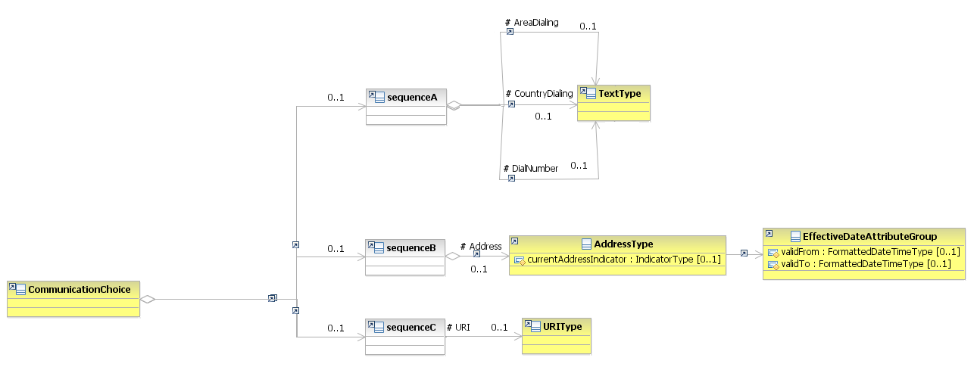
Figure 35: Communication Choice Attributes Schema
Attributes | Description | Card. | Rule
This element has no attributes.
CountryDialling sub-element
Attributes | Description | Card. | Rule
This element has no attributes.
AreaDialling sub-element
Attributes | Description | Card. | Rule
This element has no attributes.
DialNumber sub-element
Attributes | Description | Card. | Rule
This element has no attributes.
Address sub-element
Attributes | Description | Card. | Rule
See section “4.10.3.2 Address Attributes” for more information
URIs sub-element
Attributes | Description | Card. | Rule
This sub-element has no attributes.

Communication Choice Examples
This example shows how to fill in the person’s business telephone number.
<PositionOpening xmlns="http://www.hr-xml.org/3" xsi:schemaLocation="http://www.hr-xml.org/3 ../Developer/Nouns/PositionOpening.xsd">
<PositionProfile languageCode="en">
<PostingInstruction>
<ApplicationMethod>
<Instructions>In order to apply for the job, call directly to the person of contact.</Instructions>

<PersonContact>
<PersonName>
<!-- EURES Conformant layer required -->
<oa:GivenName>John</oa:GivenName>
<FamilyName prefix="Van">Whye</FamilyName>
</PersonName>

<Communication>
<ChannelCode listName="ChannelCodeContentType" listVersionID="1.0" listURI="http://www.hr-xml.org/" >Telephone</ChannelCode>
<UseCode listName="ContactUseCodeContentType" listURI="http://www.hr-xml.org/" listVersionID="1.0">Business</UseCode>

<oa:CountryDialing>34</oa:CountryDialing>
<oa:AreaDialing>93</oa:AreaDialing>
<oa:DialNumber>55445676</oa:DialNumber>
</Communication>
</PersonContact>
</ApplicationMethod>
</PostingInstruction>
</PositionProfile>
</PositionOpening>

This example shows how to fill in the person’s business e-mail.
<PositionOpening xmlns="http://www.hr-xml.org/3" xsi:schemaLocation="http://www.hr-xml.org/3 ../Developer/Nouns/PositionOpening.xsd">
<PositionProfile languageCode="en">
<PostingInstruction>
<ApplicationMethod>
<Instructions>In order to apply for the job, send the CV through the e-mail.</Instructions>

<PersonContact>
<PersonName>
<!-- EURES Conformant layer required -->
<oa:GivenName>John</oa:GivenName>
<FamilyName prefix="Van">Whye</FamilyName>
</PersonName>
<Communication>
<ChannelCode listName="ChannelCodeContentType" listVersionID="1.0" listURI="http://www.hr-xml.org/" >Email</ChannelCode>
<UseCode>Business</UseCode>

<oa:URI>fake-account@aol.es</oa:URI>
</Communication>
</PersonContact>
</ApplicationMethod>
</PostingInstruction>
</PositionProfile>
</PositionOpening>

/Position Profile /Travel Preferences (level 2)

Travel Preferences Element Description
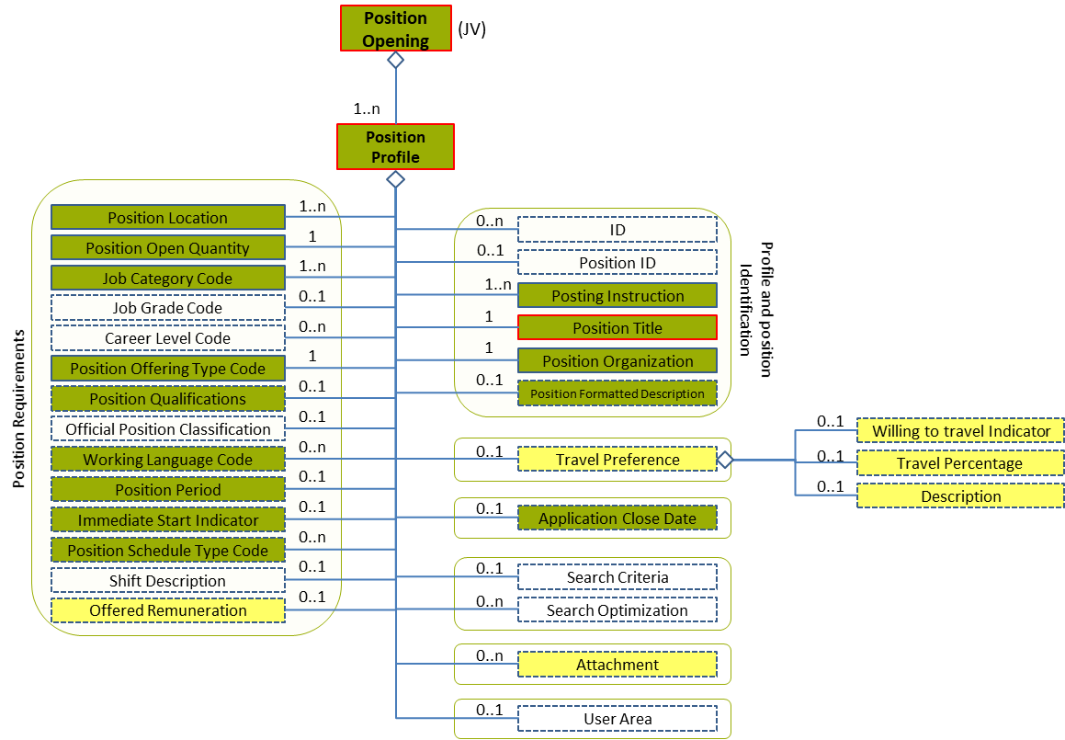
Figure 36: Travel Preferences Level 2 Entity Diagram
Element | Description | Layer /  Cardinality |  | Rule | Examples
Travel Preference | A position’s travel requirements and the percentage of time |  | EURES Optional  /  0..1 | N/A | N/A
Sub-elements
Willing to travel Indicator | Indicates that a person is willing to travel within the capacity of his/her position |  | EURES Optional  /  0..1 | N/A | “true” = The Candidate is willing to travel  “false” = The candidate is not willing to travel
Travel Percentage | A rate, number or proportion per hundred. The percentage of time required for a position or the percentage of time a person is willing to travel for a particular position |  | EURES Optional  /  0..1 | N/A | “25”, “35”, etc.
Description | Description of the travel preference |  | EURES Optional  /  0..1 | N/A | “Description of the travel preference”, etc.

Travel Preferences Attributes
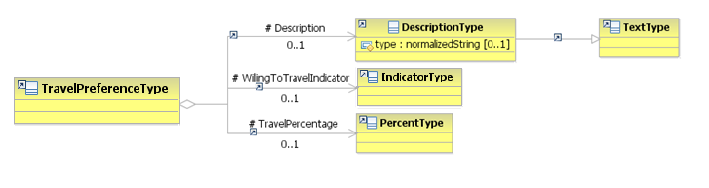
Figure 37: Travel Preferences Attributes Schema
Attributes | Description | Card. | Rule
This element has no attributes.
WillingToTravelIndicator sub-element
Attributes | Description | Card. | Rule
This sub-element has no attributes.
TravelPercentage sub-element
Attributes | Description | Card. | Rule
This sub-element has no attributes.
Description sub-element
Attributes | Description | Card. | Rule
type | The comment type | 0..1 | N/A

Travel Preferences Examples
This example shows a job position which requires travelling 50% of the time:
<PositionOpening xmlns="http://www.hr-xml.org/3" xsi:schemaLocation="http://www.hr-xml.org/3 ../Developer/Nouns/PositionOpening.xsd">
<PositionProfile languageCode="en">
<TravelPreference>
<WillingToTravelIndicator>true</WillingToTravelIndicator>
<TravelPercentage>50</TravelPercentage>
</TravelPreference>
</PositionProfile>
</PositionOpening>

/Position Profile /Position Location (level 2)

Position Location Element Description
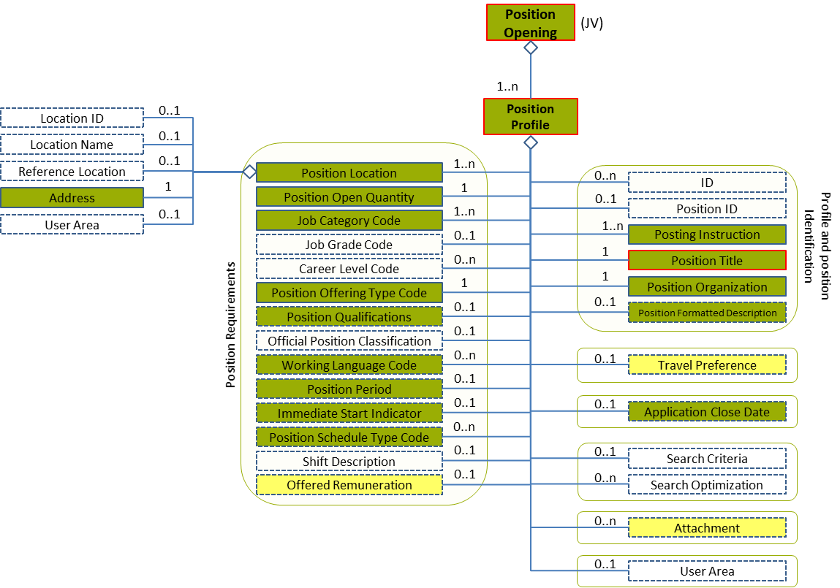
Figure 38: Position Location Level 2 Entity Diagram
Element | Description | Layer /  Cardinality |  | Rule | Examples
Position Location | Description of the position’s physical location |  | EURES Conformant  /  1..n | N/A | N/A
Sub-elements
Address | Properties specifying an entity’s physical location |  | EURES Conformant  /  1 | N/A | N/A
 | See section “4.10.3 Sub-element: /Address (level 3)” for more information

Position Location Attributes
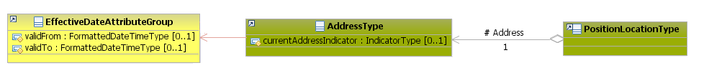
Figure 39: Position Location Attributes Schema
Attributes | Description | Card. | Rule
This element has no attributes.
Address sub-element
Attributes | Description | Card. | Rule
See section “4.10.3.2 Address Attributes” for more information

Sub-element: /Address (level 3)

Address Element Description
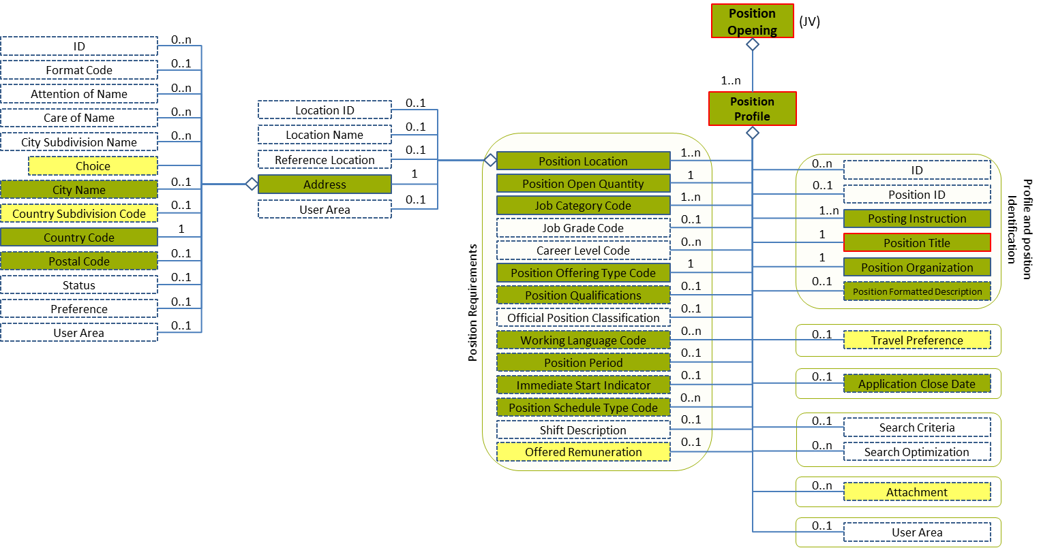
Figure 40: Address Level 3 Entity Diagram
Element | Description | Layer /  Cardinality |  | Rule | Examples
Address | Properties specifying an entity’s physical location |  | EURES Conformant  /  1 | N/A | N/A
Sub-elements
Choice | Selection between the address types:  1-Address Line  2-Building Number  3-Street Name  4-Unit | N/A |  | N/A | N/A
 | See section “4.10.4 Sub-element: /Address /Choice (level 4)” for more information
City Name | Identifies the town or city |  | EURES Conformant Optional  /  0..1 | N/A | “Bruxelles”, “Roma”, etc.
Country Subdivision Code | Qualifies further division of the Member States of Europe, possibly into Districts, Regions, States, Provinces, etc. |  | EURES Optional  /  0..1 | BR-COM-21: Compulsory use of the “EURES_CountrySubdivisionCodes-CodeList.gc” list defined by EURES. This is based on NUTS 2013 – Level 3.  BR-COM-53: If CountryCode is specified, CountrySubDivisionCode value must correspond to CountryCode value. | “BE07”, “CS01”, etc.  Full code list: “4.15.6 Country Subdivision Codes [CL08]”
Country Code | The address’ Country Code |  | EURES Conformant  /  1 | BR-COM-52: Compulsory use of the “EURES_MemberCountries-CodeList.gc” list defined by EURES. This is based on ISO 3166-1 Alpha-2, adapted to the Member States and EFTA countries. | “AT” – Austria, “BE” – Belgium, “BG” – Bulgaria, etc.  Full code list: “4.15.16 Members Countries from Europe [CL29]”
Postal Code | The Address Postal Code |  | EURES Conformant Optional  /  0..1 | N/A | N/A

Address Attributes
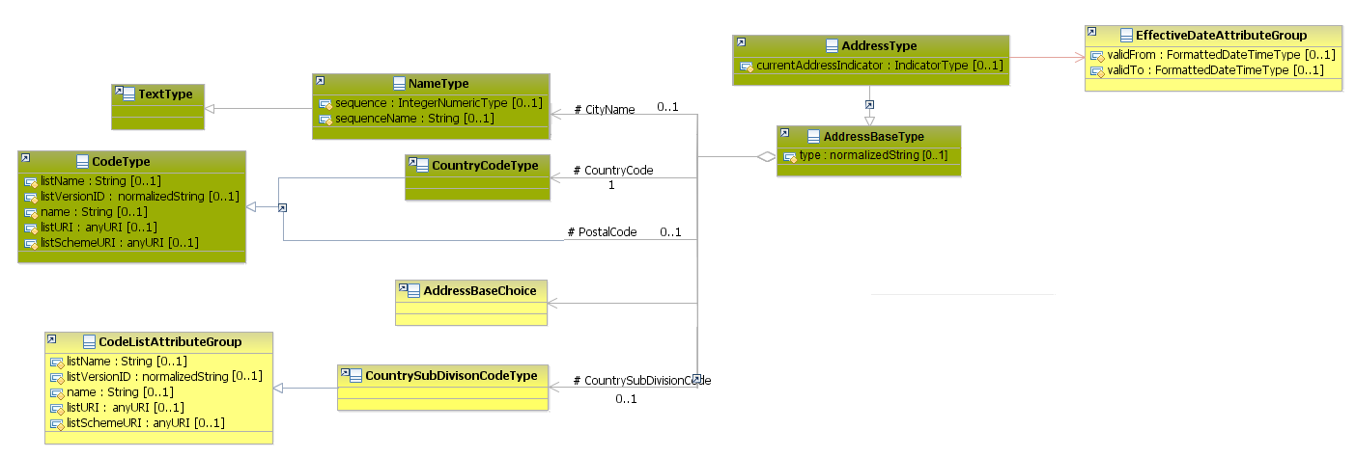
Figure 41: Address Attributes Schema
Attributes | Description | Card. | Rule
validFrom | Validity start date for this entity’s information | 0..1 | BR-COM-06: Compulsory Date Format is: YYYY-MM-DD, YYYY-MM, YYYY or YYYY-MM-DDThh:mm:ss.
validTo | Validity end date for this entity’s information | 0..1 | BR-COM-06: Compulsory Date Format is: YYYY-MM-DD, YYYY-MM, YYYY or YYYY-MM-DDThh:mm:ss.
currentAddressIndicator | Current address of the information | 0..1 | N/A
type | The address type | 0..1 | N/A
CityName sub-element
Attributes | Description | Card. | Rule
sequence | Establishes the order of the contact data | 0..1 | N/A
sequenceName | Establishes the order of the contact data | 0..1 | N/A
CountrySubdivisionCode sub-element
Attributes | Description | Card. | Rule
listName | Code list name | 0..1 | N/A
listVersionID | Code list identification | 0..1 | N/A
name | Text equivalent of the code content component | 0..1 | N/A
listURI | The Uniform Resource Identifier that identifies where the code list is located | 0..1 | N/A
listSchemeURI | The Uniform Resource Identifier that identifies where the code list scheme is located | 0..1 | N/A
CountryCode sub-element
Attributes | Description | Card. | Rule
The same as “CountrySubdivisionCode”
PostalCode sub-element
Attributes | Description | Card. | Rule
The same as “CountrySubdivisionCode”

Sub-element: /Address /Choice (level 4)

Address Choice Element Description
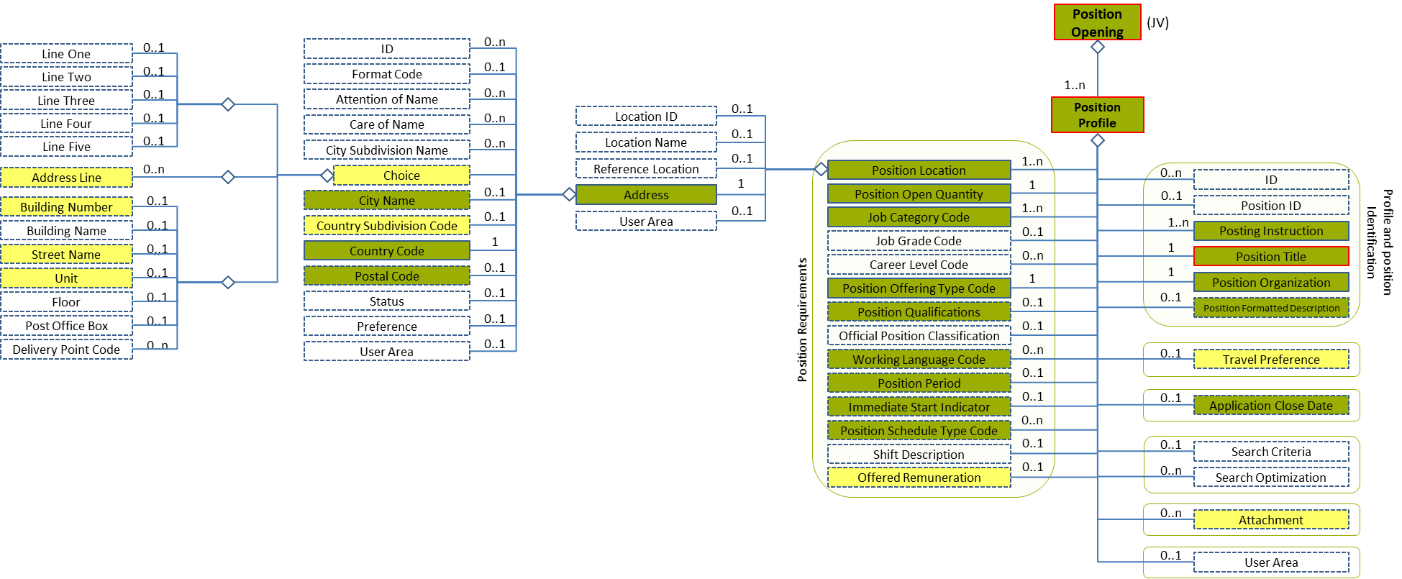
Figure 42: Choice Level 4 Entity Diagram
Element |  | Description | Layer /  Cardinality |  | Rule | Examples
Choice |  | Selection between the types of addresses:  1-Address Line  2-Building Number  3-Street Name  4-Unit | N/A |  | N/A | N/A
Sub-elements
A | Address Line | Full address text in a text field |  | EURES Optional  /  0..n | N/A | “Apartment 10, Derp House, 20 Longstreet, Rotterdam, Netherlands, 3000 AA”, etc.
B | Building Number | The Building/house Number on the street that identifies where to deliver mail (for example, Building 300 on Standards Parkway) |  | EURES Optional  /  0..1 | N/A | “10”, etc.
 | Street Name | The Street Name where the building/house is located |  | EURES Optional  /  0..1 | N/A | “Longstreet”, etc.
 | Unit | The apartment number or office suite |  | EURES Optional  /  0..1 | N/A | “20”, etc.

Address Choice Attributes
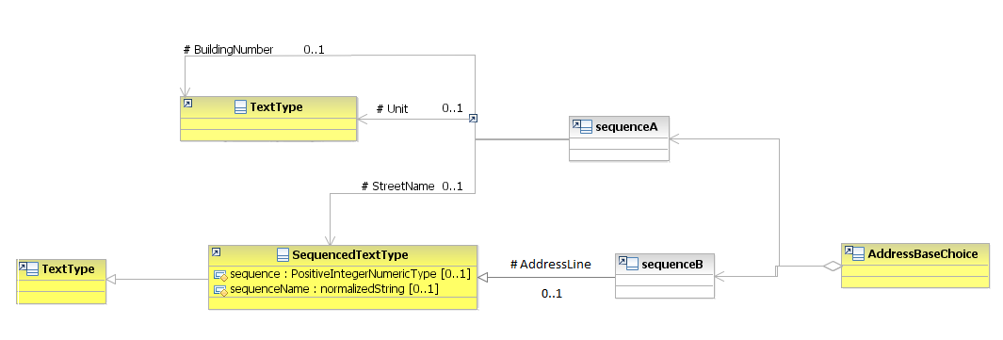
Figure 43: Address Choice Attributes Schema
Attributes | Description | Card. | Rule
This element has no attributes.
BuildingNumber, Unit sub-elements
Attributes | Description | Card. | Rule
This sub-element has no attributes.
StreetName, AddressLine sub-element
Attributes | Description | Card. | Rule
sequence | Establishes the order of the contact data | 0..1
sequenceName | Establishes the order of the contact data | 0..1

Address Choice Examples
This is an example of how to fill in a post office address in a line:
Address example:
Les Marchands de Bruxelles SA
Boîte postale 10 Bruxelles 1
1000 BRUSSELS
BELGIUM
<PositionOpening xmlns="http://www.hr-xml.org/3" xsi:schemaLocation="http://www.hr-xml.org/3 ../Developer/Nouns/PositionOpening.xsd">
<PositionProfile languageCode="en">
<PositionLocation>
<Address currentAddressIndicator="true">
<oa:CityName>Brussels</oa:CityName>

<oa:AddressLine>Les Marchands de Bruxelles SA, Boîte postale 10 Bruxelles 1, 1000 Brussels (Belgium)</oa:AddressLine>

<oa:CountrySubDivisionCode listName="EURES_CountrySubdivisionCodes" listVersionID="2013-Level-3" name="Arr. de Bruxelles-Capitale" listURI="http://ec.europa.eu/eurostat"
>BE100</oa:CountrySubDivisionCode>

<CountryCode listName="EURES_MemberCountries" listVersionID="3166-1-alpha-2" name="Belgium" listURI="http://www.iso.org/iso/"
>BE</CountryCode>

</Address>
</PositionLocation>
</PositionProfile>
</PositionOpening>

This is an example of how to fill in a standard address in specific fields:
Address example:
LOCAL 480, 4ème étage
ZONING INDUSTRIEL
Rue Louis Hap 25
1040 Etterbeek
Belgium
<PositionOpening xmlns="http://www.hr-xml.org/3" xsi:schemaLocation="http://www.hr-xml.org/3 ../Developer/Nouns/PositionOpening.xsd">
<PositionProfile languageCode="en">
<PositionLocation>
<Address currentAddressIndicator="true">
<oa:CityName>Etterbeek</oa:CityName>

<oa:BuildingNumber>25</oa:BuildingNumber>
<oa:StreetName>Rue Louis Hap</oa:StreetName>
<oa:Unit>Local 480, 4ème étage</oa:Unit>

<oa:CountrySubDivisionCode listName="EURES_CountrySubdivisionCodes" listVersionID="2013-Level-3" name="Arr. de Bruxelles-Capitale" listURI="http://ec.europa.eu/eurostat"
>BE100</oa:CountrySubDivisionCode>

<CountryCode listName="EURES_MemberCountries" listVersionID="3166-1-alpha-2" name="Belgium" listURI="http://www.iso.org/iso/"
>BE</CountryCode>

</Address>
</PositionLocation>
</PositionProfile>
</PositionOpening>

/Position Profile /Position Qualifications (level 2)

Position Qualifications Element Description
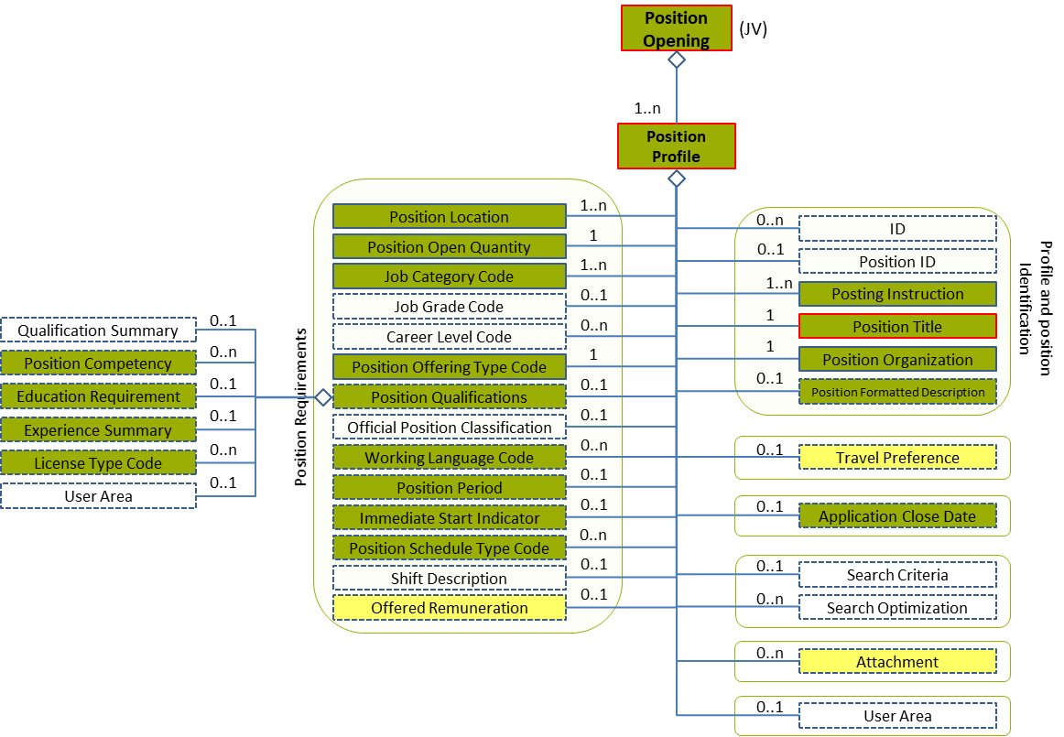
Figure 44: Position Qualifications Level 2 Entity Diagram
Element | Description | Card. |  | Rule | Examples
Position Qualifications | Information related to matching capacities, knowledge, skills, abilities, awards and other resource deployment-related characteristics (including “competencies”) required by a potential employer or client |  | EURES Conformant Optional  /  0..1 | N/A | N/A
Sub-elements
Position Competency | A qualified position competency has a specified required and/or desired level of proficiency and has an explicit or implicit level of importance (weight) among sibling competencies associated with a position |  | EURES Conformant Optional  /  0..n |  | N/A
 | See section “4.11.3 Sub-element: /Position Competency (level 3)” for more information
Education Requirement | Required education for the position |  | EURES Conformant Optional  /  0..1 | N/A | N/A
 | See section “4.11.8 Sub-element: /Education Requirement (level 3)” for more information
Experience Summary | Required experience for the position |  | EURES Conformant Optional  /  0..1 | N/A | N/A
 | See section “4.11.9 Sub-element: /Experience Summary (level 3)” for more information
License Type Code | Contains the driving licenses required for the position |  | EURES Conformant Optional  /  0..n | BR-COM-43: Multiple entries of this code list are allowed.  BR-COM-41: Compulsory use of the “EURES_LicenseTypeCode-CodeList” list. This is based on Directive 2006/126/EC. | “A” – Motorcycle, “B” - Car with up to 8 passengers; lorry up to 3.5 tons, etc.  Full code list: “4.15.10 Driving License Codes [CL14]”

Position Qualifications Attributes
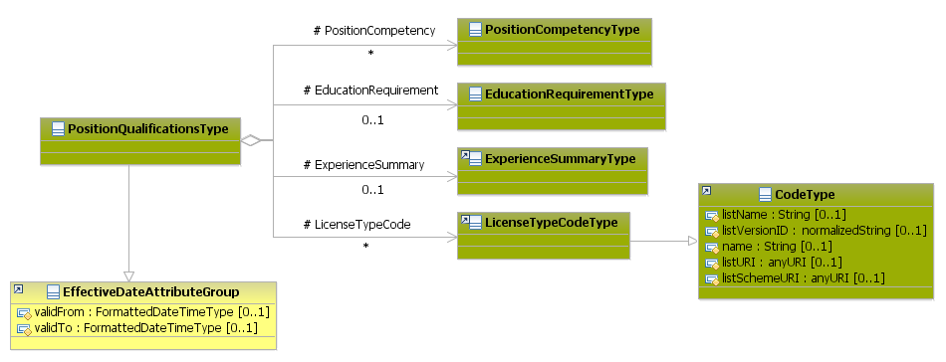
Figure 45: Position Qualifications Attributes Schema
Attributes | Description | Card. | Rule
validFrom | Validity start date for this entity’s information | 0..1 | BR-COM-06: Compulsory Date Format is: YYYY-MM-DD, YYYY-MM, YYYY or YYYY-MM-DDThh:mm:ss.
validTo | Validity end for this entity’s information | 0..1 | BR-COM-06: Compulsory Date Format is: YYYY-MM-DD, YYYY-MM, YYYY or YYYY-MM-DDThh:mm:ss.
PositionCompetency sub-element
Attributes | Description | Card. | Rule
See section “4.11.3.2 Position Competency Attributes” for more information
EducationRequirement sub-element
Attributes | Description | Card. | Rule
See section “4.11.8.2 Education Requirement Attributes” for more information
ExperienceSummary sub-element
Attributes | Description | Card. | Rule
See section “4.11.9.2 Experience Summary Attributes” for more information
LicenseTypeCode sub-element
Attributes | Description | Card. | Rule
listName | Code list name | 0..1
listVersionID | Code list identification | 0..1
name | Text equivalent of the code content component | 0..1
listURI | The Uniform Resource Identifier that identifies where the code list is located | 0..1
listSchemeURI | The Uniform Resource Identifier that identifies where the code list scheme is located | 0..1

Sub-element: /Position Competency (level 3)

Position Competency Element Description
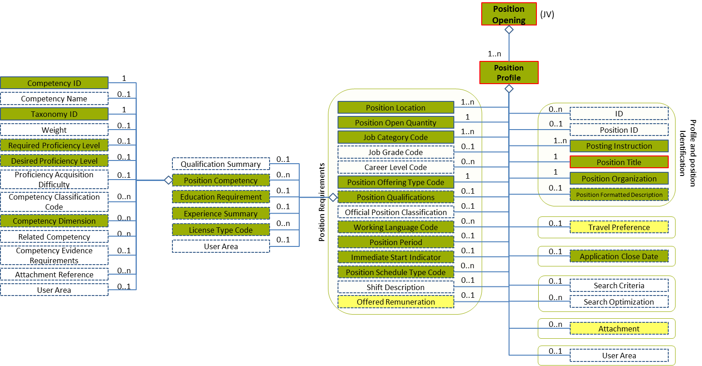
Figure 46: Position Competency Level 3 Entity Diagram
Element | Description | Layer /  Cardinality |  | Rule | Examples
Position Competency | A qualified position competency has a specified required and/or desired level of proficiency and has an explicit or implicit level of importance (weight) among sibling competencies associated with a position |  | EURES Conformant Optional  /  0..n | N/A | N/A
Sub-elements
Competency ID | Unique identifier for a skill or competency that depends on the taxonomy used.  Taxonomy information is included in the ID attributes. |  | EURES Conformant  /  1 | BR-COM-46: Compulsory use of Language Code [CL24], based on ISO-639-1:2002 Alpha 2 (ISO), if TaxonomyID’s value is “language”. Or the Skills and Competences Codes defined by ESCO, if TaxonomyID’s value is “other”. | “EN”, “FR”, etc.  Full code list: “4.15.14 Language Codes [CL24]”  Or,  “Aircraft Assembly”, “Aircraft Elecronics”, etc.  Full code list: “4.15.29 Skills and Competences Codes [CL58] ”
Taxonomy ID | Unique identifier for the type of competency. |  | EURES Conformant  /  1 | BR-COM-54: TaxonomyID’s value should be “language” if the CompetencyID is a language or “other”, in the other competencies. | “language”, “other”
Required Proficiency Level | A minimum level of proficiency for a competency associated with a position, role, course, or other item. The proficiency level is expressed as a score, a point scale or a mark within a value range. |  | EURES ConformantOptional  /  0..1 | BR-COM-49: If “CompetencyDimension / TypeCode” is specified, “RequiredProficiencyLevel” or “DesiredProficiencyLevel” is mandatory. | N/A
 | See section “4.11.4 Sub-element: /Position Competency /Required Proficiency Level (level 4)” for more information
Desired Proficiency Level | An optimum or ideal level of proficiency for a competency with respect to an associated position, role, course, or other item. Proficiency levels are expressed as a score, a point scale or a mark within a value range |  | EURES ConformantOptional  /  0..1 | BR-COM-49: If “CompetencyDimension / TypeCode” is specified, “RequiredProficiencyLevel” or “DesiredProficiencyLevel” is mandatory. | N/A
 | See section “4.11.5 Sub-element: /Position Competency /Desired Proficiency Level (Level 4)” for more information
Competency Dimension | A measurable characteristic of a competency |  | EURES Conformant Optional  /  0..n | N/A | N/A
 | See section “4.11.6 Sub-element: /Position Competency /Competency Dimension (level 4)” for more information

Position Competency Attributes
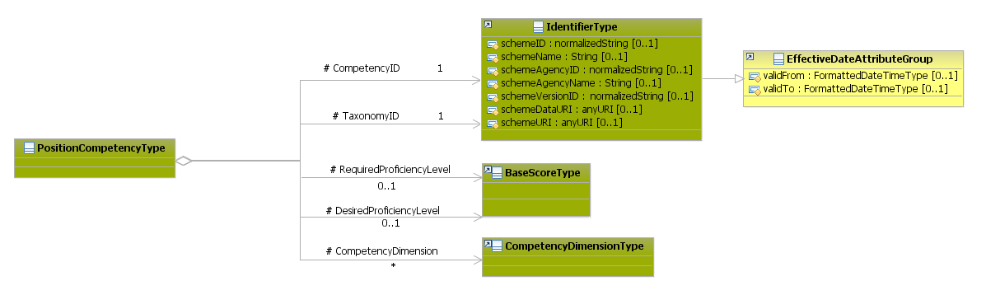
Figure 47: Position Competency Attributes Schema
Attributes |  | Description | Card. | Rule
This element has no attributes
CompetencyID sub-element
Attributes | Description |  |  | Card. | Rule
schemeID | Identification of the identifier scheme |  |  | 0..1
schemeName | The identification scheme name |  |  | 0..1
schemeAgencyID | Identification of the agency that maintains the scheme |  |  | 0..1
schemeAgencyName | The name of the agency that maintains the scheme |  |  | 0..1
schemeVersionID | The identification scheme version |  |  | 0..1
schemeDataURI | The Uniform Resource Identifier that identifies where the data scheme is located |  |  | 0..1
schemeURI | The Uniform Resource Identifier that identifies where the scheme is located |  |  | 0..1
validFrom | Validity start date for this entity’s information |  |  | 0..1 | BR-COM-06: Compulsory Date Format is: YYYY-MM-DD, YYYY-MM, YYYY or YYYY-MM-DDThh:mm:ss.
validTo | Validity end date for this entity’s information |  |  | 0..1 | BR-COM-06: Compulsory Date Format is: YYYY-MM-DD, YYYY-MM, YYYY or YYYY-MM-DDThh:mm:ss.
TaxonomyID sub-elements
Attributes |  | Description | Card. | Rule
schemeID |  | Identification of the identifier scheme | 0..1 | N/A
schemeName |  | The identification scheme name | 0..1 | N/A
schemeAgencyID |  | Identification of the agency that maintains the identification scheme | 0..1 | N/A
schemeAgencyName |  | The name of the agency that maintains the identification scheme | 0..1 | N/A
schemeVersionID |  | The identification scheme version | 0..1 | N/A
schemeDataURI |  | The Uniform Resource Identifier that identifies where the identification scheme data is located | 0..1 | N/A
schemeURI |  | The Uniform Resource Identifier that identifies where the identification scheme is located | 0..1 | N/A
validFrom |  | Validity start date for this ID | 0..1 | BR-COM-06: Compulsory Date Format is: YYYY-MM-DD, YYYY-MM, YYYY or YYYY-MM-DDThh:mm:ss.
validTo |  | Validity end date for this ID | 0..1 | BR-COM-06: Compulsory Date Format is: YYYY-MM-DD, YYYY-MM, YYYY or YYYY-MM-DDThh:mm:ss.
RequiredProficiencyLevel sub-elements
Attributes |  | Description | Card. | Rule
See section “4.11.4.2 Required Proficiency Level Attributes” for more information
DesiredProficiencyLevel sub-elements
Attributes |  | Description | Card. | Rule
See section “4.11.5.2 Desired Proficiency Level Attributes” for more information
CompetencyDimension sub-elements
Attributes |  | Description | Card. | Rule
See section “4.11.6.2 Competency Dimension Attributes” for more information

Position Competency Examples
This is an example of how to add the required language skills. In this case, A2 level English language skills are required, as defined by CEFR, but a B2 level is desired:
<PositionOpening xmlns="http://www.hr-xml.org/3" xsi:schemaLocation="http://www.hr-xml.org/3 ../Developer/Nouns/PositionOpening.xsd">
<PositionProfile languageCode="en">
<PositionQualifications>
<PositionCompetency>
<CompetencyID schemeID="ISO-639-1/2-Languages" schemeAgencyID="ISO" schemeAgencyName="ISO" schemeVersionID="639-1:2002 Alpha 2" schemeDataURI="http://www.loc.gov">EN</CompetencyID>

<TaxonomyID>language</TaxonomyID>

<RequiredProficiencyLevel>
<ScoreText>A2</ScoreText>
</RequiredProficiencyLevel>

<DesiredProficiencyLevel>
<ScoreText>B2</ScoreText>
</DesiredProficiencyLevel>

<CompetencyDimension>
<CompetencyDimensionTypeCode listName="EURES_Dimension" listVersionID="1.0" listURI="http://www.coe.int">
CEF-Speaking-Interaction
</CompetencyDimensionTypeCode>
</CompetencyDimension>
</PositionCompetency>
</PositionQualifications>
</PositionProfile>
</PositionOpening>

This is an example of how to add other skills. In this case, it adds the Problems Management skill and is defined by a national agency.
The elements to define non-language skills are CompetencyID (it identifies the skills) and TaxonomyID (it identifies that it is a non-language skill):
<PositionOpening xmlns="http://www.hr-xml.org/3" xsi:schemaLocation="http://www.hr-xml.org/3 ../Developer/Nouns/PositionOpening.xsd">
<PositionProfile languageCode="en">
<PositionQualifications>
<PositionCompetency>
<CompetencyID schemeID="Identifier of schema" schemeAgencyID="Identifier of the agency" schemeAgencyName="Name of the agency" schemeVersionID="Version of the schema" schemeDataURI="URL">Problems Management</CompetencyID>

<TaxonomyID>other</TaxonomyID>
</PositionCompetency>
</PositionQualifications>
</PositionProfile>
</PositionOpening>

Sub-element: /Position Competency /Required Proficiency Level (level 4)

Required Proficiency Level Element Description
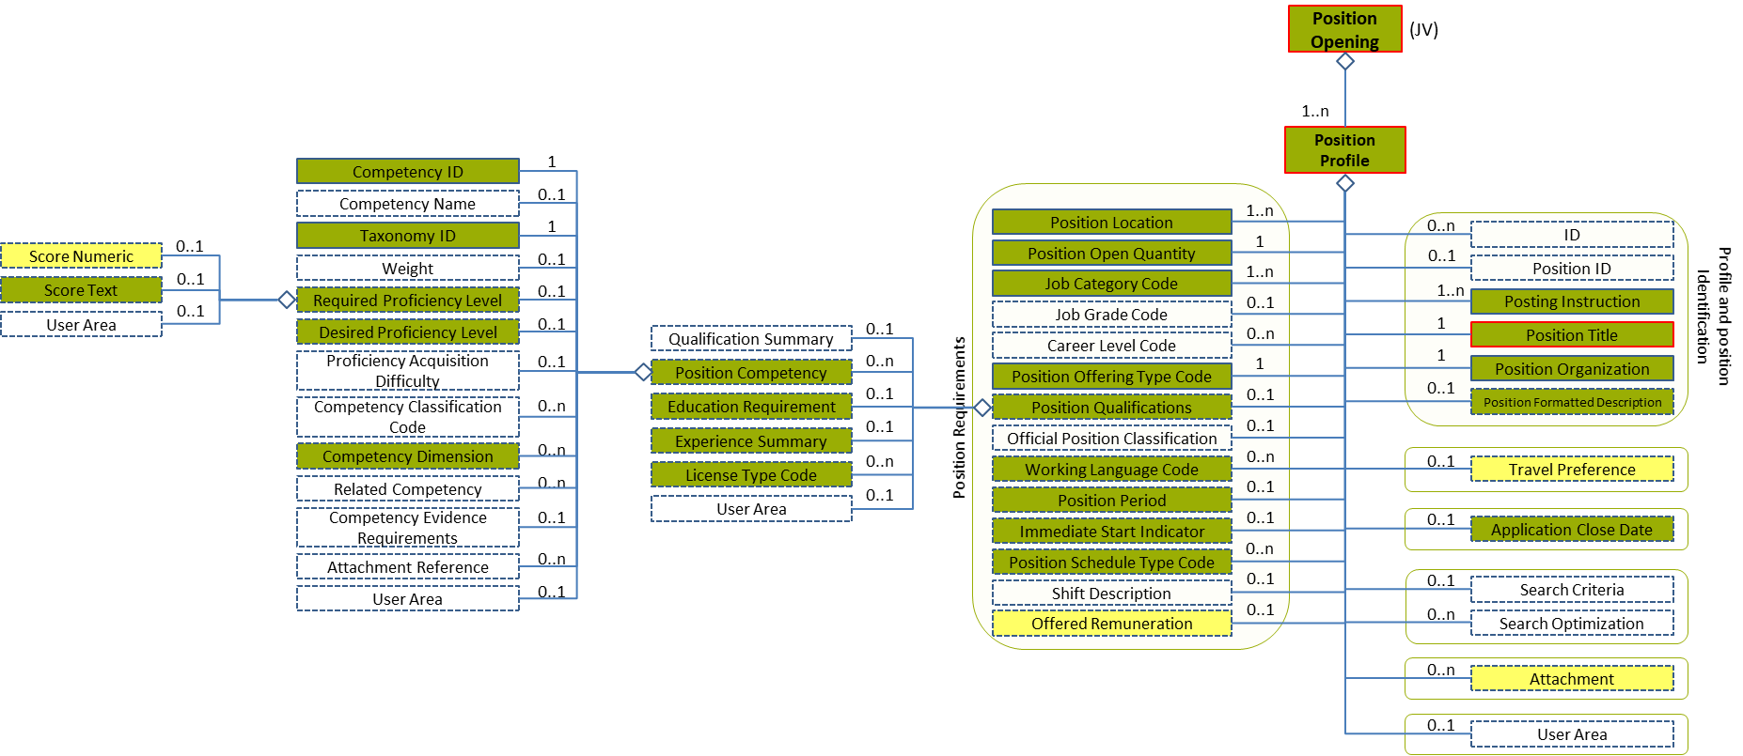
Figure 48: Required Proficiency Level 4 Entity Diagram
Element | Description | Layer /  Cardinality |  | Rule | Examples
Required Proficiency Level | A minimum level of proficiency for a competency associated with a position, role, course, or other item. Proficiency levels are expressed as a score, a point scale or a mark within a value range |  | EURES Conformant Optional  /  0..1 | BR-COM-49: If “CompetencyDimension / TypeCode” is specified, “RequiredProficiencyLevel” or “DesiredProficiencyLevel” is mandatory. | N/A
Sub-elements
Score Numeric | A numerical record of the marks allotted to individuals in the measurement of abilities, capacity to learn, personality assessment, or in other measurable characteristics (e.g. credit worthiness), including a set of attributes to identify the scoring scheme and its characteristics |  | EURES Optional  /  0..1 | N/A | 1, 2, 3, etc.
Score Text | A non-numerical or text representation of a score. A record of the marks allotted to an individual in measuring his/her abilities, capacity to learn, personality assessment, or in other measurable characteristics (e.g., credit worthiness). It represents either the total number of points awarded, or a general standard achieved, including a set of attributes to identify the scoring scheme |  | EURES  Conformant Optional  /  0..1 | BR-COM-47: Compulsory use of Language Proficiency Codes [CL25], if TaxonomyID’s value is “language”. | “A1”, “A2”, “B1”, etc.  Full code list: “4.15.15 Language Proficiency Codes [CL25]”

Required Proficiency Level Attributes
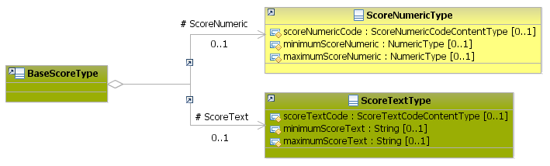
Figure 49: Required Proficiency Level Attributes Schema
Attributes | Description | Card. | Rule
This element has no attributes
ScoreNumeric sub-element
Attributes | Description | Card. | Rule
scoreNumericCode | The numeric type of scoring scheme | 0..1 | N/A
minimumScoreNumeric | The minimum score | 0..1 | N/A
maximumScoreNumeric | The maximum score | 0..1 | N/A
ScoreText sub-element
Attributes | Description | Card. | Rule
scoreTextCode | The score text | 0..1 | N/A
minimumScoreText | The minimum score | 0..1 | N/A
maximumScoreText | The maximum score | 0..1 | N/A

Required Proficiency Level Examples
This example shows how to fill in the score, according to Language Proficiency Codes.
<PositionOpening xmlns="http://www.hr-xml.org/3" xsi:schemaLocation="http://www.hr-xml.org/3 ../Developer/Nouns/PositionOpening.xsd">
<PositionProfile languageCode="en">
<PositionQualifications>
<PositionCompetency>
<CompetencyID schemeID="ISO-639-1/2-Languages" schemeAgencyID="ISO" schemeAgencyName="ISO" schemeVersionID="639-1:2002 Alpha 2" schemeDataURI="http://www.loc.gov">EN</CompetencyID>

<TaxonomyID>language</TaxonomyID>

<RequiredProficiencyLevel>
<ScoreText>B1</ScoreText>
</RequiredProficiencyLevel>
</PositionCompetency>
</PositionQualifications>
</PositionProfile>
</PositionOpening>

Sub-element: /Position Competency /Desired Proficiency Level (Level 4)

Desired Proficiency Level Element Description
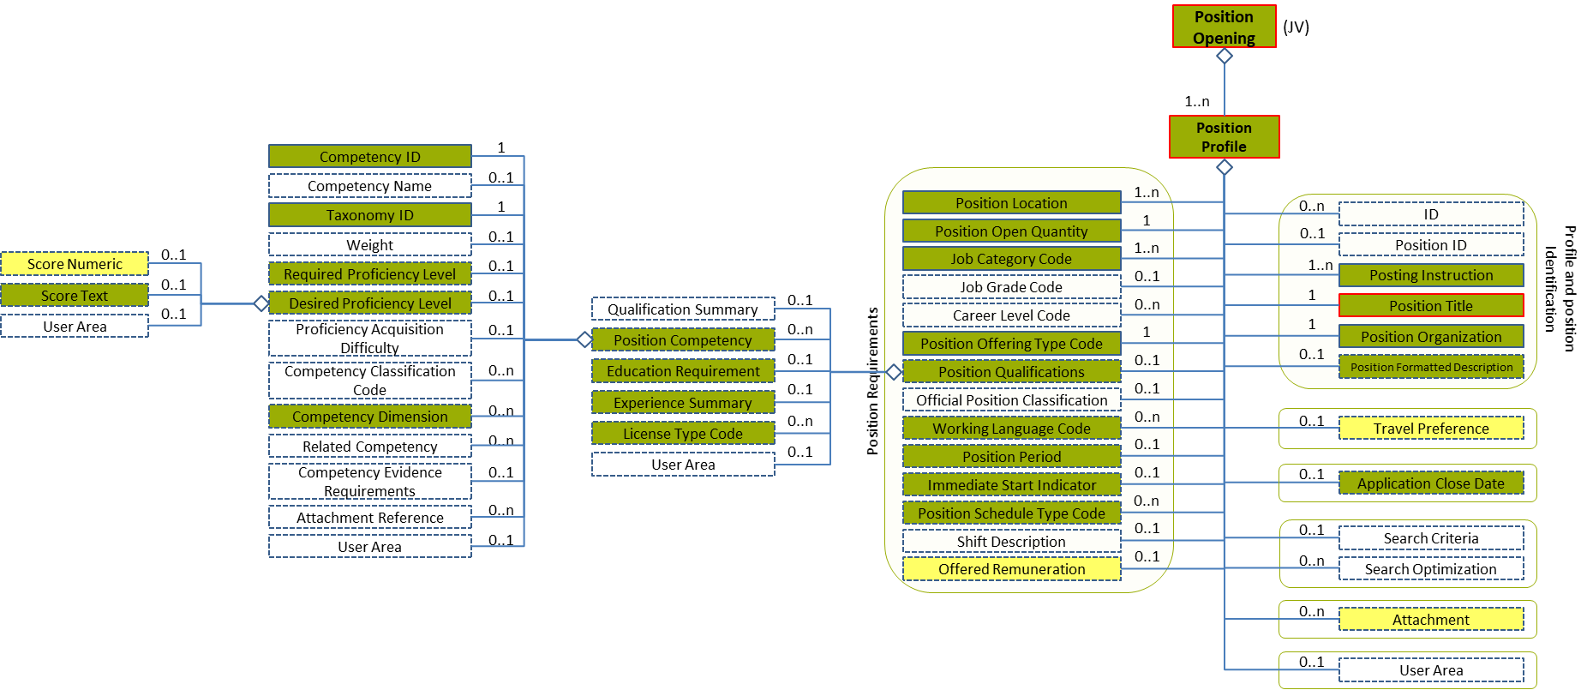
Figure 50: Desired Proficiency Level 4 Entity Diagram
Element | Description | Layer /  Cardinality |  | Rule | Examples
Desired Proficiency Level | An optimum or ideal level of proficiency for a competency with respect to a position, role, course, or other item. Proficiency levels are expressed as a score, a point scale or a mark within a value range |  | EURES Conformant Optional  /  0..1 | BR-COM-49: If “CompetencyDimension / TypeCode” is specified, “RequiredProficiencyLevel” or “DesiredProficiencyLevel” is mandatory. | N/A
Sub-elements
The same as “4.11.4.1 Required Proficiency Level Element Description”

Desired Proficiency Level Attributes
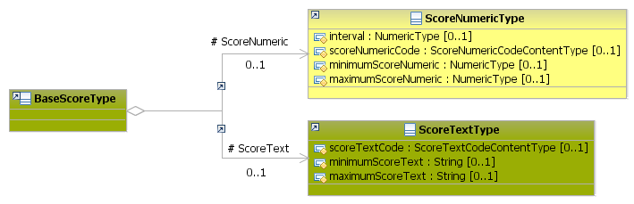
Figure 51: Desired Proficiency Level Attributes Schema
Attributes | Description | Card. | Rule | Examples
The same as “4.11.4.2 Required Proficiency Level Attributes”

Desired Proficiency Level Examples
It is the same example as “4.11.4.3 Required Proficiency Level Examples”

Sub-element: /Position Competency /Competency Dimension (level 4)

Competency Dimension Element Description
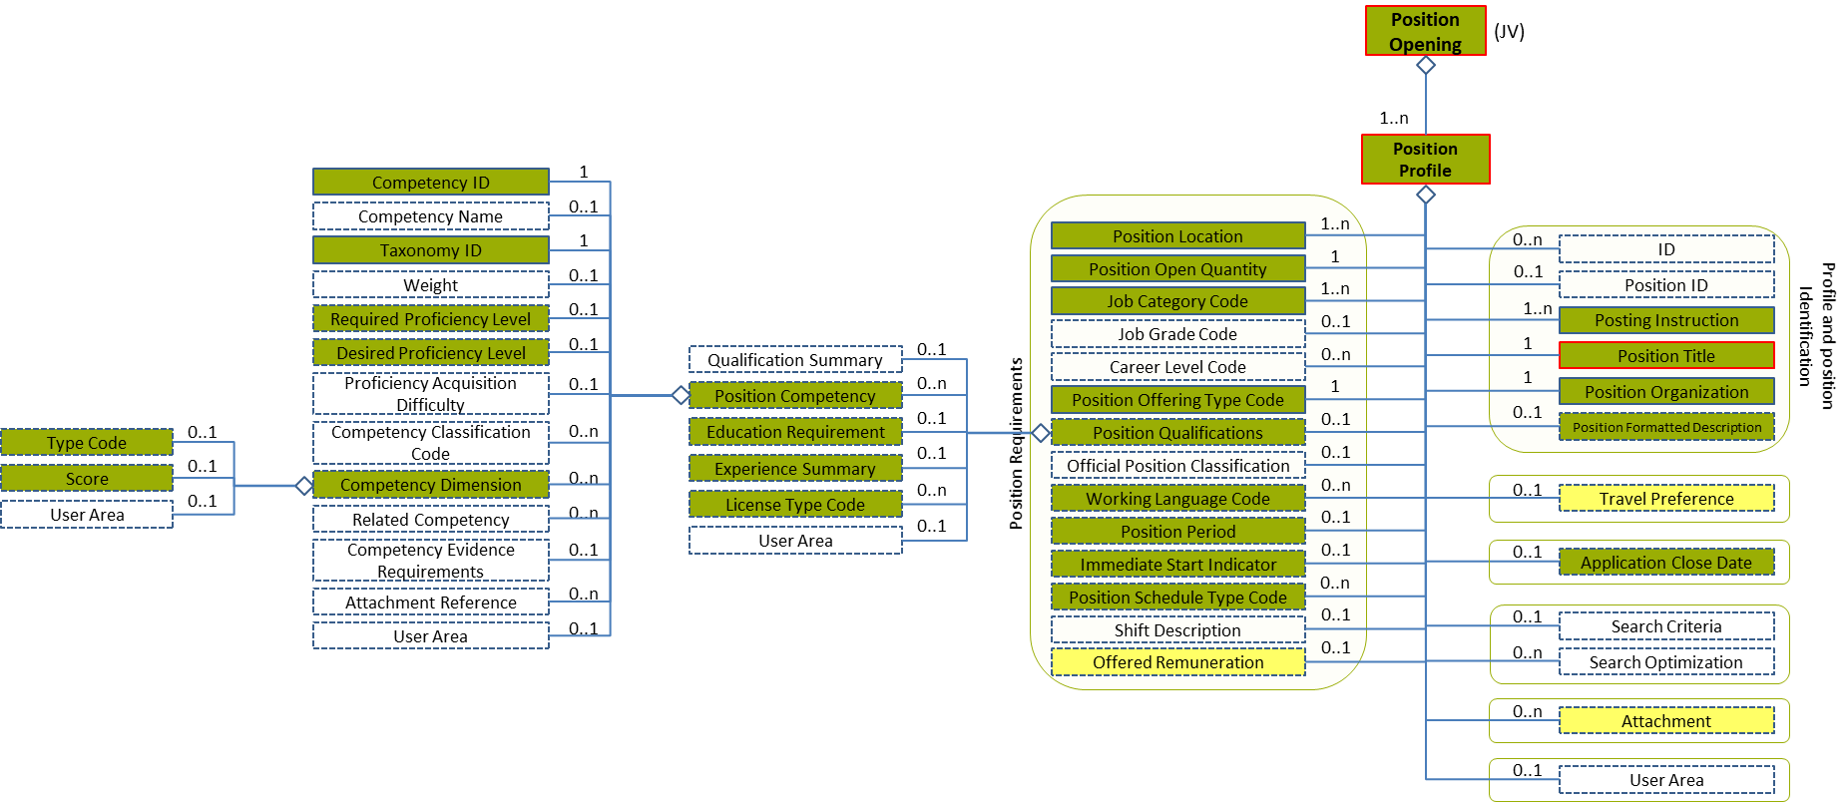
Figure 52: Competency Dimension Level 4 Entity Diagram
Element | Description | Card. |  | Rule | Examples
Competency Dimension | A measurable characteristic of a competency |  | EURES Conformant Optional  /  0..n | Only used for language skills  BR-COM-48: If "CompetencyDimension" element is specified, "TypeCode" and "Score" are mandatory elements.  BR-COM-49: If “CompetencyDimension / TypeCode” is specified, “RequiredProficiencyLevel” or “DesiredProficiencyLevel” is mandatory. | N/A
Sub-elements
Type Code | A code classifying the type of competency dimension described |  | EURES Conformant Optional  /  0..1 | BR-COM-37: Compulsory use of the “EURES_Dimension-CodeList.gc” list defined by EURES. This is based on CEFR, if TaxonomyID’s value is “language”.  BR-COM-55: Compulsory use of the attributes “listVersionID”, “listName” and “listURI”. | “CEF-Understanding-Reading”, “CEF-Understanding-Listening”, etc.  Full code list: “4.15.9 Dimension Codes [CL11]”
Score | Details regarding the student's scores at a specific dimension |  | EURES Conformant Optional  /  0..1 | N/A | N/A
 | See section “4.11.7 Sub-element: /Position Competency /Competency Dimension /Score (level 5)” for more information

Competency Dimension Attributes
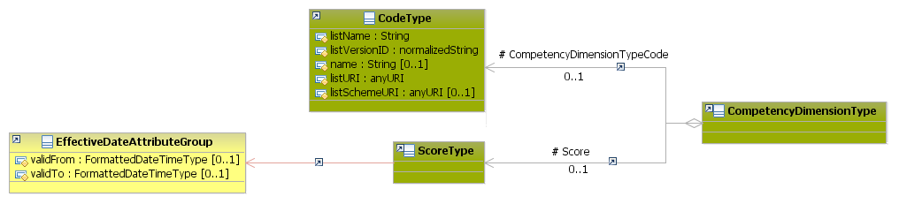
Figure 53: Competency Dimension Attributes Schema
Attributes | Description | Card. | Rule
This element has no attributes.
CompetencyDimensionTypeCode sub-element
Attributes | Description | Card. | Rule
listName | Code list name | 1 | N/A
listVersionID | Code list identification | 1 | N/A
name | Text equivalent of the code content component | 0..1 | N/A
listURI | The Uniform Resource Identifier that identifies where the code list is located | 1 | N/A
listSchemeURI | The Uniform Resource Identifier that identifies where the code list scheme is located | 0..1 | N/A
Score sub-element
Attributes | Description | Card. | Rule
See section “4.11.7.2 Score Attributes” for more information

Competency Dimension Examples
This example shows how to fill in the dimensions of language skills:
<PositionOpening xmlns="http://www.hr-xml.org/3" xsi:schemaLocation="http://www.hr-xml.org/3 ../Developer/Nouns/PositionOpening.xsd">
<PositionProfile languageCode="en">
<PositionQualifications>
<PositionCompetency>
<CompetencyID schemeID="ISO-639-1/2-Languages" schemeAgencyID="ISO" schemeAgencyName="ISO" schemeVersionID="639-1:2002 Alpha 2" schemeDataURI="http://www.loc.gov">EN</CompetencyID>

<TaxonomyID>language</TaxonomyID>

<CompetencyDimension>
<CompetencyDimensionTypeCode listName="EURES_Dimension" listVersionID="1.0" listURI="http://www.coe.int">
CEF-Speaking-Interaction
</CompetencyDimensionTypeCode>
<Score>
<ScoreText>B1</ScoreText>
</Score>
</CompetencyDimension>
</PositionCompetency>
</PositionQualifications>
</PositionProfile>
</PositionOpening>

Sub-element: /Position Competency /Competency Dimension /Score (level 5)

Score Element Description
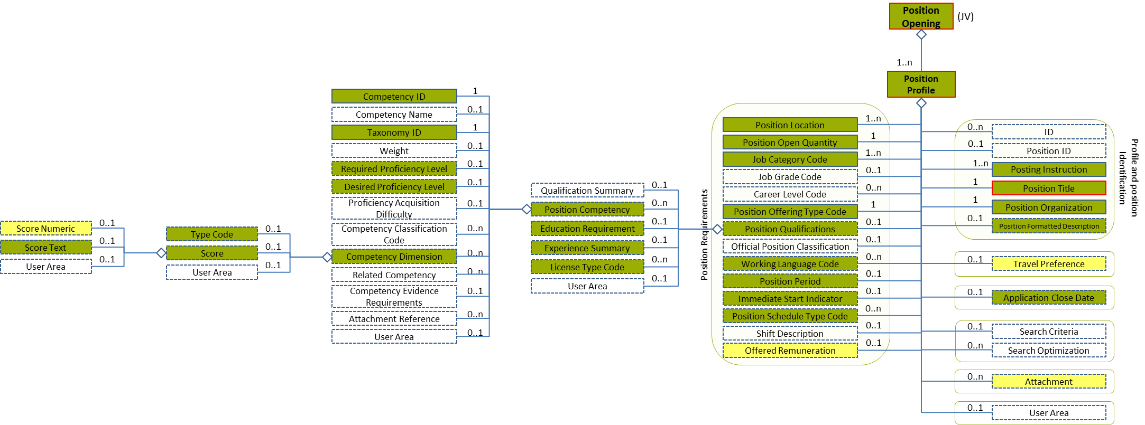
Figure 54: Score Level 5 Entity Diagram
Element | Description | Layer /  Cardinality |  | Rule | Examples
Score | Details regarding the student's scores at a specific dimension. |  | EURES Conformant Optional  /  0..1 | N/A | N/A
Sub-elements
The same as “4.11.4.1 Required Proficiency Level Element Description”

Score Attributes
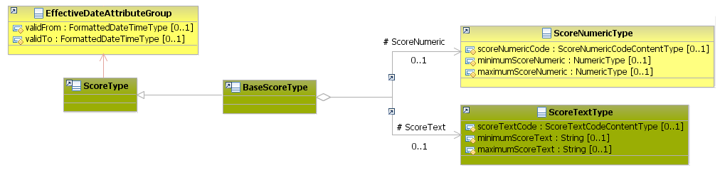
Figure 55: Score Attributes Schema
Attributes | Description | Card. | Rule | Examples
validFrom | Validity start date for this entity’s information | 0..1 | BR-COM-06: Compulsory Date Format is: YYYY-MM-DD, YYYY-MM, YYYY or YYYY-MM-DDThh:mm:ss.
validTo | Validity end for this entity’s information | 0..1 | BR-COM-06: Compulsory Date Format is: YYYY-MM-DD, YYYY-MM, YYYY or YYYY-MM-DDThh:mm:ss.
ScoreText, ScoreNumeric sub-element
The same as “4.11.4.2 Required Proficiency Level Attributes”

Sub-element: /Education Requirement (level 3)

Education Requirement Element Description
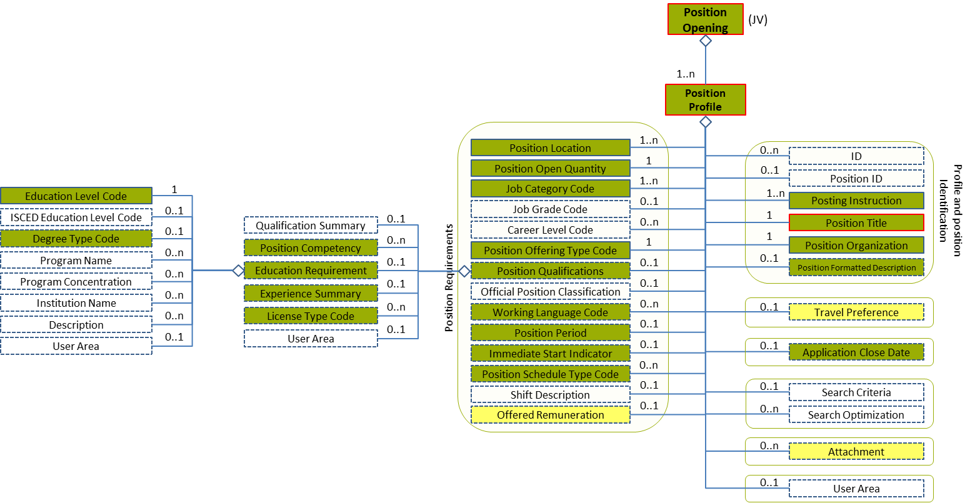
Figure 56: Education Requirement Level 3 Entity Diagram
Element | Description | Layer /  Cardinality |  | Rule | Examples
Education Requirement | Required education for the position |  | EURES Conformant Optional  /  0..1 | N/A | N/A
Sub-elements
Education Level Code | A code classifying the level of educational organisation. In this case, the standard used could be EQF or ISCED |  | EURES Conformant  /  1 | BR-COM-15: Compulsory use of the “EURES_ISCEDEducationLevel-CodeList.gc” list defined by EURES. This is based on ISCED-2011 (UNESCO). Or “EURES_EQF-CodeList.gc”, list defined by EURES and based on EQF (EU).  BR-COM-55: Compulsory use of the attributes “listVersionID”, “listName” and “listURI”. | “0”, “1”, “2”, etc.  Full code list: “4.15.11 Education Level Codes [CL15]”
Degree Type Code | The certificate obtained with the degree, or award granted, for the successful completion of requirements of an academic program |  | EURES Conformant Optional  /  0..1 | BR-COM-17: Compulsory use of the “EURES_DegreeType-CodeList.gc” list defined by EURES. This is based on ESCO Qualifications – version 1.0. | “23938”, “23399”, etc.  Full code list: “4.15.8 Degree Codes [CL10]”

Education Requirement Attributes
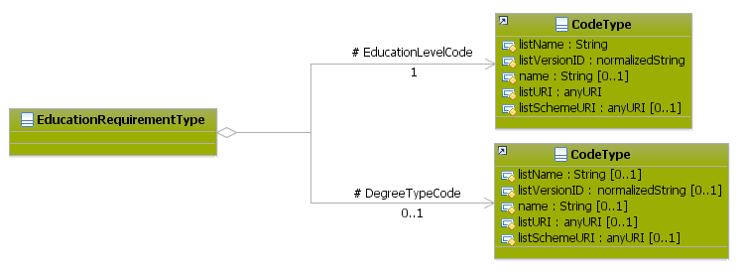
Figure 57: Education Requirement Attributes Schema
Attributes | Description | Card. | Rule
This element has no attributes.
EducationLevelCode sub-element
Attributes | Description | Card. | Rule
listName | Code list name | 0..1 | N/A
listVersionID | Code list identification | 0..1 | N/A
name | Text equivalent of the code content component | 0..1 | N/A
listURI | The Uniform Resource Identifier that identifies where the code list is located | 0..1 | N/A
listSchemeURI | The Uniform Resource Identifier that identifies where the code list scheme is located | 0..1 | N/A
DegreeTypeCode sub-element
Attributes | Description | Card. | Rule
listName | Code list name | 0..1 | N/A
listVersionID | Code list identification | 0..1 | N/A
name | Text equivalent of the code content component | 0..1 | N/A
listURI | The Uniform Resource Identifier that identifies where the code list is located | 0..1 | N/A
listSchemeURI | The Uniform Resource Identifier that identifies where the code list scheme is located | 0..1 | N/A

Education Requirement Examples
This example shows how to add a specific education requirement. In this case, adding the European Hairdressing Certificate:
<PositionOpening xmlns="http://www.hr-xml.org/3" xsi:schemaLocation="http://www.hr-xml.org/3 ../Developer/Nouns/PositionOpening.xsd">
<PositionProfile languageCode="en">
<PositionQualifications>
<EducationRequirement>
<EducationLevelCode listName="EURES_EQF" listVersionID="2008/C11/01" name="Master" listURI="http://ec.europa.eu/esco/ConceptScheme/EQF2012/ConceptScheme">7</EducationLevelCode>

<DegreeTypeCode listName="ESCO_Qualifications" listVersionID="ESCOv1" listURI="https://ec.europa.eu/esco/portal">
http://ec.europa.eu/esco/qualifications/23887
</DegreeTypeCode>
</EducationRequirement>
</PositionQualifications>
</PositionProfile>
</PositionOpening>

Sub-element: /Experience Summary (level 3)

Experience Summary Element Description
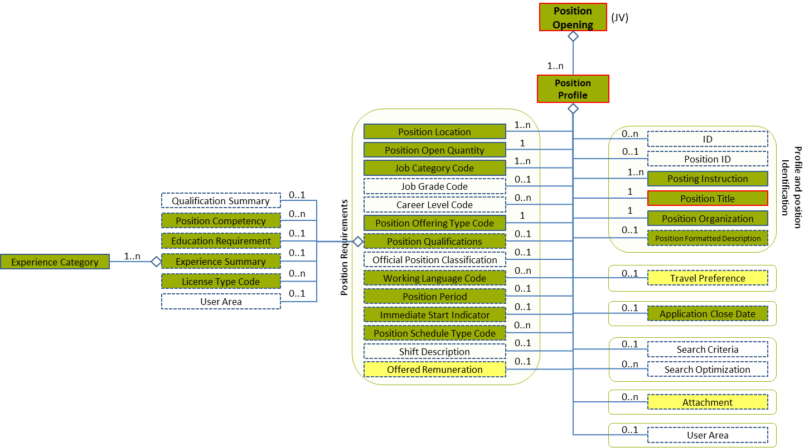
Figure 58: Experience Summary Level 3 Entity Diagram
Element | Description | Layer /  Cardinality |  | Rule | Examples
Experience Summary | Required experience for the position. |  | EURES Conformant Optional  /  0..1 | N/A | N/A
Sub-elements
Experience Category | This is intended as fielded summary of experience. It can be used as a "roll-up" of data within of Candidate history and experience components. |  | EURES Conformant  /  1..n | N/A | N/A
 | See section “4.11.10 Sub-element: /Experience Summary /Experience Category (level 4)” for more information

Experience Summary Attributes
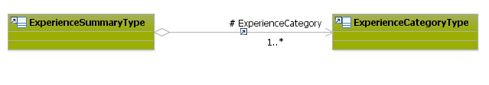
Figure 59: Experience Summary Attributes Schema
Attributes | Description | Card. | Rule
This element has no attributes.
Experience Category sub-element
Attributes | Description | Card. | Rule
See section “4.11.10.2 Experience Category Attributes” for more information

Sub-element: /Experience Summary /Experience Category (level 4)

Experience Category Element Description
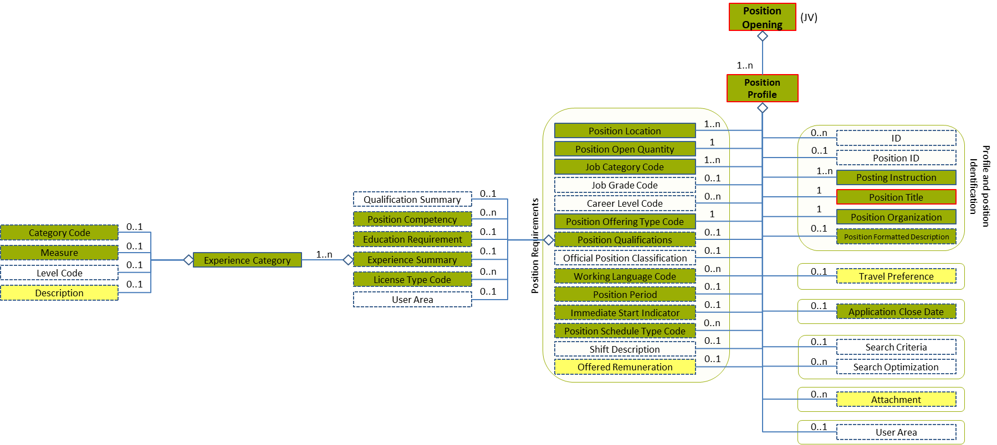
Figure 60: Category Level 4 Entity Diagram
Element | Description | Layer /  Cardinality |  | Rule | Examples
Experience Category | This is intended as fielded summary of qualifications. It can be used as a "roll-up" of data within of Candidate history and experience components |  | EURES Conformant  /  1..n | N/A | N/A
Sub-elements
Category Code | A code classifying the job type or category. This may be used for occupational classification of the job. The JobCategoryCode will usually be repeatable so that a single job can be classified across multiple dimensions.  The JobCategoryCode can be used to classify the job by industry, but note that an explicit IndustryCode is available in contexts such as PositionOrganizationDetails |  | EURES Conformant Optional  /  0..1 | BR-COM-29: Compulsory use of the “ISCO2008-CodeList.gc” list defined by EURES and based on ISCO-08. Alternatively, use of ESCO Occupations – version 1.0.  BR-COM-55: Compulsory use of the attributes “listVersionID”, “listName” and “listURI”. | “1” – Managers,  “12” – Administrative, etc.  Full code list: “4.15.13 Job Category Codes [CL20]”
Measure | Code indicating the period of time, measured in years or months of experience |  | EURES Conformant Optional  /  0..1 | N/A | 5, 3, etc.
Description | Description of the category |  | EURES Optional  /  0..1 | N/A | “Years of Financial Industry Management Experience”, etc.

Experience Category Attributes
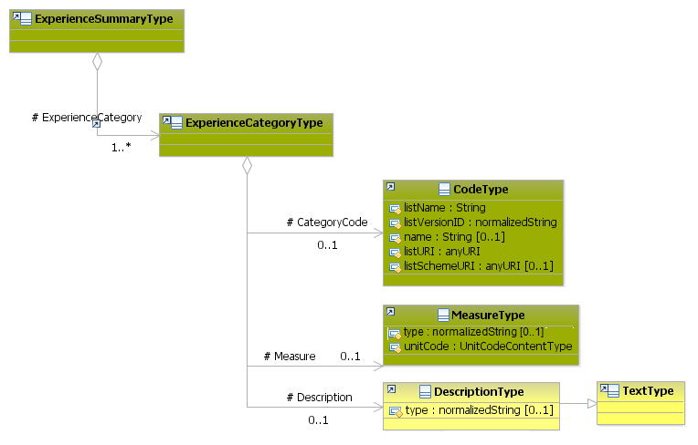
Figure 61: Experience Category Attributes Schema
Attributes | Description | Card. | Rule
This element as no attributes.
CategoryCode sub-element
Attributes | Description | Card. | Rule
listName | Code list name | 0..1 | N/A
listVersionID | Code list identification | 0..1 | N/A
name | Text equivalent of the code content component | 0..1 | N/A
listURI | The Uniform Resource Identifier that identifies where the code list is located | 0..1 | N/A
listSchemeURI | The Uniform Resource Identifier that identifies where the code list scheme is located | 0..1 | N/A
Measure sub-element
Attributes | Description | Card. | Rule
unitCode | Code indicating the type of unit measure, such as “minutes” or “hours” (full code list: “4.15.31 Unit Codes [CL54]”) | 1 | BR-COM-36: Compulsory use of the Unit Codes [CL54]
type | The description type | 0..1 | N/A
Description sub-element
Attributes | Description | Card. | Rule
type | The description type | 0..1 | N/A

Experience Category Examples
This example shows how to fill in the required experience. In this case, there are three years of experience and the job category is childcare.
<PositionOpening xmlns="http://www.hr-xml.org/3" xsi:schemaLocation="http://www.hr-xml.org/3 ../Developer/Nouns/PositionOpening.xsd">
<PositionProfile languageCode="en">
<PositionQualifications>
<ExperienceSummary>
<ExperienceCategory>
<CategoryCode listName="ISCO2008" listVersionID="2008" listURI="http://ec.europa.eu/esco/ConceptScheme/ISCO2008">http://ec.europa.eu/esco/occupation/15562</CategoryCode>

<Measure unitCode="year">3</Measure>

<oa:Description>Applicants must have 3 years of experience in care of children.</oa:Description>
</ExperienceCategory>
</ExperienceSummary>
</PositionQualifications>
</PositionProfile>
</PositionOpening>

/Position Profile /Position Period (level 2)

Position Period Element Description
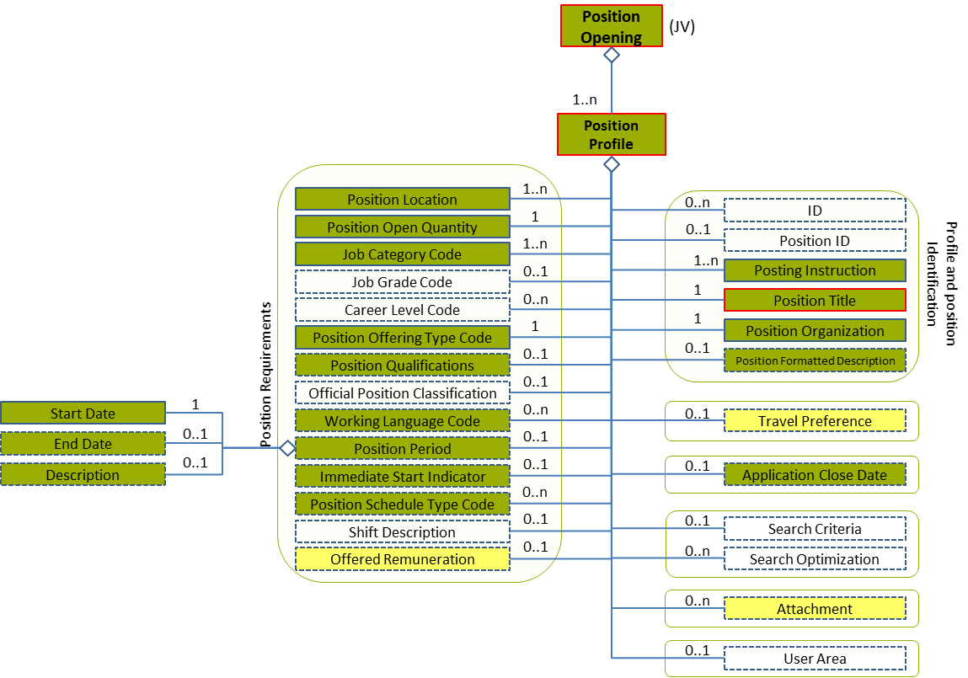
Figure 62: Position Period Level 2 Entity Diagram
Element | Description | Layer /  Cardinality |  | Rule | Examples
Position Period | Period of time during which the Position will be open |  | EURES Conformant Optional  /  0..1 | N/A | N/A
Sub-elements
Start Date | A timestamp marking the beginning of the attendance period |  | EURES Conformant  /  1 | BR-COM-16: At least one of its sub-elements must be provided. | N/A
 | See section “4.12.4 Sub-element: /Start Date (level 3)” for more information
End Date | A timestamp marking the end of the attendance period |  | EURES Conformant Optional  /  0..1 | BR-COM-16: At least one of its sub-elements must be provided. | N/A
 | See section “4.12.5 Sub-element: /End Date (level 3)” for more information
Description | Narrative details of the attendance period |  | EURES Conformant Optional  /  0..1 | N/A | “Additional information about the position period.”

Position Period Attributes
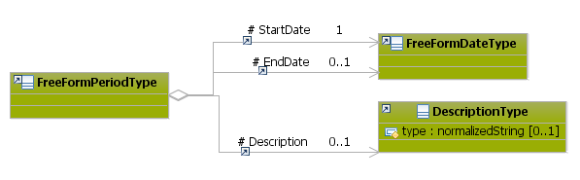
Figure 63: Position Period Attributes Schema
Attributes | Description | Card. | Rule
This element has no attributes.
StartDate sub-element
Attributes | Description | Card. | Rule
See section “4.12.4.2 Start Date Attributes” for more information
EndDate sub-element
Attributes | Description | Card. | Rule
See section “4.12.5.2 End Date Attributes” for more information
Description sub-element
Attributes | Description | Card. | Rule
type | The description type | 0..1 | N/A

Position Period Examples
This example shows a job that is temporary because it has a start and end date:
<PositionOpening xmlns="http://www.hr-xml.org/3" xsi:schemaLocation="http://www.hr-xml.org/3 ../Developer/Nouns/PositionOpening.xsd">
<PositionProfile languageCode="en">
<PositionPeriod>
<!-- Starting date -->
<StartDate>
<FormattedDateTime>2015-05-06</FormattedDateTime>
</StartDate>

<!-- Ending date -->
<EndDate>
<FormattedDateTime>2015-09-30</FormattedDateTime>
</EndDate>
</PositionPeriod>
</PositionProfile>
</PositionOpening>

This example shows a job that has only a start date, because it could be a permanent job:
<PositionOpening xmlns="http://www.hr-xml.org/3" xsi:schemaLocation="http://www.hr-xml.org/3 ../Developer/Nouns/PositionOpening.xsd">
<PositionProfile languageCode="en">
<PositionPeriod>
<!-- Starting date -->
<StartDate>
<FormattedDateTime>2015-05-06</FormattedDateTime>
</StartDate>
</PositionPeriod>
</PositionProfile>
</PositionOpening>

Sub-element: /Start Date (level 3)

Start Date Element Description
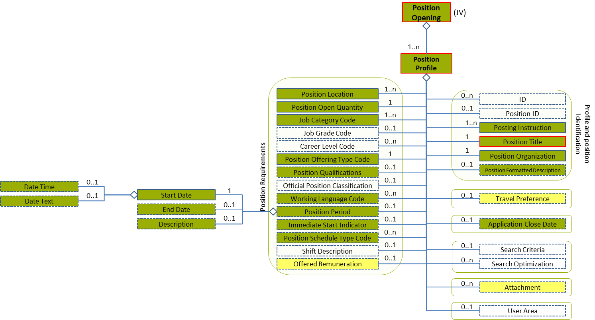
Figure 64: Start Date Level 3 Entity Diagram
Element | Description | Layer /  Cardinality |  | Rule | Examples
Start Date | A timestamp marking the beginning of the attendance period |  | EURES Conformant  /  1 | BR-COM-16: At least one of its sub-elements must be provided. | N/A
Sub-elements
Formatted Date Time | A formatted representation of a date, which may be specified as a date, date/time, year, or year/month |  | EURES Conformant Optional  /  0..1 | N/A | “2009-01-04”
Date Text | A text or formatted representation of a date or date information |  | EURES Conformant Optional  /  0..1 | N/A | "January 4, 2009" or "Two Years Ago"

Start Date Attributes
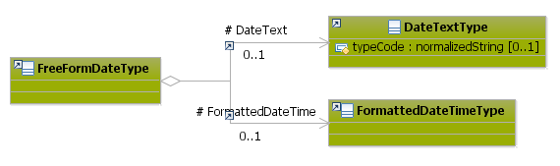
Figure 65: Start Date Attributes Schema
Attributes | Description | Card. | Rule | Examples
This element has no attributes.
FormattedDateTime sub-element
Attributes | Description | Card. | Rule | Examples
This sub-element has no attributes.
DateText sub-element
Attributes | Description | Card. | Rule | Examples
typeCode | The type of the date text. | 0..1 | N/A | N/A

Sub-element: /End Date (level 3)

End Date Element Description
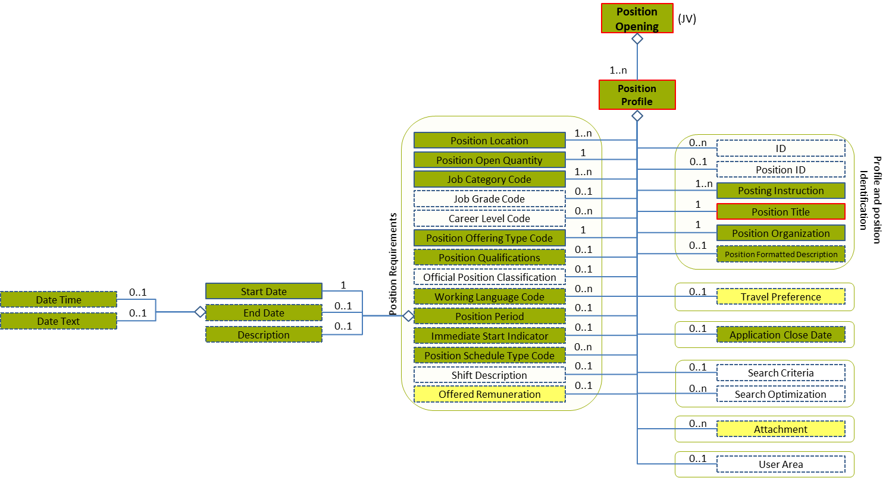
Figure 66: End Date Level 3 Entity Diagram
Element | Description | Layer /  Cardinality |  | Rule | Examples
End Date | A timestamp marking the end of the attendance period |  | EURES Conformant Optional  /  0..1 | N/A | N/A
Sub-elements
The same as “4.12.4.1 Start Date Element Description”

End Date Attributes
Figure 67: End Date Attributes Schema
Attributes | Description | Card. | Rule | Examples
Same as “4.12.4.2 Start Date Attributes”

/Position Profile /Offered Remuneration (level 2)

Offered Remuneration Element Description
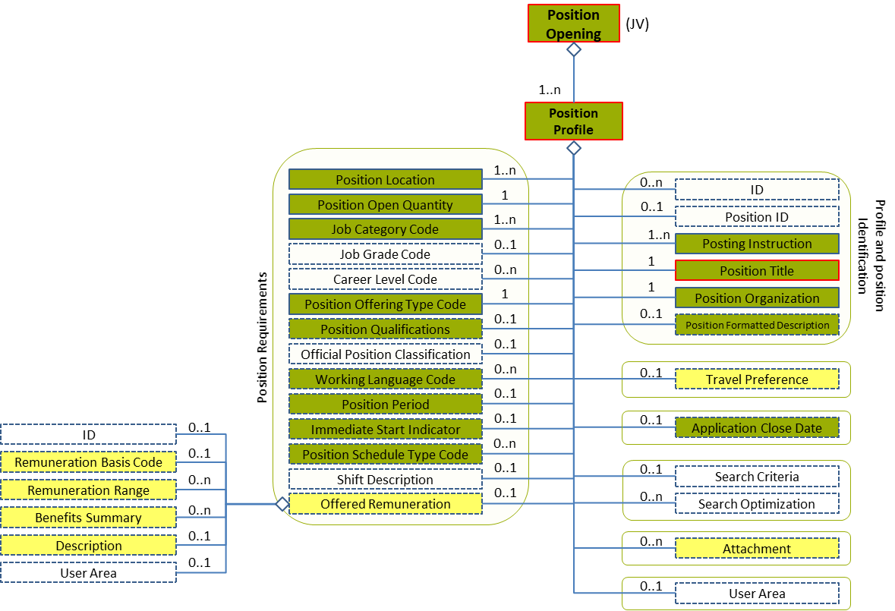
Figure 68: Offered Remuneration Level 2 Entity Diagram
Element | Description | Layer /  Cardinality |  | Rule | Examples
Offered Remuneration | Remuneration offered and benefits |  | EURES Optional  /  0..1 | N/A | N/A
Sub-elements
Remuneration Basis Code | A code classifying the primary method of payment for the associated position or employment. This classifies the method by which remuneration for a position is provided or calculated  This is an HR-Open Standards open list. |  | EURES Optional  /  0..1 | BR-COM-30: Compulsory use of the “RemunerationBasisCodeContentType” list. | “Hourly”, “Salaried”, “SalariedPlusComission”, “ComissionOnly”  Full code list: “4.15.26 Remuneration Basis Codes [CL48]”
Remuneration Range | Remuneration range details |  | EURES Optional  /  0..n | BR-COM-31: All its sub elements must be expressed using the same currency. | N/A
 | See section “4.13.3 Sub-element: /Remuneration Range (level 3)” for more information
Benefits Summary | Summary of benefits |  | EURES Optional  /  0..n | N/A | N/A
 | See section “4.13.4 Sub-element: /Benefits Summary (level 3)” for more information
Description | Description of the remuneration offered |  | EURES Optional  /  0..1 | N/A | “Description of the remuneration offered”, etc.

Offered Remuneration Attributes
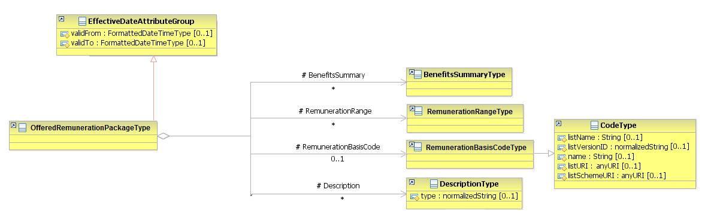
Figure 69: Offered Remuneration Attributes Schema
Attributes | Description |  | Card. | Rule
validFrom | Validity start date for this entity’s information |  | 0..1 | BR-COM-06: Compulsory Date Format is: YYYY-MM-DD, YYYY-MM, YYYY or YYYY-MM-DDThh:mm:ss.
validTo | Validity end date for this entity’s information |  | 0..1 | BR-COM-06: Compulsory Date Format is: YYYY-MM-DD, YYYY-MM, YYYY or YYYY-MM-DDThh:mm:ss.
RemunerationBasisCode sub-element
Attributes | Description | Card. |  | Rule
listName | Code list name | 0..1 |  | N/A
listVersionID | Code list identification | 0..1 |  | N/A
name | Text equivalent of the code content component | 0..1 |  | N/A
listURI | The Uniform Resource Identifier that identifies where the code list is located | 0..1 |  | N/A
listSchemeURI | The Uniform Resource Identifier that identifies where the code list scheme is located | 0..1 |  | N/A
RemunerationRange sub-element
Attributes | Description |  | Card. | Rule
See section “4.13.3.2 Remuneration Range Attributes” for more information
BenefitsSummary sub-element
Attributes | Description |  | Card. | Rule
See section “4.13.4.2 Benefits Summary Attributes” for more information
Description sub-element
Attributes | Description | Card. |  | Rule
type | The comment type | 0..1 |  | N/A

Sub-element: /Remuneration Range (level 3)

Remuneration Range Element Description
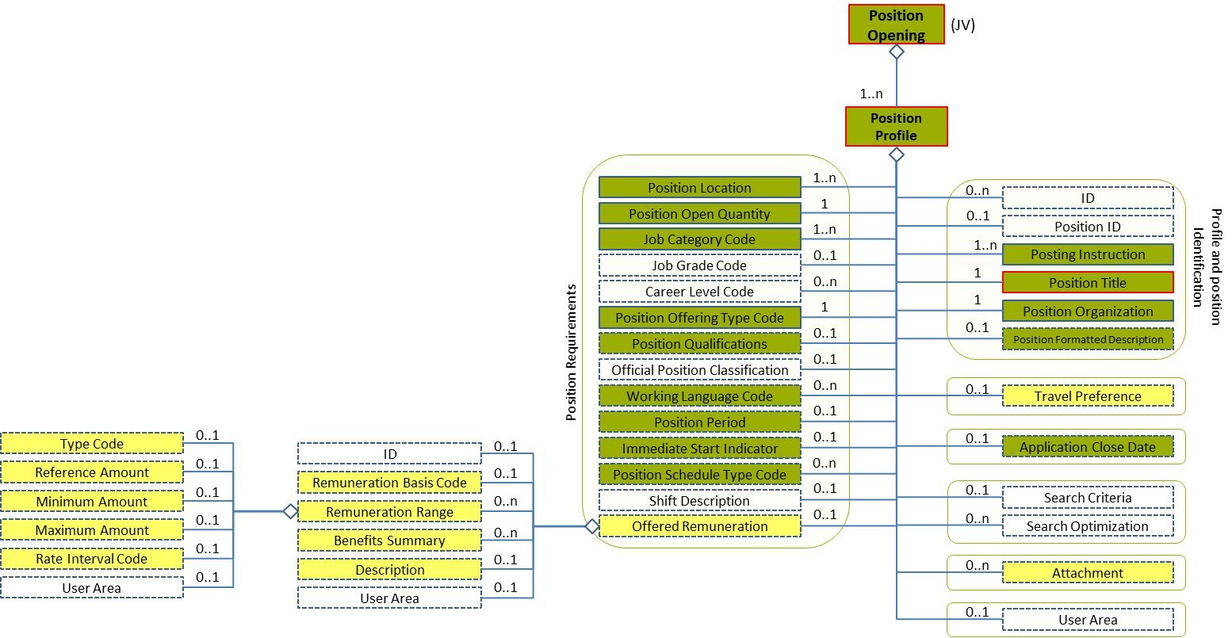
Figure 70: Remuneration Range Level 3 Entity Diagram
Element | Description | Layer /  Cardinality |  | Rule | Examples
Remuneration Range | Remuneration range details |  | EURES Optional  /  0..n | BR-COM-31: All its sub elements must be expressed using the same currency. | N/A
Sub-elements
Remuneration Type Code | A code classifying the type of pay or remuneration being described  This is an HR-Open Standards open list. |  | EURES Optional  /  0..1 | BR-COM-32: Compulsory use of the “RemunerationCodeContentType” list. | “BasePay”, “Commission”, “Bonus”,  “ShortTermIncentive”,  “ShiftPremium”  Full code list: “4.15.28 Remuneration Type Codes [CL49]”
Reference Amount | A reference to an associated monetary quantity. An attribute is available to express the currency in which the amount is expressed |  | EURES Optional  /  0..1 | N/A | “20000”, “35000”, etc.
Minimum Amount | The minimum amount an organization is willing to pay for a position |  | EURES Optional  /  0..1 | N/A | “20000”, “35000”, etc.
Maximum Amount | The maximum amount an organization is willing to pay for a position |  | EURES Optional  /  0..1 | N/A | “20000”, “35000”, etc.
Rate Interval Code | An interval of time or other basis used to express a rate of pay or remuneration  This is an HR-Open Standards open list. |  | EURES Optional  /  0..1 | BR-COM-33: Compulsory use of the “RemunerationRateIntervalCodeContentType” list. | “Hour”, “Day”, “Week”, etc.  Full code list: “4.15.27 Remuneration Rate Interval Codes [CL50]”

Remuneration Range Attributes
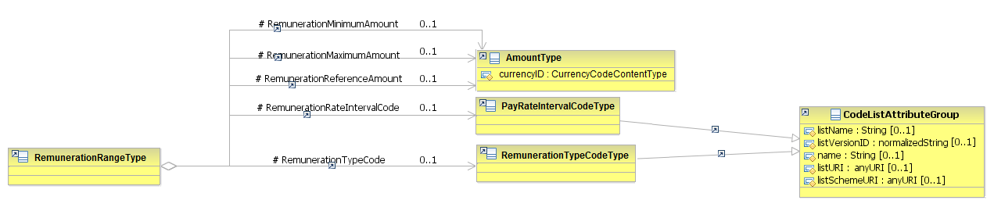
Figure 71: Remuneration Range Attributes Schema
Attributes | Description | Card. | Rule
This element has no attributes.
RemunerationTypeCode sub-element
Attributes | Description | Card. | Rule
The same as “RemunerationRateIntervalCode”
RemunerationReferenceAmount sub-element
Attributes | Description | Card. | Rule
The same as “RemunerationMinimumAmount”
RemunerationMinimumAmount sub-element
Attributes | Description | Card. | Rule
currencyID | The currency in which the maximal and minimal salary are indicated  Full code list: “4.15.7 Currency Codes [CL09]” | 1 | BR-COM-34: Compulsory use of the Currency Codes [CL09].
RemunerationMaximumAmount sub-element
Attributes | Description | Card. | Rule
The same as “RemunerationMinimumAmount”
RemunerationRateIntervalCode sub-element
Attributes | Description | Card. | Rule
listName | Code list name | 0..1 | N/A
listVersionID | Code list identification | 0..1 | N/A
name | Text equivalent of the code content component | 0..1 | N/A
listURI | The Uniform Resource Identifier that identifies where the code list is located | 0..1 | N/A
listSchemeURI | The Uniform Resource Identifier that identifies where the code list scheme is located | 0..1 | N/A

Remuneration Range Examples
This is an example to indicate the amount of base pay per months in Euros:
<PositionOpening xmlns="http://www.hr-xml.org/3" xsi:schemaLocation="http://www.hr-xml.org/3 ../Developer/Nouns/PositionOpening.xsd">
<PositionProfile languageCode="en">
<OfferedRemunerationPackage>
<RemunerationRange>
<RemunerationTypeCode listName="RemunerationTypeCodeContentType" listVersionID="1.0" listURI="http://www.hr-xml.org/">BasePay</RemunerationTypeCode>

<RemunerationRateIntervalCode listName="PayRateIntervalCodeContentType" listVersionID="1.0" listURI="http://www.hr-xml.org/">
Year</RemunerationRateIntervalCode>
<RemunerationMinimumAmount currencyID="EUR">2000</RemunerationMinimumAmount>
<RemunerationMaximumAmount currencyID="EUR">2500</RemunerationMaximumAmount>
</RemunerationRange>
</OfferedRemunerationPackage>
</PositionProfile>
</PositionOpening>

Sub-element: /Benefits Summary (level 3)

Benefits Summary Element Description
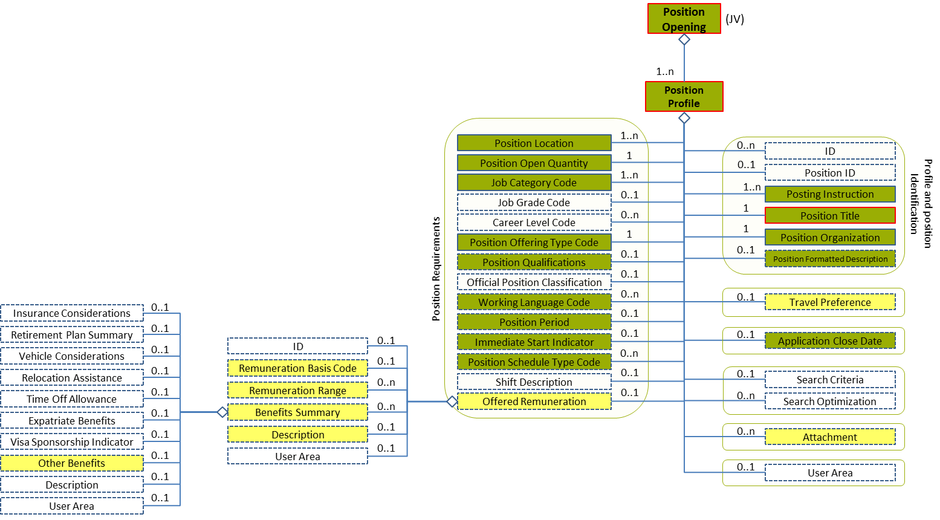
Figure 72: Benefits Summary Level 3 Entity Diagram
Element | Description | Layer /  Cardinality |  | Rule | Examples
Benefits Summary | Summary of benefits |  | EURES Optional  /  0..n | N/A | N/A
Sub-elements
Other Benefits | Details of benefits |  | EURES Optional  /  0..1 | N/A | N/A
 | See section “4.13.5 Sub-element: /Benefits Summary /Other Benefits (Level 4)” for more information

Benefits Summary Attributes
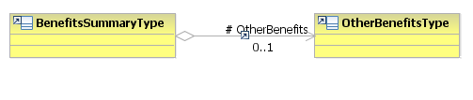
Figure 73: Benefits Summary Attributes Schema
Attributes | Description | Card. | Rule | Examples
This element has no attributes.
OtherBenefits sub-element
Attributes | Description | Card. | Rule | Examples
See section “4.13.5.2 Other Benefits Attributes” for more information

Sub-element: /Benefits Summary /Other Benefits (Level 4)

Other Benefits Element Description
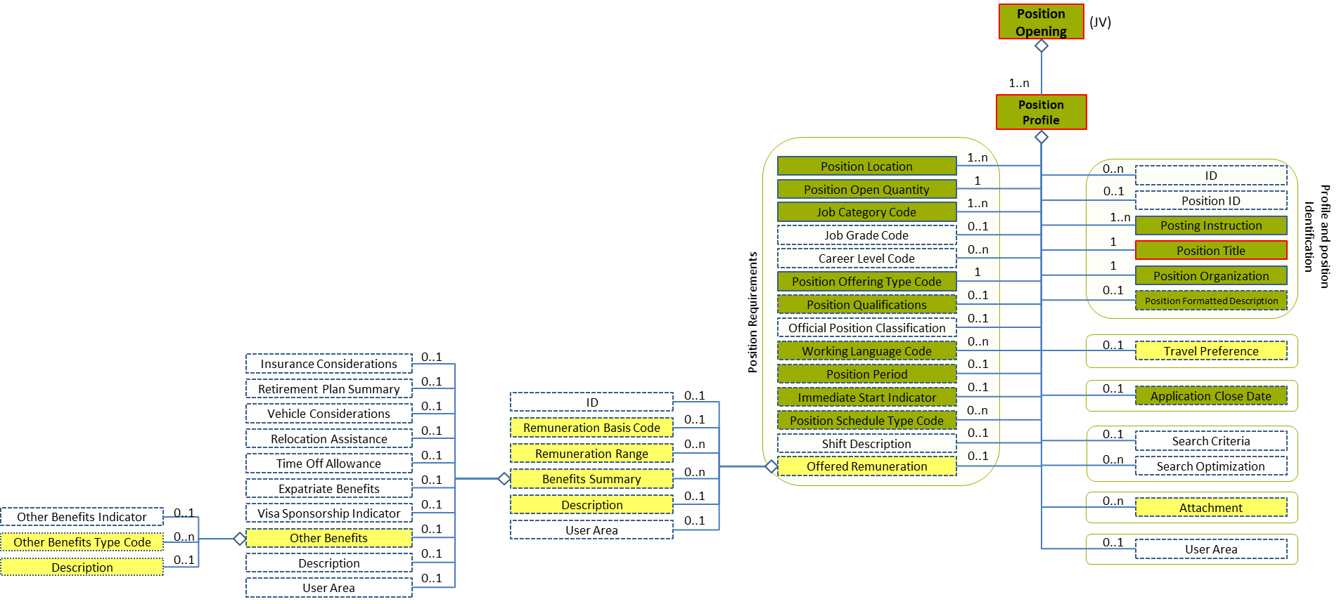
Figure 74: Other Benefits Level 4 Entity Diagram
Element | Description | Layer /  Cardinality |  | Rule | Examples
Other Benefits | Details of the other benefits |  | EURES Optional  /  0..1 | N/A | N/A
Sub-elements
Other Benefits Type Code | Code of benefits that the candidate would like |  | EURES Optional  /  0..n | BR-COM-40: Compulsory use of the “EURES_SocialBenefitsCodes-CodeList.gc” list defined by EURES.  BR-COM-43: Multiple entries of this code list are allowed. | “1” = Accommodation included,  “2” = Meals included, etc.  Full code list: “4.15.30 Social Benefits Codes [CL52]”
Description | Narrative details of benefits |  | EURES Optional  /  0..1 | N/A | “Description of other benefits”, etc.

Other Benefits Attributes
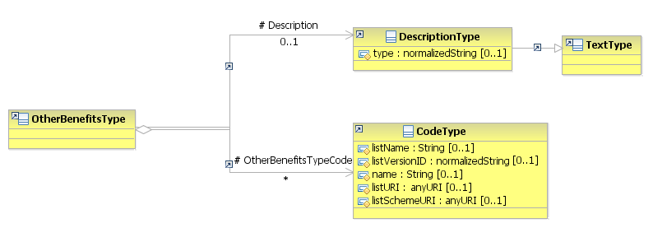
Figure 75: Other Benefits Attributes Schema
Attributes | Description | Card. | Rule
This element has no attributes.
OtherBenefitsTypeCode sub-element
Attributes | Description | Card. | Rule
listName | Code list name | 0..1 | N/A
listVersionID | Code list identification | 0..1 | N/A
name | Text equivalent of the code content component | 0..1 | N/A
listURI | The Uniform Resource Identifier that identifies where the code list is located | 0..1 | N/A
listSchemeURI | The Uniform Resource Identifier that identifies where the code list scheme is located | 0..1 | N/A
Description sub-element
Attributes | Description | Card. | Rule
type | The comment type | 0..1 | N/A

/Position Profile /Attachment (level 2)

Attachment Element Description
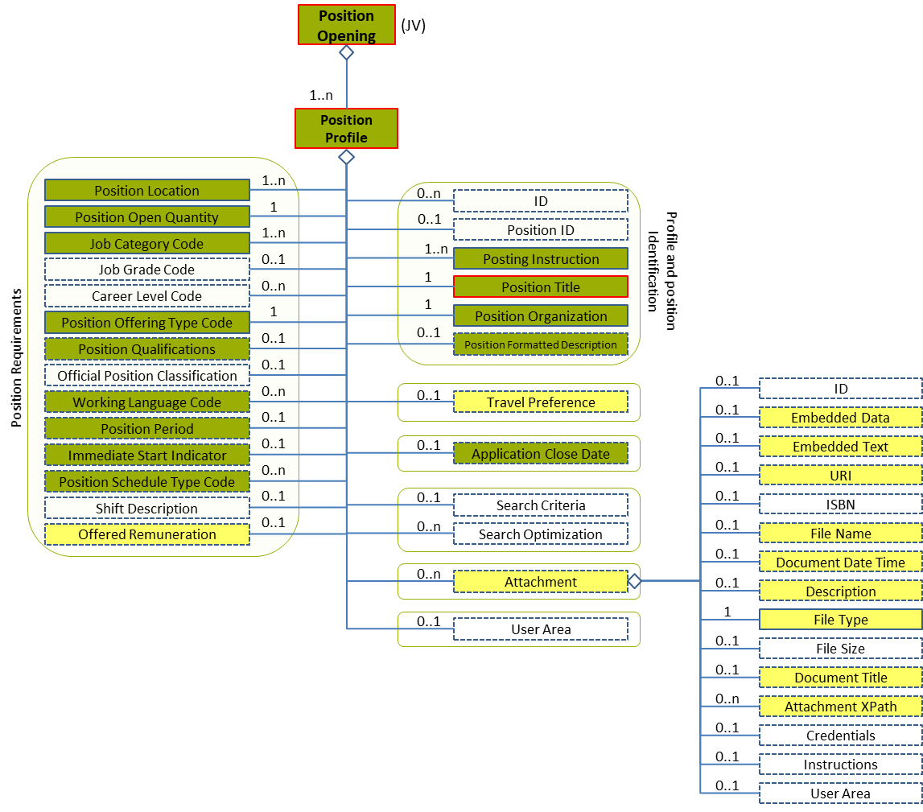
Figure 76: Attachment Level 2 Entity Diagram
Element | Description | Layer /  Cardinality |  | Rule | Examples
Attachment | Allows external documents or digital objects to be embedded or referenced |  | EURES Optional  /  0..n | BR-COM-42: An Attachment shall not embed and simultaneously refer to an URI that contains the same document. External references to documents, using the URI element, are the recommended method (when possible) for attaching documents. | N/A
Sub-elements
Embedded Data | Allows the data to be embedded directly into the BOD instance |  | EURES Optional  /  0..1 | N/A | -
Embedded Text | Embedded text |  | EURES Optional  /  0..1 | N/A | “Embedded text”
URI | Represents a Uniform Resource Identifier Reference (URI). A URI value can be absolute or relative, and may have an optional fragment identifier (i.e. it can be a URI Reference). This type should be used to specify the intention that the value fulfil the role of a URI, as defined by [RFC 2396] and as amended by [RFC 2732] |  | EURES Optional  /  0..1 | N/A | “http://uri.org”, etc.
File Name | Indicates the name of the File being referenced |  | EURES Optional  /  0..1 | N/A | “File Name”
Document Date Time | The date and/or time associated with the current or referenced version of a document |  | EURES Optional  /  0..1 | N/A | “2012/12/23”, etc.
Description | Description of the attachment |  | EURES Optional  /  0..1 | N/A | “Description of the attachment”
File Type | Identifies the attachment file type |  | EURES Conformant Optional  /  1 | BR-COM-35: Compulsory use of the “EURES_FileTypeCode-CodeList.gc” list defined by EURES.  Reference: Use Code List File Type Codes [CL17] | “PDF”, “DOC”, etc.  Full code list: “4.15.12 File Type Codes [CL17]”
Document Title | The name of the document |  | EURES Optional  /  0..1 | N/A | “Photo”, “Presentation of the company”, etc.
Attachment XPath | Path to the external documents attached |  | EURES Optional  /  0..n | N/A | “/PositionOpening/PostingRequester”, etc.
Instructions | Identifies the type of attachment uploaded |  | EURES Conformant Optional  /  1 | BR-JV-14: Compulsory use of the “EURES_AttachmentInstructionJVCode” list defined by EURES. | “JobDescription”, “CompanyLogo”, “Other”, etc.  Full code list: “4.15.2 Attachment Instruction Codes [CL62]”

Attachment Attributes
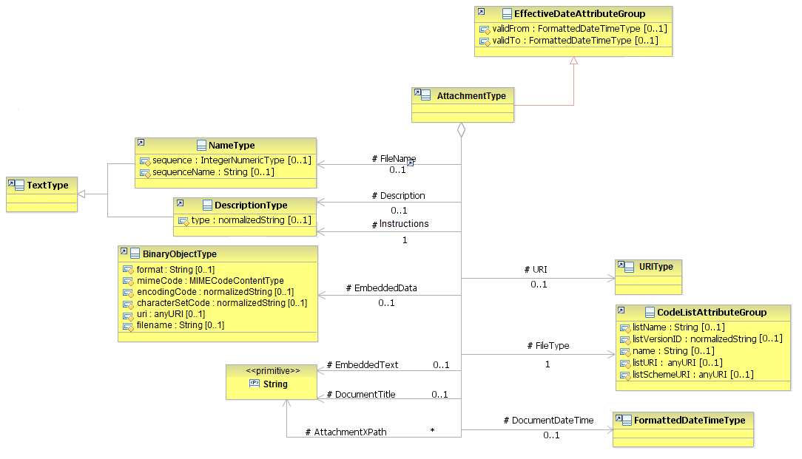
Figure 77: Attachment Attributes Schema
Attributes | Description | Card. | Rule
validFrom | Validity start date for this entity’s information | 0..1 | BR-COM-06: Compulsory Date Format is: YYYY-MM-DD, YYYY-MM, YYYY or YYYY-MM-DDThh:mm:ss.
validTo | Validity end date for this entity’s information | 0..1 | BR-COM-06: Compulsory Date Format is: YYYY-MM-DD, YYYY-MM, YYYY or YYYY-MM-DDThh:mm:ss.
EmbeddedData sub-element
Attributes | Description | Card. | Rule
mimeCode | Codes that specify the data mime code | 1 | BR-COM-50: Compulsory use of Mime Codes [CL56].
encodingCode | The data encoding type | 1 | BR-COM-51: Only ‘base64Binary’ is allowed.
uri | The file’s URI | 0..1 | N/A
filename | The name of the file | 0..1 | N/A
Embedded Text sub-element
Attributes | Description | Card. | Rule
This sub-element has no attributes.
URI sub-element
Attributes | Description | Card. | Rule
This sub-element has no attributes.

FileName sub-element
Attributes | Description | Card. | Rule
sequence | Establishes the order of contact data | 0..1 | N/A
sequenceName | Establishes the order of contact data | 0..1 | N/A
DocumentDateTime sub-element
Attributes | Description | Card. | Rule
This sub-element has no attributes.
Description sub-element
Attributes | Description | Card. | Rule
type | The comment type | 0..1 | N/A
FileType sub-element
Attributes | Description | Card. | Rule
listName | Code list name | 0..1 | N/A
listVersionID | Code list identification | 0..1 | N/A
name | Text equivalent of the code content component | 0..1 | N/A
listURI | The Uniform Resource Identifier that identifies where the code list is located | 0..1 | N/A
listSchemeURI | The Uniform Resource Identifier that identifies where the code list scheme is located | 0..1 | N/A
Document Title sub-element
Attributes | Description | Card. | Rule
This sub-element has no attributes.
Attachment XPath sub-element
Attributes | Description | Card. | Rule
This sub-element has no attributes.
Instructions sub-element
Attributes | Description | Card. | Rule
The same as “Description”

Attachment Examples
This is an example of how to fill in the elements of an attached document:
<PositionOpening xmlns="http://www.hr-xml.org/3" xsi:schemaLocation="http://www.hr-xml.org/3 ../Developer/Nouns/PositionOpening.xsd">
<PositionProfile languageCode="en">
<Attachment>
<oa:URI>http://europass.cedefop.europa.eu/es/documentsJV/jv01222.pdf</oa:URI>

<oa:Description>Document that describes the position.</oa:Description>

<oa:FileType listName="EURES_FileTypeCode" listVersionID="1.0" name="PDF document" listURI="https://ec.europa.eu/eures">PDF</oa:FileType>

<DocumentTitle>pdf_en_GB-a</DocumentTitle>

<Instructions>JobDescription</Instructions>
</Attachment>
</PositionProfile>
</PositionOpening>

This is an example of how to fill in an embedded document:
<PositionOpening xmlns="http://www.hr-xml.org/3" xsi:schemaLocation="http://www.hr-xml.org/3 ../Developer/Nouns/PositionOpening.xsd">
<PositionProfile languageCode="en">
<Attachment>
<oa:EmbeddedData mimeCode="image/jpeg" encodingCode="base64Binary">/9j/4AAQSkZJRgABAQAAAQABAAD//gA7Q1JFQVRPUjog</oa:EmbeddedData>
<oa:FileName>logo.jpg</oa:FileName>
<DocumentDateTime>2013-01-30</DocumentDateTime>
<oa:FileType listName="EURES_FileTypeCode" listVersionID="1.0" name="photo" listURI="https://ec.europa.eu/eures">photo</oa:FileType>
<DocumentTitle>Logo</DocumentTitle>
<AttachmentXPath>/PositionOpening/PositionProfile</AttachmentXPath>

<Instructions>CompanyLogo</Instructions>
</Attachment>
</PositionProfile>
</PositionOpening>

Code Lists
Code Lists are tables containing codes or values representing concepts that have been agreed amongst several parties as having exactly the same meaning for all.
HR-Open Standards 3.1 provides many Code Lists for many different concepts. HR-Open Standards Code Lists are based on W3C XSD Enumeration Schemas. The new EURES JV specifications re-use a large bunches of these Code Lists.
In addition to HR-Open Standards Code Lists, EURES also defines several other ones based on the OASIS Code Lists specification, another representation method that is compatible with the HR-Open Standards specification. Detailed information about this specification can be found here:
https://www.oasis-open.org/committees/tc_home.php?wg_abbrev=codelist
Thus, these code lists could be defined as:
- HR-Open Standards: code lists defined and maintained by HR-Open Standards organisation.
- EURES standards: code lists defined and maintained by international entities, such as NUTS or ISO.
- EURES standards new: code lists defined and maintained by EURES, and therefore, they are only used by EURES.
A set of attributes might be filled in for each code list not representing the HR-Open Standards.
Attributes | Description
listName | Code list name
listVersionID | Code list identification
name | Text equivalent of the code content component
listURI | The Uniform Resource Identifier that identifies where the code list is located
listSchemeURI | The Uniform Resource Identifier that identifies where the code list scheme is located
The following is an explanation of the code lists, including the standard version used, the values of the attributes and some examples. Identification is also added in order to relate the same codes with the EURES-CV-StandardStaticModel (RD01 – “EURES CV standard “static” description”).
All values from the code lists are case insensitive.

Agency Role Code Enum Type [CL55]
A code classifying the job vacancy’s role within the organization or the role with which that organization is associated.
The values come from an HR-Open Standards list, and the values could be:
Code | Description
Customer | The organisation is the job vacancy’s customer
Supplier | The organisation is the job vacancy’s supplier
Requester | The organisation is the job vacancy’s requester
The code attribute values are as follows:
Attributes | Value
listName | AgencyRoleCodeEnumType
listVersionID | 1.0
name | {Code name or description}
listURI | http://www.hr-xml.org/
listSchemeURI | http://www.hr-xml.org/3 ../Developer/Common/CodeLists.xsd
Because roles are filled in as attributes, they are filled in differently:
<PostingRequester agencyRoleCode="Supplier">
...
</PostingRequester>

Attachment Instruction Codes [CL62]
These codes classify the type of the attachment uploaded.
The New EURES Standard is used.
Code | Description
JobDescription | Job description
CompanyLogo | Company logo
Other | Other type of attachment

This example fills in Job Description in the instructions element:
<Instructions>JobDescription</Instructions>

Channel Type Codes [CL05]
These codes classify the communication channel used to contact a person or organisation.
Their values come from an HR-Open Standards list, and the values could be:
Code | Description
Telephone | The communication channel is the telephone number
MobileTelephone | The communication channel is the cell phone number
Fax | The communication channel is the fax number
Email | The communication channel is the email address
InstantMessage | The communication channel is the instant message
Web | The communication channel is the web address
The code attribute values are as follows:
Attributes | Value
listName | ChannelCodeContentType
listVersionID | 1.0
name | {Code name or description}
listURI | http://www.hr-xml.org/
listSchemeURI | http://www.hr-xml.org/3 ../Developer/Common/CodeLists.xsd
This example fills in the communication channel as a telephone code:
<ChannelCode listName="ChannelCodeContentType" listVersionID="1.0" name="Telephone" listURI="http://www.hr-xml.org/" listSchemeURI="http://www.hr-xml.org/3 ../Developer/Common/CodeLists.xsd"
>telephone</ChannelCode>

Contact Use Type Codes [CL06]
These codes classify the type of use given to the communication channel to contact a person or an organization.
Their values come from an HR-Open Standards list, and the values could be:
Code | Description
personal | The communication channel is for personal use
business | The communication channel is for business communication
The code attribute values are as follows:
Attributes | Value
listName | ContactUseCodeContentType
listVersionID | 1.0
name | {Code name or description}
listURI | http://www.hr-xml.org/
listSchemeURI | http://www.hr-xml.org/3 ../Developer/Common/CodeLists.xsd
This example fills in communication use as a personal code:
<UseCode listName="ContactUseCodeContentType" listVersionID="1.0" name="Business" listURI="http://www.hr-xml.org/" listSchemeURI="http://www.hr-xml.org/3 ../Developer/Common/CodeLists.xsd"
>Business</UseCode>

Country Codes [CL07]

The standard used is EURES Standards: ISO 3166-1-alpha-2 code (ISO adapted to EC codification).
The Country codes are given in the following file: EURES ReferenceData File [RD02]

The code attribute values are as follows:
Attributes | Value
listName | Countries
listVersionID | 3166-1-alpha-2
name | {Code name or description}
listURI | http://ec.europa.eu/esco/ConceptScheme/country
listSchemeURI | PENDING DEFINITION
This example fills in the country as Belgium code:
<CountryCode listName="Countries" listVersionID="3166-1-alpha-2" name="Belgium" listURI="http://ec.europa.eu/esco/ConceptScheme/country"
>BE</CountryCode>

Country Subdivision Codes [CL08]
These codes are the regions of the European Union countries and the European Free Trade Association (EFTA) countries.
The standard used is the EURES Standards: NUTS 2013 – Level 3.
The Country Subdivision codes are given in the following file: EURES ReferenceData File [RD02]

The code attribute values are as follows:
Attributes | Value
listName | EURES_CountrySubdivisionCodes
listVersionID | 2013-Level-3
name | {Code’s name or description}
listURI | http://ec.europa.eu/eurostat
listSchemeURI | PENDING DEFINITION
This example fills in the country as Belgium code:
<oa:CountrySubDivisionCode listName="EURES_CountrySubdivisionCodes" listVersionID="2013-Level-3" name="Arr. Antwerpen" listURI="http://ec.europa.eu/eurostat"
>BE211</oa:CountrySubDivisionCode>

Currency Codes [CL09]
These codes specify the types of currency in the EEA / EFTA and Switzerland.
The standard used is the EURES Standards: ISO 4217:2008, adapted to EEA/EFTA and including Switzerland.
Code | Description
EUR | Euro
BGN | Lev
CHF | Swiss franc
CZK | Czech koruna
DKK | Danish krone
GBP | Pound sterling
HRK | Kuna
HUF | Forint
ISK | Króna
LTL | Litas
NOK | Norwegian krone
PLN | Zloty
RON | Romanian leu
SEK | Krona
The code attribute values are as follows:
Attributes | Value
listName | EURES_CurrencyCodes
listVersionID | 4217:2008
name | {Code name or description}
listURI | http://www.iso.org/iso/
listSchemeURI | PENDING DEFINITION
As currency is filled in as an attribute, it is filled in differently:
<RemunerationReferenceAmount currencyID="EUR">25000</RemunerationReferenceAmount>

Degree Codes [CL10]
Codes used to specify the degree certification obtained.
EURES Standards: ESCO Qualifications are the standard used. The values are in the ESCO official website:
- https://ec.europa.eu/esco/portal/browse?type=Qualification
The code attribute values are as follows:
Attributes | Value
listName | ESCO_Qualifications
listVersionID | ESCOv1
name | {Cod name or description}
listURI | https://ec.europa.eu/esco/portal
listSchemeURI | https://ec.europa.eu/esco/portal
This example fills in the PMP qualification:
<DegreeTypeCode listName="ESCO_Qualifications" listVersionID="ESCOv1" name="Spoken interaction" listURI="https://ec.europa.eu/esco/portal"
>http://ec.europa.eu/esco/skill/23847</DegreeTypeCode>

Dimension Codes [CL11]
These codes are used to classify the language competency dimension.

The EURES Standard, based on CEFR:
Code | Description
CEF-Understanding-Listening | Listening comprehension
CEF-Understanding-Reading | Reading comprehension
CEF-Speaking-Interaction | Spoken interaction
CEF-Speaking-Production | Spoken production
CEF-Writing-Interaction | Written interaction
CEF-Writing-Production | Written production
The code attribute values are as follows:
Attributes | Value
listName | EURES_Dimension
listVersionID | 1.0
name | {Code name or description}
listURI | http://www.coe.int
listSchemeURI | PENDING DEFINITION
This example fills in the Spoken interaction skill:
<CompetencyDimensionTypeCode listName="EURES_Dimension" listVersionID="1.0" name="Spoken interaction" listURI="http://www.coe.int"
>CEF-Speaking-Interaction</CompetencyDimensionTypeCode>

Driving License Codes [CL14]
Codes used to specify a type of drivers licence.
The EURES Standards: Directive 2006/126/EC (EU) standard is used.
Code | Description
AM | Mopeds
A1 | Motorcycles and motor tricycles not exceeding a certain power level  The minimum age for category A1 is 16 years.
A2 | Motorcycles not exceeding a certain power level  The minimum age for category A2 is 18 years.
A | Motor tricycles not exceeding a certain power level and a minimum age of 21 years.
B1 | Quadricycles  The minimum age for category B1 is 16 years,
B | Motor vehicles not exceeding certain authorised mass.  The minimum age for category B is 18 years.
BE | A combination of vehicles consisting of a tractor vehicle in category B and a trailer or semi-trailer not exceeding a certain mass  The minimum age for category BE is 18 years.
C1 | Motor vehicles which are between mass  The minimum age for category C1 is 18 years.
C1E | A combination of vehicles consisting of a tractor vehicle in category B or C1 and a trailer or semi-trailer which are between mass  The minimum age for category C1E is 18 years.
C | Motor vehicles whose maximum authorised exceed a mass and carriage of no more than eight passengers, including the driver  Motor vehicles in this category may be combined with a trailer not exceeding a maximum authorised mass.  The minimum age for category C is 21 years.
CE | A combination of vehicles where the tractor vehicle is category C and its trailer or semi-trailer does not exceed a maximum authorised mass  The minimum age for categories CE is 21 years.
D | Motor vehicles designed and constructed for the carriage of more than eight passengers in addition to the driver.  Motor vehicles which may be driven with a category D licence may be combined with a trailer having a maximum authorised mass which does not exceed 750 kg.
D1 | Motor vehicles or carriage of no more than 16 passengers including the driver and with a maximum length  Motor vehicles in this category may be combined with a trailer not exceeding a maximum authorised mass.  The minimum age for categories D1 is 21 years.
D1E | A combination of vehicles where the tractor vehicle is category C1 and its trailer does not exceed a maximum authorised mass.  The minimum age for categories D1E is fixed at 21 years.
DE | Combination of vehicles where the tractor vehicle is in category D and its trailer not exceeds a maximum authorised mass.  The minimum age for categories DE is fixed at 24 years.
The code attribute values are as follows:
Attributes | Value
listName | EURES_LicenceTypeCode
listVersionID | 2006/126/EC
name | {Code name or description}
listURI | https://ec.europa.eu/eures
listSchemeURI | Placeholder
This example fills in the A1 driver’s license:
<LicenseTypeCode listName="EURES_LicenceTypeCode" listVersionID="2006/126/EC" name="A1" listURI="https://ec.europa.eu/eures">A1</LicenseTypeCode>

Education Level Codes [CL15]
The Education level the jobseeker has completed.
Two standards can be used to classify the education level:
- The EURES Standards: ISCED-2011 (UNESCO)
Code | Description
0 | Early childhood education
1 | Primary education
2 | Lower secondary education
3 | Upper secondary education
4 | Post-secondary non-tertiary education
5 | Short-cycle tertiary education
6 | Bachelor’s or equivalent level
7 | Master’s or equivalent level
8 | Doctoral or equivalent level
The code attribute values are as follows:
Attributes | Value
listName | EURES_ISCEDEducationLevel
listVersionID | 2011
name | {Code name or description}
listURI | https://ec.europa.eu/eures
listSchemeURI | Placeholder
This example fills in Master’s code:
<EducationLevelCode listName="EURES_ISCEDEducationLevel" listVersionID="2011" name="Master" listURI="https://ec.europa.eu/eures">7</EducationLevelCode>

- The EURES Standards: EQF (European Qualifications Framework)

Code | Description
1 | Basic general knowledge.  Basic skills required to carry out simple tasks.  Work or study under direct supervision in a structured context.
2 | Basic factual knowledge of a field of work or study.  Basic cognitive and practical skills required to use relevant information in order to carry out tasks and to solve routine problems using simple rules and tools.  Work or study under supervision with some autonomy.
3 | Knowledge of facts, principles, processes and general concepts, in a field of work or study.  A range of cognitive and practical skills required to accomplish tasks and solve problems by selecting and applying basic methods, tools, materials and information.  Take responsibility for completion of tasks in work or study; adapt own behaviour to circumstances in solving problems.
4 | Factual and theoretical knowledge in broad contexts within a field of work or study.  A range of cognitive and practical skills required to generate solutions to specific problems in a field of work or study.  Exercise self-management within the guidelines of work or study contexts that are usually predictable, but are subject to change; supervise the routine work of others, taking some responsibility for the evaluation and improvement of work or study activities.
5 | Comprehensive, specialised, factual and theoretical knowledge within a field of work or study and an awareness of the boundaries of that knowledge.  A comprehensive range of cognitive and practical skills required to develop creative solutions to abstract problems.  Exercise management and supervision in contexts of work or study activities where there is unpredictable change review and develop performance of self and others.
6 | Advanced knowledge of a field of work or study, involving a critical understanding of theories and principles.  Advanced skills, demonstrating mastery and innovation, required to solve complex and unpredictable problems in a specialised field of work or study.  Manage complex technical or professional activities or projects, taking responsibility for decision making in unpredictable work or study contexts; take responsibility for managing professional development of individuals and groups.
7 | Highly specialised knowledge, some of which is at the forefront of knowledge in a field of work or study, as the basis for original thinking and/or research; critical awareness of knowledge issues in a field and at the interface between different fields.  Specialised problem-solving skills required in research and/or innovation in order to develop new knowledge and procedures and to integrate knowledge from different fields.  Manage and transform work or study contexts that are complex, unpredictable and require new strategic approaches; take responsibility for contributing to professional knowledge and practice and/or for reviewing the strategic performance of teams.
8 | Knowledge at the most advanced frontier of a field of work or study and at the interface between fields.  The most advanced and specialised skills and techniques, including synthesis and evaluation, required to solve critical problems in research and/or innovation and to extend and redefine existing knowledge or professional practice.  Demonstrate substantial authority, innovation, autonomy, scholarly and professional integrity and sustained commitment to the development of new ideas or processes at the forefront of work or study contexts including research.
The code attribute values are as follows:
Attributes | Value
listName | EURES_EQF
listVersionID | 2008/C11/01
name | {Code name or description}
listURI | http://ec.europa.eu/esco/ConceptScheme/EQF2012/ConceptScheme
listSchemeURI | http://ec.europa.eu/esco/ConceptScheme/EQF2012/ConceptScheme
This example fills in the Masters code:
<EducationLevelCode listName="EURES_EQF" listVersionID="2008/C11/01" name="Master" listURI="http://ec.europa.eu/esco/ConceptScheme/EQF2012/ConceptScheme" listSchemeURI="http://ec.europa.eu/esco/ConceptScheme/EQF2012/ConceptScheme"
>7</EducationLevelCode>
The relationship between these code lists is as follows:
EQF | 1 | 2 | 3 | 4 | 5 | 6 | 7 | 8
ISCED 2011 | - | - | - | - | 5 | 6 | 7 | 8
As can be seen, the ISCED 2011 codes from 0 to 4 do not match the EQF.

File Type Codes [CL17]
Codes used to identify the file type of the attachment
The EURES Standard is used.
Code | Description
photo | Image
doc | Word document
pdf | Adobe PDF
The code attribute values are as follows:
Attributes | Value
listName | EURES_FileTypeCode
listVersionID | 1.0
name | {Code’s name or description}
listURI | https://ec.europa.eu/eures
listSchemeURI | PENDING DEFINITION
This example fills in the certificate as evidence:
<oa:FileType listName="EURES_FileTypeCode" listVersionID="1.0" name="Image" listURI="https://ec.europa.eu/eures">photo</oa:FileType>

Job Category Codes [CL20]
These are the codes classifying the type of job, which may be used for occupational classification.
The Job Category codes are given in the following file: EURES ReferenceData File [RD02]
Two standards can be used to classify the education level:
- The EURES Standards: ISCO-08 (ISCO) taxonomy, this is the minimal required:

The code attribute values are as follows:
Attributes | Value
listName | ISCO2008
listVersionID | 2008
name | {Code name or description}
listURI | http://ec.europa.eu/esco/ConceptScheme/ISCO2008
listSchemeURI | http://ec.europa.eu/esco/ConceptScheme/ISCO2008
This example fills in the job category as an ISCO code:
<JobCategoryCode listName="ISCO2008" listVersionID="2008" name="Legislators" listURI="http://ec.europa.eu/esco/ConceptScheme/ISCO2008" listSchemeURI="http://ec.europa.eu/esco/ConceptScheme/ISCO2008"
>1111</JobCategoryCode>

- The EURES Standards: ESCO Occupations taxonomy, it will become mandatory from 2020:
https://ec.europa.eu/esco/portal/occupation
The code attribute values are as follows:
Attributes | Value
listName | ESCO_Occupations
listVersionID | ESCOv1
name | {Code name or description}
listURI | https://ec.europa.eu/esco/portal
listSchemeURI | https://ec.europa.eu/esco/portal
This example fills in the job category as an ESCO code:
<JobCategoryCode listName="ESCO_Occupations" listVersionID="ESCOv1" name="Head of division" listURI="https://ec.europa.eu/esco/portal"
>http://data.europa.eu/esco/occupation/01484951-15e6-4b88-a20f-1201868d36a0 </JobCategoryCode>

Language Codes [CL24]
These codes include all languages of the world, because the candidate can speak any of them.
The standard used is EURES Standards: ISO-639-1:2002 Alpha 2 (ISO), because:
- It is more restrictive
- It focuses on languages for which specialised terminologies have been developed.
The Language codes are given in the following file: EURES ReferenceData File [RD02]

- If the element is CompetencyID, the code attribute values are as follows:
Attributes | Value
schemeID | ISO-639-1/2-Languages
schemeAgencyID | ISO
schemeAgencyName | ISO
schemeVersionID | 639-1:2002 Alpha 2
schemeDataURI | http://www.loc.gov
This example fills in the English language:
<CompetencyID schemeID="ISO-639-1/2-Languages" schemeAgencyID="ISO" schemeAgencyName="ISO" schemeVersionID="639-1:2002 Alpha 2" schemeDataURI="http://www.loc.gov">EN</CompetencyID>

- If the element is WorkingLanguageCode,the code attribute values are as follows:
Attributes | Value
listName | ISO-639-1/2-Languages
listVersionID | 639-1:2002 Alpha 2
name | {Code name or description}
listURI | http://www.loc.gov
listSchemeURI | Placeholder
This example fills in the English language:
<WorkingLanguageCode listName="ISO-639-1/2-Languages" listVersionID="639-1:2002 Alpha 2" name="English" listURI="http://www.loc.gov">EN</WorkingLanguageCode>

Language Proficiency Codes [CL25]
Language Proficiency is the level of proficiency in a language.
The standard used is the EURES Standards: CEFR (Common European Framework of Reference for Language).
Code | Description
A1 | Beginner
A2 | Elementary
B1 | Intermediate
B2 | Upper intermediate
C1 | Advanced
C2 | Proficiency
The code attribute values are as follows:
Attributes | Value
listName | EURES_ProficiencyLevel
listVersionID | 1.0
name | {Code name or description}
listURI | http://www.coe.int
listSchemeURI | Placeholder
As language proficiency is filled in as an attribute, it is filled in differently:
<ScoreText minimumScoreText="A1" maximumScoreText="C2">B2</ScoreText>

Members Countries from Europe [CL29]
These codes are the European Union countries and the European Free Trade Association (EFTA) countries.
The standard used is the European Union countries based on EURES Standards: ISO 3166 alpha-2, adapted to Member States. Note that, for two countries (Greece (EL) and United Kingdom (UK)) the code used differs from the ISO code.
Code | Description
AT | Austria
BE | Belgium
BG | Bulgaria
CY | Cyprus
CZ | Czech Republic
DK | Denmark
EE | Estonia
FI | Finland
FR | France
DE | Germany
EL | Greece
HR | Croatia
HU | Hungary
IS | Iceland
IE | Ireland
IT | Italy
LV | Latvia
LI | Liechtenstein
LT | Lithuania
LU | Luxembourg
MT | Malta
NL | Netherlands
NO | Norway
PL | Poland
PT | Portugal
RO | Romania
SK | Slovakia
SI | Slovenia
ES | Spain
SE | Sweden
CH | Switzerland
UK | United Kingdom
The code attribute values are as follows:
Attributes | Value
listName | EURES_MemberCountries
listVersionID | 3166-1-alpha-2
name | {Code name or description}
listURI | http://www.iso.org/iso/
listSchemeURI | PENDING DEFINITION
This example fills in the country as Belgium code:
<CountryCode listName="EURES_MemberCountries" listVersionID="3166-1-alpha-2" name="Belgium" listURI="http://www.iso.org/iso/"
>BE</CountryCode>

NACE Codes [CL31]
NACE Codes (Statistical classification of economic activities in the European Community) identify the current or past job’s business sector or industry.
The EURES Standards: EU is the standard used.
The NACE codes are given in the following file: EURES ReferenceData File [RD02]
The code attribute values are as follows:
Attributes | Value
listName | NACE_r2
listVersionID | NACE REVISION 2
name | {Code name or description}
listURI | http://ec.europa.eu/esco/ConceptScheme/NACErev2/cs
listSchemeURI | Placeholder
This example fills in industry code as central banking:
<IndustryCode listName="NACE_r2" listVersionID="NACE REVISION 2" name="central banking" listURI="http://ec.europa.eu/esco/ConceptScheme/NACErev2/cs" >K64.1.1</IndustryCode>

Name Enum Type Codes [CL32]
These codes classify the type of name.
Their values come from an HR-Open Standards list, and it is an enumeration:
Code | Description
CurrentName | The name indicated is the current name
FormerName | The name indicated is the prior to marriage
BirthName | The name indicated is the name given at birth
Alias | The name indicated is a pseudonym
The code attribute values are as follows:
Attributes | Value
listName | NameTypeCodeEnumType
listVersionID | 1.0
name | {Code name or description}
listURI | http://www.hr-xml.org/
listSchemeURI | http://www.hr-xml.org/3 ../Developer/Common/CodeLists.xsd
This example fills in the jobseeker’s name as the birthName:
<PersonName nameTypeCode="BirthName"/>

Official Languages in European Countries Codes [CL33]
These codes are only the official languages in European Countries.
The standard used is EURES Standards: ISO-639-1:2002 Alpha 2 (ISO), because:
- It is more restrictive
- It focuses on languages for which specialised terminologies have been developed
Code | Description |  | Code | Description
bg | Bulgarian |  | is | Icelandic
cs | Czech |  | it | Italian
da | Danish |  | lt | Lithuanian
de | German |  | lv | Latvian
el | Greek |  | mt | Maltese
en | English |  | nl | Dutch
es | Spanish |  | no | Norwegian
et | Estonian |  | pl | Polish
fi | Finnish |  | pt | Portuguese
fr | French |  | ro | Romanian
ga | Irish |  | sk | Slovak
hr | Croatian |  | sl | Slovenian
hu | Hungarian |  | sv | Swedish
The code attribute values are as follows:
Attributes | Value
listName | EURES_EULanguageCodes
listVersionID | 639-1:2002
name | {Code name or description}
listURI | http://www.loc.gov
listSchemeURI | PENDING DEFINITION
This example fills in the English language:
<PositionProfile languageCode="en">

Organization Ownership Codes [CL34]
These codes classify the organization ownership category.
Their values come from an HR-Open Standards list:
Code | Description
public
private
non-profit
government
The code attribute values are as follows:
Attributes | Value
listName | OrganizationOwnershipTypeCodeContentType
listVersionID | 1.0
name | {Code name or description}
listURI | http://www.hr-xml.org/
listSchemeURI | http://www.hr-xml.org/3 ../Developer/Common/CodeLists.xsd
This example fills in the preferred organisation ownership as private:
<OrganizationOwnershipTypeCode listName="OrganizationOwnershipTypeCodeContentType" listVersionID="1.0" name="private" listURI="http://www.hr-xml.org/" listSchemeURI="http://www.hr-xml.org/3 ../Developer/Common/CodeLists.xsd"
>private</OrganizationOwnershipTypeCode>

Organization Size Codes [CL35]
These codes classify an organisation’s size or business scope.
The standards used to classify small and medium-sized enterprises are EURES Standards: EU – C (2003) 1422. Large enterprises have been added, as described in Eurostat, to cover all sizes.
Code | Description
microenterprise | 0 to 9 people
smallenterprise | 10 to 49 people
medium-sizedenterprise | 50 to 249 people
largeenterprise | More than 250 people
The code attribute values are as follows:
Attributes | Value
listName | EURES_OrganizationSize
listVersionID | (2003)1422
name | {Code name or description}
listURI | https://ec.europa.eu/eures
listSchemeURI | Placeholder
This example fills in the preferred organization size as a small enterprise:
<OrganizationSizeCode listName="EURES_OrganizationSize" listVersionID="(2003)1422" name="small enterprise" listURI="https://ec.europa.eu/eures"
>smallenterprise</OrganizationSizeCode>

Position Offering Codes [CL37]
These codes classify the preferred contract type.
Their values come from an HR-Open Standards list and EURES standards:
Code | Description
DirectHire | Hired directly by the employer, without any external staffing
Temporary | Position only for a certain period
TemporaryToHire | Position starting as a temporary job, with the option of a permanent job
ContractToHire | Position starting as a contract job, with the option of a permanent job
Contract | Contract hire
Internship | Period of job training
Apprenticeship | Combines job training with academic education
Seasonal | Temporary and short-term job
OnCall | Position on an “as needed” basis
RecruitmentReserve | Candidate is on the waiting list for the job vacancy
SelfEmployed | Self-employed person
Volunteer | Volunteer work
The code attribute values are as follows:
Attributes | Value
listName | PositionOfferingTypeCodeContentType
listVersionID | 1.0
name | {Code name or description}
listURI | http://www.hr-xml.org/
listSchemeURI | http://www.hr-xml.org/3 ../Developer/Common/CodeLists.xsd
This example fills in the jobseeker’s preferred contract type as temporary:
<PositionOfferingTypeCode listName="PositionOfferingTypeCodeContentType" listVersionID="1.0" name="temporary job" listURI="http://www.hr-xml.org/" listSchemeURI="http://www.hr-xml.org/3 ../Developer/Common/CodeLists.xsd"
>Temporary</PositionOfferingTypeCode>

Position Schedule Codes [CL38]
These codes classify the general schedule.
Their values come from an HR-Open Standards list:
Code | Description
FullTime | Minimum number of hours defined by the employer
PartTime | Fewer hours per week than a full-time job
FlexTime | Variable work schedule
Any | Any type of schedule is allowed
The code attribute values are as follows:
Attributes | Value
listName | PositionScheduleCodeContentType
listVersionID | 1.0
name | {Code’s name or description}
listURI | http://www.hr-xml.org/
listSchemeURI | http://www.hr-xml.org/3 ../Developer/Common/CodeLists.xsd
This example fills in the jobseeker’s preferred schedule as part time:
<PositionScheduleTypeCode listName="PositionScheduleCodeContentType" listVersionID="1.0" name="part time job" listURI="http://www.hr-xml.org/" listSchemeURI="http://www.hr-xml.org/3 ../Developer/Common/CodeLists.xsd"
>PartTime</PositionOfferingTypeCode>

Posting Option Code [CL53]
Codes used to communicate a choice among options available with respect to the posting.
The EURES Standard New is used:
Code | Description
EURESFlag | The job vacancy has enabled the EURES flag, which means that that organization is interested in recruiting internationally
The code attribute values are as follows:
Attributes | Value
listName | EURES_PostingOptionCodes
listVersionID | 1.0
name | {Code name or description}
listURI | https://ec.europa.eu/eures
listSchemeURI | PENDING DEFINITION
This example fills in with the enabled EURES Flag option:
<PostingOptionCode listName="EURES_PostingOptionCodes" listVersionID="1.0" name="EURES Flag" listURI="https://ec.europa.eu/eures"
>EURESFlag</PostingOptionCode>

Recruiting Document Status Code Enum Type [CL57]
These codes classify the opening status of the position.
Their values come from an HR-Open Standards list:
Code | Description
Active | The job vacancy status is open
Closed | The job vacancy status is closed
Incomplete | The job vacancy is still incomplete
The code attribute values are as follows:
Attributes | Value
listName | RecruitingDocumentStatusCodeEnumType
listVersionID | 1.0
name | {Code name or description}
listURI | http://www.hr-xml.org/
listSchemeURI | http://www.hr-xml.org/3 ../Developer/Common/CodeLists.xsd
This example fills in the status of the job vacancy as active:
<PositionOpeningStatusCode listName="RecruitingDocumentStatusCodeEnumType" listVersionID="1.0" name="Active" listURI="http://www.hr-xml.org/" listSchemeURI="http://www.hr-xml.org/3../Developer/Common/CodeLists.xsd">
Active</PositionOpeningStatusCode>

Remuneration Basis Codes [CL48]
These codes classify the primary or fundamental basis upon which a pay is calculated for the position.
Their values come from an HR-Open Standards list:
Code | Description
Hourly | The candidate is paid according to the work done
Salaried | Fix base paid
SalariedPlusCommission | Fix base paid, plus commission
CommissionOnly | Commissions paid
The code attribute values are as follows:
Attributes | Value
listName | RemunerationBasisCodeContentType
listVersionID | 1.0
name | {Code name or description}
listURI | http://www.hr-xml.org/
listSchemeURI | http://www.hr-xml.org/3 ../Developer/Common/CodeLists.xsd
This example fills in with the remuneration basis as salaried:
<RemunerationBasisCode listName="RemunerationBasisCodeContentType" listVersionID="1.0" name="salaried" listURI="http://www.hr-xml.org/" listSchemeURI="http://www.hr-xml.org/3 ../Developer/Common/CodeLists.xsd"
>Salaried</RemunerationBasisCode>

Remuneration Rate Interval Codes [CL50]
An interval of time used to express a rate of pay or remuneration.
Their values come from an HR-Open Standards list:
Code | Description
Hour | Remuneration per hour
Day | Remuneration per day
Week | Remuneration per week
TwoWeeks | Remuneration per two weeks
FourWeeks | Remuneration per four weeks
HalfMonth | Remuneration per half month
Month | Remuneration per month
TwoMonths | Remuneration per two months
Quarter | Remuneration per quarter
SeasonalTerm | Remuneration per seasonal term
HalfYear | Remuneration per half year
Year | Remuneration per year
QuarterToDate | Remuneration per quarter to date
YearToDate | Remuneration per year to date
Once | Whole remuneration
The code attribute values are as follows:
Attributes | Value
listName | PayRateIntervalCodeContentType
listVersionID | 1.0
name | {Code name or description}
listURI | http://www.hr-xml.org/
listSchemeURI | http://www.hr-xml.org/3 ../Developer/Common/CodeLists.xsd
This example fills in an interval of payment per year:
<RemunerationRateIntervalCode listName="PayRateIntervalCodeContentType" listVersionID="1.0" name="per year" listURI="http://www.hr-xml.org/" listSchemeURI="http://www.hr-xml.org/3 ../Developer/Common/CodeLists.xsd"
>Year</RemunerationRateIntervalCode>

Remuneration Type Codes [CL49]
These codes classify the type of pay or remuneration.
Their values come from an HR-Open Standards list:
Code | Description
BasePay | Initial rate of compensation
Commission | Commission paid
Bonus | Extra salary paid
ShortTermIncentive | Bonus to incentive the employee
ShiftPremium | Additional pay for working split shifts
The code attribute values are as follows:
Attributes | Value
listName | RemunerationTypeCodeContentType
listVersionID | 1.0
name | {Code name or description}
listURI | http://www.hr-xml.org/
listSchemeURI | http://www.hr-xml.org/3 ../Developer/Common/CodeLists.xsd
This example fills in the remuneration type as base pay:
<RemunerationTypeCode listName="RemunerationTypeCodeContentType" listVersionID="1.0" name="base pay" listURI="http://www.hr-xml.org/" listSchemeURI="http://www.hr-xml.org/3 ../Developer/Common/CodeLists.xsd"
>BasePay</RemunerationTypeCode>

Skills and Competences Codes [CL58]
Skills and competences relevant to a board range of jobs and occupations and within a specific economic sector, context or occupation.
The standard used in the EURES Standards: ESCO Skills and Competences.
The Skills and Competences codes are given in the following file: EURES ReferenceData File [RD02]

The code attribute values are as follows:
Attributes | Value
schemeID | ESCO_Skills
schemeVersionID | ESCOv1
This example fills in the Competency ID as product data management:
<CompetencyID schemeID="ESCO_Skills" schemeVersionID="ESCOv1">
http://data.europa.eu/esco/skill/e2d0daae-2aa1-40cc-99e2-b340b02f97d3
</CompetencyID>

Social Benefits Codes [CL52]
Social benefits codes specify an additional benefit beyond the salary.
The EURES standard New is used:
Code | Description
1 | Accommodation included
2 | Meals included
3 | Relocation assisted
4 | Travel expenses
5 | Medical insurance
6 | Dental insurance
7 | Vision insurance
8 | Life insurance
9 | Short-term disability insurance
10 | Long-term disability insurance
11 | Retirement plan
12 | Vehicle consideration
13 | Relocation assistance
14 | Expatriate benefits
15 | Other benefits
The code attribute values are as follows:
Attributes | Value
listName | EURES_SocialBenefitsCodes
listVersionID | 1.0
name | {Code name or description}
listURI | https://ec.europa.eu/eures
listSchemeURI | PENDING DEFINITION
This example fills in a benefit of life insurance:
<OtherBenefitsTypeCode listName="EURES_SocialBenefitsCodes" listVersionID="1.0" name="life insurance" listURI="https://ec.europa.eu/eures"
>8</OtherBenefitsTypeCode>

Unit Codes [CL54]
These codes classify the type of measurement unit.
The EURES Standards: EU – Units of Measurement standard is used:
Code | Description
km | Kilometre
day | Day
week | Week
month | Month
year | Year
The code attribute values are as follows:
Attributes | Value
listName | EURES_UnitCodes
listVersionID | 1.0
name | {Code name or description}
listURI | https://ec.europa.eu/eures
listSchemeURI | PENDING DEFINITION
This example fills in the year as unit code:
<ExperienceMeasure unitCode="year">5</ExperienceMeasure>

Version Codes [CL63]
These codes classify the EURES HR Standard version.
Code | Description
1.0 | 1.0
1.1 | 1.1
1.2 | 1.2
1.3 | 1.3

Mime Codes [CL56]
These codes specify the data mime code of an attachment.
The EURES standard New is used:
Code | Description
application/msword | Mime type for Word documents (.doc)
application/vnd.openxmlformats-officedocument.wordprocessingml.document | Mime type for Word documents (.docx)
application/pdf | Mime type for PDF documents
image/gif | Mime type for GIF’s images
image/jpeg | Mime type for JPEG’s images
image/png | Mime type for PNG’s images
image/tiff | Mime type for TIFF’s images
image/bmp | Mime type for BPM’s images

The code attribute values are as follows:
Attributes | Value
listName | EURES_MimeCodes
listVersionID | 1.0
name | {Code name or description}
listURI | https://ec.europa.eu/eures
listSchemeURI
This example fills in the year as unit code:
<oa:EmbeddedData mimeCode="image/jpeg" encodingCode="base64Binary"
>/9j/4AAQSkZJRgABAQAAAQABAAD//gA7Q1JFQVRPUjog</oa:EmbeddedData>

Annex 1. Ordered List With all Code Lists
This annex provides an ordered list with all code lists and pages referenced. Each reference corresponds to an element reference.
Rules
Agency Role Code Enum Type [CL55] 24, 93
Channel Type Codes [CL05] 45, 94
Contact Use Type Codes [CL06] 45, 94
Country Codes [CL07] 54, 95
Country Subdivision Codes [CL08] 53, 95
Currency Codes [CL09] 83, 96
Degree Codes [CL10] 96
Dimension Codes [CL11] 67, 97
Driving License Codes [CL14] 59, 97
Education Level Codes [CL15] 70, 99
File Type Codes [CL17] 89, 101
Job Category Codes [CL20] 27, 101
Language Codes [CL24] 28, 102
Members Countries from Europe [CL29] 104
NACE Codes [CL31] 33, 105
Name Enum Type Codes [CL32] 44, 105
Official Languages in European Countries Codes [CL33] 106
Organization Ownership Codes [CL34] 34, 107
Organization Size Codes [CL35] 34, 107
Position Offering Codes [CL37] 27, 108
Position Schedule Codes [CL38] 28, 109
Posting Option Code [CL56] 38, 109, 121
Recruiting Document Status Code Enum Type [CL57] 18, 110
Remuneration Basis Codes [CL48] 81, 110
Remuneration Rate Interval Codes [CL50] 83, 111
Remuneration Type Codes [CL49] 83, 112
Social Benefits Codes [CL52] 86, 113
Unit Codes [CL54] 74, 113, 114, 120

Annex 2. Ordered List With all JV Schema Elements
This annex provides an ordered list with all the elements of the JV schema and the page where they are located.

Address 47, 52, 53
Address /Choice 53, 55
Application Method 38, 40
Attachment 28, 88
Benefits Summary 81, 85
Communication 42, 45
Communication /Choice 45, 47
Competency Dimension 61, 67
Desired Proficiency Level 61, 66
Education Requirement 58, 70
End Date 76, 79
Experience Category 72, 73
Experience Summary 59, 72
ID 15, 18, 20
Offered Remuneration 28, 80
Organization IDs 33, 36
Other Benefits 85, 86
Person Contact 40, 41
Person Name 42
Position Competency 58, 60
Position Description 27, 31
Position Location 27, 52
Position Opening 18
Position Organization 27, 33
Position Period 28, 76
Position Profile 19, 26
Position Qualifications 27, 58
Posting Instruction 27, 38
Posting Requester 18, 23
Remuneration Range 81, 82
Required Proficiency Level 64
Score 67, 69
Start Date 76, 78
Travel Preferences 28, 50

Annex 3. Treatment of Unfulfilled Business Rules
This annex provides the actions to be carried out for each Business Rule that is not met:
Business Rule | Treatment of the BR unfulfilled
- : If not otherwise specified, “EN” (English) is used as the default language. | English is taken as the default language.
- : Multiple profiles are allowed, but it must be expressed in different languages. | The document is rejected.
- : Compulsory use of the “EURES_EULanguageCodes-CodeList.gc” list defined by EURES. Only adapted EU countries are used, based on ISO 639-1:2002 Alpha-2.  Reference: Use Code List Official Languages in European Countries Codes [CL33] | The value is not saved. If the element belongs to the EURES Technical minimum layer, the document is rejected.
- : Compulsory Date Format is: YYYY-MM-DD, YYYY-MM, YYYY or YYYY-MM-DDThh:mm:ss. | The value is not saved. If the element belongs to EURES Technical minimum layer, the document is rejected. The timezone considered is always UTC=0;
- : Compulsory use of the Name Enum Type Codes [CL32].  Reference: Use Code List Name Enum Type Codes [CL32] | The value is not saved. If the element belongs to EURES Technical minimum layer, the document is rejected.
- : If the Communication element is filled in, at least one of its sub elements should be filled in too. | The Communication element and its sub elements are not saved.
- : Compulsory use of the “LanguageCodes-CodeList.gc” list defined by EURES. This is based on ISO-639-1:2002 Alpha-2, which includes all world languages.  Reference: Use Code List Language Codes [CL24] | The value is not saved. If the element belongs to EURES Technical minimum layer, the document is rejected.
- : Compulsory use of the “Countries-CodeList.gc” list defined by EURES. This is based on ISO 3166-1 Alpha-2, which includes all countries of the world.  Reference: Use Code List Country Codes [CL07] | The value is not saved. If the element belongs to EURES Technical minimum layer, the document is rejected.
- : The Open HR-Open Standards Code List “ChannelCodeContentType” must be used to codify the /ChannelCode element.  Reference: Use Code List Channel Type Codes [CL05] | The value is not saved. If the element belongs to EURES Technical minimum layer, the document is rejected.
- : The Open HR-Open Standards Code List “ContactUseCodeContentType” must be used to codify the /UseCode element.  Reference: Use Code List Contact Use Type Codes [CL06] | The value is not saved. If the element belongs to EURES Technical minimum layer, the document is rejected.
- : Compulsory use of the “EURES_ISCEDEducationLevel-CodeList.gc” list defined by EURES. This is based on ISCED-2011 (UNESCO). Or “EURES_EQF-CodeList.gc”, list defined by EURES and based on EQF (EU).  Reference: Use Code List Education Level Codes [CL15] | The value is not saved. If the element belongs to EURES Technical minimum layer, the document is rejected.
- : At least one of its sub-elements must be provided. | The value is not saved. If the element belongs to EURES Technical minimum layer, the document is rejected.
- : Compulsory use of the “EURES_DegreeType-CodeList.gc” list defined by EURES. This is based on ESCO Qualifications – version 1.0.  Reference: Use Code List Degree Codes [CL10] | The value is not saved. If the element belongs to EURES Technical minimum layer, the document is rejected.
- : Compulsory use of the “NACE-CodeList.gc” list defined by EURES. This is based on EU NACE.  Reference: Use Code List NACE Codes [CL31] | The value is not saved. If the element belongs to EURES Technical minimum layer, the document is rejected.
- : Compulsory use of the “EURES_CountrySubdivisionCodes-CodeList.gc” list defined by EURES. This is based on NUTS 2013 – Level 3.  Reference: Use Code List Country Subdivision Codes [CL08] | The value is not saved. If the element belongs to EURES Technical minimum layer, the document is rejected.
- : Compulsory use of the “EURES_OrganizationSize-CodeList.gc” list defined by EURES. This is based on EU – C (2003) 1422, including Large enterprises.  Reference: Use Code List Organization Size Codes [CL35] | The value is not saved. If the element belongs to EURES Technical minimum layer, the document is rejected.
- : Compulsory use of the “OrganizationOwnershipTypeCodeContentType” list.  Reference: Use Code List Organization Ownership Codes [CL34] | The value is not saved. If the element belongs to EURES Technical minimum layer, the document is rejected.
- : Compulsory use of the “ISCO2008-CodeList.gc” list defined by EURES and based on ISCO-08. Alternatively, use of ESCO Occupations – version 1.0.  Reference: Use Code List Job Category Codes [CL20] | The value is not saved. If the element belongs to EURES Technical minimum layer, the document is rejected.
- : Compulsory use of the “RemunerationBasisCodeContentType” list.  Reference: Use Code List Remuneration Basis Codes [CL48] | The value is not saved. If the element belongs to EURES Technical minimum layer, the document is rejected.
- : All its sub elements must be expressed using the same currency. | The value is not saved. If the element belongs to EURES Technical minimum layer, the document is rejected.
- : Compulsory use of the “RemunerationCodeContentType” list.  Reference: Use Code List Remuneration Type Codes [CL49] | The value is not saved. If the element belongs to EURES Technical minimum layer, the document is rejected.
- : Compulsory use of the “RemunerationRateIntervalCodeContentType” list.  Reference: Use Code List Remuneration Rate Interval Codes [CL50] | The value is not saved. If the element belongs to EURES Technical minimum layer, the document is rejected.
- : Compulsory use of the Currency Codes [CL09].  Reference: Use Code List Currency Codes [CL09] | The value is not saved. If the element belongs to EURES Technical minimum layer, the document is rejected.
- : Compulsory use of the “EURES_FileTypeCode-CodeList.gc” list defined by EURES.  Reference: Use Code List File Type Codes [CL17] | The value is not saved. If the element belongs to EURES Technical minimum layer, the document is rejected.
- : Compulsory use of the Unit Codes [CL54]  Reference: Use Code List Unit Codes [CL54] | The value is not saved. If the element belongs to EURES Technical minimum layer, the document is rejected.
- : Compulsory use of the “EURES_Dimension-CodeList.gc” list defined by EURES. This is based on CEFR, if TaxonomyID’s value is “language”.  Reference: Use Code List Dimension Codes [CL11] | The value is not saved. If the element belongs to EURES Technical minimum layer, the document is rejected.
- : Compulsory use of the “PositionOfferingCodeContentType” list.  Reference: Use Code List Position Offering Codes [CL37] | The value is not saved. If the element belongs to EURES Technical minimum layer, the document is rejected.
- : Compulsory use of the “PositionScheduleCodeContentType” list.  Reference: Use Code List Position Schedule Codes [CL38] | The value is not saved. If the element belongs to EURES Technical minimum layer, the document is rejected.
- : Compulsory use of the “EURES_SocialBenefitsCodes-CodeList.gc” list defined by EURES.  Reference: Use Code List Social Benefits Codes [CL52] | The value is not saved. If the element belongs to EURES Technical minimum layer, the document is rejected.
- : Compulsory use of the “EURES_LicenseTypeCode-CodeList” list. This is based on Directive 2006/126/EC.  Reference: Use Code List Driving License Codes [CL14] | The value is not saved. If the element belongs to EURES Technical minimum layer, the document is rejected.
- : An Attachment shall not embed and simultaneously refer to an URI that contains the same document. External references to documents, using the URI element, are the recommended method (when possible) for attaching documents. | The value is not saved. If the element belongs to EURES Technical minimum layer, the document is rejected.
- : Multiple entries of this code list are allowed. | If the values come from a different code list, they will not be saved.  If the element belongs to EURES Technical minimum layer, the document will be rejected.
- : Compulsory use of EURES HR Standard version Version Codes [CL63]  Reference: Use Code List Version Codes [CL63] | The document is rejected.
- : Compulsory use of Language Code [CL24], based on ISO-639-1:2002 Alpha 2 (ISO), if TaxonomyID’s value is “language”. Or the Skills and Competences Codes defined by ESCO, if TaxonomyID’s value is “other”.  Reference: If taxanomy is language, use Code List Language Codes [CL24]. Else, use Code List Skills and Competences Codes [CL58] | The value is not saved. If the element belongs to EURES Technical minimum layer, the document is rejected.
- : Compulsory use of Language Proficiency Codes [CL25], if TaxonomyID’s value is “language”.  Reference: Use Code List Language Proficiency Codes [CL25] | The value is not saved. If the element belongs to EURES Technical minimum layer, the document is rejected.
- : If "CompetencyDimension" element is specified, "TypeCode" and "Score" are mandatory elements. | The document is rejected.
- : If “CompetencyDimension / TypeCode” is specified, “RequiredProficiencyLevel” or “DesiredProficiencyLevel” is mandatory. | The document is rejected.
- : Compulsory use of Mime Codes [CL56].  Reference: Use Code List Mime Codes [CL56] | The document is rejected.
- : Only ‘base64Binary’ is allowed. | ‘base64Binary’ is taken as the default encoding type.
- : Compulsory use of the “EURES_MemberCountries-CodeList.gc” list defined by EURES. This is based on ISO 3166-1 Alpha-2, adapted to the Member States and EFTA countries.  Reference: Use Code List Members Countries from Europe [CL29] | The value is not saved. If the element belongs to EURES Technical minimum layer, the document is rejected.
- : If CountryCode is specified, CountrySubDivisionCode value must correspond to CountryCode value. | The value is not saved. If the element belongs to EURES Technical minimum layer, the document is rejected.
- : TaxonomyID’s value should be “language” if the CompetencyID is a language or “other”, in the other competencies. | The value is not saved. If the element belongs to EURES Technical minimum layer, the document is rejected.
- : Compulsory use of the attributes “listVersionID”, “listName” and “listURI”. | The document is rejected.
- : The attributes “majorVersionID” and “minorVersionID” are mandatory. | The document is rejected.
- : Compulsory use of the version 3.2 of HR-OS (“majorVersionID” is 3 and “minorVersionID” is 2). | The document is rejected.
- : The “RecruitingDocumentStatusCodeCondentType” HROpen Standards code list must be used to codify the /PositionOpening /PositionOpeningStatusCode.  Reference: Use Code List Recruiting Document Status Code Enum Type [CL57] | The value is not saved. If the element belongs to EURES Technical minimum layer, the document is rejected.
- : Compulsory use of the Agency Role Code Enum Type [CL55]  Reference: Use Code List Agency Role Code Enum Type [CL55] | The value is not saved. If the element belongs to EURES Technical minimum layer, the document is rejected.
- : The absence of the /PositionOpenQuantity element means that at least 1 position is currently available. | The value is filled in with 1 position.
- : Compulsory use of the “EURES_AttachmentInstructionJVCode” list defined by EURES.  Reference: Use Code List Attachment Instruction Codes [CL62] | The value is not saved. If the element belongs to EURES Technical minimum layer, the document is rejected.
- : Compulsory use of the “EURES_PostingOptionCodes” list defined by EURES.  Reference: Use Code List Posting Option Code [CL53] | The value is not saved. If the element belongs to EURES Technical minimum layer, the document is rejected.

Annex 4. Examples

Example 1 [EX-01]
Example of the XML with the mandatory elements. This sample describes the following position:
- It is a job vacancy posted by the “Requester01” the 10th of December 2015.
- The job is for the company “Consulting Business SL” in the UK.
- There are 2 positions available as “Business and administration professionals” and with a contract.
The example has passed the XML validation using Schematron. For each element, there is the description of the applied business rule(s).
<?xml version="1.0" encoding="UTF-8"?>
<!-- BR-COM-01: If not otherwise specified, “EN” (English) is used as the default language.
BR-COM-02: Multiple profiles are allowed, but it must be expressed in different languages. -->
<PositionOpening xsi:schemaLocation="http://www.hr-xml.org/3 ../Developer/Nouns/PositionOpening.xsd" xmlns="http://www.hr-xml.org/3" xmlns:xsi="http://www.w3.org/2001/XMLSchema-instance" xmlns:oa="http://www.openapplications.org/oagis/9" majorVersionID="3" minorVersionID="2">
<DocumentID schemeID="Test-0001" schemeName="DocumentIdentifier" schemeAgencyID="EURES" schemeAgencyName="EURES" schemeVersionID="1.3" validFrom="2015-12-10">DOC-1828217</DocumentID>

<!-- BR-JV-03: The “RecruitingDocumentStatusCodeContentType” HR-Open Standards code list must be used to codify the /PositionOpening /PositionOpeningStatusCode. -->
<PositionOpeningStatusCode>Active</PositionOpeningStatusCode>

<PostingRequester>
<PartyID schemeID="TestParty-01" schemeAgencyID="EURES" schemeAgencyName="EURES" schemeVersionID="1.0" validFrom="2015-12-10">Requester01</PartyID>
</PostingRequester>

<!-- BR-COM-01: If not otherwise specified, “EN” (English) is used as the default language.
BR-COM-02: Multiple profiles are allowed, but it must be expressed in different languages.
@languageCode: BR-COM-04: Compulsory use of the “EURES_EULanguageCodes-CodeList.gc” list defined by EURES. Only adapted EU countries are used, based on ISO 639-1:2002 Alpha-2. The full code list is available here: Official Languages in European Countries Codes [CL33] -->
<PositionProfile languageCode="en">
<PostingInstruction>
<ApplicationMethod>
<Instructions>To apply for the job, contact directly to the Human Resources team.</Instructions>
</ApplicationMethod>
</PostingInstruction>

<PositionTitle>Business Analyst</PositionTitle>

<PositionLocation>
<Address>
<!-- BR-COM-52: Compulsory use of the “EURES_MemberCountries-CodeList.gc” list defined by EURES. This is based on ISO 3166-1 Alpha-2, adapted to the Member States. -->
<CountryCode>UK</CountryCode>
</Address>
</PositionLocation>

<PositionOrganization>
<OrganizationIdentifiers>
<OrganizationName>Consulting Business SL</OrganizationName>
</OrganizationIdentifiers>
<!-- BR-COM-20: Compulsory use of the “NACE r2.gc” list defined by EURES. This is based on EU NACE.
BR-COM-43: Multiple entries of this code list are allowed. -->
<IndustryCode name="Activities of holding companies">K64.2.0</IndustryCode>
</PositionOrganization>

<!-- BR-JV-08: The absence of the /PositionOpenQuantity element means that at least 1 position is currently available. -->
<PositionOpenQuantity>2</PositionOpenQuantity>

<!-- BR-COM-29: Compulsory use of the “ISCO2008-CodeList.gc” list defined by EURES and based on ISCO-08. Alternatively, use of ESCO Occupations – version 1.0.
BR-COM-55: Compulsory use of the attributes “listVersionID”, “listName” and “listURI”. -->
<JobCategoryCode listName="ISCO2008" listURI="http://ec.europa.eu/esco/ConceptScheme/ISCO2008" listVersionID="2008" name="Business and administration professionals">24</JobCategoryCode>

<!-- BR-COM-38: Compulsory use of the “PositionOfferingEnumType” list.-->
<PositionOfferingTypeCode>Contract</PositionOfferingTypeCode>
</PositionProfile>
</PositionOpening>

Example 2 [EX-02]
Example of the XML with the conformant elements. This sample describes the following position:
- It is a job vacancy posted by the “Requester01” the 10th of December 2015.
- The job is for the company “Consulting Business SL”, a medium sized enterprise in Oxford, the UK.
- There are 2 positions available as “Business and administration professionals”, a contract as full-time job and starting the 1st of December 2015.
- The candidate must have at least a B2 in English and the “Business Intelligence” skill. Also, it is required he or she has the PMP certificate. And at least 4 months of experience in “Business and administration professional” skill.
The example has passed the XML validation using Schematron. For each element, there is the description of the applied business rule(s).
<?xml version="1.0" encoding="UTF-8"?>
<!-- BR-COM-01: If not otherwise specified, “EN” (English) is used as the default language.
BR-COM-02: Multiple profiles are allowed, but it must be expressed in different languages. -->
<PositionOpening xsi:schemaLocation="http://www.hr-xml.org/3 ../Developer/Nouns/PositionOpening.xsd" xmlns="http://www.hr-xml.org/3" xmlns:xsi="http://www.w3.org/2001/XMLSchema-instance" xmlns:oa="http://www.openapplications.org/oagis/9" majorVersionID="3" minorVersionID="2">
<DocumentID schemeID="Test-0001" schemeName="DocumentIdentifier" schemeAgencyID="EURES" schemeAgencyName="EURES" schemeVersionID="1.0" validFrom="2015-12-10">DOC-1828217</DocumentID>

<!-- BR-JV-03: The “RecruitingDocumentStatusCodeContentType” HR-Open Standards code list must be used to codify the /PositionOpening /PositionOpeningStatusCode. -->
<PositionOpeningStatusCode listName="RecruitingDocumentStatusCodeEnumType" listVersionID="1.0" listURI="http://www.hr-xml.org/">Active</PositionOpeningStatusCode>

<PostingRequester>
<PartyID schemeID="TestParty-01" schemeAgencyID="PES01" schemeAgencyName="PES01" schemeVersionID="1.0" validFrom="2015-12-10">Requester01</PartyID>

<PartyName>Requester 01</PartyName>
</PostingRequester>

<!-- BR-COM-01: If not otherwise specified, “EN” (English) is used as the default language.
BR-COM-02: Multiple profiles are allowed, but it must be expressed in different languages.
@languageCode: BR-COM-04: Compulsory use of the “EURES_EULanguageCodes-CodeList.gc” list defined by EURES. Only adapted EU countries are used, based on ISO 639-1:2002 Alpha-2. The full code list is available here: Official Languages in European Countries Codes [CL33] -->
<PositionProfile languageCode="en">
<PostingInstruction>
<!-- BR-JV-16: Compulsory use of the “EURES_PostingOptionCodes” list defined by EURES.
BR-COM-43: Multiple entries of this code list are allowed. -->
<PostingOptionCode>EURESFlag</PostingOptionCode>
<ApplicationMethod>
<Instructions>To apply for the job, contact directly to the Human Resources team.</Instructions>
</ApplicationMethod>
</PostingInstruction>

<PositionTitle>Business Analyst</PositionTitle>

<PositionLocation>
<Address>
<oa:CityName>Oxford</oa:CityName>
<!-- BR-COM-52: Compulsory use of the “EURES_MemberCountries-CodeList.gc” list defined by EURES. This is based on ISO 3166-1 Alpha-2, adapted to the Member States. -->
<CountryCode>UK</CountryCode>

<oa:PostalCode>OX11RQ</oa:PostalCode>
</Address>
</PositionLocation>

<PositionOrganization>
<OrganizationIdentifiers>
<OrganizationName>Consulting Business SL</OrganizationName>
<OrganizationLegalID schemeID="Government" schemeAgencyID="Government" schemeAgencyName="Government" schemeVersionID="1.0" >BE0999999999</OrganizationLegalID>
</OrganizationIdentifiers>

<!-- BR-COM-20: Compulsory use of the “NACE r2.gc” list defined by EURES. This is based on EU NACE.
BR-COM-43: Multiple entries of this code list are allowed. -->
<IndustryCode name="Activities of holding companies">K64.2.0</IndustryCode>
<!-- BR-COM-26: Compulsory use of the “EURES_OrganizationSize.gc” list defined by EURES. This is based on EU – C (2003) 1422, including Large enterprises. -->
<OrganizationSizeCode>medium-sizedenterprise</OrganizationSizeCode>
</PositionOrganization>

<!-- BR-JV-08: The absence of the /PositionOpenQuantity element means that at least 1 position is currently available. -->
<PositionOpenQuantity>2</PositionOpenQuantity>

<!-- BR-COM-29: Compulsory use of the “ISCO2008-CodeList.gc” list defined by EURES and based on ISCO-08. Alternatively, use of ESCO Occupations – version 1.0.
BR-COM-55: Compulsory use of the attributes “listVersionID”, “listName” and “listURI”. -->
<JobCategoryCode listName="ISCO2008" listVersionID="2008" listURI="http://ec.europa.eu/esco/ConceptScheme/ISCO2008" name="Business and administration professionals">24</JobCategoryCode>

<!-- BR-COM-38: Compulsory use of the “PositionOfferingEnumType” list.-->
<PositionOfferingTypeCode>Contract</PositionOfferingTypeCode>

<PositionQualifications>
<PositionCompetency>
<!-- BR-COM-46: Compulsory use of Language Code [CL24], based on ISO-639-1:2002 Alpha 2 (ISO), if TaxonomyID’s value is “language”. Or the Skills and Competences Codes defined by ESCO, if TaxonomyID’s value is “other”. -->
<CompetencyID schemeID="ISO-639-1/2-Languages" schemeAgencyID="ISO" schemeAgencyName="ISO" schemeVersionID="639-1:2002 Alpha 2" schemeDataURI="http://www.loc.gov">EN</CompetencyID>
<!-- BR-COM-54: TaxonomyID’s value should be “language” if the CompetencyID is a language or “other”, in the other competencies. -->
<TaxonomyID>language</TaxonomyID>
<!-- BR-COM-49: If “CompetencyDimension / TypeCode” is specified, “RequiredProficiencyLevel” or “DesiredProficiencyLevel” is mandatory. -->
<RequiredProficiencyLevel>
<!-- BR-COM-47: Compulsory use of Language Proficiency Codes [CL25], if TaxonomyID’s value is “language”. -->
<ScoreText>A1</ScoreText>
</RequiredProficiencyLevel>
<!-- BR-COM-49: If “CompetencyDimension / TypeCode” is specified, “RequiredProficiencyLevel” or “DesiredProficiencyLevel” is mandatory. -->
<DesiredProficiencyLevel>
<!-- BR-COM-47: Compulsory use of Language Proficiency Codes [CL25], if TaxonomyID’s value is “language”. -->
<ScoreText>B2</ScoreText>
</DesiredProficiencyLevel>

<!-- BR-COM-48: If "CompetencyDimension" element is specified, "TypeCode" and "Score" are mandatory elements.
BR-COM-49: If “CompetencyDimension / TypeCode” is specified, “RequiredProficiencyLevel” or “DesiredProficiencyLevel” is mandatory. -->
<CompetencyDimension>
<!-- BR-COM-37: Compulsory use of the “EURES_Dimension-CodeList.gc” list defined by EURES. This is based on CEFR. -->
<CompetencyDimensionTypeCode listName="EURES_Dimension" listVersionID="1.0" listURI="http://www.coe.int">CEF-Speaking-Interaction</CompetencyDimensionTypeCode>
<Score>
<ScoreText>B2</ScoreText>
</Score>
</CompetencyDimension>
</PositionCompetency>

<PositionCompetency>
<CompetencyID schemeID="ESCO_Skills" schemeVersionID="ESCOv1">http://data.europa.eu/esco/skill/19b04a30-2e1d-4893-a86c-bde277765c7f</CompetencyID>

<TaxonomyID>other</TaxonomyID>
</PositionCompetency>

<EducationRequirement>
<!-- BR-COM-15: Compulsory use of the “EURES_ISCEDEducationLevel.gc” list defined by EURES. This is based on ISCED-2011 (UNESCO). Or “EURES_EQFEducationLevel.gc”, list defined by EURES and based on EQF (EU).
BR-COM-55: Compulsory use of the attributes “listVersionID”, “listName” and “listURI”. -->
<EducationLevelCode listName="EURES_EQF" listURI="http://ec.europa.eu/esco/ConceptScheme/EQF2012/ConceptScheme" listVersionID="2008/C11/01">5</EducationLevelCode>

<!-- BR-COM-17: Compulsory use of the “EURES_DegreeType.gc” list defined by EURES. This is based on ESCO Qualifications code. -->
<DegreeTypeCode>http://ec.europa.eu/esco/qualification/23847</DegreeTypeCode>
</EducationRequirement>

<ExperienceSummary>
<ExperienceCategory>
<!-- BR-COM-29: Compulsory use of the “ISCO2008-CodeList.gc” list defined by EURES and based on ISCO-08.
BR-COM-55: Compulsory use of the attributes “listVersionID”, “listName” and “listURI”. -->
<CategoryCode listName="ISCO2008" listVersionID="2008" listURI="http://ec.europa.eu/esco/ConceptScheme/ISCO2008" name="Business and administration professionals">24</CategoryCode>
<Measure unitCode="month">4</Measure>
</ExperienceCategory>
</ExperienceSummary>

<!-- BR-COM-43: Multiple entries of this code list are allowed.
BR-COM-41: : Compulsory use of the “EURES_LicenseTypeCode-CodeList” list. This is based on Directive 2006/126/EC. -->
<LicenseTypeCode>B</LicenseTypeCode>
</PositionQualifications>

<PositionFormattedDescription>
<Content>Analyst in banking business.</Content>
</PositionFormattedDescription>

<!-- BR-COM-11: Compulsory use of the “EURES_LanguageCodes.gc” list defined by EURES. This is based on ISO-639-1:2002 Alpha-2, which includes all world languages.
BR-COM-43: Multiple entries of this code list are allowed. -->
<WorkingLanguageCode>en</WorkingLanguageCode>

<PositionPeriod>
<!-- BR-COM-16: At least one of its sub-elements must be informed. -->
<StartDate><FormattedDateTime>2015-12-01</FormattedDateTime></StartDate>
<!-- BR-COM-16: At least one of its sub-elements must be informed. -->
<EndDate><FormattedDateTime>2016-01-15</FormattedDateTime></EndDate>
<oa:Description>Additional information related to the period.</oa:Description>
</PositionPeriod>
<ImmediateStartIndicator>true</ImmediateStartIndicator>

<!-- BR-COM-39: Compulsory use of the “PositionScheduleEnumType” list.
BR-COM-43: Multiple entries of this code list are allowed. -->
<PositionScheduleTypeCode>FullTime</PositionScheduleTypeCode>

<!-- BR-COM-06: Compulsory Date Format is: YYYY-MM-DD, YYYY-MM, YYYY or YYYY-MM-DDThh:mm:ss. -->
<ApplicationCloseDate>2016-01-15</ApplicationCloseDate>
</PositionProfile>
</PositionOpening>

Example 3 [EX-03]
Example of the XML with the conformant elements. This sample describes the following position:
- It is a job vacancy posted by the “Requester01” the 10th of December 2015.
- The job is for the company “Consulting Business SL”, a medium sized and private enterprise in Oxford, the UK.
- There are 2 positions available as “Business and administration professionals”, a contract as full-time job and starting the 1st of December 2015.
- The candidate must have at least a B2 in English and the “Business Intelligence” skill. Also, it is required he or she has the PMP certificate. And at least 4 months of experience in “Business and administration professional” skill.
- The travel is around 25% of the time, the salary is 30,000 € per year and the meals and accommodation are included.
The example has passed the XML validation using Schematron. For each element, there is the description of the applied business rule(s).
<?xml version="1.0" encoding="UTF-8"?>
<!-- BR-COM-01: If not otherwise specified, “EN” (English) is used as the default language.
BR-COM-02: Multiple profiles are allowed, but it must be expressed in different languages. -->
<PositionOpening xsi:schemaLocation="http://www.hr-xml.org/3 ../Developer/Nouns/PositionOpening.xsd" xmlns="http://www.hr-xml.org/3" xmlns:xsi="http://www.w3.org/2001/XMLSchema-instance" xmlns:oa="http://www.openapplications.org/oagis/9" majorVersionID="3" minorVersionID="2" validFrom="2015-06-01">
<DocumentID schemeID="Test-0001" schemeName="DocumentIdentifier" schemeAgencyID="EURES" schemeAgencyName="EURES" schemeVersionID="1.0" validFrom="2015-12-10">DOC-1828217</DocumentID>

<AlternateDocumentID schemeID="EuresID" schemeName="DocumentIdentifier" schemeAgencyID="TestPES01" schemeAgencyName="TestPES01" schemeVersionID="1.0" validFrom="2015-06-01" validTo="2015-12-09">DOC-0055741</AlternateDocumentID>
<AlternateDocumentID schemeID="EuresID" schemeName="DocumentIdentifier" schemeAgencyID="TestPES02" schemeAgencyName="TestPES02" schemeVersionID="1.0" validFrom="2015-01-01" validTo="2015-05-31">DOC-0055741</AlternateDocumentID>

<!-- BR-JV-03: The “RecruitingDocumentStatusCodeContentType” HR-Open Standards code list must be used to codify the /PositionOpening /PositionOpeningStatusCode. -->
<PositionOpeningStatusCode>Active</PositionOpeningStatusCode>

<PostingRequester>
<PartyID schemeID="TestParty-01" schemeAgencyID="EURES" schemeAgencyName="EURES" schemeVersionID="1.0" validFrom="2015-12-10">Requester01</PartyID>

<PartyName>Requester 01</PartyName>
</PostingRequester>

<!-- BR-COM-01: If not otherwise specified, “EN” (English) is used as the default language.
BR-COM-02: Multiple profiles are allowed, but it must be expressed in different languages.
@languageCode: BR-COM-04: Compulsory use of the “EURES_EULanguageCodes-CodeList.gc” list defined by EURES. Only adapted EU countries are used, based on ISO 639-1:2002 Alpha-2. The full code list is available here: Official Languages in European Countries Codes [CL33] -->
<PositionProfile languageCode="en">
<PostingInstruction>
<!-- BR-JV-16: Compulsory use of the “EURES_PostingOptionCodes” list defined by EURES.
BR-COM-43: Multiple entries of this code list are allowed. -->
<PostingOptionCode listName="EURES_PostingOptionCodes" listVersionID="1.0" listURI="https://ec.europa.eu/eures">EURESFlag</PostingOptionCode>

<ApplicationMethod>
<Instructions>To apply for the job, contact directly to the Human Resources team.</Instructions>
<PersonContact>
<PersonName>
<FormattedName formatCode="Family Name, Given Name">Graham, John</FormattedName>
<LegalName formatCode="Given Name Family Name">John GRAHAM</LegalName>
<oa:GivenName>John</oa:GivenName>
<FamilyName>Graham</FamilyName>
</PersonName>
<!-- BR-COM-10: If the Communication element is filled in, at least one of its sub elements should be filled in too. -->
<Communication>
<!-- BR-COM-13: The Open HR-Open Standards Code List “ChannelCodeEnumType” must be used to codify the /ChannelCode element. -->
<ChannelCode>Email</ChannelCode>
<!-- BR-COM-14: The Open HR-Open Standards Code List “ContactUseCodeEnumType” must be used to codify the /UseCode element. -->
<UseCode>Business</UseCode>
<oa:URI>no-reply@no-reply.com</oa:URI>
</Communication>
</PersonContact>
</ApplicationMethod>
</PostingInstruction>

<PositionTitle>Business Analyst</PositionTitle>

<PositionLocation>
<Address>
<oa:CityName>Oxford</oa:CityName>
<!-- BR-COM-21: Compulsory use of the “EURES_CountrySubdivisionCodes-CodeList.gc” list defined by EURES. This is based on NUTS 2013 – Level 3.
BR-COM-53: If CountryCode is specified, CountrySubDivisionCode value must correspond to CountryCode value. -->
<oa:CountrySubDivisionCode listName="EURES_CountrySubdivisionCodes" listURI="http://ec.europa.eu/eurostat" listVersionID="2013-Level-3">UKC11</oa:CountrySubDivisionCode>
<!-- BR-COM-52: Compulsory use of the “EURES_MemberCountries-CodeList.gc” list defined by EURES. This is based on ISO 3166-1 Alpha-2, adapted to the Member States.-->
<CountryCode listName="EURES_MemberCountries" listURI="http://www.iso.org/iso/" listVersionID="3166-1-alpha-2">UK</CountryCode>

<oa:PostalCode listName="NUTS 2013" listURI="http://epp.eurostat.ec.europa.eu/portal/page/portal/nuts_nomenclature/introduction" listVersionID="2010">OX11RQ</oa:PostalCode>
</Address>
</PositionLocation>
<PositionOrganization>
<OrganizationIdentifiers>
<OrganizationName>Consulting Business SL</OrganizationName>
<OrganizationLegalID schemeID="Government" schemeAgencyID="Government" schemeAgencyName="Government" schemeVersionID="1.0" >BE0999999999</OrganizationLegalID>
</OrganizationIdentifiers>
<!-- BR-COM-20: Compulsory use of the “NACE r2.gc” list defined by EURES. This is based on EU NACE.
BR-COM-43: Multiple entries of this code list are allowed. -->
<IndustryCode listName="NACE_r2" listURI="http://ec.europa.eu/esco/ConceptScheme/NACErev2/cs" listVersionID="" name="Activities of holding companies">K64.2.0</IndustryCode>
<!-- BR-COM-26: Compulsory use of the “EURES_OrganizationSize.gc” list defined by EURES. This is based on EU – C (2003) 1422, including Large enterprises. -->
<OrganizationSizeCode listName="EURES_OrganizationSize" listVersionID="(2003)1422" listURI="https://ec.europa.eu/eures">medium-sizedenterprise</OrganizationSizeCode>
<!-- BR-COM-27: Compulsory use of the “OrganizationOwnershipEnumType” list. -->
<OrganizationOwnershipTypeCode listName="OrganizationOwnershipTypeCodeContentType" listVersionID="1.0" listURI="http://www.hr-xml.org/">Private</OrganizationOwnershipTypeCode>
<InternetDomainName>https://ec.europa.eu/eures/public/homepage</InternetDomainName>
</PositionOrganization>

<!-- BR-JV-08: The absence of the /PositionOpenQuantity element means that at least 1 position is currently available. -->
<PositionOpenQuantity>2</PositionOpenQuantity>

<!-- BR-COM-29: Compulsory use of the “ISCO2008-CodeList.gc” list defined by EURES and based on ISCO-08. Alternatively, use of ESCO Occupations – version 1.0.
BR-COM-55: Compulsory use of the attributes “listVersionID”, “listName” and “listURI”. -->
<JobCategoryCode listName="ISCO2008" listVersionID="2008" listURI="http://ec.europa.eu/esco/ConceptScheme/ISCO2008" name="Business and administration professionals">24</JobCategoryCode>

<!-- BR-COM-38: Compulsory use of the “PositionOfferingEnumType” list.-->
<PositionOfferingTypeCode listName="PositionOfferingTypeCodeContentType" listVersionID="1.0" listURI="http://www.hr-xml.org/">SelfEmployed</PositionOfferingTypeCode>

<PositionQualifications>
<PositionCompetency>
<!-- BR-COM-46: Compulsory use of Language Code [CL24], based on ISO-639-1:2002 Alpha 2 (ISO), if TaxonomyID’s value is “language”. Or the Skills and Competences Codes defined by ESCO, if TaxonomyID’s value is “other”. -->
<CompetencyID schemeID="ISO-639-1/2-Languages" schemeAgencyID="ISO" schemeAgencyName="ISO" schemeVersionID="639-1:2002 Alpha 2" schemeDataURI="http://www.loc.gov">EN</CompetencyID>
<!-- BR-COM-54: TaxonomyID’s value should be “language” if the CompetencyID is a language or “other”, in the other competencies. -->
<TaxonomyID>language</TaxonomyID>
<!-- BR-COM-49: If “CompetencyDimension / TypeCode” is specified, “RequiredProficiencyLevel” or “DesiredProficiencyLevel” is mandatory. -->
<RequiredProficiencyLevel>
<!-- BR-COM-47: Compulsory use of Language Proficiency Codes [CL25], if TaxonomyID’s value is “language”. -->
<ScoreText>A1</ScoreText>
</RequiredProficiencyLevel>
<!-- BR-COM-49: If “CompetencyDimension / TypeCode” is specified, “RequiredProficiencyLevel” or “DesiredProficiencyLevel” is mandatory. -->
<DesiredProficiencyLevel>
<!-- BR-COM-47: Compulsory use of Language Proficiency Codes [CL25], if TaxonomyID’s value is “language”. -->
<ScoreText>B2</ScoreText>
</DesiredProficiencyLevel>

<!-- BR-COM-48: If "CompetencyDimension" element is specified, "TypeCode" and "Score" are mandatory elements.
BR-COM-49: If “CompetencyDimension / TypeCode” is specified, “RequiredProficiencyLevel” or “DesiredProficiencyLevel” is mandatory. -->
<CompetencyDimension>
<!-- BR-COM-37: Compulsory use of the “EURES_Dimension-CodeList.gc” list defined by EURES. This is based on CEFR. -->
<CompetencyDimensionTypeCode listName="EURES_Dimension" listVersionID="1.0" listURI="http://www.coe.int">CEF-Speaking-Interaction</CompetencyDimensionTypeCode>
<Score>
<ScoreText>B2</ScoreText>
</Score>
</CompetencyDimension>
</PositionCompetency>

<EducationRequirement>
<!-- BR-COM-15: Compulsory use of the “EURES_ISCEDEducationLevel.gc” list defined by EURES. This is based on ISCED-2011 (UNESCO). Or “EURES_EQFEducationLevel.gc”, list defined by EURES and based on EQF (EU).
BR-COM-55: Compulsory use of the attributes “listVersionID”, “listName” and “listURI”. -->
<EducationLevelCode listName="EURES_EQF" listURI="http://ec.europa.eu/esco/ConceptScheme/EQF2012/ConceptScheme" listVersionID="2008/C11/01">5</EducationLevelCode>

<!-- BR-COM-17: Compulsory use of the “EURES_DegreeType.gc” list defined by EURES. This is based on ESCO Qualifications code. -->
<DegreeTypeCode listName="ESCO_Qualifications" listVersionID="v0_upgrade_2.600" listURI="http://ec.europa.eu/esco/ConceptScheme/ESCO_Qualifications">http://ec.europa.eu/esco/qualification/23847</DegreeTypeCode>
</EducationRequirement>

<ExperienceSummary>
<ExperienceCategory>
<!-- BR-COM-29: Compulsory use of the “ISCO2008-CodeList.gc” list defined by EURES and based on ISCO-08. -->
<CategoryCode listName="ISCO2008" listVersionID="2008" listURI="http://ec.europa.eu/esco/ConceptScheme/ISCO2008" name="Business and administration professionals">24</CategoryCode>
<Measure unitCode="month">4</Measure>
</ExperienceCategory>
</ExperienceSummary>

<!-- BR-COM-43: Multiple entries of this code list are allowed.
BR-COM-41: : Compulsory use of the “EURES_LicenseTypeCode-CodeList” list. This is based on Directive 2006/126/EC. -->
<LicenseTypeCode listName="EURES_LicenceTypeCode" listURI="https://ec.europa.eu/eures" listVersionID="2006/126/EC">B</LicenseTypeCode>
</PositionQualifications>

<PositionFormattedDescription>
<Content>Analyst in banking business.</Content>
</PositionFormattedDescription>

<TravelPreference>
<WillingToTravelIndicator>true</WillingToTravelIndicator>
<TravelPercentage>25</TravelPercentage>
</TravelPreference>

<!-- BR-COM-11: Compulsory use of the “EURES_LanguageCodes.gc” list defined by EURES. This is based on ISO-639-1:2002 Alpha-2, which includes all world languages.
BR-COM-43: Multiple entries of this code list are allowed. -->
<WorkingLanguageCode listName="ISO-639-1/2-Languages" listVersionID="639-1:2002 Alpha 2" listURI="http://www.loc.gov">en</WorkingLanguageCode>

<PositionPeriod>
<!-- BR-COM-16: At least one of its sub-elements must be informed. -->
<StartDate><FormattedDateTime>2015-12-01</FormattedDateTime></StartDate>
<!-- BR-COM-16: At least one of its sub-elements must be informed. -->
<EndDate><FormattedDateTime>2016-01-15</FormattedDateTime></EndDate>
<oa:Description>Additional information related to the period.</oa:Description>
</PositionPeriod>
<ImmediateStartIndicator>true</ImmediateStartIndicator>

<!-- BR-COM-39: Compulsory use of the “PositionScheduleEnumType” list.
BR-COM-43: Multiple entries of this code list are allowed. -->
<PositionScheduleTypeCode listName="PositionScheduleCodeContentType" listVersionID="1.0" listURI="http://www.hr-xml.org/">FullTime</PositionScheduleTypeCode>

<OfferedRemunerationPackage>
<!-- BR-COM-30: Compulsory use of the “RemunerationBasisEnumType” list. -->
<RemunerationBasisCode listName="RemunerationBasisCodeContentType" listVersionID="1.0" listURI="http://www.hr-xml.org/">Salaried</RemunerationBasisCode>
<!-- BR-COM-31: All its sub elements must be expressed using the same currency. -->
<RemunerationRange>
<!-- BR-COM-32: Compulsory use of the “RemunerationEnumType” list. -->
<RemunerationTypeCode listName="RemunerationTypeCodeContentType" listVersionID="1.0" listURI="http://www.hr-xml.org/">BasePay</RemunerationTypeCode>
<RemunerationReferenceAmount currencyID="EUR">30000</RemunerationReferenceAmount>
<!-- BR-COM-33: Compulsory use of the “RemunerationRateIntervalEnumType” list. -->
<RemunerationRateIntervalCode listName="PayRateIntervalCodeContentType" listVersionID="1.0" listURI="http://www.hr-xml.org/">Year</RemunerationRateIntervalCode>
</RemunerationRange>
<BenefitsSummary>
<OtherBenefits>
<!-- BR-COM-40: Compulsory use of the “EURES_SocialBenefitsCode.gc” list defined by EURES.
BR-COM-43: Multiple entries of this code list are allowed. -->
<OtherBenefitsTypeCode listName="EURES_SocialBenefitsCodes" listVersionID="1.0" listURI="https://ec.europa.eu/eures">1</OtherBenefitsTypeCode>
<OtherBenefitsTypeCode listName="EURES_SocialBenefitsCodes" listVersionID="1.0" listURI="https://ec.europa.eu/eures">2</OtherBenefitsTypeCode>
<oa:Description>Accommodation and meals are included.</oa:Description>
</OtherBenefits>
</BenefitsSummary>
</OfferedRemunerationPackage>

<!-- BR-COM-06: Compulsory Date Format is: YYYY-MM-DD, YYYY-MM, YYYY or YYYY-MM-DDThh:mm:ss. -->
<ApplicationCloseDate>2016-01-15</ApplicationCloseDate>

<Attachment>
<oa:URI>http://europass.cedefop.europa.eu/es/documentsJV/jv01222.pdf</oa:URI>
<oa:Description>Document that describes the position.</oa:Description>
<!-- BR-COM-35: Compulsory use of the “EURES_FileTypeCode.gc” list defined by EURES.
BR-COM-43: Multiple entries of this code list are allowed. -->
<oa:FileType listName="EURES_FileTypeCode" listVersionID="1.0" name="PDF document" listURI="https://ec.europa.eu/eures">PDF</oa:FileType>
<DocumentTitle>pdf_en_GB-a</DocumentTitle>
<!-- BR-JV-15: Compulsory use of the “EURES_AttachmentInstructionJVCode” list defined by EURES. -->
<Instructions>JobDescription</Instructions>
</Attachment>
<Attachment>
<oa:EmbeddedData mimeCode="image/jpeg" encodingCode="base64Binary">/9j/4AAQSkZJRgABAQAAAQABAAD//gA7Q1JFQVRPUjog</oa:EmbeddedData>
<oa:FileName>logo.jpg</oa:FileName>
<DocumentDateTime>2013-01-30</DocumentDateTime>
<oa:FileType listName="EURES_FileTypeCode" listVersionID="1.0" name="photo" listURI="https://ec.europa.eu/eures">photo</oa:FileType>
<DocumentTitle>Logo</DocumentTitle>
<AttachmentXPath>/PositionOpening/PositionProfile</AttachmentXPath>
<!-- BR-JV-15: Compulsory use of the “EURES_AttachmentInstructionJVCode” list defined by EURES. -->
<Instructions>CompanyLogo</Instructions>
</Attachment>
</PositionProfile>
</PositionOpening>

“PositionOpening” is the HR-Open Standards Noun of the ProcessPositionOpening package: http://www.hropenstandards.org/
NUTS 2013: http://ec.europa.eu/eurostat/web/nuts/overview
ISO – ISO-4217:2008: http://www.iso.org/iso/catalogue_detail?csnumber=46121
Official currencies of the Member States of EU: http://publications.europa.eu/code/en/en-370302.htm
There is currently no validation as the list of qualifications is incomplete. The rule may become active only when the ESCO team finalizes the code list.
CEFR: http://www.coe.int/t/dg4/linguistic/CADRE1_EN.asp
EU – Directive 2006/126/EU: http://eur-lex.europa.eu/LexUriServ/LexUriServ.do?uri=OJ:L:2006:403:0018:0060:EN:PDF
UNESCO – ISCED 2011: http://www.uis.unesco.org/EDUCATION/Pages/international-standard-classification-of-education.aspx
EQF: http://ec.europa.eu/eqf/home_en.htm
ISCO – ISCO-08: http://www.ilo.org/public/english/bureau/stat/isco/isco08/
ESCO – Occupations: https://ec.europa.eu/esco/portal/browse?type=Occupation
ISO – ISO-639-1:2002 Alpha 2: http://www.iso.org/iso/catalogue_detail?csnumber=22109
CEFR: http://www.coe.int/t/dg4/linguistic/CADRE1_EN.asp
ISO-3166 Alpha-2: http://www.iso.org/iso/country_codes/iso_3166_code_lists/country_names_and_code_elements.htm
Member States of the European Union: http://publications.europa.eu/code/en/en-370100.htm
Country names of the Member States of EU: http://publications.europa.eu/code/en/en-370100.htm
EU – NACE: http://ec.europa.eu/competition/mergers/cases/index/nace_all.html
Official languages in EU: http://publications.europa.eu/code/en/en-370200.htm
ISO – ISO-639-1:2002 Alpha 2: http://www.iso.org/iso/catalogue_detail?csnumber=22109
EU – C (2003) 1422: http://publications.europa.eu/code/en/en-5000300.htm
Eurostat – Enterprise size: http://epp.eurostat.ec.europa.eu/statistics_explained/index.php/Glossary:Large_enterprises
There is currently no validation as the list of qualifications is incomplete. The rule may become active only when the ESCO team finalizes the code list.

